

SOFTWARE REQUIREMENT SPECIFICATION
Restaurant Internal Management System (RIMS)

– Hanoi, July 2026 –

Version: 2.0

Student ID | Member
HE190385 | Nguyễn Thành Vinh
HE194015 | Phạm Tuấn Anh
HE172532 | Nguyễn Thị Thu Hiền
HE191779 | Nguyễn Xuân Bắc
HE191410 | Phạm Minh Nghĩa
HE200426 | Nguyễn Anh Tuấn

Record of Changes

Version | Date | A*  M, D | In charge | Change Description
V1.0 | 19/5 | A | All
V2.0 | 26/7 | M | All
*A - Added M - Modified D - Deleted

Contents

Record of Changes 2
Contents 3
I. Overview 7
1. System Context 7
2. External Entities 8
3. Business Processes 8
3.1 Booking Flow 9
3.2 Creating Order Flow 9
3.3 Customer Checkout Flow 10
4. User Requirements 10
4.1 UCs for Authenticated User 15
4.2 UCs for Admin 16
4.3 UCs for Cashier 17
4.4 UCs for Chef 17
4.5 UCs for Customer 18
4.6 UCs for Waiter 19
5.UC Specification 19
5.1 Authentication UC Specification 19
UC-AU-01- Login 19
UC-AU-02 – Register Account 21
UC-AU-03 – Forgot Password 22
UC-AU-04 – Change Password 24
5.2 Admin UC Specification 25
UC-ADMIN-01– Create Account 25
UC-ADMIN-02 – View List Account 27
UC-ADMIN-03 – View Account Details 28
UC-ADMIN-04 – Update Account 29
UC-ADMIN-05 – Set Status Account 31
UC-ADMIN-06 - View Weekly Revenue Overview Dashboard 33
UC-ADMIN-07 - View Total Revenue Report 34
UC-ADMIN-08 - View Top Best-Selling Dishes by Category 35
UC-ADMIN-09 - View Top 10 Best-Selling Dishes 35
UC-ADMIN-10 - View Order Statistics by Shift 36
UC-ADMIN-11 - View Invoice History 38
UC-ADMIN-12 - View Invoice Details 39
UC-ADMIN-13 - View Menu 39
UC-ADMIN-14 -View Dish Details 40
UC-ADMIN-15 - Create Dish 41
UC-ADMIN-16 - Update Dish 42
UC-ADMIN-17 - Delete Dish 43
UC-ADMIN-18 - View Category Details 44
UC-ADMIN-19 - Create Category 45
UC-ADMIN-20 - Update Category 46
UC-ADMIN-21 - Delete Category 47
5.3 Cashier UC Specification 48
UC-CAS-01 Monitor Table Map 48
UC-CAS-02 View Order Details 49
UC-CAS-03 Manage Customer Loyalty 51
UC-CAS-04 Process Checkout 52
UC-CAS-05 Manage Daily Invoices 55
UC-CAS-06 Export Invoice PDF 56
5.4 Chef UC Specification 57
UC-CH-01 – View Dashboard 57
UC-CH-02 – View Preparing Orders 58
UC-CH-04 – Mark Dish as Completed 62
UC-CH-05 – Request Dish Cancellation 63
UC-CH-06 – Add/Update Internal Note 65
UC-CH-07 – View Grouped Kitchen Orders 67
UC-CH-08 – Complete Grouped Kitchen Orders 69
UC-CH-09 – View Dish List 71
UC-CH-10 – Update Dish Availability 72
UC-CH-11 – View Completed Orders 74
UC-CH-12 – View Cancelled Orders 75
5.5 Customer UC Specification 77
UC-CU- 01 Reservation Table 77
UC-CU-02 Cancel Reservation Table 78
5.6 Waiter UC Specification 79
UC-WT-01 – View Restaurant Tables 79
UC-WT-02 – Create Order 82
UC-WT-03 – View Active Order Details 86
UC-WT-04 – Update Order 90
UC-WT-05 – Create Order From Reservation 94
UC-WT-06 – Create Reservation 97
UC-WT-07 – View Current Reservation By Table 101
UC-WT-08 – View Reservation Detail 103
UC-WT-09 – View Reservation by Table and Date 106
UC-WT-10 – Update Reservation 109
5.7 Profile UC Specification 112
UC-PR-01– View Profile 112
UC-PR-02—Update Profile 113
6. System Functionalities 116
6.1 Screens Flow 116
6.1.1 Screens Flow for Admin 116
6.1.2 Screens Flow for Cashier 117
6.1.3 Screens Flows for Chef 118
6.1.4 Screens Flow for Customer 119
6.1.5 Screens Flow for Waiter 120
6.2 Screen Authorization 120
6.3 Non-UI Functions 125
II. Functional Requirements 127
1. User Authentication 127
1.1 Login 127
1.2 Register 128
2. Admin 129
2.1 Manage Account 129
2.1.1. Account List Screen 129
2.1.2 Account Details Screen 130
2.1.3 Update Account 131
2.1.4 Create Account 132
2.2 Manage menu 133
2.2.1. Menu Overview Screen 133
2.2.2 Category Management Screen 135
2.2.3. Category Creation Screen 138
2.2.4. Category Details Screen 139
2.2.5. Category Update Screen 141
2.2.6. Dish Management Screen 142
2.2.7. Dish Creation Screen 144
2.2.8. Dish Details Screen 146
2.2.9. Dish Update Screen 148
2.3 Statistics 150
2.3.1 Dashboard Overview Screen 150
2.3.2 Revenue Report Screen 152
2.3.3 Best-Selling By Category Report Screen 153
2.3.4 Top 10 Best-Selling Dish Report Screen 156
2.3.5 Order Statistics By Shift Screen 157
2.4 Invoice History 158
2.4.1 Invoice History Screen 159
2.4.2 Invoice Detail Screen 161
3. Cashier 163
3.1 Table Map 163
3.1.1 Table List Screen 163
3.2 Order & Checkout 164
3.2.1 Order Details Panel 164
3.2.2 Customer Loyalty Panel (Customer Found) 165
3.2.3 New Customer Registration Panel 165
3.2.4 Payment Method Selection Pop-up 166
3.2.5 Cash Payment Pop-up 167
3.2.6 VNPay Confirmation Pop-up 168
3.2.7 Payment Cash Success Screen 169
3.2.8 Payment Detail and Export PDF Invoice Screen 170
3.2.9 VNPay Successed Payment Screen 171
3.2.10 VNPay Failed Payment Screen 172
3.3 Invoice Management 172
3.3.1 Invoice List 172
3.3.2 Invoice Detail 174
4. Chef 175
4.1 Chef Dashboard Screen 175
4.2 Kitchen Queue Screen 176
4.3 Preparing Dish Details Pop-up 178
4.4 Dish List Screen 180
4.5 Today Completed Dishes Screen 181
4.6 Today Cancelled Dishes Screen 186
4.7 Grouped Dishes Screen 189
5. Customer 193
5.1. Customer Profile Screen 193
5.2. Password Change Screen 195
5.3. Profile Update Screen 196
5.4. Reservation Creation Screen 198
5.5. Reservation Cancellation Screen 200
6. Waiter 201
6.1 Table Management Screen 201
6.2 Create Order Screen 204
6.3 Serving Order Detail Screen 206
6.4 Update Order Screen 208
6.5 Current Reservation Detail Screen 210
6.6 Create Reservation Screen 212
6.7 Edit Reservation Screen 213
III. System Design 216
1. Software Architecture 216
1.1 Overall Architectural Diagram 216
1.2 Component Descriptions 216
2. Database Design 218
2.1 Database Schema 218
2.2 Table Descriptions 218
2.2.1 User 218
2.2.2 Restaurant Tables 219
2.2.3 Categories 219
2.2.4 Dishes 220
2.2.5 Orders 220
2.2.6 Order Items 220
2.2.7 Invoices 221
2.2.8 Payments 221
2.2.9 Payment Transaction 222
2.2.10 Reservations 222
2.2.11 Revoked Tokens 223
IV. Non-Functional Requirements 223
1.1 External Interfaces 223
1.1.1 User Interfaces 223
1.1.2 Software Interfaces 224
1.1.3 Communication Interfaces 224
2.2 Quality Attributes 224
2.2.1 Usability 224
2.2.2 Performance 225

I. Overview

1. System Context
The Restaurant Internal Management System (RIMS) is a web-based application developed to support and streamline the daily operations of a restaurant. It serves as a centralized platform that connects internal users, including the Administrator, Waiters, Chefs, and Cashiers, making communication and operational management more efficient. In addition, customers can make table reservations directly through the website without having to contact restaurant staff. The system also integrates with external services such as VNPay for online payment processing and an Email Service for sending notifications and verification emails. By centralizing information exchange, RIMS enables smooth coordination among different users while ensuring that each user can only access information relevant to their assigned responsibilities.
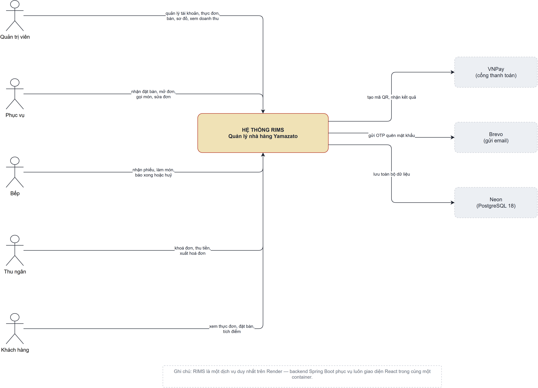

Figure 1: Context Diagram

2. External Entities

# | Entity | Description
1 | Admin | System administrator responsible for managing staff and customer accounts, viewing reports, maintaining restaurant information, and overseeing all system operations.
2 | Customer | Restaurant customer who can register an account, manage their profile, change or reset password, make reservations, earn loyalty points, and view reservation history.
3 | Waiter | Restaurant staff responsible for receiving customer orders, managing tables, updating order information, and serving customers during dining.
4 | Chef | Kitchen staff responsible for viewing assigned orders, preparing dishes, updating cooking status, and managing dish availability.
5 | Cashier | Staff responsible for generating invoices, processing customer payments (cash or VNPay), redeeming customer loyalty points, and completing transactions.
6 | VN Pay | External online payment gateway used to process customer electronic payments and return payment confirmation to the system.
7 | Email Service | External email service used to send OTP verification codes, password reset emails, account notifications, and other system-generated emails.

3. Business Processes

3.1 Booking Flow
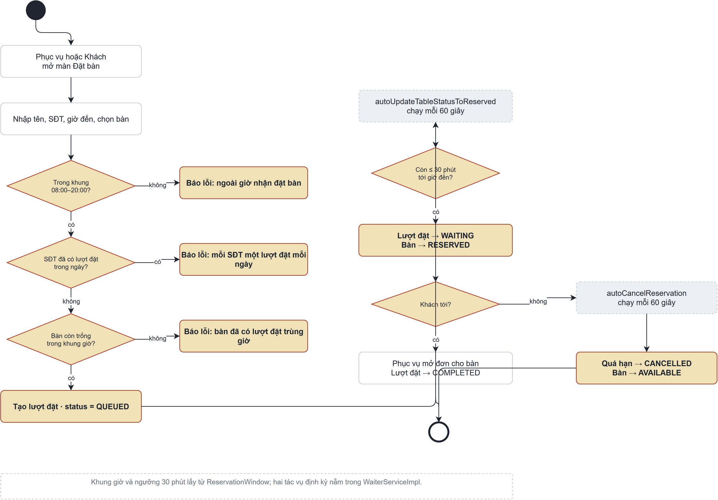
Figure 2: Booking Flow

3.2 Creating Order Flow
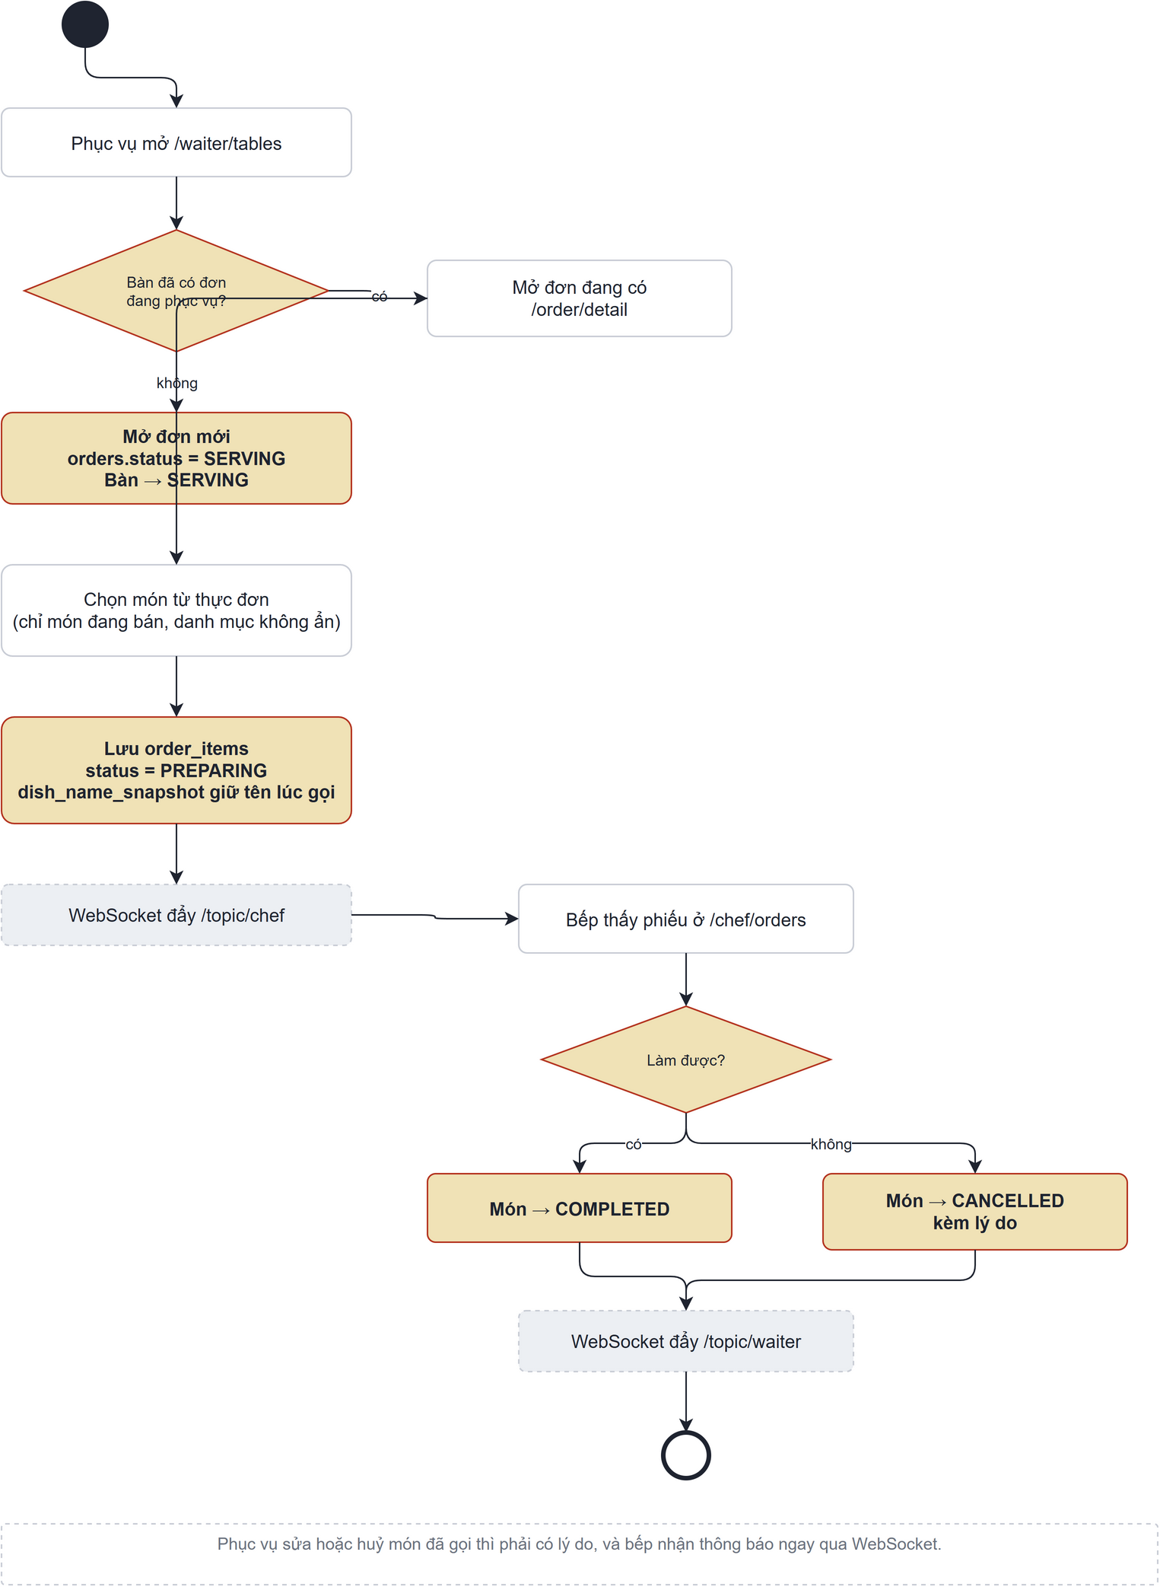
Figure 3: Creating Order Flow

3.3 Customer Checkout Flow
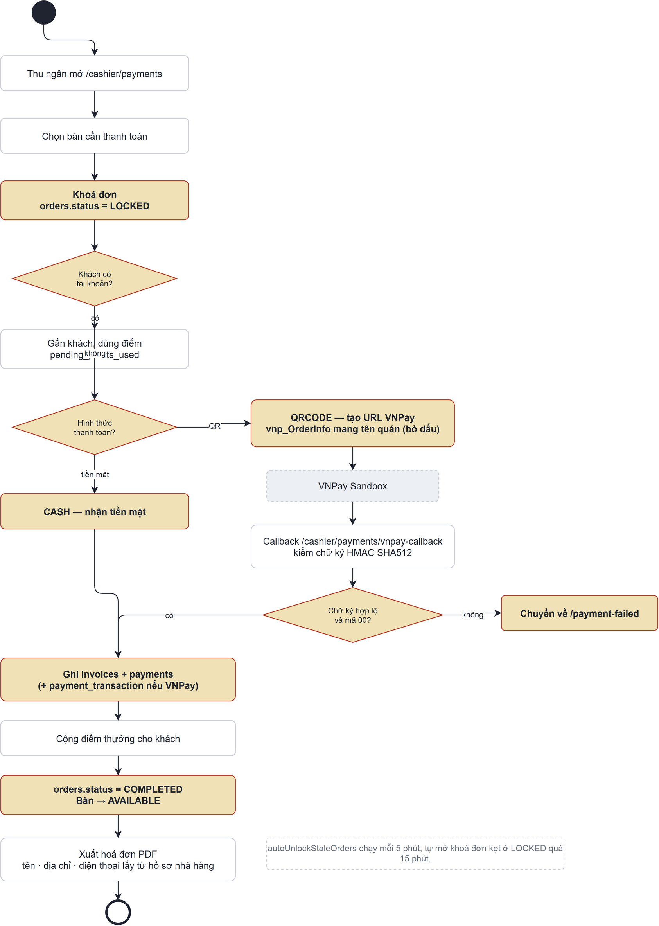
Figure 4: Customer Checkout Flow

4. User Requirements

ID | Use Case | Feature | Main Actor | Use Case Description
UC-AU-01 | Login | Authentication | All Actor | The use case allows a registered user to log in to the system. After successful authentication, the system redirects the user to the appropriate interface based on their role.
UC-AU-02 | Register | Authentication | Customer | Customers register an account (username, email, phone number). The system assigns the default password configured for the deployment (RIMS_DEFAULT_PASSWORD) and returns it in the registration response; the account must change it at first login.
UC-AU-03 | Forgot Password | Authentication | Customer | The customer requests a password reset by providing a registered email address. The system sends a 6-digit OTP to the email. After successful OTP verification, the customer can set a new password.
UC-AU-04 | Change Password | Authentication | Customer | The customer changes the current password by entering the current password, a new password, and confirming the new password.
UC-PR-01 | View profile | Profile Management | User | User views their personal profile information, including full name, username, email, phone number, role, and avatar.
UC-PR-02 | Update profile | Profile Management | Customer + Admin | User updates their personal information. The system validates the input before saving the changes.
UC-ADMIN-01 | Create Account | Manage Account | Admin | Admin creates a new staff or customer account by entering the required information.
UC-ADMIN-02 | View List Account | Manage Account | Admin | Admin views all staff and customer accounts.
UC-ADMIN-03 | View Account Details | Manage Account | Admin | Admin views detailed information of a selected account, including full name, username, email, phone number, role, account status,
UC-ADMIN-04 | Update Account | Manage Account | Admin | Admin updates account information such as full name, username, email, phone number, and role (if applicable).
UC-ADMIN-05 | Set Status Account | Manage Account | Admin | Admin activates or deactivates a user account. Deactivated users cannot log in until the account is reactivated.
UC-ADMIN-06 | View Weekly Revenue Overview Dashboard | Statistics | Admin | Admin views the weekly revenue overview, including revenue data for each day of the week.
UC-ADMIN-07 | View Total Revenue Report | Statistics | Admin | Admin views total revenue by today, week, month, year, or a custom date range.
UC-ADMIN-08 | View Top Best-Selling Dishes by Category | Statistics | Admin | Admin selects a category and time range to view the best-selling dishes in that category.
UC-ADMIN-09 | View Top Best-Selling Dishes | Statistics | Admin | Admin views the top best-selling dishes based on sold quantity and revenue in the selected time range.
UC-ADMIN-10 | View Order Statistics by Shift | Statistics | Admin | Admin views the number of orders in each shift, total paid orders, the shift with the highest number of orders, and the percentage of orders for each shift.
UC-ADMIN-11 | View Invoice History | Invoice History | Admin | Admin views the list of paid invoices, including invoice ID, order ID, table number, payment method, amount, and payment time.
UC-ADMIN-12 | View Invoice Details | Invoice Details | Admin | Admin selects an invoice from the history to view dish list, quantity, unit price, subtotal, total amount, payment time, and payment method.
UC-ADMIN-13 | View Menu | Menu Management | Admin | Admin can view category statistics and dish statistics.
UC-ADMIN-14 | View Dish Details | Dish Management | Admin | The admin can view detailed information about a specific dish.
UC-ADMIN-15 | Create Dish | Dish Management | Admin | The admin creates a new dish in the system
UC-ADMIN-16 | Update Dish | Dish Management | Admin | The admin updates the information dish in the system.
UC-ADMIN-17 | Delete Dish | Dish Management | Admin | The admin hides dishes from the menu without deleting physical data.
UC-ADMIN-18 | View Category Details | Category Management | Admin | The admin views detailed information for a food category.
UC-ADMIN-19 | Create Category | Category Management | Admin | The admin creates a new food category.
UC-ADMIN-20 | Update Category | Category Management | Admin | Admin edits the information of an existing category.
UC-ADMIN-21 | Delete Category (Soft Delete) | Category Management | Admin | Admin hides categories without deleting physical data.
UC-CAS-01 | Monitor Table Map | Table Management | Cashier | The cashier views the real-time status of all tables in the restaurant (Available / Serving).
UC-CAS-02 | View Order Details | Order Management | Cashier | The cashier views the list of completed dishes, quantities, subtotal, and VAT of a specifically selected serving table.
UC-CAS-03 | Manage Customer Loyalty | Customer Management | Cashier | The cashier searches for a customer by phone number, registers new walk-in customers, and applies accumulated reward points to discount the bill.
UC-CAS-04 | Process Checkout | Payment Management | Cashier | The cashier locks the order and finalizes the payment using Cash (calculating change) or generating a VNPay QR code. This includes the ability to cancel the checkout to unlock the table, and covers the automatic handling of orders where every dish was cancelled.
UC-CAS-05 | Manage Daily Invoices | Invoice Management | Cashier | The cashier views, filters, and paginates through the list of all successfully paid invoices across the restaurant for the current day.
UC-CAS-06 | Export Invoice PDF | Invoice Management | Cashier | The cashier downloads a detailed invoice in PDF format, either immediately after a successful checkout or from the daily invoice history.
UC-CH-01 | View Chef Dashboard | Chef Dashboard | Chef | View an overview of current kitchen operations, including the numbers of preparing dishes, completed dishes, cancelled dishes, and unavailable dishes.
UC-CH-02 | View Preparing Orders | Kitchen Order Management | Chef | View the list of order items currently in Preparing status, including the order ID, table number, dish name, quantity, status, and creation time.
UC-CH-03 | View Dish Details | Kitchen Order Management | Chef | View detailed information about a selected dish currently being prepared, including the table number, dish information, quantity, customer note, status, creation time, and Chef internal note.
UC-CH-04 | Mark Dish as Completed Dish | Kitchen Order Management | Chef | Mark a selected dish in PREPARING status as COMPLETED after preparation has finished. The system then notifies the Waiter that the dish is ready to be served.
UC-CH-05 | Request Dish Cancellation | Kitchen Order Management | Chef | Cancel a selected dish that is currently in PREPARING status by providing a valid cancellation reason. The cancelled dish is excluded when the system recalculates the order total.
UC-CH-06 | Add or Update Internal Note | Kitchen Order Management | Chef | Add, update, or remove an internal kitchen note for a dish currently in PREPARING status to support preparation and coordination among kitchen staff.
UC-CH-07 | View Grouped Kitchen Orders | Kitchen Order Management | Chef | View preparing order items grouped by dish to improve kitchen efficiency. Identical dishes without customer notes may be grouped together, while dishes with specific notes are displayed separately.
UC-CH-08 | Complete Grouped Kitchen Orders | Kitchen Order Management | Chef | Mark all selected order items in the same kitchen preparation group as COMPLETED after the entire group has been prepared.
UC-CH-09 | View Dish List | Menu Management | Chef | View the restaurant’s dish list, including the dish name, category, price, and current availability status.
UC-CH-10 | Update Dish Availability | Menu Management | Chef | Update whether a dish is available or unavailable for serving. When a dish is marked unavailable, all related order items currently in PREPARING status are automatically cancelled, and the affected order totals are recalculated.
UC-CH-11 | View Completed Orders | Kitchen Order History | Chef | View the list of dishes that have been completed to review finished kitchen orders and preparation results.
UC-CH-12 | View Cancelled Orders | Kitchen Order History | Chef | View the list of cancelled dishes, including the related order, table number, dish name, quantity, cancellation reason, and cancellation time.
UC-CU-01 | Reserve Table | Reservation | Customer | Customers can reserve a table.
UC-CU-02 | Cancel Reservation Table | Reservation | Customer | Customers can cancel a table reservation.
UC-WT-01 | View Restaurant Tables | Table Management | Waiter | View the complete list of restaurant tables, including their current status, capacity, and upcoming reservation information to determine table availability.
UC-WT-02 | Create Order | Order Management | Waiter | Create a new order for a walk-in customer by selecting an available table and adding menu items.
UC-WT-03 | View Active Order Details | Order Management | Waiter | View the complete information of the active order assigned to a selected table, including ordered dishes, preparation status, customer notes, and chef internal notes.
UC-WT-04 | Update Order | Order Management | Waiter | Modify an active order by adding new dishes, updating quantities, removing eligible items, or changing notes while complying with kitchen processing constraints.
UC-WT-05 | Create Order from Reservation | Order Management | Waiter | Create a new order for a customer with a valid reservation after the customer arrives and occupies the reserved table.
UC-WT-06 | Create Reservation | Reservation Management | Waiter | Create a reservation by assigning a suitable table and reservation time for a customer.
UC-WT-07 | View Current Reservation by Table | Reservation Management | Waiter | View the reservation currently associated with a reserved table before serving the customer.
UC-WT-08 | View Reservation Detail | Reservation Management | Waiter | View detailed information about a specific reservation, including customer information, reservation time, assigned table, and reservation status.
UC-WT-09 | View Reservations by Table and Date | Reservation Management | Waiter | View all reservations assigned to a selected table on a specified date for scheduling and planning purposes.
UC-WT-10 | Update Reservation | Reservation Management | Waiter | Modify reservation information such as customer details, reservation time, notes, or assigned table while ensuring no scheduling conflicts occur.

4.1 UCs for Authenticated User
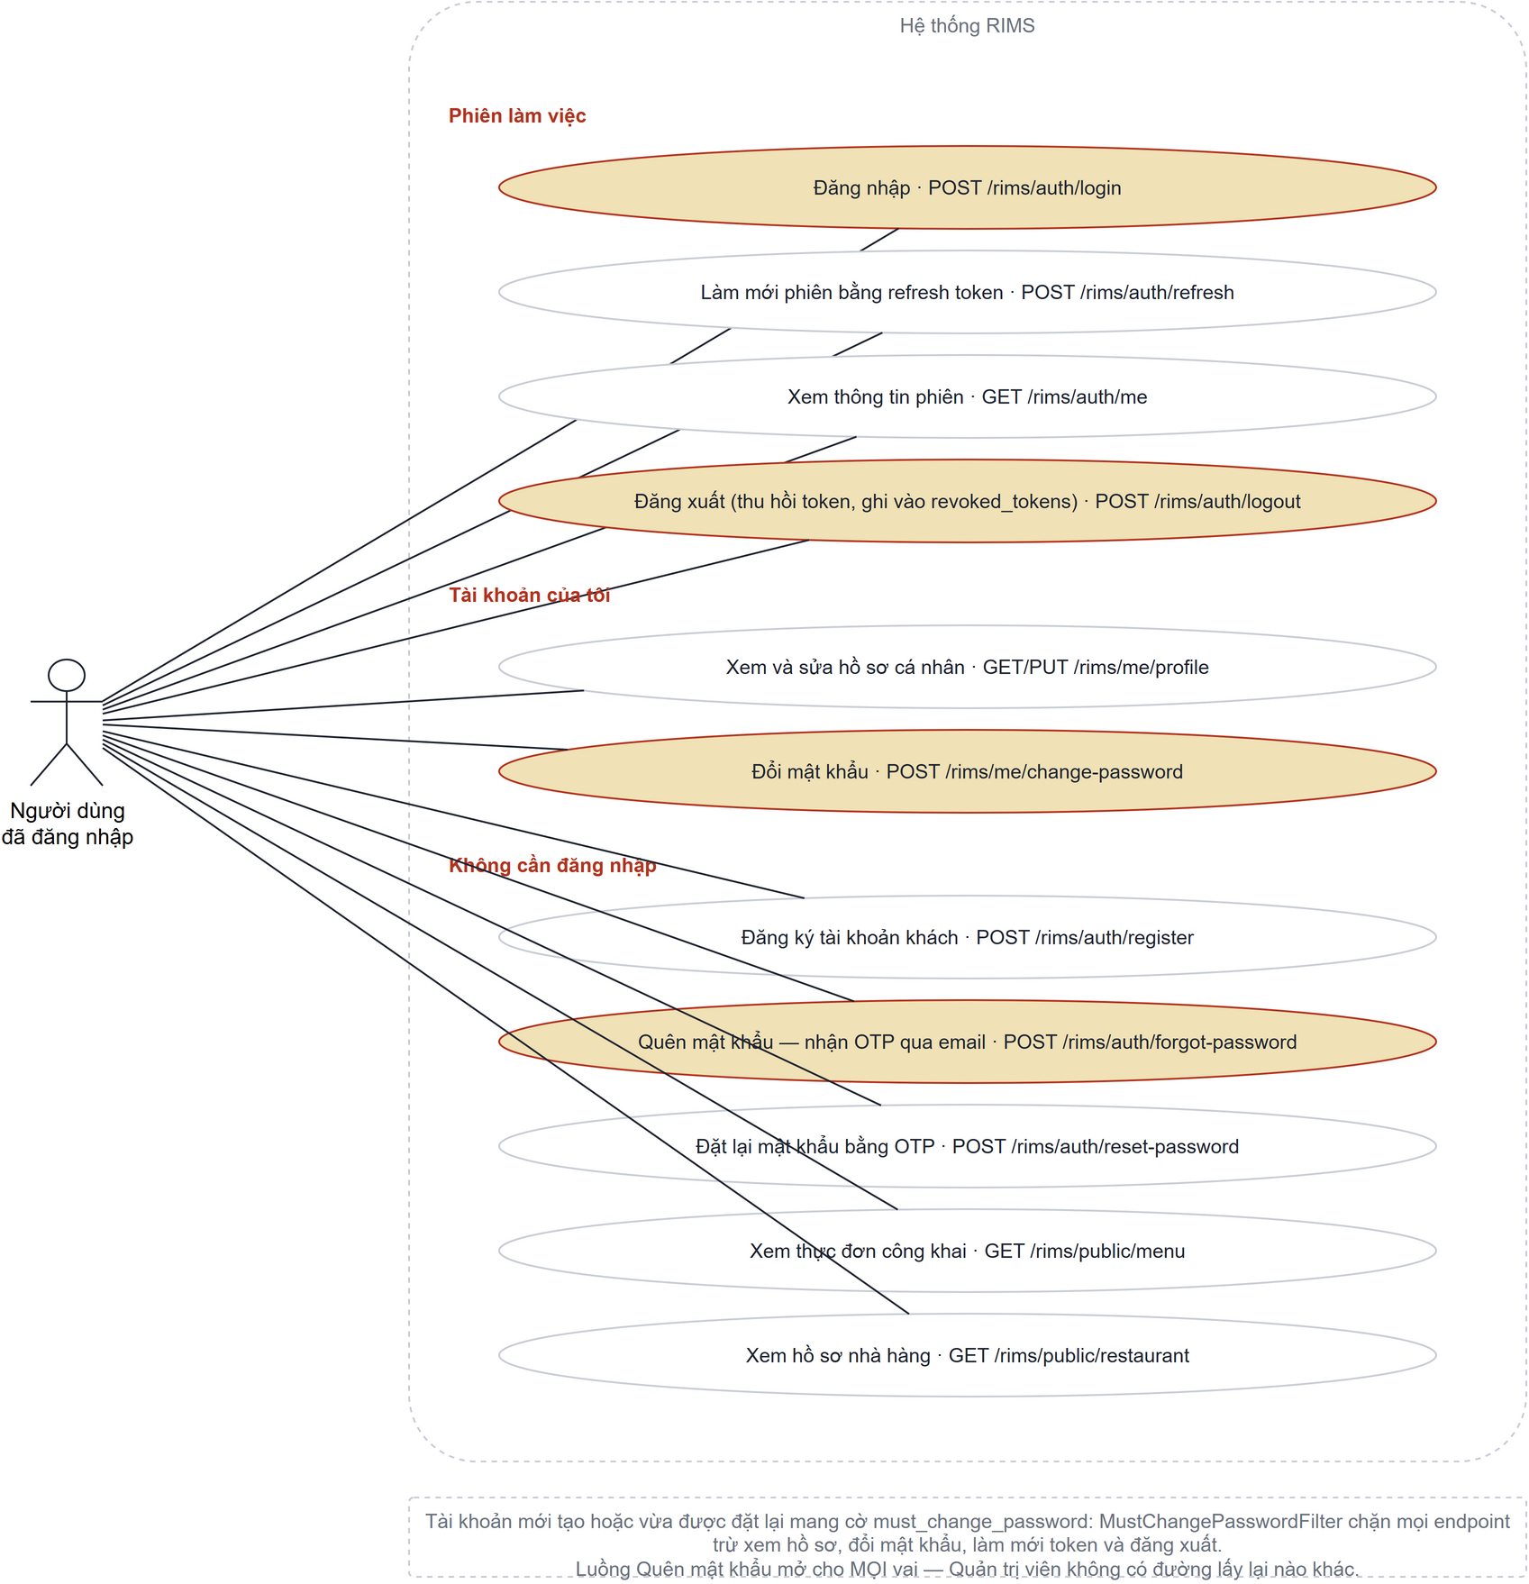
Figure 5 UCs for Authenticated User

4.2 UCs for Admin

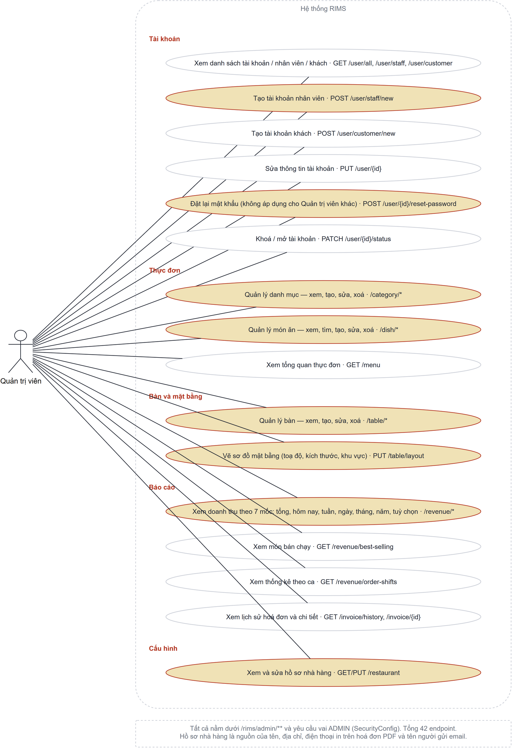

4.3 UCs for Cashier
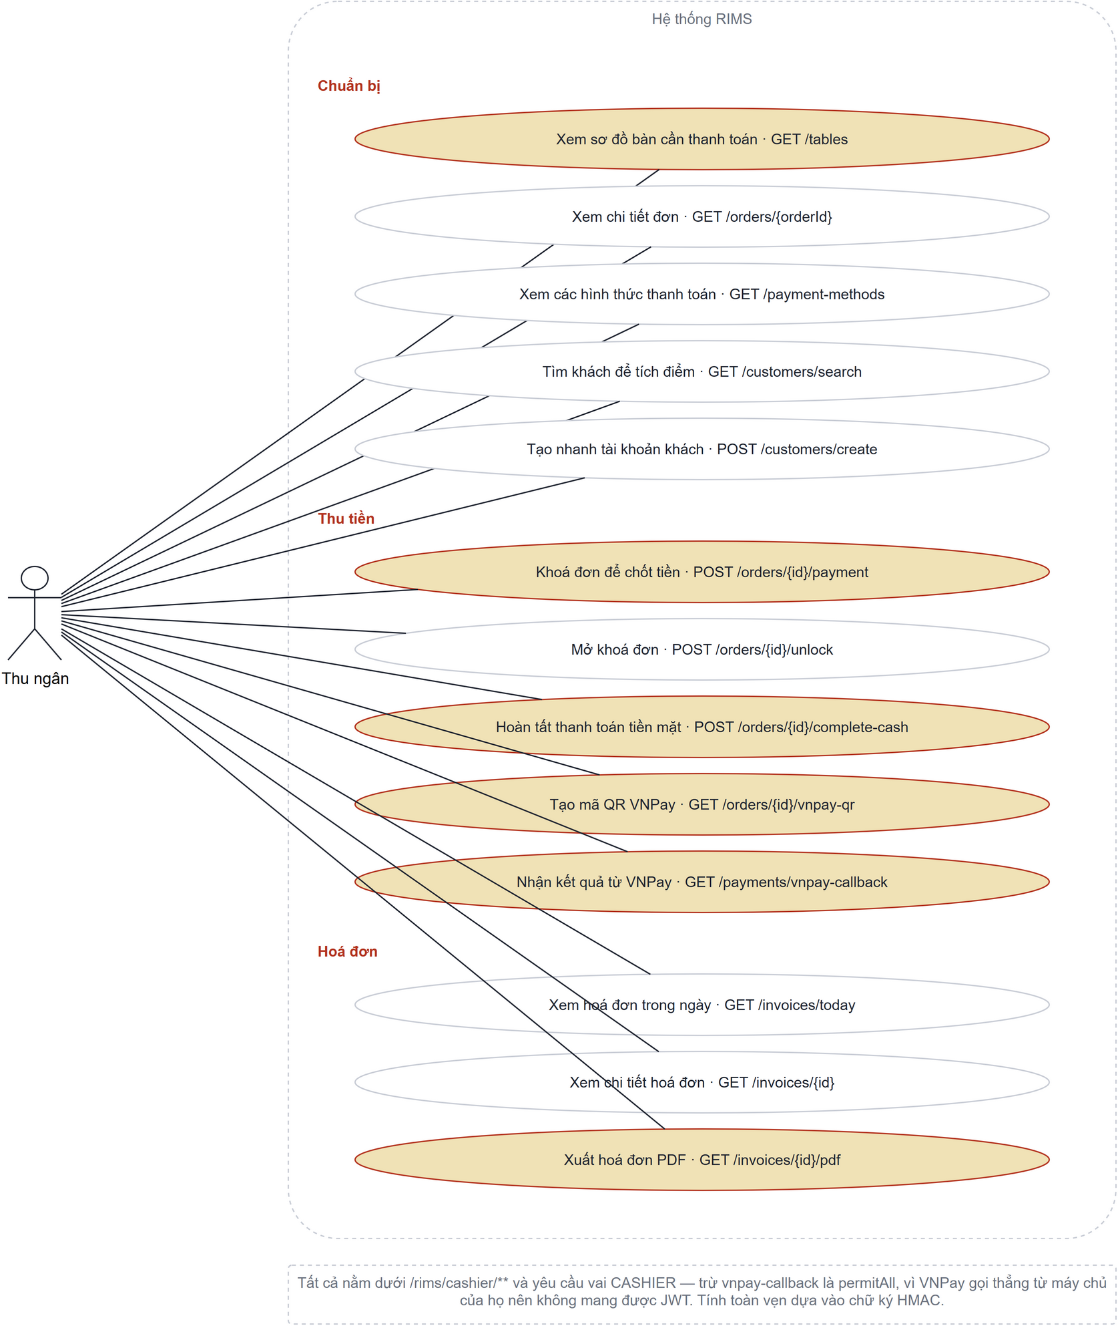

4.4 UCs for Chef
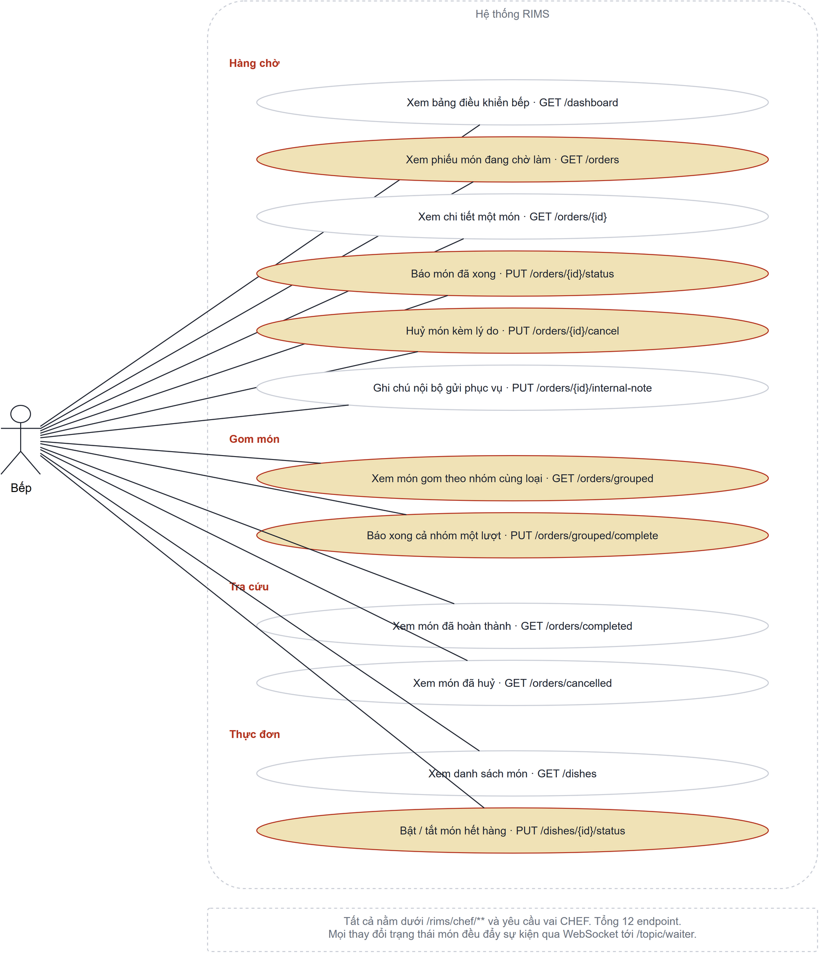

4.5 UCs for Customer
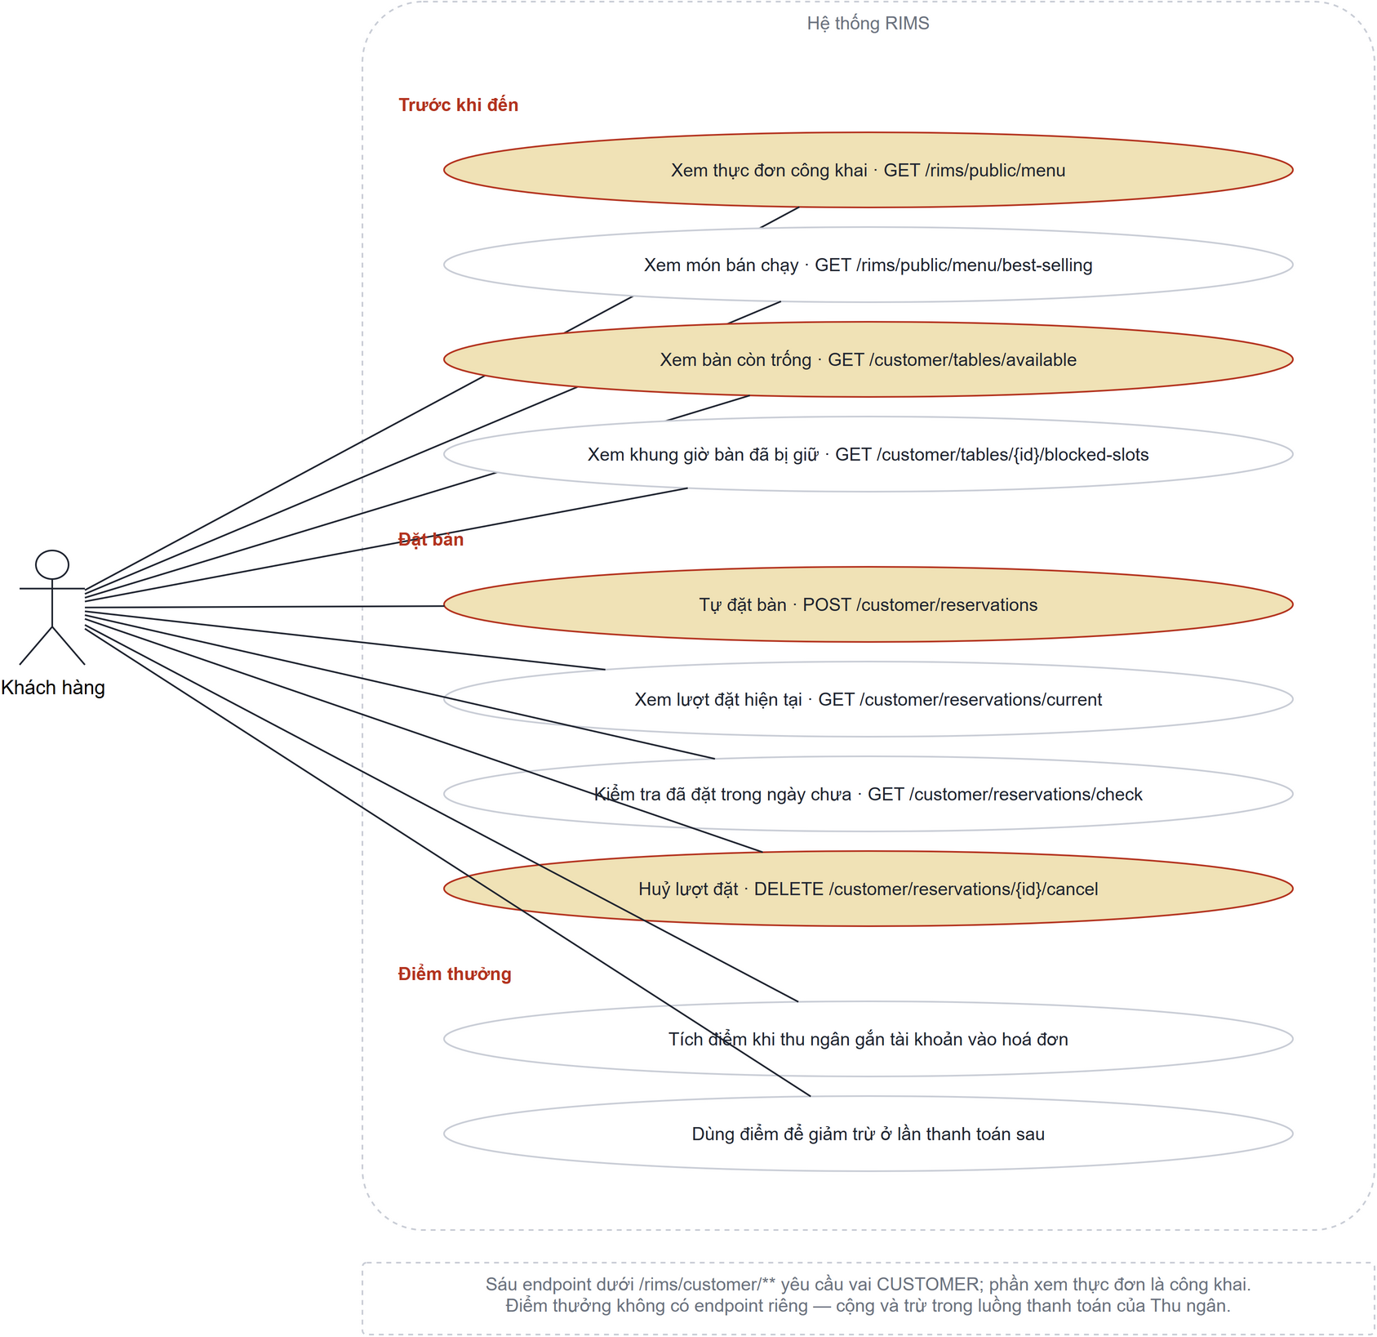

4.6 UCs for Waiter
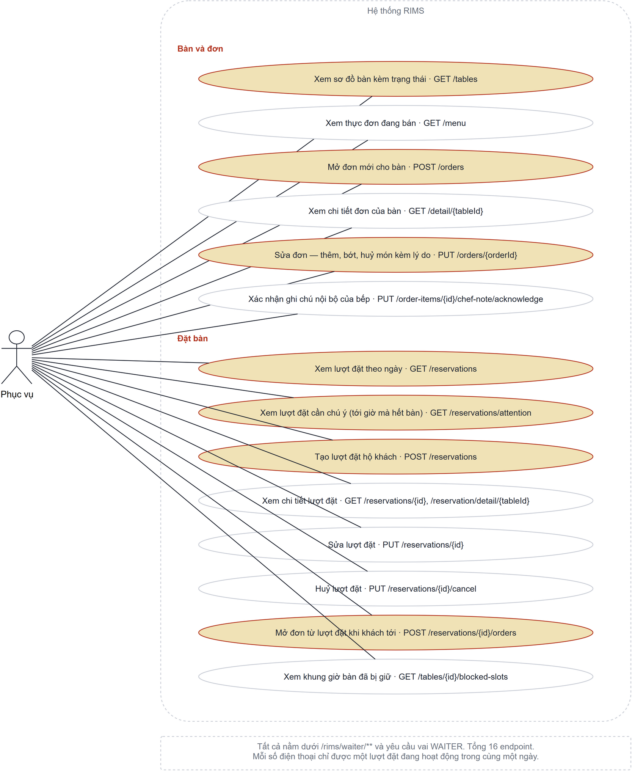

5.UC Specification

5.1 Authentication UC Specification

UC ID and Name: | UC-AU-01- Login
Created By: | HienNTT | Date Created: | 16/07/2026
Primary Actor: | All User | Secondary Actors: | None
Trigger: | The user selects the Login option and submits login credentials.
Description: | This use case allows a registered user to log in to the Restaurant Internal Management System. After successful authentication, the system redirects the user to the appropriate interface based on their role.
Preconditions: | 1. The user has a registered account in the system.  2. The user is not currently logged in.  3. The system is available and connected to the database.
Postconditions: | The user is authenticated, a login session is created, and the user is redirected to the appropriate page.
Normal Flow: | - The user opens the Login page.  - The system displays the Login form.  - The user enters a username (or email) and password.  - The user clicks the Login button.  - The system redirects the user to the corresponding homepage according to the assigned role.
Alternative Flows: | A1. Required Field Validation  - At Step 5, if the username/email field is empty, the system displays "Username or Email is required."  - If the password field is empty, the system displays "Password is required."  - The Login page remains displayed.  AF2 – Invalid Credentials  - At Step 6 or Step 7, if the username/email does not exist or the password is incorrect:  - The system displays "Invalid username/email or password."  - The Login page remains displayed.  AF3 – Locked Account  - At Step 8, if the account status is Inactive or Locked:  - The system denies authentication.  - The system displays "Your account has been locked. Please contact the administrator."  AF4 – Forgot Password  - At Step 2, the Customer selects Forgot Password.  - The system redirects the Customer to the Forgot Password process.
Exceptions: | E1 – Database Error  - If the system cannot connect to the database, the system displays:  "Unable to process your request. Please try again later."
Priority: | High
Frequency of Use: | Frequent
Business Rules: | BR1: Username is required and must not be empty.  BR2: Username must contain 4–30 characters.  BR3: Username may contain only letters (A–Z, a–z), numbers (0–9), and underscores (_).  BR4: Password is required and must not be empty.  BR5: Password must contain at least 6 characters and no more than 100 characters.  BR6: Leading and trailing spaces in the Username shall be removed before authentication.  BR7: The system shall authenticate the Username and Password against the stored account information.  BR8: Only accounts with ACTIVE status are allowed to log in.  BR9: If the Username or Password is incorrect, the system shall display "Invalid username or password."  BR10: If the account status is INACTIVE, the system shall display "Your account has been deactivated."

UC ID and Name: | UC-AU-02 – Register Account
Created By: | BACNX | Date Created: | 16/07/2026
Primary Actor: | Customer | Secondary Actors: | None
Trigger: | Customer selects the "Register" function on the system interface.
Description: | This use case allows a customer to self-register a new account by providing a username, email, and phone number; the system automatically assigns the default password configured for the deployment (RIMS_DEFAULT_PASSWORD) and returns it in the registration response, so the screen never states the password in advance.
Preconditions: | 1. The customer does not yet have an account in the system.  2. The customer is on the system's registration page.
Postconditions: | 1. A new account is created in the Users table with role = CUSTOMER and an encrypted (hashed) default password.  2. The customer can log in using the newly registered credentials.
Normal Flow: | 1. Customer selects "Register".  2. The system displays the registration form (username, email, phone number).  3. The customer enters the information and clicks "Register".  4. The system validates and checks the uniqueness of the username, email, and phone.  5. The system creates the new account, hashes the deployment-configured default password (RIMS_DEFAULT_PASSWORD) into password_hash, sets must_change_password, and assigns role = CUSTOMER.  6. The system displays a success message and prompts the customer to log in.
Alternative Flows: | 6a. The system may automatically redirect the customer to the login page after a successful registration.
Exceptions: | E1. Username already exists: the system displays the error "Username is already in use".  E2. Email already exists: the system displays the error "Email is already in use".  E3. Phone number already exists: the system displays the error "Phone number is already in use".  E4. Invalid input format (invalid email/phone): the system requests re-entry.
Priority:  Frequency of Use: | Priority: High  Frequency of Use: Frequent (whenever a new customer signs up).
Business Rules: | BR1. Username, email, and phone must all be unique across the entire system.  BR2. The default password for a newly registered account is encrypted by PasswordEncoder.  BR3. All accounts registered through this use case default to role = CUSTOMER and isActive = true.  BR4. Username, fullName and email are all required; email must be unique. Email is the only password-recovery channel, so an account without one cannot be recovered.  BR5. Phone number is required and must be unique.

UC ID and Name: | UC-AU-03 – Forgot Password
Created By: | HienNTTHE172532 | Date Created: | 17/7/2026
Primary Actor: | Customer | Secondary Actors: | System, Email Service (Brevo API)
Trigger: | The customer clicks the Forgot Password button on the Login page.
Description: | This use case allows a customer to reset their password by verifying a One-Time Password (OTP) sent to their registered email address.
Preconditions: | - The customer already has an account.  - The registered email exists in the system.  - The registered account contains a valid email address.
Postconditions: | - The customer's password is successfully updated.  - Customers can log in using the new password.
Normal Flow | - Customer clicks Forgot Password.  - The system requests the customer's registered email.  - The customer enters the email address.  - The system validates the email.  - The system generates a 6-digit OTP.  - The system sends the OTP to the customer's email.  - The customer enters the OTP.  - The system verifies the OTP.  - The customer enters a new password and confirms it.  - The system validates the new password.  - The system encrypts and updates the password.  - The system displays a successful password reset message.
Alternative Flows: | A1. Resend OTP  - The customer requests another OTP.  - The system generates and sends a new OTP to the registered email.
Exceptions: | E1. Invalid email format  • The system displays an email validation message.  E2. Email is not associated with a Customer account  • System rejects the reset request.  E3. Incorrect OTP  • The system displays an invalid OTP message.  • Customers may enter the OTP again.  E4. Expired OTP  • The system requests the customer to obtain a new OTP.  E5. New Password and Confirm Password do not match  • The system displays a mismatched message.  E6. Email cannot be sent  • The system displays an email-service error.  • The password has not changed.
Priority: | High
Frequency of Use: | Frequently
Business Rules: | BR1. Only Customer accounts can use the Forgot Password function.  BR2. The entered email must exist in the system.  BR3. OTP shall contain exactly 6 numeric digits.  BR4. OTP shall expire after 5 minutes.  BR5. Each OTP can only be used once.  BR6. If a new OTP is generated, the previous OTP becomes invalid.  BR7. New Password is required.  BR8. New Password must contain at least 6 characters.  BR9. The Confirmed Password must exactly match the New Password.  BR10. Password shall be encrypted before being stored.

UC ID and Name: | UC-AU-04 – Change Password
Created By: | HienNTTHE172532 | Date Created: | 17/7/2026
Primary Actor: | Customer | Secondary Actors: | None
Trigger: | Customer selects the Change Password option in the Profile page.
Description: | This use case allows a logged-in customer to change their current password by entering the current password, a new password, and confirming the new password.
Preconditions: | - The customer has successfully logged in.  - The customer account is active.
Postconditions: | - Password is successfully updated.  - Customers must use the new password for future logins.
Normal Flow | - Customer opens the Profile page.  - Customer selects Change Password.  - The system displays the Change Password form.  - Customer enters: Current Password, New Password, Confirm New Password  - Customer clicks Save.  - The system validates the current password.  - The system validates the new password.  - The system encrypts and updates the password.  - The system displays a success message.
Alternative Flows: | None
Exceptions: | - The current password is incorrect.  - New password and confirmation do not match.  - The new password does not satisfy password policy.
Priority: | High
Frequency of Use: | Occasionally
Business Rules: | BR1. Only Customer accounts can access this function.  BR2. Current Password is required.  BR3. Current Password must match the encrypted password stored in the database.  BR4. New Password is required and must contain at least 6 characters.  BR5. New Password must be different from the Current Password.  BR6. Confirm Password must exactly match the New Password.  BR7. Password shall be encrypted before updating the database.

5.2 Admin UC Specification

UC ID and Name: | UC-ADMIN-01– Create Account
Created By: | HienNTTHE172532 | Date Created: | 17/7/2026
Primary Actor: | Admin | Secondary Actors: | None
Trigger: | Admin selects the Create Account button on the Account Management page.
Description: | This use case allows the Admin to create a new Staff or Customer account by entering the required information. The system validates the input and stores the account in the database.
Preconditions: | - Admin has successfully logged in.  - Admin has permission to manage accounts.  - The Account Management screen is available.
Postconditions: | - A new account is successfully created and stored in the system.  - The new account is displayed in the corresponding Staff or Customer account  list.  - No account is created if the operation fails or is cancelled.
Normal Flow | - Admin selects Account Management from the navigation menu.  - System displays the account list screen.  - Admin selects Create Account.  - System displays the account creation form.  - Admin selects the account type: Staff or Customer.  - Admin enters Full Name, Username, Email and Phone Number.  - If Staff is selected, Admin selects a Staff Role.  - System validates all entered information.  - System checks whether Username, Email and Phone Number already exist.  - System creates the account.  - System displays a successful creation message.  - System refreshes the account list.
Alternative Flows: | A1. Create a Customer account  1. Admin selects Customer as the account type.  2. System automatically assigns the CUSTOMER role.  3. System assigns the configured default password.  4. Use case continues at Step 8 of the Normal Flow.  A2. Cancel account creation  1. Admin selects Cancel.  2. System closes the creation form.  3. No account information is saved.
Exceptions: | E1. Required information is missing  - System identifies one or more empty required fields.  - System displays validation messages.  - Admin must complete all required fields before continuing.  E2. Username, Email or Phone Number already exists  - System displays the corresponding duplicate-data message.  - Admin remains on the creation form.  E3. Invalid input format  - System identifies the invalid field and displays a validation message.
Priority: | High
Frequency of Use: | Frequently
Business Rules: | BR1. Full Name is required and cannot be empty.  BR2. Full Name must be between 2 and 100 characters.  BR3. Username is required and cannot be empty.  BR4. Username must contain 4–30 characters, only letters, numbers, and underscores (_), and must be unique.  BR5. Email is required and cannot be empty.  BR6. Email must follow the standard email format (e.g., example@gmail.com,..) and must be unique.  BR7. Phone Number is required and cannot be empty.  BR8. Phone Number must contain exactly 10 digits, start with 0, contain only numeric characters, and must be unique.  BR9. Staff Role can only be CHEF, WAITER, or CASHIER.  BR10. The ADMIN role shall not be selectable when creating a staff account.  BR11. Customer accounts shall automatically be assigned the CUSTOMER role.  BR12. Newly created Customer accounts shall receive the default password configured for the deployment (RIMS_DEFAULT_PASSWORD, read from the environment) and shall be forced to change it at first login. The password shall not be hard-coded in the source or committed to the repository.  BR13. Passwords shall be encrypted before being stored in the database.

UC ID and Name: | UC-ADMIN-02 – View List Account
Created By: | HienNTTHE172532 | Date Created: | 17/7/2026
Primary Actor: | Admin | Secondary Actors: | None
Trigger: | Admin selects Account Management from the navigation menu.
Description: | This use case allows the Admin to view all Staff and Customer accounts managed by the system.
Preconditions: | - Admin has successfully logged in.  - Admin has permission to access Account Management.
Postconditions: | - The system displays the account list.  - No account information is changed.
Normal Flow | - Admin selects Account Management from the navigation menu.  - System retrieves account information from the database.  - System classifies accounts into Staff and Customer groups.  - System displays the Staff account list by default.  - Admin switches between the Staff and Customer tabs.  - System displays the corresponding account list.  - Each account row displays Full Name, Username, Email, Phone Number, Role and Status.
Alternative Flows: | A1. View Customer accounts  1. Admin selects the Customer tab.  2. System displays accounts whose role is CUSTOMER.  A2. Refresh the account list  1. Admin refreshes or reopens the screen.  2. System retrieves and displays the latest account information.
Exceptions: | E1. No account is available  • System displays an empty-state message.  E2. Account information cannot be retrieved  • System displays an error message.  • Admin remains on the current screen.  E3. Session expired  • System redirects Admin to the Login page.
Priority: | High
Frequency of Use: | Frequently
Business Rules: | None

UC ID and Name: | UC-ADMIN-03 – View Account Details
Created By: | HienNTTHE172532 | Date Created: | 17/7/2026
Primary Actor: | Admin | Secondary Actors: | None
Trigger: | Admin selects an account from the account list and clicks the View Details button.
Description: | This use case allows the Admin to view detailed information about a selected Staff or Customer account.
Preconditions: | - Admin has successfully logged in.  - Admin account is active.  - The selected account exists in the system.  - Admin is viewing the Account Management page.
Postconditions: | - Detailed information about the selected account is displayed.  - No account information is changed.
Normal Flow | - Admin opens the Account Management screen.  - System displays the account list.  - Admin selects an account.  - Admin selects View Details.  - System receives the selected account identifier.  - System retrieves the latest account information.  - System displays Full Name, Username, Email, Phone Number, Role and Status.  - Admin reviews the account information.
Alternative Flows: | A1. Close account details  1. Admin selects Close or Back.  2. System returns Admin to the account list.  A2. Continue to update account  1. Admin selects Edit from the detail screen.  2. System opens the Update Account form.
Exceptions: | E1. Account not found  • System displays an “Account not found” message.  • System returns Admin to the account list.  E2. Account information cannot be retrieved  • System displays an error message.  E3. Session expired  • System redirects Admin to the Login page.
Priority: | High
Frequency of Use: | Frequently
Business Rules: | BR1: Only Admin can view another user's account details.  BR2: The selected account must exist in the database.  BR3: Password information must never be displayed.

UC ID and Name: | UC-ADMIN-04 – Update Account
Created By: | HienNTTHE172532 | Date Created: | 17/7/2026
Primary Actor: | Admin | Secondary Actors: | None
Trigger: | Admin selects an account and clicks the Update Account button.
Description: | This use case allows the Admin to update the information of an existing Staff or Customer account. The system validates the updated information before saving the changes.
Preconditions: | - Admin has successfully logged in.  - Admin account is active.  - Admin has permission to manage accounts.  - The selected account exists in the system.
Postconditions: | - The selected account information is successfully updated.  - Updated information is saved in the database.  - The account list displays the latest information.
Normal Flow | - Admin opens the Account Management page.  - System displays the account list.  - Admin selects an account.  - Admin clicks the Update Account button.  - System displays the current account information.  - Admin updates one or more fields: Full Name, Username, Email, Phone Number, Role (Staff) (A1)  - Admin clicks the Save button.  - System validates the updated information.
Alternative Flows: | A1. Admin cancels the update  - At Step 6, Admin clicks Cancel.  - System closes the Update Account form.  - System does not save any changes.  A2. Account information remains unchanged  - Admin opens the Update Account form.  - Admin does not change any information.  - Admin closes or cancels the form.  - System keeps the original account information.
Exceptions: | E1. Required information is missing  - System displays validation messages.  - Admin must complete the required fields.  E2. Username already belongs to another account  - System displays a duplicate username message.  - Admin must enter another username.  E3. Email already belongs to another account  - System displays a duplicate email message.  - Admin must enter another email.  E4. Phone number already belongs to another account  - System displays a duplicate phone number message.  - Admin must enter another phone number.  E6. Account no longer exists  - System displays an account-not-found message.  - System returns Admin to the account list.
Priority: | High
Frequency of Use: | Frequently
Business Rules: | BR1. Full Name cannot be empty.  BR2. Full Name must contain 2–100 characters.  BR3. Username cannot be empty and must contain 4–30 characters.  BR4. Username must remain unique, except for the current account.  BR5. Email cannot be empty.  BR6. Email must follow the standard email format and must remain unique.  BR7. Phone Number cannot be empty.  BR8. Phone Number must contain exactly 10 digits, start with 0, and remain unique.  BR9. Customer accounts cannot be changed to Staff accounts, and Staff accounts cannot be changed to Customer accounts.  BR10. Password cannot be updated through the Update Account function.  BR11. The system shall update the Last Updated Date after a successful update.

UC ID and Name: | UC-ADMIN-05 – Set Status Account
Created By: | HienNTTHE172532 | Date Created: | 17/7/2026
Primary Actor: | Admin | Secondary Actors: | None
Trigger: | Admin clicks the account status button of a selected Staff or Customer account.
Description: | This use case allows the Admin to activate or deactivate an account. A deactivated account cannot log in until it is reactivated.
Preconditions: | - Admin has successfully logged in.  - Admin account is active.  - Admin has permission to manage accounts.  - The selected account exists in the system.
Postconditions: | - The selected account status is updated.  - The new status is saved in the database.  - The updated status is displayed in the account list.  - A deactivated account can no longer log in.
Normal Flow | - Admin opens the Account Management page.  - System displays the account list and account statuses.  - Admin selects an account.  - Admin clicks the account status button.  - System displays a confirmation message.  - Admin confirms the status change.  - System updates the account status.  - System saves the new status to the database.  - System refreshes the account list.  - System displays a success message:  - A green message when an account is activated.  - A red message when an account is deactivated.
Alternative Flows: | A1. Deactivate an active account  - Admin selects an Active account.  - Admin confirms account deactivation.  - System changes the status from Active to Inactive.  - The account can no longer log in.  A2. Activate an inactive account  - Admin selects an Inactive account.  - Admin confirms account activation.  - System changes the status from Inactive to Active.  - The account can log in again.
Exceptions: | E1. Account no longer exists  - System displays an account-not-found message.  - System refreshes the account list.  E2. Status update fails  - System cannot update the account status.  - System displays an error message.  - The current account status remains unchanged.  E3. Admin attempts to deactivate their own account  - System rejects the request.  - System displays a message indicating that Admin cannot deactivate their own account.
Priority: | High
Frequency of Use: | Occasionally
Business Rules: | BR1. Account Status can only be ACTIVE or INACTIVE.  BR2. Accounts with INACTIVE status shall not be allowed to log in.  BR3. The system shall require a confirmation before changing account status.  BR4. The Admin account shall not be allowed to be set to INACTIVE.  BR5. The account list shall be refreshed after the status is updated successfully.

UC ID and Name: | UC-ADMIN-06 - View Weekly Revenue Overview Dashboard
Created By: | VinhNTHE190385 | Date Created: | 16/07/2026
Primary Actor: | Admin | Secondary Actors: | None
Trigger: | Admin opens the Weekly Revenue Overview Dashboard.
Description: | Admin views the weekly revenue overview, including total weekly revenue, daily revenue chart, paid orders, top best-selling dishes, and order statistics by shift.
Preconditions: | Admin is logged in.
Postconditions: | The weekly revenue overview displays the weekly revenue overview, including total weekly revenue, daily revenue chart, paid orders, top best-selling dishes, and order statistics by shift.
Normal Flow | 1. Admin opens the Weekly Revenue Overview Dashboard.(E1)  2. System displays the default week.  3. Admin can select another week.  4. System loads revenue, daily revenue, best-selling dishes, and order shift data.  5. System displays the weekly overview dashboard.
Alternative Flows: | 1.If Admin selects another week,  2.The system reloads data for that week.
Exceptions: | 1.If data cannot be loaded, the system shows an error message.
Priority: | High
Frequency of Use: | Daily or weekly
Business Rules: | BR-01: Revenue is calculated from invoices.  BR-02: Top dishes are sorted by sold quantity and revenue.  BR-03: Order shift percentage is calculated from total paid orders.

UC ID and Name: | UC-ADMIN-07 - View Total Revenue Report
Created By: | VinhNTHE190385 | Date Created: | 16/07/2026
Primary Actor: | Admin | Secondary Actors: | None
Trigger: | Admin opens the Total Revenue Report in the Statistics page.
Description: | Admin views total revenue, total revenue by today, week, month, year, or a custom date range.
Preconditions: | - Admin is logged in.
Postconditions: | -The system displays total revenue, today revenue, weekly revenue, monthly revenue, yearly revenue, or custom date range revenue according to the admin’s selection.
Normal Flow | 1. Admin opens the Statistics page.  2. Admin selects Total Revenue Report  3. System loads total revenue, today revenue, weekly revenue, monthly revenue, and yearly revenue.(E1)  4. System displays the revenue values.
Alternative Flows: | 1.Admin enters a custom date range.(E2)(E3)  2.System loads and displays revenue for that range.
Exceptions: | 1. If data cannot be loaded, the system shows an error message.  2. If the date format is invalid, the system shows an error message.  3. If From Date is greater than To Date, the system shows an error message.
Priority: | High
Frequency of Use: | Daily or weekly
Business Rules: | BR-01:Revenue is calculated only from invoices. Every invoice represents a successfully paid order.  BR-02:If no invoices exist for a selected period, revenue is displayed as 0.  BR-03:Future dates are not used for revenue calculation. When To Date is in the future, the system automatically adjusts To Date to the current date.

UC ID and Name: | UC-ADMIN-08 - View Top Best-Selling Dishes by Category
Created By: | VinhNTHE190385 | Date Created: | 16/07/2026
Primary Actor: | Admin | Secondary Actors: | None
Trigger: | Admin selects Top Best-Selling Dishes by Category in the Statistics page.
Description: | Admin selects a category and time range to view the best-selling dishes in that category.
Preconditions: | - Admin is logged in.
Postconditions: | - The top best-selling dishes by category are displayed.
Normal Flow | 1.Admin opens the Statistics page.  2.Admin selects Top Best-Selling Dishes by Category.(E1)  3.System loads the category list.  4.System selects the default category and default time range.  5.System loads best-selling dishes for the selected category and time range.  6.System displays the result.
Alternative Flows: | 1.Admin selects another category or another time range.  2.System reloads the report.
Exceptions: | 1.If the report cannot be loaded, the system shows an error message.
Priority: | Medium
Frequency of Use: | Weekly
Business Rules: | BR-01:The report uses paid invoice data.  BR-02: Dishes are sorted by sold quantity in descending order.  BR-03:If multiple dishes have the same sold quantity, they are sorted by revenue in descending order

UC ID and Name: | UC-ADMIN-09 - View Top 10 Best-Selling Dishes
Created By: | VinhNTHE190385 | Date Created: | 16/07/2026
Primary Actor: | Admin | Secondary Actors: | None
Trigger: | Admin selects Top Best-Selling Dishes in the Statistics page.
Description: | Admin views the top 10 best-selling dishes based on sold quantity and revenue in the selected time range.
Preconditions: | - Admin is logged in.
Postconditions: | - The top 10 best-selling dishes displays dish rank, dish name, image and sold quantity.
Normal Flow | 1. Admin opens the Statistics page.  2. Admin selects Top 10 Best-Selling Dishes.(E1)  3. System loads best-selling dish data.  4. System displays dish rank, dish name, image and sold quantity.
Alternative Flows: | - Admin selects another time range.  - System reloads the report.
Exceptions: | 1. If the report cannot be loaded, the system shows an error message.
Priority: | Medium
Frequency of Use: | Weekly
Business Rules: | BR-01: The report uses paid invoice data.  BR-02: Dishes are sorted by sold quantity and revenue.  BR-03: The report displays a maximum of 10 dishes. If fewer than 10 dishes have sales data in the selected time range, the system displays all available best-selling dishes.

UC ID and Name: | UC-ADMIN-10 - View Order Statistics by Shift
Created By: | VinhNTHE190385 | Date Created: | 16/07/2026
Primary Actor: | Admin | Secondary Actors: | None
Trigger: | Admin selects Order Statistics by Shift in the Statistics page.
Description: | Admin views the number of orders in each shift, total paid orders, the shift with the highest number of orders, and the percentage of orders for each shift.
Preconditions: | - Admin is logged in.
Postconditions: | - The order statistics by shift report is displayed with total paid orders, average orders per day, highest order shift, order count by shift, and percentage by shift.
Normal Flow | 1.Admin opens the Statistics page.  2.Admin selects Order Statistics by Shift.  3.System selects the default time range.(E1)  4.System loads paid order data in the selected time range.  5.System groups orders by shift.  6.System displays total paid orders, average orders per day, highest order shift, order count by shift, and percentage by shift.
Alternative Flows: | 1.Admin selects another time range.  2.System reloads paid order data in the selected time range.  3.System groups orders by shift.  4.System displays the updated order statistics by shift report.
Exceptions: | 1.If the report cannot be loaded, the system shows an error message.
Priority: | Medium
Frequency of Use: | Daily or weekly
Business Rules: | BR-01:The report counts only paid orders that have invoices in the selected time range.  BR-02:Orders are grouped by shift based on the order creation time.  BR-03:Total paid orders is the number of paid orders in the selected time range.  BR-04:Average orders per day is calculated by dividing total paid orders by the number of days in the selected time range.  BR-05:If the selected range is the last 7 days, the average is calculated over 7 days.  BR-06:If the selected week is incomplete, such as the current week, the average is calculated over the number of days from the start of that week to the current day.  BR-07:The percentage of each shift is calculated from total paid orders.  BR-08:The highest shift is the shift with the highest order count.

UC ID and Name: | UC-ADMIN-11 - View Invoice History
Created By: | VinhNTHE190385 | Date Created: | 16/07/2026
Primary Actor: | Admin | Secondary Actors: | None
Trigger: | Admin opens the Invoice History page.
Description: | Admin views the list of paid invoices, including invoice ID, order ID, table number, payment method, amount, and payment time.
Preconditions: | - Admin is logged in.
Postconditions: | The invoice history list displays invoice ID, order ID, table number, payment method, amount, and payment time
Normal Flow | 1. Admin opens the Invoice History page.  2. System loads invoice history.(E1)  3. System displays invoice ID, order ID, table number, payment method, amount, and payment time.
Alternative Flows: | At step 2:  1.Admin selects another page.  2. System loads invoice history for that page.  At step 3:  1.Admin select name table, payment method, code of invoice.  2.System loads invoice history according to name table, payment method and code invoices.  3.System loads invoice history for that page.
Exceptions: | 1.If invoice history cannot be loaded, the system shows an error message.
Priority: | Medium
Frequency of Use: | Daily
Business Rules: | BR-01: Invoice history is sorted by invoice date in descending order.  BR-02: Each page displays up to 10 invoices.  BR-03: The system displays the current invoice range and total invoices, with up to 10 invoices per page.  BR-04: The payment method is displayed with a corresponding icon: CASH uses a cash icon, and QRCODE uses a QR code icon

UC ID and Name: | UC-ADMIN-12 - View Invoice Details
Created By: | VinhNTHE190385 | Date Created: | 16/07/2026
Primary Actor: | Admin | Secondary Actors: | None
Trigger: | Admin clicks an invoice row in the Invoice History page
Description: | Admin views invoice details, including dish list, quantity, unit price, subtotal, total amount and payment time.
Preconditions: | Admin is logged in.
Postconditions: | The invoice details display the order ID, invoice date, invoice items, quantity, unit price, item amount, final amount, VAT, payment method, customer paid, and change due.
Normal Flow | 1.Admin is on the Invoice History page.  2.Admin clicks a specific invoice row in the invoice history list.  3.System loads the selected invoice details.(E1)  4.System displays the order ID, invoice date, invoice items, quantity, unit price, item amount, final amount, VAT, payment method, customer paid, and change due .
Alternative Flows: | Admin goes back to the Invoice History page.
Exceptions: | 1. If the invoice cannot be found or loaded, the system shows an error message.
Priority: | Medium
Frequency of Use: | Daily
Business Rules: | BR-01: Invoice details are read-only.  BR-02:The invoice item list is loaded from the order linked to the selected invoice.

UC ID and Name: | UC-ADMIN-13 - View Menu
Created By: | BACNX | Date Created: | 16/07/2026
Primary Actor: | Admin | Secondary Actors: | None
Trigger: | Admin selects the "Menu Management" section on the admin dashboard.
Description: | This use case allows the Admin to view an overview of category statistics (number of categories, available/hidden categories) and dish statistics (total dishes, active/inactive dishes) in the RIMS system.
Preconditions: | 1. The Admin has successfully logged into the system.  2. The account has permission to access the menu management feature.
Postconditions: | The system displays complete statistics for categories and dishes currently in the system.
Normal Flow: | 1. Admin logs in and navigates to the Menu Management page.  2. The system queries data from the Categories and Dishes tables.  3. The system calculates statistics (total categories, total dishes, availability status).  4. The system displays the statistics table/chart to the Admin.
Alternative Flows: | 3a. If no category/dish data exists yet: the system displays a "No data available" message instead of an empty table.
Exceptions: | E1. Database connection lost: the system displays an error message and allows the Admin to retry loading the page.
Priority:  Frequency of Use: | Priority: Medium  Frequency of Use: Frequent (daily, whenever the Admin checks the menu status).
Business Rules: | BR1. Only accounts with the ADMIN role can view menu statistics.  BR2. Statistics must reflect real-time data from the Dish and Category repositories at the time of the query.  BR3. Category statistics include: total categories, active/hidden status, and dish count per category.  BR4. Dashboard shows total dishes, total categories, total paused dishes, latest 4 dishes, and category statistics.

UC ID and Name: | UC-ADMIN-14 -View Dish Details
Created By: | BACNX | Date Created: | 16/07/2026
Primary Actor: | Admin | Secondary Actors: | None
Trigger: | Admin chooses to view the details of a specific dish from the dish list.
Description: | This use case allows the Admin to view the full details of a dish, including its name, description, price, image, category, and availability status.
Preconditions: | 1. The Admin has successfully logged in.  2. The dish to be viewed already exists in the system (valid dish_id).
Postconditions: | The dish's detailed information is displayed fully and accurately to the Admin.
Normal Flow: | 1. Admin selects a dish from the Dishes list.  2. The system takes the dish_id and queries detailed information from the Dishes table (with the related Category).  3. The system displays the complete information: name, description, price, image, category, and is_available status.
Alternative Flows: | No significant alternative flow.
Exceptions: | E1. dish_id does not exist: the system displays a "Dish not found" message.  E2. Data query error: the system displays an error message and allows a retry.
Priority:  Frequency of Use: | Priority: Medium  Frequency of Use: Frequent.
Business Rules: | BR1. Only the Admin can view full dish details.  BR2. The dish details include: id, name, description, price, imageUrl, isAvailable, category information, createdAt, updatedAt.  BR3. The dish_id must exist in the Dish repository; otherwise, an EntityNotFoundException is thrown.

UC ID and Name: | UC-ADMIN-15 - Create Dish
Created By: | BACNX | Date Created: | 16/07/2026
Primary Actor: | Admin | Secondary Actors: | None
Trigger: | Admin selects the "Add New Dish" function from the dish management page.
Description: | This use case allows the Admin to create a new dish and add it to the system, including entering the name, description, price, image, and selecting the category it belongs to.
Preconditions: | 1. The Admin has successfully logged in.  2. At least one Category already exists to assign to the new dish.
Postconditions: | 1. The new dish is saved to the Dishes table with is_available defaulted to true.  2. The dish appears in the menu list.
Normal Flow: | 1. Admin selects "Add New Dish".  2. The system displays an input form (name, description, price, image, category).  3. Admin enters the information and selects a category, then clicks "Save".  4. The system validates the data (unique name, valid price).  5. The system saves the new dish to the database.  6. The system displays a success message and updates the dish list.
Alternative Flows: | 3a. Admin can either upload an image directly or enter an image path (image_url).
Exceptions: | E1. Dish name already exists (violates unique constraint): the system displays the error "Dish name already exists".  E2. Missing required field (name, price, category): the system displays an error and requests re-entry.  E3. Invalid price entered (negative or not a number): the system rejects the save and displays an error.
Priority:  Frequency of Use: | Priority: High  Frequency of Use: Occasional (when adding a new dish to the menu).
Business Rules: | BR1. The dish name (name) must be unique across the entire system (dishRepository.existsByName()).  BR2. A newly created dish must belong to a valid category (category_id must exist).  BR3. A newly created dish defaults to isAvailable = true.  BR4. The price must be a positive integer (@Positive validation).  BR5. The dish name must not exceed 50 characters.  BR6. The category_id is required (@NotNull validation).

UC ID and Name: | UC-ADMIN-16 - Update Dish
Created By: | BACNX | Date Created: | 16/07/2026
Primary Actor: | Admin | Secondary Actors: | None
Trigger: | Admin selects the "Edit" function on an existing dish.
Description: | This use case allows the Admin to update the information of an existing dish, such as name, description, price, image, category, or availability status.
Preconditions: | 1. The Admin has successfully logged in.  2. The dish to be edited already exists in the system.
Postconditions: | 1. The dish's information is updated in the Dishes table.  2. The dish's updated_at field is set to the current timestamp.
Normal Flow: | 1. Admin selects the dish to edit and clicks "Edit".  2. The system displays the form pre-filled with the dish's current data.  3. Admin edits the necessary fields and clicks "Save".  4. The system validates the new data.  5. The system updates the data in the database.  6. The system displays a success message.
Alternative Flows: | 3a. Admin only toggles the is_available status without editing other fields.
Exceptions: | E1. The new dish name conflicts with another dish: the system displays an error and does not save.  E2. The dish no longer exists (deleted by another session): the system displays a "Dish not found" error.
Priority:  Frequency of Use: | Priority: High  Frequency of Use: Frequent.
Business Rules: | BR1. The dish name must remain unique after update, excluding the current dish (existsByNameAndIdNot()).  BR2. category_id must not be left empty after the update.  BR3. The updated_at field is automatically updated by JPA's @UpdateTimestamp.  BR4. The price must remain positive.  BR5. The isAvailable status can be toggled independently.

UC ID and Name: | UC-ADMIN-17 - Delete Dish
Created By: | BACNX | Date Created: | 16/07/2026
Primary Actor: | Admin | Secondary Actors: | None
Trigger: | Admin selects the "Delete/Hide Dish" function on a specific dish.
Description: | This use case allows the Admin to hide a dish from the menu shown to customers without physically deleting its data, by setting is_available to false.
Preconditions: | 1. The Admin has successfully logged in.  2. The dish to be hidden currently has is_available = true.
Postconditions: | 1. The dish's is_available field is set to false.  2. The dish no longer appears in the customer-facing menu, but its data remains stored.
Normal Flow: | 1. Admin selects the dish to delete/hide.  2. The system displays a confirmation dialog.  3. Admin confirms the action.  4. The system sets is_available = false for the dish.  5. The system displays a success message and updates the displayed list.
Alternative Flows: | 3a. Admin cancels the action at the confirmation step: the system makes no changes.  4a. Admin can restore the dish by setting is_available back to true.
Exceptions: | E1. The dish is still referenced in an in-progress order (OrderItem): the system still allows hiding it but warns the Admin that existing orders are not affected.
Priority:  Frequency of Use: | Priority: Medium  Frequency of Use: Occasional.
Business Rules: | BR1. If the dish has never been ordered (countOrderItemsByDishId == 0), it can be permanently deleted from the database.  BR2. If the dish has been ordered at least once, it is soft-deleted by setting isAvailable = false.  BR3. A dish with isAvailable = false will not appear in the customer-facing menu.  BR4. The system preserves historical order data by not physically deleting dishes that have order history.  BR5. If the dish does not exist, an EntityNotFoundException is thrown.

UC ID and Name: | UC-ADMIN-18 - View Category Details
Created By: | BACNX | Date Created: | 16/07/2026
Primary Actor: | Admin | Secondary Actors: | None
Trigger: | Admin chooses to view the details of a specific dish category.
Description: | This use case allows the Admin to view the full details of a dish category, including its name, description, availability status, and the list of dishes belonging to it.
Preconditions: | 1. The Admin has successfully logged in.  2. The category to be viewed already exists in the system (valid category_id).
Postconditions: | The category's detailed information is displayed fully to the Admin.
Normal Flow: | 1. Admin selects a category from the Categories list.  2. The system queries detailed information from the Categories table along with the related Dishes.  3. The system displays the name, description, is_available status, and the number of dishes in the category.
Alternative Flows: | No significant alternative flow.
Exceptions: | E1. category_id does not exist: the system displays a "Category not found" message.
Priority:  Frequency of Use: | Priority: Low  Frequency of Use: Occasional.
Business Rules: | BR1. Only the Admin has permission to view the full details of a category.  BR2. The category details include: id, name, description, isAvailable, createdAt, updatedAt.  BR3. The category_id must exist in the Category repository; otherwise, an EntityNotFoundException is thrown.

UC ID and Name: | UC-ADMIN-19 - Create Category
Created By: | BACNX | Date Created: | 16/07/2026
Primary Actor: | Admin | Secondary Actors: | None
Trigger: | Admin selects the "Add New Category" function from the category management page.
Description: | This use case allows the Admin to create a new dish category to support menu classification.
Preconditions: | 1. The Admin has successfully logged in.
Postconditions: | The new category is saved to the Categories table with is_available defaulted to true.
Normal Flow: | 1. Admin selects "Add New Category".  2. The system displays a form to enter the category's name and description.  3. Admin enters the information and clicks "Save".  4. The system checks whether the category name is already in use.  5. The system saves the new category to the database.  6. The system displays a success message.
Alternative Flows: | No significant alternative flow.
Exceptions: | E1. The category name already exists: the system displays the error "Category name already exists" and does not save.  E2. Missing category name (required field): the system requests re-entry.
Priority:  Frequency of Use: | Priority: Medium  Frequency of Use: Rare (when expanding the menu with a new group of dishes).
Business Rules: | BR1. The category name (name) must be unique across the entire system (categoryRepository.existsByName()).  BR2. A newly created category defaults to isAvailable = true.  BR3. The category name must not exceed 50 characters.  BR4. The description must not exceed 100 characters.

UC ID and Name: | UC-ADMIN-20 - Update Category
Created By: | BACNX | Date Created: | 16/07/2026
Primary Actor: | Admin | Secondary Actors: | None
Trigger: | Admin selects the "Edit" function on an existing category.
Description: | This use case allows the Admin to update the information of an existing dish category, including its name, description, and availability status.
Preconditions: | 1. The Admin has successfully logged in.  2. The category to be edited already exists in the system.
Postconditions: | 1. The category's information is updated in the Categories table.  2. The category's updated_at field is set to the current timestamp.
Normal Flow: | 1. Admin selects the category to edit and clicks "Edit".  2. The system displays the form pre-filled with the category's current data.  3. Admin edits the information and clicks "Save".  4. The system validates the data (name does not conflict with another category).  5. The system updates the data in the database.  6. The system displays a success message.
Alternative Flows: | No significant alternative flow.
Exceptions: | E1. The new category name conflicts with another category: the system displays an error and does not save.
Priority:  Frequency of Use: | Priority: Medium  Frequency of Use: Rare.
Business Rules: | BR1. The category name must remain unique after update, excluding the current category.  BR2. If changing from isAvailable = true to false, the system must check that the category has no dishes before hiding it (countDishesByCategoryId == 0).  BR3. If the category still contains dishes, an IllegalStateException is thrown with the number of dishes preventing the hide action.  BR4. The updated_at field is automatically updated by JPA's @UpdateTimestamp.

UC ID and Name: | UC-ADMIN-21 - Delete Category
Created By: | BACNX | Date Created: | 16/07/2026
Primary Actor: | Admin | Secondary Actors: | None
Trigger: | Admin selects the "Delete/Hide Category" function on a specific category.
Description: | This use case allows the Admin to hide a dish category from the displayed menu without physically deleting its data, by setting is_available to false.
Preconditions: | 1. The Admin has successfully logged in.  2. The category to be hidden currently has is_available = true.
Postconditions: | 1. The category's is_available field is set to false.  2. The category no longer appears in the customer-facing menu, but its data remains stored.
Normal Flow: | 1. Admin selects the category to delete/hide.  2. The system displays a confirmation dialog.  3. Admin confirms the action.  4. The system sets is_available = false for the category.  5. The system displays a success message.
Alternative Flows: | 3a. Admin cancels the action at the confirmation step: the system makes no changes.
Exceptions: | E1. The category still contains dishes with is_available = true: the system warns the Admin that dishes belonging to this category will also disappear from the public menu until reassigned to another category.
Priority:  Frequency of Use: | Priority: Low  Frequency of Use: Rare.
Business Rules: | BR1. The system does not allow deletion of a category that still has dishes (countDishesByCategoryId > 0).  BR2. If a category contains dishes, an IllegalStateException is thrown.  BR3. Only empty categories (with no dishes) can be physically deleted from the database.  BR4. If the category does not exist, an EntityNotFoundException is thrown.

5.3 Cashier UC Specification

UC ID and Name: | UC-CAS-01 Monitor Table Map
Created By: | AnhPTHE194015 | Date Created: | July 16, 2026
Primary Actor: | Cashier | Secondary Actors: | None
Trigger: | The cashier navigates to the "Table Map" (Thanh Toán) screen.
Description: | This use case allows the cashier to view the real-time layout of all restaurant tables to see which tables are Available or Serving, so they know which tables currently have an open order that may need checkout.
Preconditions: | The cashier is logged into the system with the CASHIER role.
Postconditions: | The system displays the current status of every table, and keeps the display up to date automatically for as long as the cashier remains on the screen.
Normal Flow | 1. The cashier opens the Table Map screen.  2. The system requests the list of all restaurant tables and their current status.  3. For each table, the system determines its status: SERVING if the table has an order whose status is SERVING or is currently LOCKED (i.e. mid-checkout at any till), otherwise AVAILABLE.  4. The system displays every table with its computed status and, for SERVING tables, a reference to the associated order so the cashier can open it.  5. The system subscribes to a real-time update channel. Whenever any table's status changes elsewhere in the system (a waiter opens a new order, a reservation is created or cancelled, another till completes a payment, etc.), the system automatically refreshes the table map without a manual reload.
Alternative Flows: | None
Exceptions: | E1. Loading Failure: If the system cannot load the table list (network/server error), the table map is replaced by a full-screen error message with a retry button; the cashier must click retry or manually reload the page to try again.
Priority: | High
Frequency of Use: | Very frequent (Used constantly during a shift).
Business Rules: | BR1: A table's status is SERVING if it has an order that is currently SERVING (actively being ordered/prepared) or LOCKED (checkout in progress).  BR2: A table's status is AVAILABLE if it has no order in SERVING or LOCKED status.  BR3: The cashier's table map does not distinguish AVAILABLE from RESERVED — a table that is reserved but not yet occupied is shown as AVAILABLE. This is an accepted design decision, not a defect.

UC ID and Name: | UC-CAS-02 View Order Details
Created By: | AnhPTHE194015 | Date Created: | July 16, 2026
Primary Actor: | Cashier | Secondary Actors: | None
Trigger: | The cashier clicks on a table with SERVING status on the Table Map.
Description: | This use case allows the cashier to view the detailed bill of a specific table, including the list of served dishes, total amount before VAT, VAT amount, and the final amount to pay.
Preconditions: | The cashier is on the Table Map screen, and the selected table has an associated order.
Postconditions: | The system successfully displays the order details and the correct calculations for the selected table.
Normal Flow | 1. The cashier selects a SERVING table from the map.  2. The system retrieves the active order associated with that table.  3. The system filters the order items to keep only the dishes with COMPLETED status.  4. The system calculates the subtotal (total amount before VAT) for these completed dishes.  5. The system calculates the VAT amount (10% of the subtotal) and the final amount (subtotal + VAT).  6. The system displays the order details, including dish names, quantities, unit prices, subtotal per dish, VAT, and the final amount.  7. While the cashier remains on this screen, the system periodically re-fetches the order details in the background (without a full page reload), so that any dish the kitchen marks as COMPLETED while the cashier is viewing the bill appears automatically, without requiring the cashier to reopen the table.
Alternative Flows: | A1. No Completed Dishes:  - If the active order has no dishes in COMPLETED status (e.g. all dishes are still PREPARING, or all were CANCELLED), the system displays an empty dish list. The subtotal, VAT, and final amount are calculated and displayed as 0.
Exceptions: | E1. Order Not Found: If the system cannot find the order for the selected table, it displays an error message ("Không tìm thấy đơn hàng tương ứng") and the cashier remains on (or returns to) the Table Map.  E2. Loading Failure: If the system loses connection while fetching order details, it displays a generic error message to the cashier.
Priority: | High
Frequency of Use: | Very frequent
Business Rules: | BR1: Only dishes with COMPLETED status are included in the bill calculation. Dishes that are still PREPARING or that were CANCELLED are excluded from both the displayed list and the amount calculation.  BR2: The VAT amount is strictly calculated as 10% of the subtotal of the completed dishes.

UC ID and Name: | UC-CAS-03 Manage Customer Loyalty
Created By: | AnhPTHE194015 | Date Created: | July 16, 2026
Primary Actor: | Cashier | Secondary Actors: | None
Trigger: | The cashier interacts with the "Tích Điểm Thành Viên" section on the Order Details panel.
Description: | This use case allows the cashier to search for an existing customer by phone number, register a new walk-in customer with mandatory details (Name, Email), and manually enter reward points to apply a discount to the current bill.
Preconditions: | The cashier has opened the details of a SERVING table.
Postconditions: | The customer is linked to the current order for this checkout, and the final amount displayed is updated to reflect any points applied.
Normal Flow | 1. The cashier enters the customer's 10-digit phone number (starting with 0) in the search box and clicks "Tìm".  2. The system retrieves and displays the customer's name and current available reward points.  3. The cashier manually types the number of points the customer wants to use into the input field (the input is capped automatically at the maximum allowed, see BR2).  4. The system dynamically deducts the discount value from the Final Amount and updates the on-screen total.  5. This selection is only applied to the customer's account and finalized once the checkout in UC-CAS-04 completes successfully.
Alternative Flows: | A1. Register New Customer:  1. After step 1, if the phone number is not found, the system displays the quick registration form and auto-fills the phone number field.  2. The cashier enters the mandatory "Tên khách hàng" and "Email".  3. The cashier clicks "Tạo Tài Khoản".  4. The system creates the new customer account with an initial 0 reward points, and links it to the current order.
Exceptions: | E1. Discount Limit Exceeded: If the cashier enters a point value whose discount would exceed 50% of the final invoice amount, or exceed the customer's available balance, the input is capped and the excess is rejected; if the backend still receives an invalid value it blocks the checkout with "Số điểm sử dụng vượt quá 50% hóa đơn cho phép!" / "Khách hàng không đủ điểm!".  E2. Missing Mandatory Information: During new customer registration (A1), if the cashier leaves the Name, Email, or Phone fields blank or invalid, the client interface disables the "Tạo Tài Khoản" button and prevents submission. The backend independently enforces only the phone-number uniqueness rule (see E3); it does not itself validate the format of the name or email fields.  E3. Duplicate Phone Number: If the phone number is already registered to another account (including a race condition where two tills register the same number at nearly the same time), the system rejects the creation with "Số điện thoại này đã tồn tại!".
Priority: | High
Frequency of Use: | Very frequent
Business Rules: | BR1: 1 reward point is equivalent to 1,000 VND of discount.  BR2: The total discount applied from points cannot exceed 50% of the final invoice amount, and cannot exceed the customer's current point balance.  BR3: Regardless of whether points were used, the invoice automatically earns the customer new points equal to 1% of the final paid amount (rounded down to the nearest 1,000 VND), credited only once the checkout in UC-CAS-04 completes successfully.  BR4: Newly registered walk-in customers are created with a system-default password; this is a known simplification for quick registration at the counter and is not covered by this use case.  BR5: Only accounts with the CUSTOMER role can be found or linked via phone search. A phone number that belongs to a staff account (Admin/Chef/Waiter/Cashier) is treated as "not found," and the cashier will be offered the quick-registration form (A1) instead.

UC ID and Name: | UC-CAS-04 Process Checkout
Created By: | AnhPTHE194015 | Date Created: | July 16, 2026
Primary Actor: | Cashier | Secondary Actors: | VNPay System
Trigger: | The cashier clicks the "CheckOut" button on the Order Details panel.
Description: | This use case describes the checkout process, allowing the cashier to choose between Cash or VNPay. It covers the calculation of change for cash payments, QR code generation for VNPay, the ability to cancel the process to unlock the table, and the automatic handling of an order in which every dish was cancelled.
Preconditions: | The selected table has an active order with status SERVING
Postconditions: | If completed with payment: the order status becomes COMPLETED, an invoice is created, and the table becomes AVAILABLE (or RESERVED if a reservation is due soon). If cancelled: the order reverts to SERVING and any temporarily selected loyalty points are discarded without being deducted. If every dish had been cancelled: the order becomes COMPLETED with no invoice and the table is released, without going through payment at all (see A3).
Normal Flow | 1. The cashier clicks the "CheckOut" button.  2. The system checks the order: if any dish is still PREPARING, checkout is blocked (see E1). If no dish is COMPLETED and none is PREPARING (i.e. every dish was cancelled), the system instead follows A3 and does not proceed with the steps below.  3. Otherwise, the system locks the order (status changes to LOCKED) to prevent further modification from the kitchen or wait staff, and records the time it was locked.  4. The system requests the current list of available payment methods from the server and displays them as a payment method popup.  5. The cashier selects the "Tiền mặt" (Cash) option.  6. The system expands the popup to show an input field for the amount received from the customer ("Khách đưa").  7. The cashier enters the amount of cash received (it does not need to match the total exactly, only be greater than or equal to it).  8. The system automatically calculates and displays the change due ("Tiền thừa trả khách").  9. The cashier clicks "Xác nhận & In Hóa Đơn".  10. The system saves the payment, creates the invoice, completes the order, and updates the table status (see UC-CAS-06 for printing/exporting the resulting invoice).
Alternative Flows: | A1. VNPay Payment (Card or QR):  1. In step 5 of the Normal Flow, the cashier selects the "Thẻ / VNPay" option instead.  2. The system redirects the cashier to the VNPay gateway.  3. The cashier (or customer) completes the payment on VNPay's page.  4. The system receives a success callback from VNPay.  5. The system saves the payment, creates the invoice, completes the order, and updates the table status.  Note: on successful VNPay payment, the on-screen result only shows the invoice code and a PDF download option — it does not display the itemized bill inline the way the Cash flow does (see UC-CAS-06). This is an intentional design difference between the two payment methods.  A2. Cancel Checkout (Unlock Table):  1. While the order is LOCKED and payment has not yet been completed (either in the Cash popup or during the VNPay redirect/callback), the cashier chooses to cancel — via the Cash popup's close button, or the VNPay failure/back screen.  2. The system unlocks the order (reverts status to SERVING), clears the recorded lock time, and discards any temporarily selected loyalty customer/points without deducting them.  3. The cashier returns to the Table Map or Order Details screen; no invoice is created.  A3. Auto-Close Order With No Completed Dishes:  1. If, at the moment CheckOut is clicked, the order has no dish in PREPARING status and no dish in COMPLETED status (every dish was CANCELLED), the system does not open the payment popup at all.  2. The system marks the order as COMPLETED without creating an invoice, releases the table (to AVAILABLE or RESERVED as appropriate), and shows the cashier a confirmation message that the table has been closed and released with nothing to charge.  3. This keeps fully-cancelled orders out of the daily invoice list and out of revenue statistics automatically.
Exceptions: | E1. Order Has Pending Dishes: If any dish in the order is still PREPARING when CheckOut is clicked, the system blocks the checkout entirely and shows an error listing the names and quantities of the pending dishes; the order is not locked.  E2. Insufficient Cash Amount: During cash payment, if the cashier enters an amount less than the final amount due (after any loyalty discount), the confirm button is disabled and the system rejects the payment if attempted anyway.  E3. Stale Lock Auto-Recovery: If an order is locked for checkout but the cashier abandons the process without cancelling or completing it (e.g. closes the browser, loses connection), the system automatically detects the order as locked for more than 15 minutes and reverts it to SERVING on its own, clearing any temporarily selected loyalty data, so the table is never permanently stuck.  E4. Duplicate Payment Attempt: If two payment requests for the same order are submitted at nearly the same time (e.g. a double-click, or a retry after a slow response), the system guarantees only the first is accepted; the second is rejected because the order is no longer in a payable state.  E5. Zero-Amount VNPay Request: If, at the moment the cashier requests the VNPay QR code, the order's completed-dish total is 0đ (an edge case that should normally already be caught by A3 at the lock step), the system rejects the request with "Đơn hàng chưa có món ăn hoàn thành (Tổng tiền = 0đ)!" and does not generate a payment link.  E6. VNPay Callback Processing Failure: If the system encounters an unexpected error while processing the VNPay callback (distinct from the customer simply cancelling or the bank declining), the cashier is still redirected to the Payment Failed screen, but the order may not be unlocked immediately; in this case, the table remains temporarily locked until the automatic stale-lock recovery in E3 releases it (up to 15 minutes later).
Priority: | High
Frequency of Use: | Very frequent(Used for every successful order).
Business Rules: | BR1: Once checkout starts (order LOCKED), no items can be added or updated by the kitchen or wait staff until the order is unlocked or completed.  BR2: For cash payments, Change = Amount Paid − Final Amount, and Amount Paid must be greater than or equal to the Final Amount after any loyalty discount is applied.  BR3: If checkout is cancelled (A2), any reward points the customer intended to use must not be deducted from their account.  BR4: An order left LOCKED with no activity for more than 15 minutes is automatically reverted to SERVING by the system (see E3). Note: the 15-minute timer restarts each time a new VNPay QR code is generated for the same order, so the effective lock duration is measured from the most recent VNPay QR request, not from the original CheckOut click.  BR5: Exactly one invoice can ever be created per order; concurrent payment attempts on the same order are serialized so a second attempt cannot create a duplicate invoice.

UC ID and Name: | UC-CAS-05 Manage Daily Invoices
Created By: | AnhPTHE194015 | Date Created: | July 16, 2026
Primary Actor: | Cashier | Secondary Actors: | None
Trigger: | The cashier navigates to the "Hóa đơn hôm nay" (Today's Invoices) screen.
Description: | This use case allows the cashier to browse, search/filter, and page through every invoice that has been successfully paid so far today, across all tables.
Preconditions: | The cashier is logged into the system with the CASHIER role.
Postconditions: | The system displays the list of matching invoices for today, and can display the full detail of any selected invoice.
Normal Flow | 1. The cashier opens the Invoices screen.  2. The system loads every invoice created between the start of the current day and now.  3. While the cashier remains on this screen, the system automatically re-fetches the invoice list in the background at a regular interval, so the list reflects newly created invoices without requiring a manual reload.  4. The cashier may narrow the results using any combination of filters: table number, a keyword matched against customer name/phone, payment method (Cash / VNPay), and invoice code.  5. The system applies the filters, sorts the results by invoice time (newest first), and displays them 10 per page with the invoice code, table, time, customer name, final amount, and payment method.  6. The cashier changes filters or page number as needed; the system re-applies filtering/sorting/pagination and refreshes the list.  7. The cashier clicks an invoice row to open its full detail (dish list, subtotal, VAT, points used/earned, amount paid, change, payment method).
Alternative Flows: | A1. No Matching Invoices:  1. If no invoice matches the current filters, the system displays an empty-state message instead of a list.
Exceptions: | E1. Loading Failure: If the system cannot load today's invoices, it displays a generic error message and the cashier may retry.  E2. Detail Loading Failure: If the system cannot load the detail of a selected invoice, it displays an error and keeps the cashier on the list.
Priority: | Medium
Frequency of Use: | Frequent (used throughout and at the end of a shift for reconciliation).
Business Rules: | BR1: Only invoices dated today (00:00 to the current moment) are shown; invoices from previous days are not accessible from this screen.  BR2: Orders that were auto-closed with no invoice (see UC-CAS-04, A3) never appear in this list, since they have no invoice record.  BR3: Filtering and pagination are applied after all of today's invoices are retrieved; this is adequate at the restaurant's current daily invoice volume.

UC ID and Name: | UC-CAS-06 Export Invoice PDF
Created By: | AnhPTHE194015 | Date Created: | July 16, 2026
Primary Actor: | Cashier | Secondary Actors: | None
Trigger: | The cashier clicks a "Tải PDF" (Download PDF) button, either right after a successful checkout or from the invoice detail in UC-CAS-05.
Description: | This use case allows the cashier to download a formatted PDF copy of a completed invoice, for printing or record-keeping.
Preconditions: | The invoice already exists (the related order has completed checkout with payment — see UC-CAS-04).
Postconditions: | A PDF file of the invoice is downloaded to the cashier's device.
Normal Flow | 1. The cashier clicks "Tải PDF" from one of the available entry points: the payment-success screen shown immediately after a Cash or VNPay checkout, or an invoice's detail view opened from UC-CAS-05.  2. The system requests the PDF for the given invoice.  3. The system generates the PDF from the invoice's order data, including only the dishes that were COMPLETED, matching the totals shown on screen.  4. The browser downloads the generated PDF file.
Alternative Flows: | None
Exceptions: | E1. Invoice Not Found: If the invoice cannot be found, the system returns an error ("Không tìm thấy hóa đơn: {id}") and the download does not proceed.  E2. PDF Generation Failure: If the system encounters an unexpected error while generating the PDF (e.g. a font-loading or rendering error), it returns a generic error ("Lỗi khi tạo file PDF: ...") and no file is downloaded.
Priority: | Medium
Frequency of Use: | Frequent (used for most completed orders, and on demand from invoice history).
Business Rules: | BR1: The PDF reflects only the COMPLETED dish items of the order, consistent with the invoice totals shown on screen and in UC-CAS-02/UC-CAS-05.  BR2: For Cash payments, the PDF additionally prints the amount received from the customer ("Khách thanh toán") and the change given ("Tiền thừa trả khách"); for VNPay payments, these two lines are omitted since the amount paid always equals the final amount exactly.

5.4 Chef UC Specification

UC ID and Name: | UC-CH-01 – View Dashboard
Created By: | NghiaPMHE191410 | Date Created: | 23 July 2026
Primary Actor: | Chef | Secondary Actors: | None
Trigger: | The Chef opens the Chef dashboard or selects “Dashboard” from the Chef navigation menu.
Description: | Provides a real-time operational summary of the kitchen, including items currently being prepared, items completed today, items cancelled today, and dishes currently unavailable for sale. The dashboard also provides quick navigation to the kitchen queue, grouped kitchen orders, completed/cancelled histories, and dish management.
Preconditions: | 1. The user is authenticated and authorized with the Chef role.  2. The Chef module and dashboard API are available.
Postconditions: | 1. No business data is changed.  2. The latest available kitchen metrics are displayed to the Chef.
Normal Flow | 1. The Chef opens the dashboard.  2. The system requests the current Chef dashboard metrics.  3. The system counts all order items in PREPARING status.  4. The system obtains the current-day COMPLETED and CANCELLED counts and the number of unavailable dishes.  5. The system displays four summary cards and quick-action links.  6. While the page remains active, the system periodically refreshes the dashboard according to the configured polling interval.
Alternative Flows: | A1. The Chef selects a summary card; the system navigates to the corresponding list page.  A2. If no matching records exist, the relevant metric is displayed as 0.  A3. If the page has no data after a successful request, the system displays a “No data” state and a retry action.
Exceptions: | E1. The dashboard request fails: the system displays an error message and a Retry action.  E2. The session is invalid or the user lacks Chef permission: access is denied and the user must authenticate with an authorized account.
Priority: | High (Must Have)
Frequency of Use: | Very High – typically checked repeatedly throughout each operating shift.
Business Rules: | BR-01. Only an authenticated Chef may access Chef functions.  BR-02. PREPARING is counted across all current order items.  BR-03. In the current implementation, “completed today” and “cancelled today” are filtered using OrderItem.createdAt rather than the status-change timestamp.  BR-04. The unavailable-dish metric counts dishes whose availability is false.

UC ID and Name: | UC-CH-02 – View Preparing Orders
Created By: | NghiaPMHE191410 | Date Created: | 23 July 2026
Primary Actor: | Chef | Secondary Actors: | None
Trigger: | The Chef selects “Kitchen Queue / Preparing Orders” or opens the /chef/orders page.
Description: | Displays individual order items that are currently in PREPARING status so the Chef can prioritize work, inspect details, complete an item, or start a cancellation action.
Preconditions: | 1. The user is authenticated and authorized with the Chef role.  2. At least one order item may exist in the system; an empty queue is allowed.
Postconditions: | 1. No order item is modified by viewing the queue.  2. The Chef sees the latest available PREPARING items and active filter/sort results.
Normal Flow | 1. The Chef opens the preparing-order queue.  2. The system retrieves all order items with status PREPARING, ordered by creation time ascending.  3. The system displays the total number of waiting items.  4. Each card shows table number, order ID, order-item ID, creation time, dish name, quantity, and PREPARING status.  5. The Chef may search by dish name, table number, order ID, or order-item ID.  6. The Chef may filter by table and sort by oldest-first or newest-first.  7. The system paginates the filtered result at 6 items per page.  8. When a kitchen WebSocket event is received, the system refreshes the queue.
Alternative Flows: | A1. The Chef enables sound notifications; when new order-item IDs appear after the initial load, the page plays a sound and displays a temporary new-order message.  A2. The Chef manually selects Refresh; the queue is reloaded and pagination returns to page 1.  A3. No PREPARING item exists: the system displays an empty state.  A4. Filters produce no match: the system displays “No matching dish” and offers Clear Filters.  A5. The Chef selects a card to initiate UC-CHEF-03 View Dish Details.  A6. The Chef selects “Done” directly on a card to initiate UC-CHEF-04 Mark Dish as Completed.
Exceptions: | E1. The queue request fails: an error state and retry action are displayed.  E2. The browser does not support audio: the system informs the Chef and leaves sound notifications disabled.  E3. A WebSocket refresh fails: the current displayed data remains and the error is logged.
Priority: | Critical (Must Have)
Frequency of Use: | Continuous – used throughout kitchen operation.
Business Rules: | BR-05. Only order items with status PREPARING are included.  BR-06. The queue is item-based; one order containing multiple dishes can produce multiple queue cards.  BR-07. Default queue order is oldest first.  BR-08. Sound notifications require explicit user activation due to browser audio restrictions.

UC ID and Name: | UC-CH-03 – View Dish Details
Created By: | NghiaPMHE191410 | Date Created: | 23 July 2026
Primary Actor: | Chef | Secondary Actors: | None
Trigger: | The Chef selects a PREPARING order-item card from the kitchen queue.
Description: | Shows the detailed information required to prepare one order item and exposes the optional actions to complete it, cancel it, or add/update an internal note for the Waiter.
Preconditions: | 1. The Chef is authenticated and has access to the kitchen queue.  2. The selected order item exists.  3. The selected order item is currently in PREPARING status.
Postconditions: | 1. No business data is changed by viewing the details.  2. The selected dish detail modal is displayed with the latest available data.
Normal Flow | 1. The Chef selects an order-item card.  2. The system requests details for the selected orderItemId.  3. The backend verifies that the item exists and is still PREPARING.  4. The system returns and displays table number, order-item ID, dish name, quantity, status, creation time, dish description, and customer/order note.  5. The system displays the Chef internal note, its creation time, and whether the Waiter has acknowledged it.  6. The modal presents actions for internal note, cancellation, and completion.
Alternative Flows: | A1. If the dish has no description, the system displays “No description”.  A2. If the order item has no customer note, the system displays “No note”.  A3. The Chef closes the modal by selecting Back, the close icon, or the backdrop.  A4. The Chef proceeds to UC-CHEF-04, UC-CHEF-05, or UC-CHEF-06.
Exceptions: | E1. The item no longer exists: the system displays a detail-loading error.  E2. The item is no longer PREPARING because another action changed it: the backend rejects the request and the modal shows an error.  E3. The API or network fails: the system displays “Unable to load dish details”.
Priority: | High (Must Have)
Frequency of Use: | High – opened for items that need inspection, notes, cancellation, or confirmation.
Business Rules: | BR-09. Dish details may be viewed only while the order item is PREPARING.  BR-10. The dish name is read from the order-item snapshot so the historical ordered name is preserved.  BR-11. Chef internal-note acknowledgement is read-only in this use case; acknowledgement is performed by the Waiter workflow.

UC ID and Name: | UC-CH-04 – Mark Dish as Completed
Created By: | NghiaPMHE191410 | Date Created: | 23 July 2026
Primary Actor: | Chef | Secondary Actors: | Waiter (receives the real-time kitchen update)
Trigger: | The Chef selects “Done / Xong món” from a queue card or the dish-detail modal.
Description: | Changes one PREPARING order item to COMPLETED after the Chef confirms that the dish is ready for service.
Preconditions: | 1. The Chef is authenticated and authorized.  2. The target order item exists.  3. The target order item is in PREPARING status.
Postconditions: | 1. The selected order item is stored with status COMPLETED.  2. The item is removed from the active preparing queue.  3. A real-time update is broadcast to the Waiter channel.  4. The item becomes eligible for the completed-order history.
Normal Flow | 1. The Chef selects Done for an order item.  2. The system displays a confirmation containing the dish name and, when available, table number and quantity.  3. The Chef confirms the action.  4. The system sends the orderItemId with target status COMPLETED.  5. The backend finds the item and verifies that its current status is PREPARING.  6. The backend updates and saves the item as COMPLETED.  7. After the transaction commits, the system broadcasts a kitchen update to Waiter clients.  8. The frontend removes the item from the queue, closes the detail modal if open, and displays a success message.
Alternative Flows: | A1. The Chef cancels the confirmation; no data is changed.  A2. The action is initiated directly from the queue card instead of the detail modal; the same validation and result apply.  A3. Multiple items belonging to one cooking group are completed using UC-CHEF-08 instead.
Exceptions: | E1. The item does not exist: the backend rejects the request.  E2. The item has already been completed or cancelled: the backend rejects the transition.  E3. The status value is missing: the backend rejects the request.  E4. Persistence or network failure: the frontend shows “Unable to update dish status” and keeps/reloads the queue item.
Priority: | Critical (Must Have)
Frequency of Use: | Very High – executed for nearly every prepared order item.
Business Rules: | BR-12. A completed dish must originate from PREPARING status.  BR-13. The Chef UI sends COMPLETED as the target status for this use case.  BR-14. Completion of one item does not automatically complete other items in the same order.  BR-15. Waiter clients are notified only after the database transaction commits.

UC ID and Name: | UC-CH-05 – Request Dish Cancellation
Created By: | NghiaPMHE191410 | Date Created: | 23 July 2026
Primary Actor: | Chef | Secondary Actors: | Waiter (receives the cancellation update)
Trigger: | From the dish-detail modal, the Chef enters a reason and selects “Cancel Dish / Hủy món”.
Description: | Cancels one selected PREPARING order item immediately and informs the Waiter so the customer can be advised. Despite the use-case name, the current implementation does not require Waiter approval.
Preconditions: | 1. The Chef is authenticated and authorized.  2. The selected order item exists and is displayed in Dish Details.  3. The selected order item is in PREPARING status.  4. A non-blank cancellation reason is provided by the Chef UI.
Postconditions: | 1. Only the selected order item is changed to CANCELLED.  2. The trimmed cancellation reason and cancellation-request time are stored.  3. The parent order total is recalculated excluding all CANCELLED items.  4. The selected item is removed from the active queue.  5. The Waiter channel receives a real-time update.
Normal Flow | 1. The Chef enters a cancellation reason.  2. The frontend trims the reason and validates that it is non-empty and no longer than 500 characters.  3. The system asks the Chef to confirm immediate cancellation.  4. The Chef confirms.  5. The backend finds the order item and verifies status PREPARING.  6. The backend changes the item to CANCELLED, stores the reason, and records the current cancellation time.  7. The backend recalculates the parent order total by summing non-cancelled item subtotals.  8. After commit, the system broadcasts a Waiter update.  9. The frontend removes the selected item, closes the modal, and displays a success message.
Alternative Flows: | A1. The reason is blank: the frontend requests a cancellation reason and does not call the backend.  A2. The reason exceeds 500 characters: the frontend displays a validation error.  A3. The Chef cancels the confirmation dialog: no data is changed.  A4. The dish is cancelled automatically because its availability is changed to unavailable; UC-CHEF-10 applies instead.
Exceptions: | E1. The order item does not exist: the backend rejects the request.  E2. The item is no longer PREPARING: the backend rejects cancellation.  E3. Saving the item or recalculating the order fails: the transaction is rolled back and the frontend displays an error.  E4. A reason accepted by the UI exceeds the database column capacity in the current entity mapping; persistence may fail. See Appendix B.
Priority: | High (Must Have)
Frequency of Use: | Occasional – used when the kitchen cannot fulfil a specific item.
Business Rules: | BR-16. Cancellation is immediate; Waiter is notified but does not approve it.  BR-17. Only the selected order item is cancelled from the detail modal.  BR-18. The order total excludes every item whose status is CANCELLED.  BR-19. The UI requires a reason; the current backend trims the reason but does not independently reject blank text.

UC ID and Name: | UC-CH-06 – Add/Update Internal Note
Created By: | NghiaPMHE191410 | Date Created: | 23 July 2026
Primary Actor: | Chef | Secondary Actors: | Waiter (receives and acknowledges the note)
Trigger: | From the dish-detail modal, the Chef enters or selects an internal note and chooses “Send to Waiter”, or clears the text and chooses “Delete Note”.
Description: | Creates, replaces, or deletes an internal operational note attached to one PREPARING order item so the Waiter can coordinate with the customer.
Preconditions: | 1. The Chef is authenticated and authorized.  2. The selected order item exists and is in PREPARING status.  3. The dish-detail modal is open.
Postconditions: | 1. For a non-blank note, the normalized note and current creation time are stored and acknowledgement is reset to null.  2. For a blank note, the note and both note timestamps are cleared.  3. The updated detail is returned to the frontend.  4. A real-time update is sent to Waiter clients.
Normal Flow | 1. The Chef types a note or chooses a predefined quick note.  2. The frontend trims the note and verifies that it does not exceed 500 characters.  3. The system asks the Chef to confirm sending the note to the Waiter.  4. The Chef confirms.  5. The backend finds the item and verifies PREPARING status.  6. The backend stores the normalized note, sets chefInternalNoteCreatedAt to the current time, and clears chefInternalNoteAcknowledgedAt.  7. The system saves the item and broadcasts a Waiter update after commit.  8. The system returns the refreshed dish detail and displays “Waiting for Waiter” until acknowledgement occurs.
Alternative Flows: | A1. The Chef clears the note field and confirms deletion; the backend clears the note and note timestamps.  A2. The Chef selects one of the quick-note templates; the template text is copied into the field before confirmation.  A3. The Chef cancels the confirmation; the stored note remains unchanged.  A4. The Waiter has already acknowledged the current note; the detail screen displays “Waiter viewed”. Updating the note resets acknowledgement.
Exceptions: | E1. The note exceeds 500 characters: frontend and backend reject it.  E2. The order item does not exist or is no longer PREPARING: the backend rejects the operation.  E3. Persistence or network failure: the frontend displays “Unable to save internal note”.  E4. A note longer than the current database column capacity may fail to persist. See Appendix B.
Priority: | Medium-High (Should Have)
Frequency of Use: | Occasional – used for shortages, delays, substitutions, or service warnings.
Business Rules: | BR-20. Internal notes are operational messages for Waiter staff, not customer-facing order notes.  BR-21. A blank normalized note means delete the current internal note.  BR-22. Updating a note always resets Waiter acknowledgement.  BR-23. Internal notes may be modified only while the item is PREPARING.

UC ID and Name: | UC-CH-07 – View Grouped Kitchen Orders
Created By: | NghiaPMHE191410 | Date Created: | 23 July 2026
Primary Actor: | Chef | Secondary Actors: | None
Trigger: | The Chef selects “Grouped Orders / Gom món để nấu” from the Chef dashboard or navigation.
Description: | Combines compatible PREPARING order items into cooking groups to help the kitchen prepare identical dishes together while keeping customized items separate.
Preconditions: | 1. The Chef is authenticated and authorized.  2. The grouped-kitchen API is available.
Postconditions: | 1. No order item is modified by viewing groups.  2. The Chef sees the latest computed groups, totals, constituent items, and waiting times.
Normal Flow | 1. The Chef opens the grouped-kitchen page.  2. The system retrieves all PREPARING order items ordered by creation time.  3. For each item, the system trims the customer/order note and computes a group key.  4. Items with a blank note are grouped by dish ID.  5. An item with a non-blank note is placed in its own group using its order-item ID.  6. For each group, the system calculates total quantity and earliest creation time and lists table/order/item details.  7. The groups are displayed with waiting time, group type, total quantity, item count, and number of tables.  8. The Chef may search by dish, table, order ID, item ID, or note; filter by table or group type; and sort by waiting time, newest, or quantity.  9. The system paginates at 6 groups per page and refreshes after kitchen WebSocket events.
Alternative Flows: | A1. No groups exist: an empty state is displayed.  A2. Filters return no groups: the system offers Clear Filters.  A3. The Chef selects “View Individual Orders” to navigate back to the preparing-order queue.  A4. A group has a note: the card is marked “With note – prepare separately”.  A5. Waiting-time styling is normal below 10 minutes, warning from 10 minutes, and danger from 15 minutes.
Exceptions: | E1. The grouped-order request fails: an error state with Retry is displayed.  E2. A WebSocket refresh fails: the current group list remains visible until the next successful refresh.
Priority: | High (Must Have)
Frequency of Use: | High – repeatedly used during busy periods to batch preparation.
Business Rules: | BR-24. Blank-note items with the same dish ID share one cooking group.  BR-25. Every non-blank-note item is isolated in its own group, even when note text matches another item.  BR-26. Backend ordering is earliest group first; ties prioritize noted groups, then higher quantity, then dish name.  BR-27. Only PREPARING items participate in grouping.

UC ID and Name: | UC-CH-08 – Complete Grouped Kitchen Orders
Created By: | NghiaPMHE191410 | Date Created: | 23 July 2026
Primary Actor: | Chef | Secondary Actors: | Waiter (receives the real-time kitchen update)
Trigger: | The Chef selects “Complete Whole Group / Xong cả nhóm” or “Done Dish / Xong món” on a grouped-order card.
Description: | Completes all order items belonging to one valid cooking group in one transactional operation.
Preconditions: | 1. The Chef is authenticated and authorized.  2. The selected group contains at least one order-item ID.  3. Every selected order item exists, is PREPARING, and belongs to the same computed cooking group.
Postconditions: | 1. All selected order items are changed to COMPLETED and saved together.  2. The completed group disappears from the grouped PREPARING view after refresh.  3. The Waiter channel receives a real-time update.  4. If validation or persistence fails, no partial group completion is committed.
Normal Flow | 1. The Chef selects the completion action on a group card.  2. The system displays confirmation; for a group without notes it includes the dish and total quantity, while a noted single-item group uses a dish-level confirmation.  3. The Chef confirms.  4. The frontend sends all order-item IDs in the selected group.  5. The backend rejects a null/empty list and removes duplicate IDs for validation.  6. The backend loads all IDs and verifies that every item exists.  7. The backend verifies that every item is PREPARING.  8. The backend recomputes group keys and verifies that all items belong to one group.  9. The backend sets every item to COMPLETED and saves them within one transaction.  10. After commit, the system broadcasts a Waiter update and reloads the grouped list from page 1.
Alternative Flows: | A1. The Chef cancels confirmation; no item is changed.  A2. A noted group contains only one item; the action label is “Done Dish” but uses the same grouped endpoint.  A3. Duplicate IDs are supplied; duplicates are removed before existence and group validation
Exceptions: | E1. The ID list is empty: the backend rejects the request.  E2. One or more IDs do not exist: the entire operation is rejected.  E3. One or more items are no longer PREPARING: the entire operation is rejected.  E4. The IDs do not resolve to the same group key: the entire operation is rejected.  E5. Persistence or network failure: the frontend displays “Unable to complete group” and reload is not treated as successful.
Priority: | Critical (Must Have)
Frequency of Use: | High – used whenever identical dishes are prepared in batches.
Business Rules: | BR-28. Group completion is atomic because the service method is transactional.  BR-29. All selected IDs must resolve to exactly one current group key.  BR-30. All items must still be PREPARING at commit time.  BR-31. Completing a group does not change the parent order status directly.

UC ID and Name: | UC-CH-09 – View Dish List
Created By: | NghiaPMHE191410 | Date Created: | 23 July 2026
Primary Actor: | Chef | Secondary Actors: | None
Trigger: | The Chef selects “Dish Management / Quản lý món ăn” or opens /chef/dishes.
Description: | Displays the non-hidden menu dishes with their category, price, and current selling availability so the Chef can find dishes and manage temporary availability.
Preconditions: | 1. The Chef is authenticated and authorized.  2. The menu and category data are accessible.
Postconditions: | 1. No dish is modified by viewing the list.  2. The Chef sees the latest non-hidden dish list and active filters.
Normal Flow | 1. The Chef opens Dish Management.  2. The system retrieves all dishes where isHidden is false.  3. For each dish, the system displays dish name, category, VND price, and availability status.  4. The system displays counts of available and unavailable dishes.  5. The Chef may search by dish name, category, or dish ID.  6. The Chef may filter by category and availability status.  7. The Chef may sort by name ascending/descending or price ascending/descending.  8. The system paginates at 8 dishes per page and refreshes after kitchen WebSocket events.
Alternative Flows: | A1. The page is opened with status=unavailable; the initial filter shows only unavailable dishes and offers “View all dishes”.  A2. No dishes match the filters: the system displays an empty state and Clear Filters.  A3. The Chef selects Refresh; the latest list is loaded and pagination resets.  A4. The Chef selects the availability action to initiate UC-CHEF-10.
Exceptions: | E1. The dish-list request fails: the system displays an error with Retry.  E2. A dish references invalid/missing category data: response construction may fail and the list request returns an error.
Priority: | High (Must Have)
Frequency of Use: | Daily and on demand throughout a shift.
Business Rules: | BR-32. Hidden dishes are excluded from the Chef dish list.  BR-33. Availability controls whether a dish is currently sellable; it does not delete or hide the dish.  BR-34. Displayed price is formatted as VND by the frontend.

UC ID and Name: | UC-CH-10 – Update Dish Availability
Created By: | NghiaPMHE191410 | Date Created: | 23 July 2026
Primary Actor: | Chef | Secondary Actors: | Waiter (receives menu and cancellation updates)
Trigger: | The Chef selects “Temporarily Unavailable / Tạm hết” or “Open for Sale / Mở bán” for a dish.
Description: | Changes whether a dish can currently be sold. Marking a dish unavailable also cancels every PREPARING order item for that dish and recalculates affected order totals.
Preconditions: | 1. The Chef is authenticated and authorized.  2. The selected dish exists.  3. A non-null target availability value is supplied.
Postconditions: | 1. The dish availability is updated and saved.  2. If changed to unavailable, all PREPARING items for that dish are CANCELLED with a standard reason and cancellation time.  3. Affected order totals are recalculated excluding cancelled items.  4. A real-time update is broadcast to Waiter clients.  5. The frontend reflects the new availability status.
Normal Flow | 1. The Chef selects the availability action for a dish.  2. If the dish is currently available, the frontend warns that waiting kitchen items will be cancelled.  3. The Chef confirms the change to unavailable.  4. The backend finds the dish and validates the target availability value.  5. The backend sets the dish availability to false.  6. The backend finds all PREPARING order items whose dish ID matches the selected dish.  7. Each matching item is changed to CANCELLED with reason “Dish was marked unavailable by Chef” and a shared cancellation timestamp.  8. The backend saves the items and recalculates every affected order total.  9. The backend saves the dish and broadcasts a Waiter update after commit.  10. The frontend updates the row to “Temporarily Unavailable”.
Alternative Flows: | A1. The Chef cancels the unavailability confirmation; no data is changed.  A2. No PREPARING item exists for the dish; only the availability flag is changed.  A3. The dish is currently unavailable and the Chef selects Open for Sale; the backend sets availability to true without cancelling items and the frontend changes the row to “Available”.
Exceptions: | E1. The dish does not exist: the backend rejects the request.  E2. The availability value is null: the backend rejects the request.  E3. Saving cancellations, recalculated totals, or the dish fails: the transactional operation is rolled back.  E4. The frontend request fails: an alert is displayed and the list should be refreshed to restore authoritative state.
Priority: | Critical (Must Have)
Frequency of Use: | Occasional but operationally urgent when ingredients or capacity run out.
Business Rules: | BR-35. Changing a dish to unavailable affects every PREPARING order item for that dish, not only one table or order.  BR-36. Automatic cancellation uses a fixed system reason.  BR-37. Cancelled items are excluded when recalculating order totals.  BR-38. Reopening a dish does not restore previously cancelled order items.  BR-39. The whole update is transactional.

UC ID and Name: | UC-CH-11 – View Completed Orders
Created By: | NghiaPMHE191410 | Date Created: | 23 July 2026
Primary Actor: | Chef | Secondary Actors: | None
Trigger: | The Chef selects “Completed Orders” from the dashboard or Chef navigation.
Description: | Displays order items currently in COMPLETED status that fall within the application’s current-day filter, allowing the Chef to review completed kitchen work.
Preconditions: | 1. The Chef is authenticated and authorized.  2. The completed-order API is available.
Postconditions: | 1. No order item is modified.  2. The Chef sees the completed items matching the current-day and frontend filter criteria.
Normal Flow | 1. The Chef opens Completed Orders.  2. The backend determines the start and end of the current local date.  3. The backend retrieves COMPLETED order items whose createdAt falls within that range, ordered ascending by createdAt.  4. The frontend displays order ID, order-item ID, dish name, table number, quantity, creation time, and COMPLETED status.  5. The Chef may search by dish name, table, order ID, or order-item ID.  6. The Chef may filter by table and sort newest-first or oldest-first.  7. The system paginates at 20 items per page.  8. Kitchen WebSocket events trigger a background refresh.
Alternative Flows: | A1. No completed item matches the criteria: the system displays an empty state.  A2. Filters produce no result: the system offers Clear Filters.  A3. The Chef selects Refresh; data reloads and pagination returns to page 1.
Exceptions: | E1. The request fails: the system displays an error state and Retry action.  E2. A WebSocket refresh fails: existing data remains until a successful retry or manual refresh.
Priority: | Medium (Should Have)
Frequency of Use: | Several times per shift for checking throughput and recent work.
Business Rules: | BR-40. Only items with current status COMPLETED are displayed.  BR-41. The current implementation’s “today” filter is based on order-item createdAt, not completion time.  BR-42. The default frontend order is newest first even though the backend returns ascending creation order.  BR-43. This page is read-only.

UC ID and Name: | UC-CH-12 – View Cancelled Orders
Created By: | NghiaPMHE191410 | Date Created: | 23 July 2026
Primary Actor: | Chef | Secondary Actors: | None
Trigger: | The Chef selects “Cancelled Orders” from the dashboard or Chef navigation.
Description: | Displays cancelled order items, including both direct Chef cancellations and automatic cancellations caused by marking a dish unavailable.
Preconditions: | 1. The Chef is authenticated and authorized.  2. The cancelled-order API is available.
Postconditions: | 1. No order item is modified.  2. The Chef sees cancelled items matching the current-day and search criteria.
Normal Flow | 1. The Chef opens Cancelled Orders.  2. The backend determines the start and end of the current local date.  3. The backend retrieves CANCELLED order items whose createdAt falls within that range.  4. For each item, the system returns order-item ID, order ID, table, dish name, quantity, cancellation reason, and cancellation-request time.  5. The frontend displays the list sorted by cancellation time descending.  6. The Chef may search by dish name, table, order ID, order-item ID, or cancellation reason.  7. The system paginates at 20 items per page.
Alternative Flows: | A1. No cancelled items exist: the system displays “No cancelled dishes yet”.  A2. Search returns no result: the system displays “No matching dish”.  A3. The Chef clears the search or manually refreshes the list.  A4. A cancellation has no reason: the page displays “No reason”.
Exceptions: | E1. The cancelled-order request fails: the system displays an error and Retry action.  E2. The cancellation timestamp is missing or invalid: the frontend displays a placeholder or the raw value.  E3. Unlike other live Chef pages, the current cancelled page has no WebSocket refresh and may remain stale until manual reload.
Priority: | Medium (Should Have)
Frequency of Use: | Several times per shift, especially after shortages or cancellation events.
Business Rules: | BR-44. The list includes both manually and automatically cancelled items.  BR-45. The current implementation’s “today” filter is based on order-item createdAt, while the displayed time is cancelRequestedAt.  BR-46. Default display order is latest cancellation first.  BR-47. This page is read-only.

5.5 Customer UC Specification

UC ID and Name: | UC-CU- 01 Reservation Table
Created By: | BACNX | Date Created: | 16/07/2026
Primary Actor: | Customer | Secondary Actors: | System (automatically updates status over time)
Trigger: | Customer wants to reserve a table
Description: | Customers can reserve a table by providing details (name, phone, note, time, table)
Preconditions: | 1. The customer has successfully logged into the system.  2. The customer has created a valid Reservation request.
Postconditions: | 1. The customer's reservation status is accurately updated/recorded in the Reservations table.  2. The related table's status (RestaurantTable) is synchronized accordingly if needed.
Normal Flow: | 1. Customer inputs information.  2. System validates if reservation time is in future.  3. System checks for existing reservation conflicts.  4. System creates reservation with status QUEUED.
Alternative Flows: | 4a. Customer actively cancels the reservation: the system changes the status to CANCELLED at any time before it reaches COMPLETED.
Exceptions: | E1. More than 15 minutes past the reservation time and the customer has not arrived (no order created yet): the system automatically changes the status to CANCELLED.  E2. The reservation does not exist or does not belong to the current customer: the system rejects the action and displays an error.
Priority:  Frequency of Use: | Priority: High  Frequency of Use: Frequent (for every customer reservation).
Business Rules: | BR1. The reservation status is automatically set to QUEUED when a reservation is first created.  BR2. The system checks for conflicts with existing reservations using ReservationConflictValidator, requiring a 2.5-hour gap (TABLE_TURNAROUND_MINUTES = 150 minutes).  BR3. Reservation time must be in the future (request.getReservationTime().isBefore(LocalDateTime.now())).  BR4. The customer can cancel a reservation by changing the status to CANCELLED.  BR5. The table status (TableStatus.SERVING) is checked to detect conflicts with ongoing orders.  BR6. Only the reservation owner can cancel their reservation; otherwise, an AccessDeniedException is thrown.  BR7. The system uses findCurrentReservationsByUser to check active reservations.  BR8. The reservation must exist and belong to the current user for cancellation or viewing.

UC ID and Name: | UC-CU-02 Cancel Reservation Table
Created By: | BACNX | Date Created: | 17/07/2026
Primary Actor: | Customer | Secondary Actors: | None
Trigger: | Customer selects to cancel an existing reservation
Description: | Customers can cancel an active reservation
Preconditions: | 1. User must exist in the system.  2. Reservation must exist and be currently active.
Postconditions: | Reservation status updated to CANCELLED.
Normal Flow: | 1. System finds current reservation by user.  2. System validates user ownership of the reservation.  3. System updates reservation status to CANCELLED.
Alternative Flows: | None.
Exceptions: | E1. User not found (ResourceNotFoundException).  E2. No active reservations found.  E3. Reservation ID not found (IllegalArgumentException).  E4. User does not own the reservation (AccessDeniedException).
Priority:  Frequency of Use: | Priority: High  Frequency of Use: Frequent.
Business Rules: | BR1. The user must exist in the system.  BR2. The reservation must exist and be currently active.  BR3. Only the reservation owner is authorized to cancel it.

5.6 Waiter UC Specification

UC ID and Name: | UC-WT-01 – View Restaurant Tables
Created By: | TuanNA | Date Created: | 16/07/2026
Primary Actor: | Waiter | Secondary Actors: | None
Trigger: | The Waiter opens the Table Management screen after logging into the Restaurant Internal Management System.
Description: | This use case allows the Waiter to view the complete restaurant table layout together with each table’s current status, seating capacity, and reservation information. Based on the displayed information, the Waiter can determine whether a table is available, currently serving customers, or reserved for an upcoming reservation, and navigate to the corresponding operation.
Preconditions: | - The Waiter has successfully authenticated into the system.  - The Waiter has permission to access the Table Management module.  - Restaurant table information exists in the system.
Postconditions: | - The system displays the latest restaurant table information.  - The Waiter can identify the current status of every table.  - The Waiter may continue to another function depending on the selected table.
Normal Flow | - The Waiter navigates to the Table Management screen.  - The system displays all restaurant tables in a table layout.  - For each table, the system displays:  - Table Number  - Seating Capacity  - Current Table Status  - If an AVAILABLE table has an upcoming reservation, the system additionally displays:  - Upcoming Reservation Time  - Upcoming Customer Name  - The Waiter reviews the displayed table information.  - The Waiter selects a table.  - The system performs one of the following actions according to the selected table's status:  - Open the action dialog for an AVAILABLE table.  - Open the Serving Order Detail Screen for a SERVING table.  - Open the Current Reservation Detail Screen for a RESERVED table.
Alternative Flows: | A1. No Upcoming Reservation Exists  At Step 4, if an AVAILABLE table does not have any upcoming reservation:  - The system displays only the table information.  - The Waiter may continue selecting the table.  A2. Available Table Has Upcoming Reservation  At Step 4, if an AVAILABLE table already has one or more upcoming reservations:  - The system displays the earliest upcoming reservation.  - The system visually indicates that the table has a future reservation.  - When the Waiter selects the table, the system displays a warning dialog containing the reservation information before allowing further actions.  A3. Waiter Selects an Available Table  At Step 7, if the selected table status is AVAILABLE:  - The system opens the action dialog.  - The Waiter may:  - Create Order.  - Create Reservation.  - Cancel and close the dialog.  A4. Waiter Selects a Serving Table  At Step 7, if the selected table status is SERVING:  - The system opens the Serving Order Detail Screen for the selected table.  A5. Waiter Selects a Reserved Table  At Step 7, if the selected table status is RESERVED:  - The system opens the Current Reservation Detail Screen for the selected table.  A6. No Restaurant Tables Exist  At Step 2, if no table information is available:  - The system displays a message indicating that no restaurant tables are available.  - The use case ends.
Exceptions: | E1. Unable to Retrieve Table Information  At Step 2, if the system cannot retrieve restaurant table information:  - The system displays an error message.  - The Waiter may retry loading the page.  - The use case ends.  E2. Unable to Retrieve Reservation Information  At Step 4, if the system cannot retrieve reservation information:  - The system displays the table information without reservation details.  - The system displays a warning message indicating that reservation information is temporarily unavailable.  - The Waiter may continue using the Table Management screen.
Priority: | High
Frequency of Use: | Very High
Business Rules: | BR-01. Every table shall display:  - Table Number  - Seating Capacity  - Current Table Status  BR-02. A restaurant table shall have one of the following statuses:  - AVAILABLE  - RESERVED  - SERVING  BR-03. Upcoming reservation information shall only be displayed for tables whose current status is AVAILABLE.  BR-04. Only the earliest upcoming reservation of an AVAILABLE table shall be displayed.  BR-05. Upcoming reservation information consists of:  - Upcoming Reservation Time  - Upcoming Customer Name  BR-06. Selecting an AVAILABLE table shall open the action dialog.  BR-07. Selecting a SERVING table shall navigate to the Serving Order Detail Screen.  BR-08. Selecting a RESERVED table shall navigate to the Current Reservation Detail Screen.  BR-09. This use case is read-only. It shall not modify any restaurant table or reservation data until the Waiter explicitly chooses another operation.

UC ID and Name: | UC-WT-02 – Create Order
Created By: | TuanNA | Date Created: | 16/07/2026
Primary Actor: | Waiter | Secondary Actors: | None
Trigger: | The Waiter selects Create Order from the action dialog of an AVAILABLE table on the Table Management screen.
Description: | This use case allows the Waiter to create a new order for an available restaurant table. The Waiter selects one or more menu items, specifies the quantity and optional notes for each item, reviews the order summary, and confirms the order. After the order is successfully created, the selected table changes to SERVING status.
Preconditions: | - The Waiter has successfully authenticated into the system.  - The Waiter has permission to access the Order Management module.  - The selected table is in AVAILABLE status.  - The selected table is not associated with another active order.  - The menu information is available.
Postconditions: | - A new order is successfully created for the selected table.  - The selected menu items are added to the order.  - The selected table status becomes SERVING.  - The Waiter is redirected to the Table Management screen.
Normal Flow | - The Waiter selects an AVAILABLE table on the Table Management screen.  - The system displays the table action dialog.  - The Waiter selects Create Order.  - The system opens the Create Order Screen for the selected table.  - The system displays:  - Table number.  - Search box.  - Food category list.  - Available menu items.  - The Waiter optionally searches menu items by keyword.  - The Waiter optionally filters menu items by category.  - The Waiter selects one or more menu items.  - For each selected menu item, the Waiter specifies:  - Quantity.  - Optional note.  - The Waiter selects Create Order.  - The system displays an order confirmation dialog showing:  - Table number.  - Selected menu items.  - Quantity of each item.  - Estimated total amount.  - The Waiter reviews the order information.  - The Waiter selects Confirm.  - The system creates the order.  - The system displays a success message.  - The Waiter closes the success dialog.  - The system redirects the Waiter to the Table Management screen.  - The system updates the selected table status to SERVING.
Alternative Flows: | A1. Search Menu Items  At Step 6, if the Waiter enters a keyword:  - The system filters the menu items matching the entered keyword.  - The Waiter continues creating the order.  A2. Filter Menu Items by Category  At Step 7, if the Waiter selects a food category:  - The system displays only menu items belonging to the selected category.  - The Waiter continues creating the order.  A3. Modify Selected Quantity  At Step 9:  - The Waiter increases or decreases the quantity of a selected menu item.  - The system immediately updates the selected quantity.  A4. Add Item Note  At Step 9:  - The Waiter enters an optional note for a menu item.  - The system stores the note together with that menu item.  A5. Cancel Order Creation  At Step 11, if the Waiter selects Cancel:  - The system closes the confirmation dialog.  - The Waiter returns to the Create Order Screen.  - The selected menu items remain unchanged.  A6. Create Order from Reservation  At Step 14, if the order is created from an existing reservation:  - The system associates the newly created order with the selected reservation.  - The system completes the order creation.  - The remaining steps continue from Step 15.  A7. No Menu Items Match the Search Criteria  At Step 6 or Step 7:  - The system displays that no menu items are found.  - The Waiter may change the search keyword or select another category.
Exceptions: | E1. No Menu Item Selected  At Step 10, if no menu item has been selected:  - The system displays an error message indicating that at least one menu item must be selected.  - The system remains on the Create Order Screen.  - The Waiter continues editing the order.  E2. Menu Information Cannot Be Retrieved  At Step 5, if the system cannot retrieve the menu:  - The system displays an error message.  - The Waiter may retry loading the menu.  - The use case ends.  E3. Order Creation Fails  At Step 14, if the order cannot be created:  - The system displays an error message.  - The confirmation dialog is closed.  - The Waiter remains on the Create Order Screen.  - The Waiter may modify the order and try again.  E4. Selected Menu Item Is Unavailable  At Step 8, if a menu item is unavailable:  - The system displays the menu item as unavailable.  - The Waiter cannot increase its quantity.  - The Waiter continues selecting other menu items.
Priority: | High
Frequency of Use: | Very High
Business Rules: | BR-01. An order shall be created only for a table whose current status is AVAILABLE.  BR-02. An order shall contain at least one menu item.  BR-03. Each selected menu item shall have a quantity greater than zero.  BR-04. The Waiter may enter an optional note for each menu item.  BR-05. The system shall calculate the estimated total amount based on the selected menu items before confirmation.  BR-06. The system shall require the Waiter to confirm the order before creating it.  BR-07. Menu items marked as unavailable shall be displayed but cannot be selected or have their quantity increased.  BR-08. After an order is successfully created, the selected table status shall become SERVING.  BR-09. If the order is created from an existing reservation, the created order shall be associated with that reservation.  BR-10. The system shall preserve the selected menu items and quantities if the Waiter cancels the confirmation dialog.  BR-11. The system shall support searching menu items by keyword and filtering menu items by category before order confirmation.

UC ID and Name: | UC-WT-03 – View Active Order Details
Created By: | TuanNA | Date Created: | 16/07/2026
Primary Actor: | Waiter | Secondary Actors: | Chef
Trigger: | The Waiter selects a table with SERVING status from the Table Management screen.
Description: | This use case allows the Waiter to view the complete information of the active order assigned to a selected table, including ordered dishes, quantities, prices, preparation status, customer notes, cancellation reasons, and chef internal notes. The displayed information enables the Waiter to monitor the preparation progress before serving customers and determine whether the order requires further updates.
Preconditions: | - The Waiter has successfully logged into the system.  - The Waiter has permission to access the Order Management module.  - The selected table exists in the system.  - The selected table has at least one active order.
Postconditions: | - The system displays the complete details of the active order for the selected table.  - The Waiter may continue to update the order if necessary.
Normal Flow | - The Waiter selects a table with SERVING status from the Table Management screen.  - The system opens the Serving Order Detail Screen of the selected table.  - The system retrieves the active order associated with the selected table.  - The system displays the list of ordered dishes.  - For each order item, the system displays:  - Dish Name  - Quantity  - Unit Price  - Preparation Status  - If available, the system additionally displays:  - Customer Note  - Chef Internal Note  - Cancellation Reason  - The Waiter reviews the displayed order information.  - The Waiter may choose Update Order to modify the active order.
Alternative Flows: | A1. Order Contains Multiple Order Items  At Step 4, if the active order contains multiple order items:  - The system displays every order item belonging to the order.  - The Waiter reviews the complete list of ordered dishes.  - The process continues from Step 6.  A2. Order Item Contains Customer Note  At Step 6, if an order item contains a customer note:  - The system displays the customer note below the corresponding dish.  A3. Order Item Contains Chef Internal Note  At Step 6, if an order item contains a chef internal note:  - The system displays the chef internal note below the corresponding dish.  - The Waiter reviews the message before serving the customer or updating the order.  A4. Order Item Has Been Cancelled  At Step 6, if an order item status is CANCELLED:  - The system displays the cancellation reason together with the order item.  - The Waiter reviews the cancellation information.  A5. Waiter Chooses to Update the Order  At Step 8, if the Waiter selects Update Order:  - The system opens the Update Order Screen.  - The current use case ends.  - The system continues with UC-WT-04 – Update Order.
Exceptions: | E1. Selected Table Does Not Exist  At Step 3, if the selected table cannot be found:  - The system displays an error message.  - The use case ends.  E2. No Active Order Exists  At Step 3, if no active order exists for the selected table:  - The system informs the Waiter that no active order is available.  - The use case ends.  E3. Unable to Retrieve Order Information  At Step 3, if the system cannot retrieve the order information:  - The system displays an error message.  - The Waiter may retry loading the page.  - The use case ends.
Priority: | High
Frequency of Use: | Very High
Business Rules: | BR-01. Only active orders associated with the selected table shall be displayed.  BR-02. Every displayed order item shall include:  - Dish Name  - Quantity  - Unit Price  - Preparation Status  BR-03. If available, the system shall display the following additional information for each order item:  - Customer Note  - Chef Internal Note  - Cancellation Reason  BR-04. An order item may have one of the following statuses:  - PREPARING  - COMPLETED  - CANCELLED  BR-05. This use case is read-only and shall not directly modify any order information.  BR-06. The Waiter may navigate to UC-WT-04 – Update Order from this screen.  BR-07. Chef internal notes are intended for restaurant staff and shall not be shown to customers.  BR-08. The displayed order information shall reflect the latest preparation status of each order item.

UC ID and Name: | UC-WT-04 – Update Order
Created By: | TuanNA | Date Created: | 16/07/2026
Primary Actor: | Waiter | Secondary Actors: | Chef
Trigger: | The Waiter selects Update Order from the Serving Order Detail Screen of a serving table.
Description: | This use case allows the Waiter to modify an active order by adding new dishes, updating quantities, editing customer notes, and reviewing chef internal notes before submitting the updated order. The system validates all update rules, displays a confirmation dialog summarizing the changes, and updates the active order after confirmation.
Preconditions: | - The Waiter has successfully logged into the system.  - The Waiter has permission to access the Order Management module.  - The selected table exists in the system.  - The selected table is in SERVING status.  - The selected order exists.  - The selected order is in SERVING status.
Postconditions: | - The active order is updated successfully.  - The system recalculates the order total.  - The system synchronizes the updated order information with other restaurant staff through the realtime notification mechanism.  - The Waiter is redirected to the Table Management screen after confirming the success dialog.
Normal Flow | - The Waiter selects Update Order from the Serving Order Detail Screen.  - The system retrieves the current active order and the available menu.  - The system displays the Update Order Screen.  - The system displays all menu items together with their current ordered quantities and notes.  - The Waiter may search or filter menu items by category.  - The Waiter performs one or more of the following actions:  - Increase the quantity of an existing dish.  - Decrease the quantity of an existing dish.  - Add a new dish.  - Modify the customer note of a dish.  - If a dish contains a chef internal note that has not been acknowledged, the Waiter may acknowledge the note.  - The Waiter selects Save Update.  - The system compares the modified order with the original order.  - The system displays a confirmation dialog summarizing all detected changes.  - The Waiter confirms the update.  - The system validates the submitted order.  - The system updates the active order.  - The system recalculates the total amount.  - The system synchronizes the updated order information with other restaurant staff.  - The system displays a success dialog.  - The Waiter closes the dialog.  - The system returns the Waiter to the Table Management screen.
Alternative Flows: | A1. Search Menu Items  At Step 5, if the Waiter enters keywords into the search box:  - The system filters the displayed menu items according to the entered keywords.  - The process continues from Step 6.  A2. Filter Menu by Category  At Step 5, if the Waiter selects a menu category:  - The system displays only dishes belonging to the selected category.  - The process continues from Step 6.  A3. Waiter Acknowledges Chef Internal Note  At Step 7, if a dish contains an unacknowledged chef internal note:  - The Waiter selects Đã xem.  - The system records that the chef note has been acknowledged.  - The process continues from Step 8.  A4. Waiter Cancels Confirmation  At Step 10, if the Waiter selects Cancel:  - The system closes the confirmation dialog.  - The Waiter continues editing the order.  - The process continues from Step 6.  A5. No Changes Detected  At Step 8, if the Waiter has not modified the order:  - The system informs the Waiter that no changes are available to update.  - The use case ends.
Exceptions: | E1. Selected Table Does Not Exist  At Step 2, if the selected table cannot be found:  - The system displays an error message.  - The use case ends.  E2. No Active Order Exists  At Step 2, if no active order exists for the selected table:  - The system informs the Waiter that no active order is available.  - The use case ends.  E3. Order Is No Longer in SERVING Status  At Step 12, if the selected order is no longer in SERVING status:  - The system rejects the update request.  - The system displays an error message.  - The use case ends.  E4. Table Is No Longer in SERVING Status  At Step 12, if the selected table is no longer in SERVING status:  - The system rejects the update request.  - The system displays an error message.  - The use case ends.  E5. Unable to Update the Order  At Step 13, if the system cannot update the order:  - The system displays an error message.  - The Waiter may retry updating the order.  - The use case ends.
Priority: | High
Frequency of Use: | Very High
Business Rules: | BR-01. Only active orders with SERVING status shall be updated.  BR-02. The associated table shall be in SERVING status before an order can be updated.  BR-03. The Waiter may perform one or more of the following actions:  - Add a new dish.  - Increase the quantity of a dish.  - Decrease the quantity of a dish.  - Modify the customer note.  BR-04. A dish with PREPARING status may have its quantity increased, decreased, or removed from the order.  BR-05. A dish with COMPLETED status shall not have its quantity reduced below the completed quantity. The Waiter may only request additional quantity for that dish.  BR-06. A dish with CANCELLED status cannot be modified. If the Waiter adds the same dish again, the system shall treat it as a newly added dish.  BR-07. Unavailable menu items shall not be allowed to increase in quantity.  BR-08. Before saving the update, the system shall display a confirmation dialog summarizing all detected changes.  BR-09. The system shall recalculate the order total after a successful update.  BR-10. The system shall synchronize the updated order information with other restaurant staff after a successful update.  BR-11. Chef internal notes are intended for restaurant staff only and may be acknowledged by the Waiter.  BR-12. The Update Order Screen shall display the latest order information available when it is loaded.

UC ID and Name: | UC-WT-05 – Create Order From Reservation
Created By: | TuanNA | Date Created: | 16/07/2026
Primary Actor: | Waiter | Secondary Actors: | None
Trigger: | The Waiter selects Start Order from the Current Reservation Detail Screen of a reserved table.
Description: | This use case allows the Waiter to create an active order for a customer who has arrived with a valid reservation. The Waiter selects dishes from the menu, reviews the order, and confirms the creation. The system validates the reservation status, creates the order, marks the reservation as completed, updates the table status, and notifies other restaurant staff.
Preconditions: | - The Waiter has successfully logged into the system.  - The Waiter has permission to access the Order Management module.  - The selected reservation exists.  - The reservation is in WAITING status.  - The associated table is in RESERVED status.  - The menu is available.
Postconditions: | - A new active order is created.  - The reservation status becomes COMPLETED.  - The table status becomes SERVING.  - The system notifies the kitchen and updates the table information through the realtime notification mechanism.  - The system displays a success message.
Normal Flow | - The Waiter opens the Current Reservation Detail Screen.  - The system displays the reservation information.  - The Waiter selects “Start Order” button.  - The system opens the Create Order Screen for the selected reservation.  - The system retrieves and displays the available menu.  - The Waiter may search dishes by name.  - The Waiter may filter dishes by category.  - The Waiter selects one or more dishes.  - The Waiter specifies the quantity and optional note for each selected dish.  - The Waiter selects Create Order.  - The system displays a confirmation dialog containing the selected dishes and the estimated total amount.  - The Waiter confirms the order.  - The system validates the reservation and table status.  - The system creates a new serving order for the reservation.  - The system marks the reservation as COMPLETED.  - The system updates the table status to SERVING.  - The system sends realtime notifications to synchronize the updated information.  - The system displays a success dialog.  - The Waiter closes the dialog.  - The system returns the Waiter to the Table Management screen.
Alternative Flows: | A1. Search Menu Items  At Step 6, if the Waiter enters keywords:  - The system filters menu items matching the entered keywords.  - The process continues from Step 8.  A2. Filter Menu by Category  At Step 7, if the Waiter selects a category:  - The system displays only dishes belonging to the selected category.  - The process continues from Step 8.  A3. Dish Is Unavailable  At Step 8, if a dish is unavailable:  - The system displays the dish as unavailable.  - The Waiter cannot increase its quantity.  - The process continues from Step 8.  A4. Waiter Cancels Confirmation  At Step 11, if the Waiter selects Cancel:  - The system closes the confirmation dialog.  - The Waiter continues editing the order.  - The process continues from Step 8.
Exceptions: | E1. Reservation Does Not Exist  At Step 13, if the reservation cannot be found:  - The system displays an error message.  - The use case ends.  E2. Reservation Is Not in WAITING Status  At Step 13, if the reservation is not in WAITING status:  - The system rejects the request.  - The system displays an error message.  - The use case ends.  E3. Table Is Not in RESERVED Status  At Step 13, if the associated table is not in RESERVED status:  - The system rejects the request.  - The system displays an error message.  - The use case ends.  E4. No Dish Is Selected  At Step 10, if no dish has been selected:  - The system informs the Waiter that at least one dish must be selected.  - The Waiter continues editing the order.  E5. Unable to Load Menu  At Step 5, if the menu cannot be retrieved:  - The system displays an error message.  - The Waiter may retry loading the menu.  - The use case ends.  E6. Unable to Create Order  At Step 14, if the system cannot create the order:  - The system displays an error message.  - The reservation remains unchanged.  - The use case ends.
Priority: | High
Frequency of Use: | High
Business Rules: | BR-01. Only reservations with status WAITING shall be used to create an order.  BR-02. The associated table shall be in RESERVED status before an order can be created from a reservation.  BR-03. The system shall automatically use the table associated with the reservation when creating the order.  BR-04. The Waiter may search dishes by name before selecting menu items.  BR-05. The Waiter may filter menu items by category.  BR-06. At least one dish shall be selected before an order can be created.  BR-07. Unavailable dishes shall not be selectable for ordering.  BR-08. Before creating the order, the system shall display a confirmation dialog summarizing the selected dishes and estimated total amount.  BR-09. After a successful order creation, the reservation status shall be updated to COMPLETED.  BR-10. After a successful order creation, the associated table status shall be updated to SERVING.  BR-11. The created order shall have status SERVING.  BR-12. After a successful order creation, the system shall synchronize the updated order and table information with other restaurant staff through the realtime notification mechanism.

UC ID and Name: | UC-WT-06 – Create Reservation
Created By: | TuanNA | Date Created: | 16/07/2026
Primary Actor: | Waiter | Secondary Actors: | None
Trigger: | The Waiter selects Create Reservation from the Table Management screen.
Description: | This use case allows the Waiter to create a reservation for a customer by entering customer information, selecting a reservation date, available time slot, and table. The system validates the reservation information, checks for scheduling conflicts, and creates a new reservation for the selected table.
Preconditions: | - The Waiter has successfully logged into the system.  - The Waiter is in the Table Management Screen or Create Reservation Screen.
Postconditions: | - A new reservation is created with status QUEUED.  - The reservation is associated with the selected table.  - The reservation schedule is updated and displayed.  - The available reservation time slots are refreshed.
Normal Flow | - The Waiter selects Create Reservation for a specific table of Table Management Screen or opens the Create Reservation Screen.  - The system displays the Create Reservation Screen.  - The system retrieves and displays the list of restaurant tables.  - The Waiter enters the customer's name.  - The Waiter enters the customer's phone number.  - The Waiter selects the reservation date.  - The Waiter selects a table.  - The system retrieves the existing reservations and unavailable time ranges for the selected table and date.  - The system displays only the available reservation time slots.  - The Waiter selects an available reservation time.  - The Waiter optionally enters a reservation note.  - The Waiter selects Save Reservation.  - The system validates the reservation information.  - The system checks reservation conflicts and table availability.  - The system creates the reservation with status QUEUED.  - The system displays a success notification.  - The system refreshes the reservation schedule for the selected table.  - The Waiter continues working or returns to the Table Management screen.
Alternative Flows: | A1. Change Reservation Date  At Step 6, if the Waiter selects another reservation date:  - The system reloads the reservation schedule and blocked time ranges.  - The system refreshes the available reservation time slots.  - The process continues from Step 9.  A2. Change Table  At Step 7, if the Waiter selects another table:  - The system retrieves the reservation schedule for the selected table.  - The system reloads blocked time ranges.  - The process continues from Step 9.  A3. Available Time Slot Changes  At Step 9, if the currently selected time slot becomes unavailable:  - The system automatically selects the first available time slot.  - The process continues from Step 10.
Exceptions: | E1. Required Information Is Missing  At Step 13, if the customer name, phone number, reservation date, reservation time, or table is missing:  - The system displays a validation message.  - The Waiter remains on the Create Reservation Screen.  E2. Reservation Time Is Invalid  At Step 13, if the reservation time is outside the restaurant operating hours or is in the past:  - The system displays an error message.  - The Waiter selects another reservation time.  E3. Reservation Conflict Detected  At Step 14, if another active reservation or an active serving order conflicts with the selected reservation time:  - The system rejects the reservation.  - The system displays an error message.  - The Waiter selects another available time.  E4. Duplicate Active Reservation  At Step 14, if the customer's phone number already has another active reservation on the same day:  - The system rejects the reservation.  - The system displays an error message.  - The Waiter updates the reservation information.  E5. Table Does Not Exist  At Step 13, if the selected table cannot be found:  - The system displays an error message.  - The use case ends.  E6. Unable to Retrieve Reservation Information  At Step 8, if the system cannot retrieve reservation schedules or blocked time ranges:  - The system displays an error message.  - The Waiter may retry.  - The use case ends.  E7. Reservation Creation Fails  At Step 15, if the reservation cannot be created:  - The system displays an error message.  - The reservation is not created.  - The use case ends.
Priority: | High
Frequency of Use: | High
Business Rules: | BR-01. Customer name, phone number, reservation date, reservation time, and table are mandatory.  BR-02. Reservations shall only be accepted for future date and time.  BR-03. The restaurant accepts reservations only between 08:00 and 20:00.  BR-04. Reservation time slots shall be generated at 30-minute intervals.  BR-05. Time slots that are already in the past shall not be available for selection.  BR-06. Time slots overlapping blocked reservation ranges or active serving periods shall not be available for selection.  BR-07. Reservations for the same table shall be separated by at least 150 minutes (2.5 hours).  BR-08. A customer phone number shall not have more than one active reservation on the same day.  BR-09. Newly created reservations shall have the status QUEUED.  BR-10. After a successful reservation, the reservation schedule for the selected table shall be refreshed.  BR-11. The system shall retrieve and display existing reservations for the selected table and reservation date before the reservation is submitted.  BR-12. The system shall retrieve blocked time ranges for the selected table and reservation date to determine the available reservation time slots before allowing the Waiter to select a reservation time.

UC ID and Name: | UC-WT-07 – View Current Reservation By Table
Created By: | TuanNA | Date Created: | 16/07/2026
Primary Actor: | Waiter | Secondary Actors: | None
Trigger: | The Waiter selects a table with status RESERVED from the Table Management screen.
Description: | This use case allows the Waiter to view the current reservation information associated with a reserved table. The system retrieves the active reservation for the selected table and displays the reservation details, allowing the Waiter to verify customer information before serving the customer or creating an order.
Preconditions: | - The Waiter has successfully logged into the system.  - The Waiter has permission to access the Reservation Management module.  - The selected table exists.  - The selected table is in RESERVED status.
Postconditions: | - The current reservation information of the selected table is displayed.  - The Waiter may proceed to create an order from the reservation.
Normal Flow | - The Waiter opens the Table Management screen.  - The system displays the list of restaurant tables together with their current statuses.  - The Waiter selects a table whose status is RESERVED.  - The system opens the Current Reservation Detail Screen for the selected table.  - The system retrieves the current reservation associated with the selected table.  - The system displays the reservation information, including:  - Reservation ID  - Reservation date and time  - Customer name  - Customer phone number  - Reservation note (if available)  - The system displays the Start Order button.  - The Waiter reviews the reservation information.  - The Waiter may select Start Order to begin creating an order for the reservation.
Alternative Flows: | A1. Return to Table List  At Step 6, if the Waiter selects the Back button:  - The system returns to the Table Management screen.  A2. Start Order  At Step 9, if the Waiter selects Start Order:  - The system navigates to the Create Order Screen for the selected reservation.  - The process continues in UC-WT-05 – Create Order From Reservation.
Exceptions: | E1. Table Cannot Be Identified  At Step 5, if the table identifier is invalid:  - The system displays an error message.  - The reservation information is not displayed.  - The use case ends.  E2. Unable to Retrieve Reservation Information  At Step 5, if the reservation information cannot be retrieved:  - The system displays an error message.  - The Waiter may retry loading the reservation.  - The use case ends.  E3. No Active Reservation Exists  At Step 5, if the selected table does not have an active reservation:  - The system informs the Waiter that no active reservation exists for the selected table.  - The Waiter may return to the Table Management screen.  - The use case ends.
Priority: | Medium
Frequency of Use: | Medium
Business Rules: | BR-01. Only tables with status RESERVED shall open the Current Reservation Detail Screen.  BR-02. The system shall retrieve only the current active reservation associated with the selected table.  BR-03. The Current Reservation Detail Screen shall display the reservation ID, reservation time, customer name, customer phone number, and reservation note when available.  BR-04. If no active reservation exists for the selected table, the system shall inform the Waiter that the reservation may have expired or has already been served.  BR-05. The Waiter shall be able to retry loading the reservation information if retrieval fails.  BR-06. The Current Reservation Detail Screen shall provide a Start Order action that navigates to the Create Order Screen using the selected reservation identifier.  BR-07. The system shall automatically associate the reservation identifier with the Create Order process when the Waiter starts an order from the Current Reservation Detail Screen.  BR-08. The Waiter may return to the Table Management screen at any time using the Back button.

UC ID and Name: | UC-WT-08 – View Reservation Detail
Created By: | TuanNA | Date Created: | 16/07/2026
Primary Actor: | Waiter | Secondary Actors: | None
Trigger: | The Waiter opens the Current Reservation Detail Screen for a reservation.
Description: | This use case allows the Waiter to view detailed information of a reservation, including reservation time, customer information, and reservation note before serving the customer or creating an order.
Preconditions: | - The Waiter has successfully logged into the system.  - The Waiter has permission to access the Reservation Management module.  - The selected reservation exists.
Postconditions: | - The reservation details are displayed.  - The Waiter may return to the Table Management screen or proceed to create an order from the reservation.
Normal Flow | - The Waiter opens the Current Reservation Detail Screen.  - The system identifies the selected table.  - The system retrieves the current reservation associated with the selected table.  - The system displays:  - Reservation ID  - Reservation date  - Reservation time  - Customer name  - Customer phone number  - Reservation note (if available)  - The system displays the Start Order button.  - The Waiter reviews the reservation information.  - The Waiter may return to the Table Management screen or continue to create an order.
Alternative Flows: | A1. Return to Table List  At Step 7, if the Waiter selects the Back button:  - The system returns to the Table Management screen.  A2. Start Order  At Step 7, if the Waiter selects Start Order:  - The system opens the Create Order Screen for the selected reservation.  - The process continues in UC-WT-05 – Create Order From Reservation.
Exceptions: | E1. Invalid Table Identifier  At Step 2, if the table identifier is invalid:  - The system displays an error message.  - The use case ends.  E2. Reservation Retrieval Fails  At Step 3, if the reservation information cannot be retrieved:  - The system displays an error message.  - The Waiter may retry loading the reservation.  - The use case ends.  E3. No Current Reservation Exists  At Step 3, if the selected table has no active reservation:  - The system informs the Waiter that no active reservation exists because the reservation may have expired or has already been served.  - The Waiter may return to the Table Management screen.  - The use case ends.
Priority: | Medium
Frequency of Use: | Medium
Business Rules: | BR-01. The Current Reservation Detail Screen shall retrieve the current reservation using the selected table identifier.  BR-02. The system shall display the reservation ID.  BR-03. The system shall display the reservation date and reservation time.  BR-04. The system shall display the customer name and phone number.  BR-05. The reservation note shall be displayed only when it exists.  BR-06. If no active reservation exists, the system shall display a notification indicating that the reservation may have expired or has already been served.  BR-07. If loading the reservation fails, the system shall display an error message and provide a Retry action.  BR-08. The page shall provide a Start Order action that navigates to the Create Order Screen using the current reservation identifier.  BR-09. The page shall provide a Back action that returns the Waiter to the Table Management screen.  BR-10. The reservation information shall be refreshed automatically while the page is open to ensure the displayed information remains up to date.

UC ID and Name: | UC-WT-09 – View Reservation by Table and Date
Created By: | TuanNA | Date Created: | 16/07/2026
Primary Actor: | Waiter | Secondary Actors: | None
Trigger: | The Waiter selects a table and a reservation date while creating or editing a reservation.
Description: | This use case allows the Waiter to view all reservations for a selected table on a specific date. The reservation schedule helps the Waiter determine table availability and avoid reservation conflicts before creating or updating a reservation.
Preconditions: | - The Waiter has successfully logged into the system.  - The Waiter has permission to access the Reservation Management module.  - A valid table is selected.  - A reservation date is selected.
Postconditions: | - The reservation schedule for the selected table and date is displayed.  - The Waiter may continue creating or updating a reservation.
Normal Flow | - The Waiter opens the Create Reservation or Edit Reservation screen.  - The system displays the reservation form.  - The Waiter selects a table.  - The Waiter selects a reservation date.  - The system retrieves all reservations associated with the selected table and date.  - The system displays the reservation schedule in chronological order.  - Each reservation displays:  - Reservation time  - Customer name  - Customer phone number  - If the Waiter is editing a reservation, the currently edited reservation is visually highlighted.  - The Waiter reviews the reservation schedule.  - The Waiter continues creating or editing the reservation.
Alternative Flows: | A1. Change Table  At Step 3, if the Waiter selects another table:  - The system reloads the reservation schedule for the newly selected table.  - The process continues from Step 5.  A2. Change Reservation Date  At Step 4, if the Waiter selects another reservation date:  - The system reloads the reservation schedule for the selected date.  - The process continues from Step 5.  A3. Edit Another Reservation  At Step 9, if the Waiter selects Edit for another reservation in the schedule:  - The system opens the Edit Reservation Screen for the selected reservation.  - The process continues in UC-WT-10 – Edit Reservation.
Exceptions: | E1. Table Is Not Selected  At Step 3, if no table is selected:  - The system does not retrieve reservation data.  - The reservation schedule remains empty.  E2. Reservation Date Is Not Selected  At Step 4, if no reservation date is selected:  - The system does not retrieve reservation data.  - The reservation schedule remains empty.  E3. No Reservation Exists  At Step 5, if no reservation exists for the selected table and date:  - The system displays a message indicating that no reservations are available for the selected date.  E4. Reservation Retrieval Fails  At Step 5, if the reservation list cannot be retrieved:  - The system displays an empty reservation schedule.  - The Waiter may retry by changing the table or reservation date.
Priority: | Medium
Frequency of Use: | High
Business Rules: | BR-01. The reservation schedule shall only be retrieved after both a table and a reservation date have been selected.  BR-02. The system shall retrieve reservations using the selected table and reservation date.  BR-03. Reservations shall be displayed in the reservation schedule for the selected table only.  BR-04. Each reservation shall display the reservation time, customer name, and customer phone number.  BR-05. If no reservation exists, the system shall display a message indicating that no reservations are available.  BR-06. When the selected table or reservation date changes, the reservation schedule shall be refreshed automatically.  BR-07. While editing a reservation, the currently edited reservation shall be visually distinguished from the other reservations in the schedule.  BR-08. Reservations other than the current one shall provide an Edit action that navigates to the corresponding Edit Reservation Screen.  BR-09. The reservation schedule shall be refreshed periodically while the page is open to ensure the displayed information remains up to date.  BR-10. Viewing the reservation schedule is read-only and shall not modify any reservation data.

UC ID and Name: | UC-WT-10 – Update Reservation
Created By: | TuanNA | Date Created: | 16/07/2026
Primary Actor: | Waiter | Secondary Actors: | None
Trigger: | The Waiter selects Edit for an existing reservation.
Description: | This use case allows the Waiter to update an existing reservation by modifying customer information, reservation date, reservation time, assigned table, and reservation note. The system validates the updated information, checks reservation conflicts, and saves the changes if all validation rules are satisfied.
Preconditions: | - The Waiter has successfully logged into the system.  - The Waiter has permission to access the Reservation Management module.  - The selected reservation exists.  - The reservation has not been cancelled.
Postconditions: | - The reservation information is updated successfully.  - The reservation schedule is refreshed.  - The Waiter is redirected to the Table Management screen.
Normal Flow | - The Waiter opens the Edit Reservation Screen.  - The system retrieves the reservation information.  - The system displays the current reservation details.  - The system retrieves the list of restaurant tables.  - The system retrieves all reservations for the selected table and reservation date.  - The system retrieves blocked time slots for the selected table.  - The Waiter modifies one or more of the following information:  - Customer name  - Phone number  - Reservation date  - Reservation time  - Assigned table  - Reservation note  - If the Waiter changes the table or reservation date, the system refreshes:  - Reservation schedule  - Blocked time slots  - Available reservation time slots  - The Waiter selects Save Changes.  - The system validates the reservation information.  - The system checks reservation conflicts.  - The system updates the reservation.  - The system displays a success notification.  - The system redirects the Waiter to the Table Management screen.
Alternative Flows: | A1. Change Reservation Date  At Step 7, if the Waiter changes the reservation date:  - The system reloads the reservation schedule.  - The system reloads blocked time slots.  - The system recalculates available reservation time slots.  - The process continues from Step 7.  A2. Change Assigned Table  At Step 7, if the Waiter selects another table:  - The system reloads the reservation schedule.  - The system reloads blocked time slots.  - The process continues from Step 7.  A3. Change Reservation Time  At Step 7, if the selected reservation time becomes unavailable:  - The system automatically selects the first available reservation time slot.  - The Waiter may choose another available time before saving.  A4. Cancel Reservation  At any time before Step 9, if the Waiter selects Cancel Reservation:  - The system cancels the reservation.  - The system displays a success notification.  - The system redirects the Waiter to the Table Management screen.  A5. Return Without Saving  At any time before Step 9, if the Waiter selects Back:  - The system returns to the Table Management screen.  - No reservation information is modified.
Exceptions: | E1. Reservation Not Found  At Step 2, if the reservation does not exist:  - The system displays an error message.  - The Waiter is redirected to the Table Management screen.  E2. Required Information Is Missing  At Step 10, if any required information is empty:  - The system displays a validation message.  - The reservation is not updated.  E3. Reservation Time Is Outside Business Hours  At Step 10, if the selected reservation time is outside 08:00–20:00:  - The system displays an error message.  - The reservation is not updated.  E4. Reservation Conflict Exists  At Step 11, if another reservation conflicts with the selected table and reservation time:  - The system displays an error message returned by the server.  - The reservation is not updated.  E5. Update Fails  At Step 12, if the reservation cannot be updated:  - The system displays an error message.  - The Waiter remains on the Edit Reservation Screen.  E6. Reservation Cancellation Fails  At Alternative Flow A4, if the reservation cannot be cancelled:  - The system displays an error message.  - The reservation remains unchanged.
Priority: | High
Frequency of Use: | Medium
Business Rules: | BR-01. The Edit Reservation Screen shall load the reservation information before allowing any modification.  BR-02. The system shall retrieve the list of restaurant tables when the page is opened.  BR-03. The system shall retrieve the reservation schedule and blocked time slots for the selected table and reservation date.  BR-04. Whenever the selected table or reservation date changes, the reservation schedule, blocked time slots, and available reservation time slots shall be refreshed automatically.  BR-05. If the currently selected reservation time becomes unavailable, the system shall automatically select the first available reservation time slot.  BR-06. Customer name, phone number, reservation date, reservation time, and assigned table are mandatory fields.  BR-07. Reservation time shall be within the restaurant operating hours of 08:00 to 20:00.  BR-08. The system shall validate reservation conflicts before updating the reservation.  BR-09. After a successful update, the system shall display a success notification and automatically return to the Table Management screen.  BR-10. The Waiter may cancel the reservation directly from the Edit Reservation Screen.  BR-11. After a successful cancellation, the system shall display a success notification and automatically return to the Table Management screen.  BR-12. While the Edit Reservation Screen is open, the system shall periodically refresh the reservation detail, reservation schedule, and table list to keep the displayed information up to date.

5.7 Profile UC Specification

UC ID and Name: | UC-PR-01– View Profile
Created By: | HienNTTHE172532 | Date Created: | 17/7/2026
Primary Actor: | All User | Secondary Actors: | None
Trigger: | The user selects the Profile option from the navigation menu.
Description: | This use case allows a logged-in user to view their personal profile information, including Full Name, Username, Email, Phone Number, and Role.
Preconditions: | - The user has successfully logged into the system.  - The user account is active.  - The user has permission to access the Profile page.
Postconditions: | - The user's profile information is displayed successfully.  - No user data is modified.
Normal Flow | - User selects Profile from the menu.  - The system receives the request to view the profile.  - The system retrieves the logged-in user's profile information from the database.  - The system displays the Profile include: Full name, username, email, phone, loyalty points (if role is Customer)
Alternative Flows: | A1. User information is updated previously  - At Step 3, the system retrieves the latest profile information from the database.  - The updated information is displayed.
Exceptions: | E1. User profile cannot be found  - At Step 3, if the user's information does not exist,  - The system displays the message: "User profile not found."  E2. Database or server error  - At Step 3, if an unexpected error occurs while retrieving data,  - The system displays the message: "Unable to load profile information. Please try again later."
Priority: | High
Frequency of Use: | High
Business Rules: | BR-01: Only authenticated users can access the Profile page.  BR-02: Each user can only view their own profile information.

UC ID and Name: | UC-PR-02—Update Profile
Created By: | HienNTTHE172532 | Date Created: | 17/7/2026
Primary Actor: | Customer, Admin | Secondary Actors: | None
Trigger: | The admin and customer click the Update Profile button on the Profile page.
Description: | This use case allows a logged-in admin and customer to update their personal information. The system validates the entered information before saving the changes.
Preconditions: | - Admin and customer have logged into the system.  - The admin's and customer's accounts are active.  - The admin and customer are viewing their profile page.
Postconditions: | - If successful, the user's profile information is updated in the database.  - The updated information is displayed on the Profile page.  - If validation fails, no data is changed.
Normal Flow | - The user opens the Profile page.  - The user clicks Update Profile.  - The system displays the current profile information in editable fields.  - The user edits one or more fields (Full Name, Username, Email, Phone Number).  - The user clicks Save Changes.  - The system updates the user's profile information in the database.  - The system displays a success message.
Alternative Flows: | A1. Cancel Update  - At Step 4, the user clicks Cancel.  - The system discards all changes.  - The Profile page is displayed with the original information.  A2. No Information Changed  - At Step 5, if no field has been modified,  - The system displays "No changes detected."
Exceptions: | E1. Required Field Missing  - If any required field is empty: Full Name, Username, Email Address, Phone Number  - The system displays the corresponding validation message and does not save the information.  E2. Invalid Username  - If Username: is shorter than 4 characters, exceeds 50 characters, contains invalid characters, the system displays an error message.  E3. Duplicate Username  - If another account already uses the entered Username,  - the system displays "Username already exists."  E4. Invalid Email  - If Email Address is not in a valid email format, the system displays "Invalid email address."  E5. Duplicate Email  - If another account already uses the Email Address, the system displays "Email address already exists."  E6. Invalid Phone Number  - If Phone Number: is not numeric, does not contain exactly 10 digits, does not start with 0, the system displays "Invalid phone number."  E7. Duplicate Phone Number  - If another account already uses the Phone Number, the system displays "Phone number already exists."
Priority: | High
Frequency of Use: | High
Business Rules: | BR-01: Only authenticated users can update their own profile.  BR-02: Users may update only Full Name, Username, Email Address, and Phone Number.  BR-03: Role, Account Status, Password, Loyalty Points, and Account ID cannot be modified through this function.  BR-04: Full Name is required and must contain between 2–100 characters.  BR-05: Username is required, unique, and must contain 4–50 valid characters.  BR-06: Email Address is required, unique, and must follow the standard email format.  BR-07: Phone Number is required, unique, must contain exactly 10 digits, and must start with 0.

6. System Functionalities

6.1 Screens Flow

6.1.1 Screens Flow for Admin
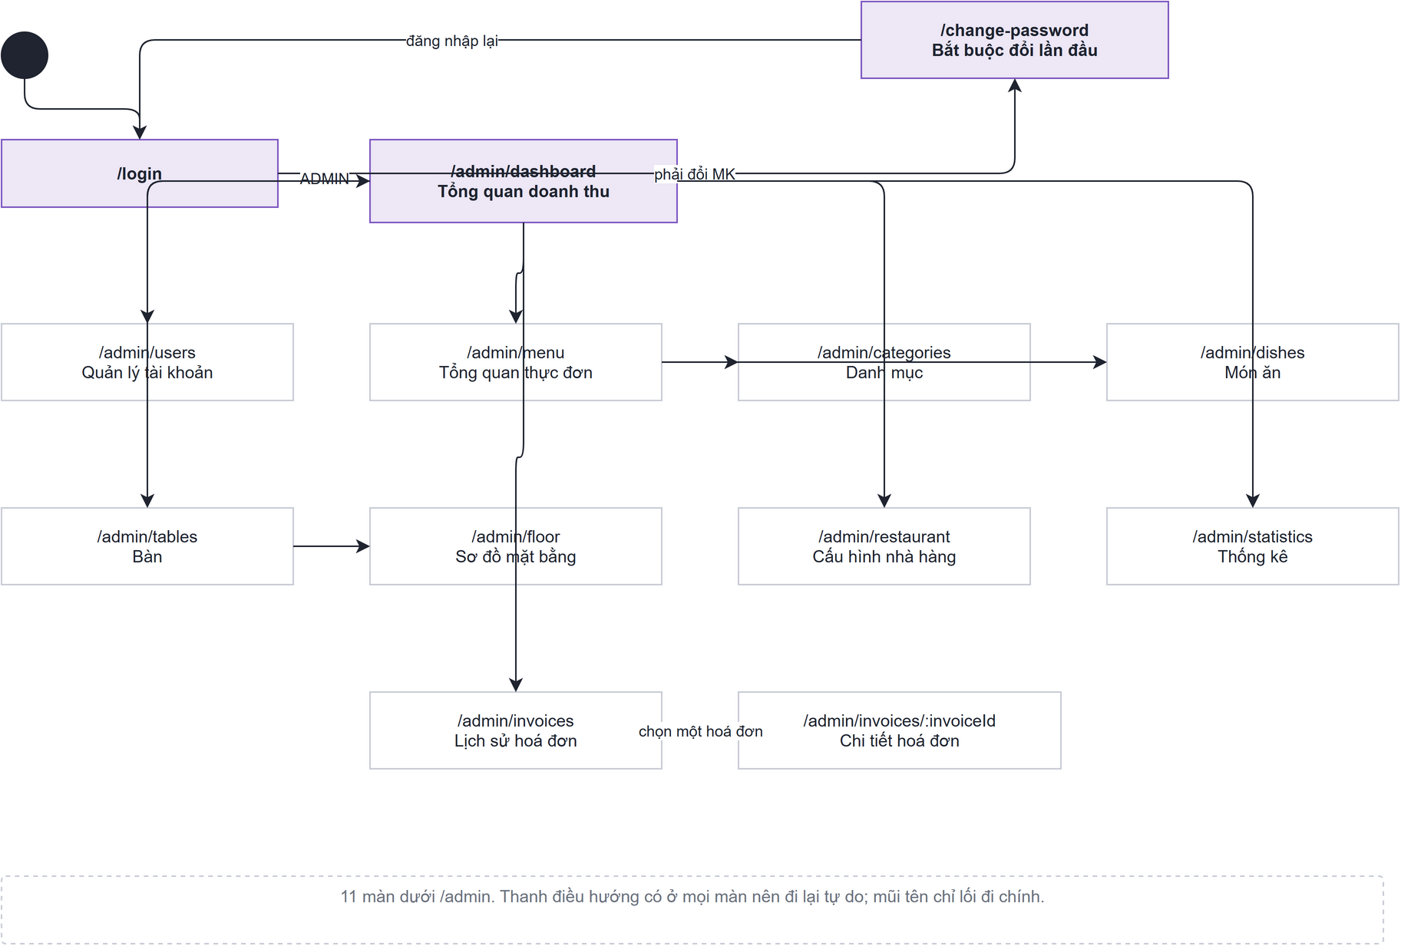

6.1.2 Screens Flow for Cashier
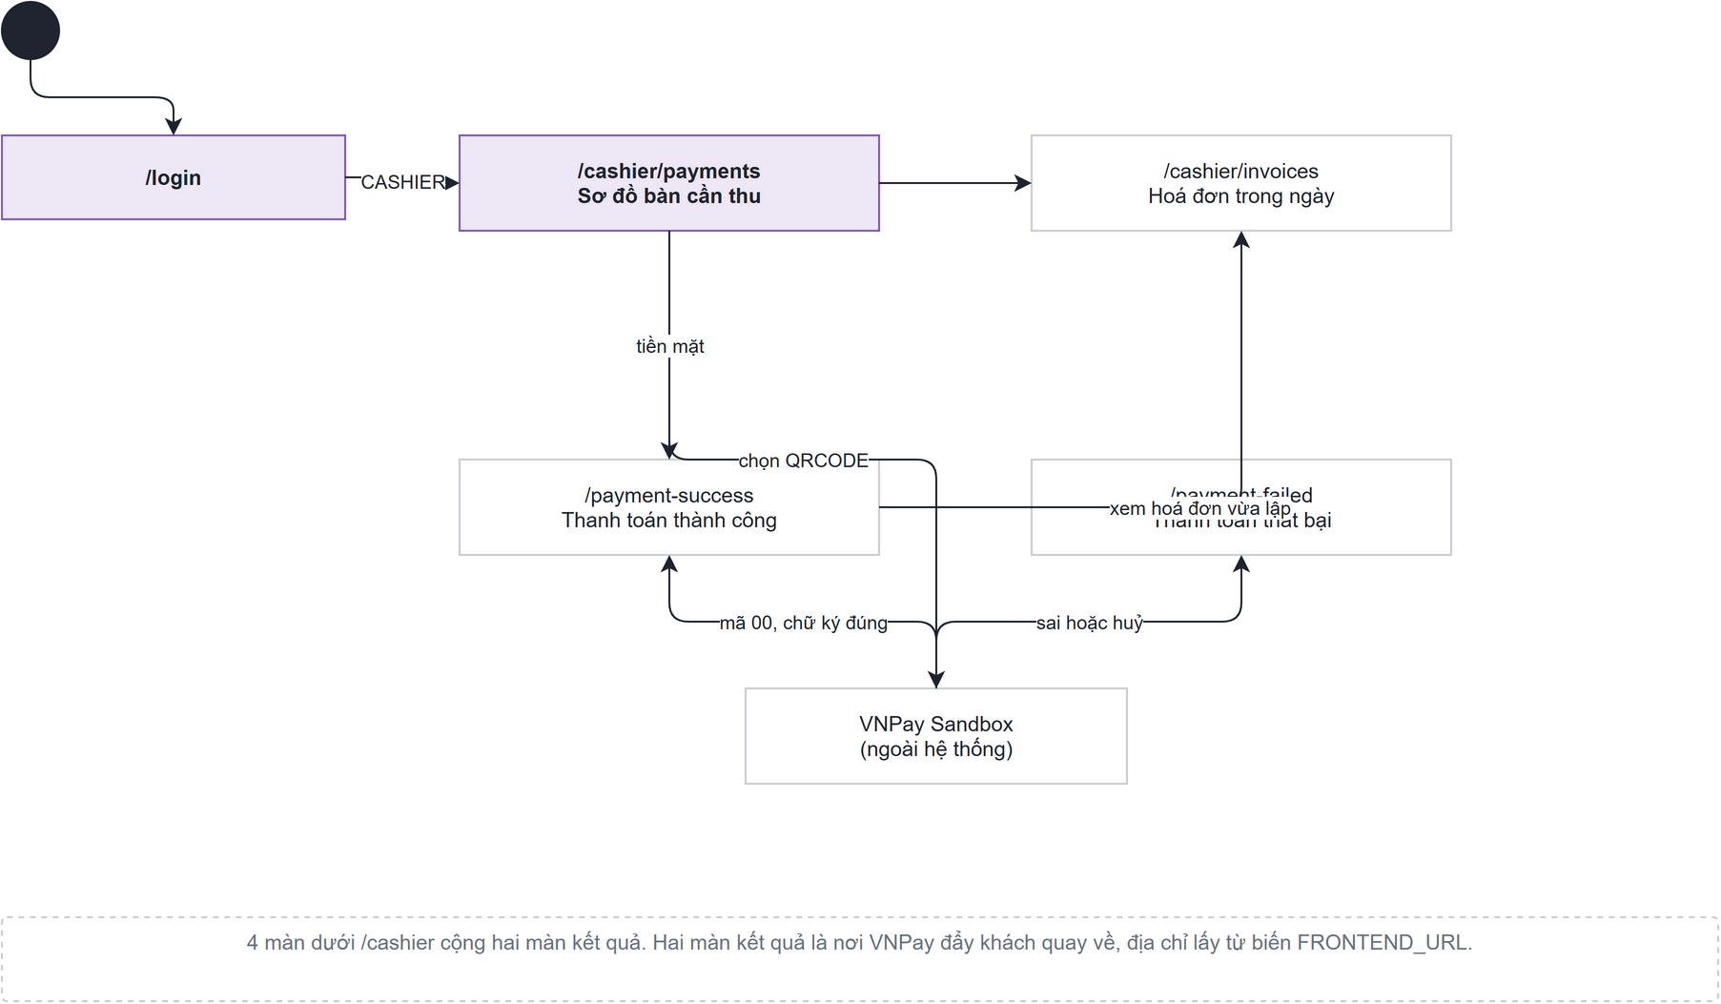

6.1.3 Screens Flows for Chef
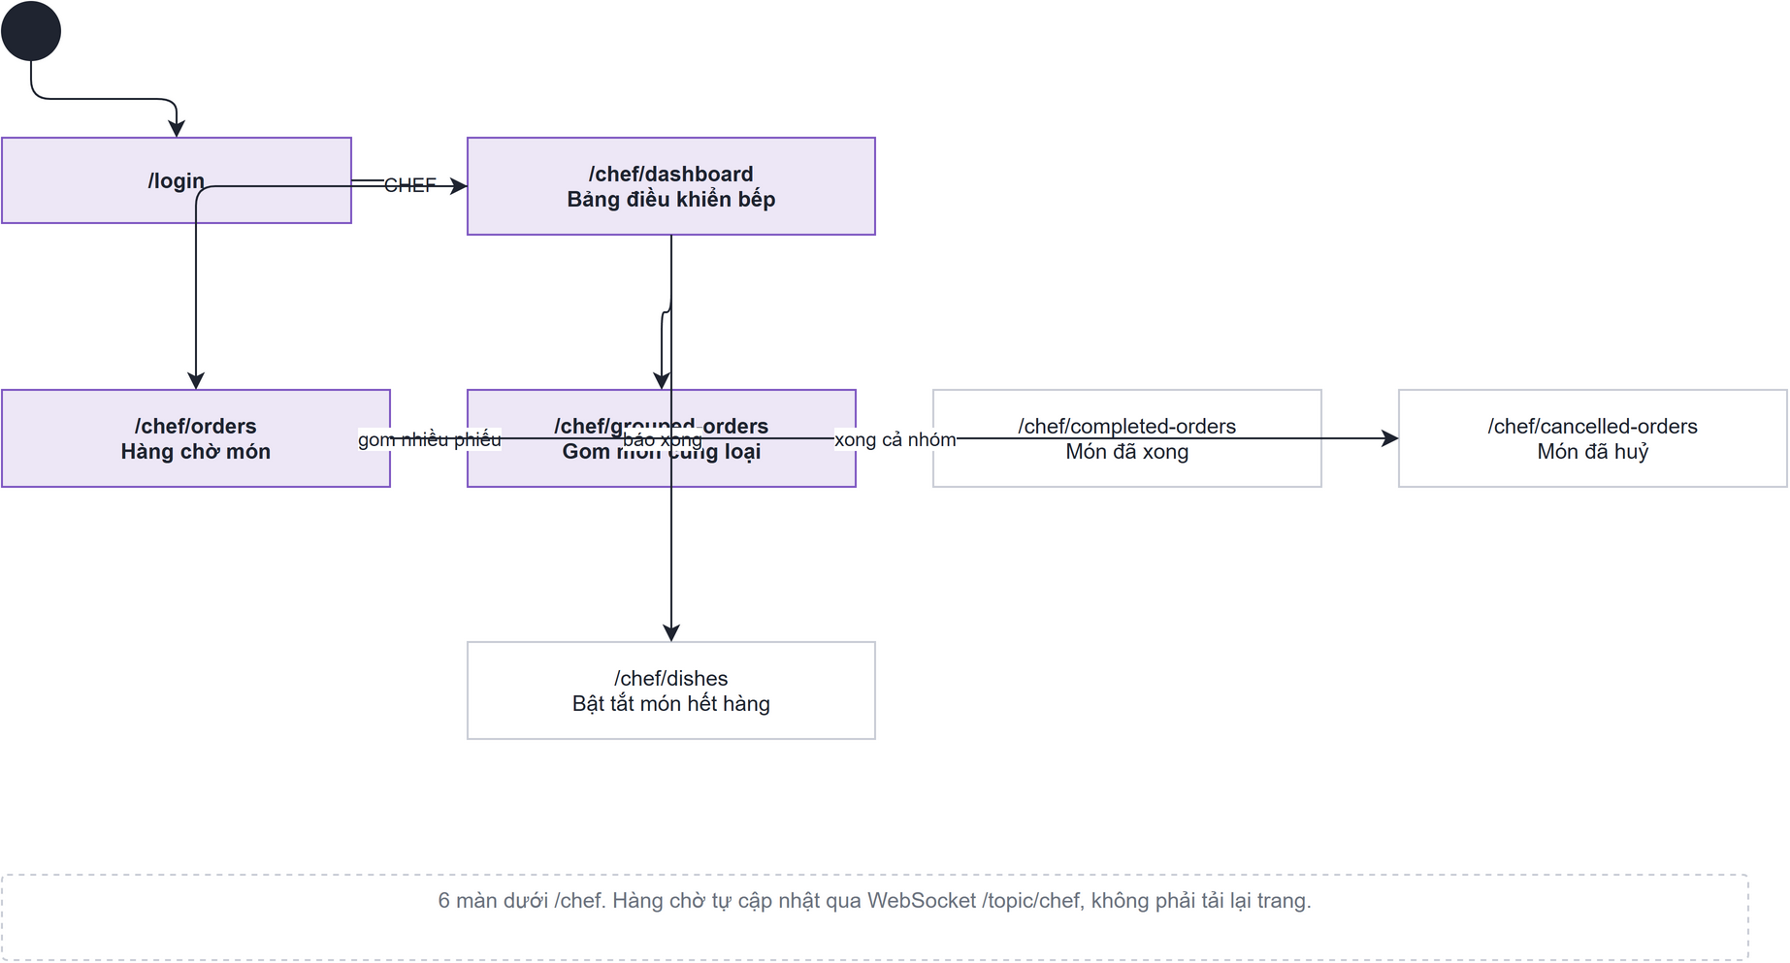

6.1.4 Screens Flow for Customer
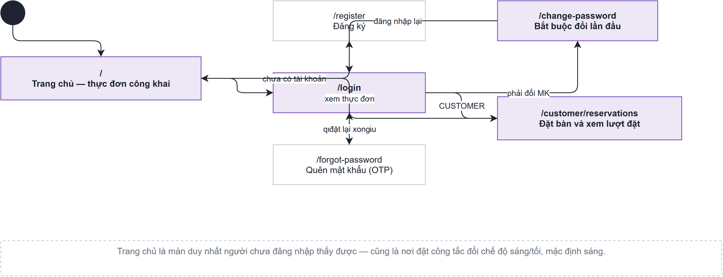

6.1.5 Screens Flow for Waiter
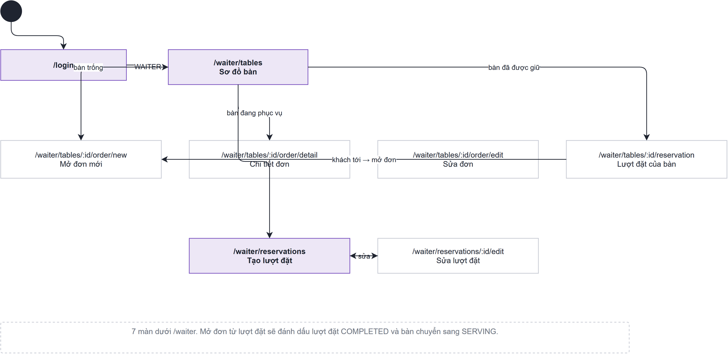

6.2 Screen Authorization

Screen | Admin | Cashier | Chef | Customer | Waiter
Public Home Page Screen | ✓ | ✓ | ✓ | ✓ | ✓
Login Screen | ✓ | ✓ | ✓ | ✓ | ✓
Profile Screen | ✓ | ✓ | ✓ | — | ✓
Customer Profile Screen | — | — | — | ✓ | —
Register Screen | — | — | — | ✓ | —
Forgot Password Screen | — | — | — | ✓ | —
Password Change Screen | — | — | — | ✓ | —
Profile Update Screen | — | — | — | ✓ | —
Reservation Creation Screen | — | — | — | ✓ | —
Reservation Cancellation Screen | — | — | — | ✓ | —
Dashboard Overview Screen | ✓ | — | — | — | —
Account List Screen | ✓ | — | — | — | —
Create Account Screen | ✓ | — | — | — | —
Account Details Screen | ✓ | — | — | — | —
Update Account Screen | ✓ | — | — | — | —
Menu Overview Screen | ✓ | — | — | — | —
Category Management Screen | ✓ | — | — | — | —
Category Creation Screen | ✓ | — | — | — | —
Category Details Screen | ✓ | — | — | — | —
Category Update Screen | ✓ | — | — | — | —
Dish Management Screen | ✓ | — | — | — | —
Dish Creation Screen | ✓ | — | — | — | —
Dish Details Screen | ✓ | — | — | — | —
Dish Update Screen | ✓ | — | — | — | —
Revenue Report Screen | ✓ | — | — | — | —
Best-Selling Dishes by Category Screen | ✓ | — | — | — | —
Top 10 Best-Selling Dishes Report Screen | ✓ | — | — | — | —
Order Statistics by Shift Screen | ✓ | — | — | — | —
Invoice History Screen | ✓ | — | — | — | —
Invoice Details Screen | ✓ | — | — | — | —
Table List Screen | — | ✓ | — | — | —
Order Details Panel | — | ✓ | — | — | —
Customer Loyalty Panel | — | ✓ | — | — | —
New Customer Registration Panel | — | ✓ | — | — | —
Payment Method Selection Pop-up | — | ✓ | — | — | —
Cash Payment Pop-up | — | ✓ | — | — | —
Payment Cash Success Screen | — | ✓ | — | — | —
VNPay Confirmation Pop-up | — | ✓ | — | — | —
VNPay Failed Payment Screen | — | ✓ | — | — | —
VNPay Succeeded Payment Screen | — | ✓ | — | — | —
Payment Detail and Export PDF Invoice Screen | — | ✓ | — | — | —
Invoice List | — | ✓ | — | — | —
Invoice Detail | — | ✓ | — | — | —
Chef Dashboard Screen | — | — | ✓ | — | —
Kitchen Queue | — | — | ✓ | — | —
Preparing Dish Details Pop-up | — | — | ✓ | — | —
Grouped Dishes | — | — | ✓ | — | —
Dish List Screen | — | — | ✓ | — | —
Today Completed Dishes Screen | — | — | ✓ | — | —
Today Cancelled Dish Screen | — | — | ✓ | — | —
Table Management Screen | — | — | — | — | ✓
Serving Order Detail Screen | — | — | — | — | ✓
Update Order Screen | — | — | — | — | ✓
Create Order Screen | — | — | — | — | ✓
Current Reservation Detail Screen | — | — | — | — | ✓
Create Reservation Screen | — | — | — | — | ✓
Edit Reservation Screen | — | — | — | — | ✓
Payment Cash Success Screen | — | ✓ | — | — | —
VNPay Confirmation Pop-up | — | ✓ | — | — | —
VNPay Failed Payment Screen | — | ✓ | — | — | —
VNPay Succeeded Payment Screen | — | ✓ | — | — | —
Payment Detail and Export PDF Invoice Screen | — | ✓ | — | — | —
Invoice List | — | ✓ | — | — | —
Invoice Detail | — | ✓ | — | — | —
Chef Dashboard Screen | — | — | ✓ | — | —
Kitchen Queue | — | — | ✓ | — | —

6.3 Non-UI Functions

# | Feature | System Function | Description
1 | Security and Authentication | JWT Token Management | Generates, validates, refreshes, and revokes access tokens. It also enforces role-based authorization for Admin, Cashier, Chef, Customer, and Waiter accounts.
2 | Reservation Automation | Reservation Status Scheduler | Automatically changes reservations from QUEUED to WAITING near the reservation time, reserves or reassigns a suitable table, and cancels expired no-show reservations.
3 | Real-Time Communication | WebSocket Event Broadcasting | Publishes real-time events for new orders, dish completion or cancellation, table-status changes, menu visibility changes, internal notes, and statistical updates.
4 | Order Processing | Order Total Recalculation | Recalculates order totals whenever item quantities or statuses change and excludes cancelled items from the payable amount.
5 | Table Management | Automatic Table Status Synchronization | Updates a table to SERVING when an order starts and changes it to AVAILABLE or RESERVED after order completion, reservation cancellation, or successful payment.
6 | Payment Integration | VNPay Transaction Processing | Creates VNPay payment requests, processes gateway callbacks, records transaction results, completes successful orders, and restores failed or cancelled payments for retry.
7 | Invoice Processing | Invoice and PDF Generation | Creates invoice and payment records after successful checkout and generates a downloadable PDF invoice containing order, customer, payment, and total information.
8 | Customer Loyalty | Reward Point Processing | Validates available reward points, limits the discount according to business rules, deducts used points, and credits newly earned points after payment.
9 | Business Validation | Server-Side Rule Validation | Checks duplicate accounts, categories, and dishes; validates reservation times and table availability; verifies order-item states; and prevents invalid deletion or checkout operations.
10 | Recovery and Timeout | Automatic Order Unlock | Returns an order from LOCKED to SERVING when a payment is cancelled, fails, or exceeds the configured timeout, allowing the cashier to retry checkout safely.
11 | Security and Authentication | Revoked Token Cleanup | Deletes revoked JWT identifiers from the database once they have passed their expiry time, so the revocation list does not grow without bound. Runs hourly.
12 | Order Processing | Stale Cancelled Order Cleanup | Removes cancelled orders that were never paid and releases the tables they were still holding. Runs hourly.

II. Functional Requirements

1. User Authentication

1.1 Login
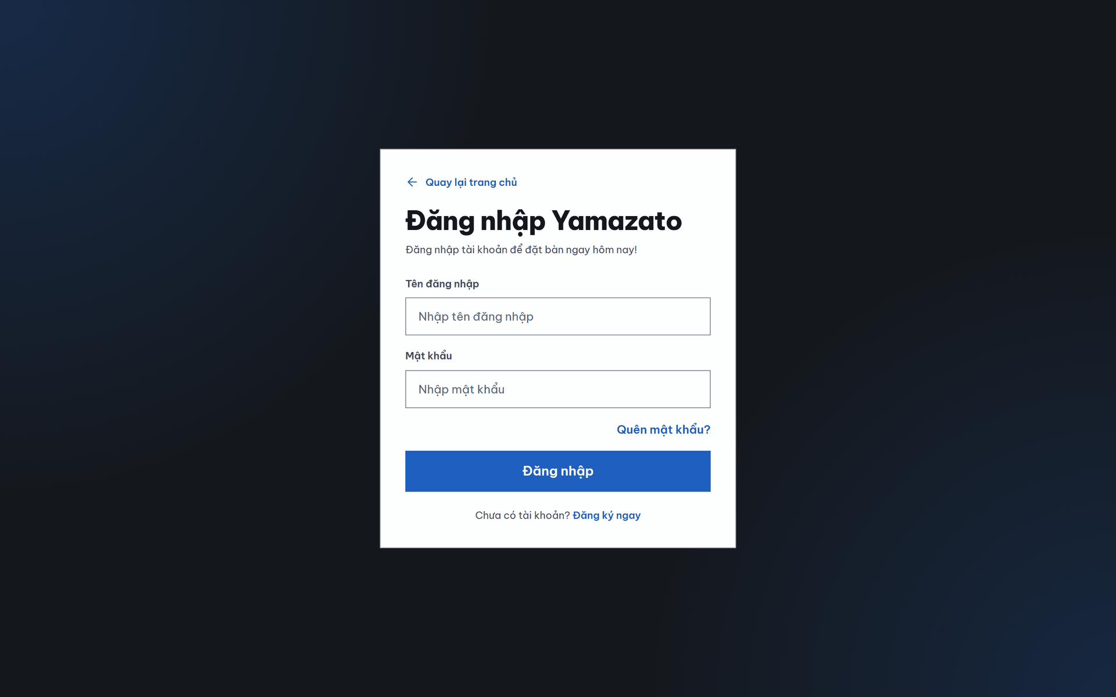

This screen allows the Customer to:
- Return to the Home Page: Click Back to Home to return to the website’s home page.
- Enter a Username: Enter the registered username in the Username field.
- Enter a Password: Enter the account password in the Password field. The entered characters are hidden for security.
- Log In: Click Log In to submit the entered username and password for authentication.
- Recover a Forgotten Password: Click Forgot Password? to access the password recovery process.
- Register a New Account: Click Register Now to open the account registration page.

Field Name | Description
Username | Allows the user to enter a username. The placeholder displays “Nhập tên đăng nhập”.
Password | Allows the user to enter a password. The placeholder displays “Nhập mật khẩu”, and the entered characters are hidden.
Quên mật khẩu? | Opens the Forgot Password page, allowing customers to reset their password using email verification (OTP).
Đăng nhập | Authenticates the entered Username and Password. If the credentials are valid, the user is redirected to the corresponding home page based on their role. If authentication fails, an error message is displayed.
Đăng ký ngay | Opens the Registration page for users who do not have an account.
Quay lại trang chủ | Returns the user to the home page.

1.2 Register
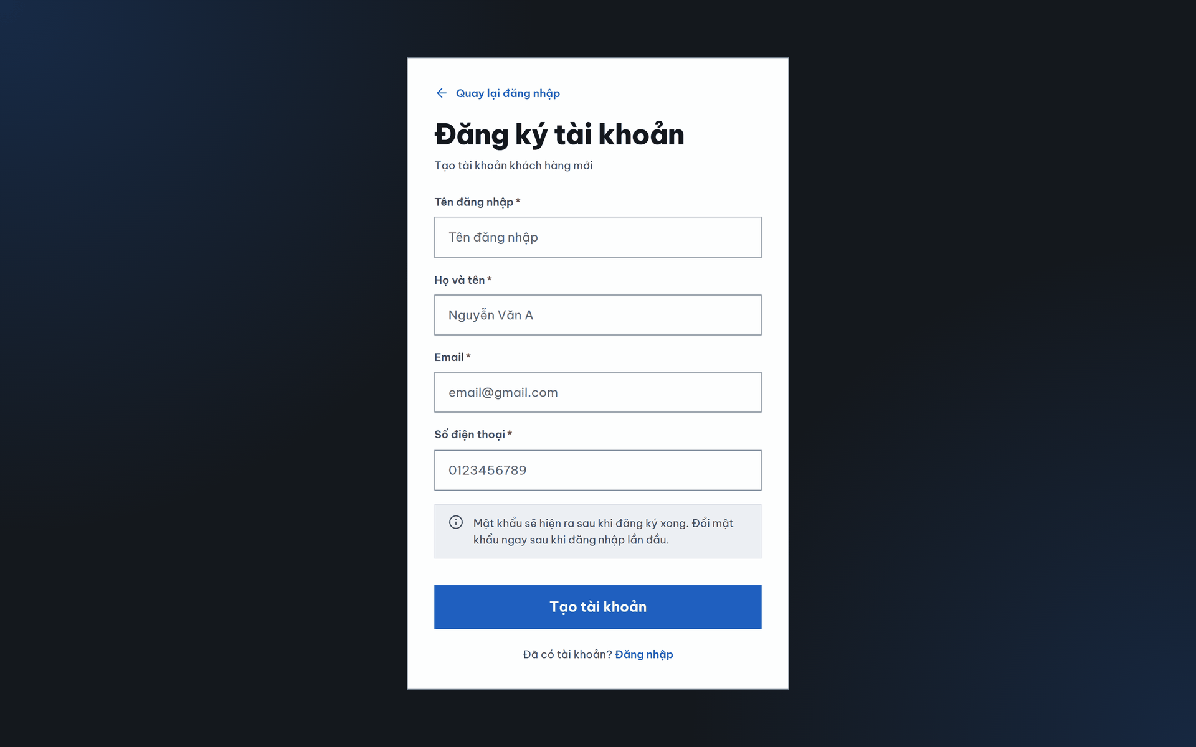
This screen allows the customer to:
• Account Information: Enter a username, full name, email address, and phone number.
• Input Validation: Receive messages for invalid or duplicated account information.
• Initial Password Notice: Review the default password assigned to the new account.
• Account Creation: Submit the registration form or return to the login screen.

Field Name | Description
Username * | Allows the Customer to enter a username for the new account. The placeholder displays “Tên đăng nhập”. This field is required.
Họ và tên * | Allows the Customer to enter their full name. The placeholder displays “Nguyễn Văn A”. This field is required.
Email * | Allows the Customer to enter an email address. The placeholder displays “email@gmail.com”. This field is required.
Số điện thoại * | Allows the Customer to enter a phone number. The placeholder displays “0123456789”. This field is required.
Tạo tài khoản | Submits the entered registration information and creates a new Customer account.
Quay lại đăng nhập | Returns the Customer to the login page.
Đã có tài khoản? | Informs existing Customers that they can access the login page instead of creating another account.
Đăng nhập | Redirects an existing Customer to the login page.
Mật khẩu sẽ hiện ra sau khi đăng ký xong | Informs the Customer that the password will be shown once registration completes. The value is configured per deployment, so the screen does not state it in advance.

2. Admin

2.1 Manage Account

2.1.1. Account List Screen
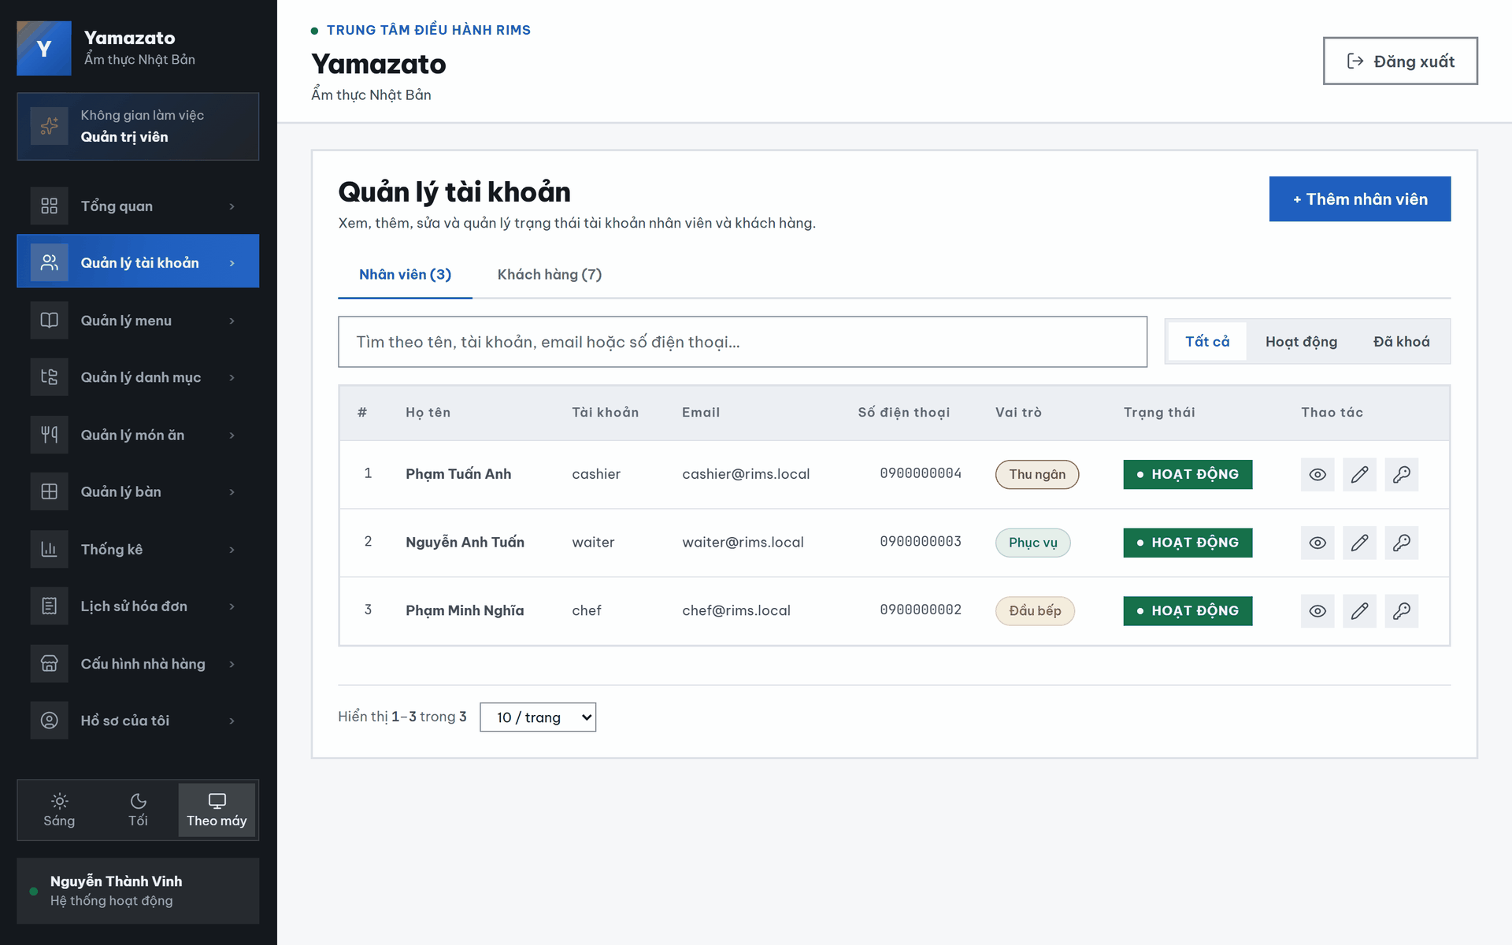
This screen allows the administrator to:
- View Account List: View all staff and customer accounts displayed in separate tabs.
- Switch Account Type: Switch between the Staff and Customer account lists.
- Search Accounts: Search accounts by full name, username, email address, or phone number.
- Filter Accounts: Filter accounts by status (All, Active, or Inactive).
- Create Account: Open the Create Staff Account or Create Customer Account screen, depending on the selected tab.
- View Account Details: Open the Account Details screen for the selected account.
- Update Account: Open the Update Account screen to modify the selected account information.
- Browse Account List: Navigate through multiple pages and select the number of accounts displayed per page.
Field Name | Description
Account Type Tabs | Allows the administrator to switch between the Staff and Customer account lists.
Search Bar | Allows the Admin to search by full name, username, email address, or phone number. The placeholder displays “Tìm theo tên, tài khoản, email, SĐT...”.
Status Filter | Displays the shift with the highest number of paid orders and its percentage of total paid orders.
Create Account Button | Displays daily revenue in the selected week. Dates without revenue are returned as 0 by the backend.
No. (#) | Displays the sequential number of each account in the current page.
Họ tên (Full Name) | Displays the full name of the account owner.
Tài khoản (Username) | Displays the username used for login.
Email | Displays the registered email address of the account.
SĐT (Phone Number) | Displays the registered phone number.
Vai trò (Role) | Displays the role assigned to the account, such as “Thu ngân”, “Phục vụ”, or “Đầu bếp”.
Trạng thái (Status) | Displays the current account status (Active or Inactive).
Chi tiết | Opens the View Account Details screen for the selected
Sửa | Opens the Update Account form for the selected account.

2.1.2 Account Details Screen
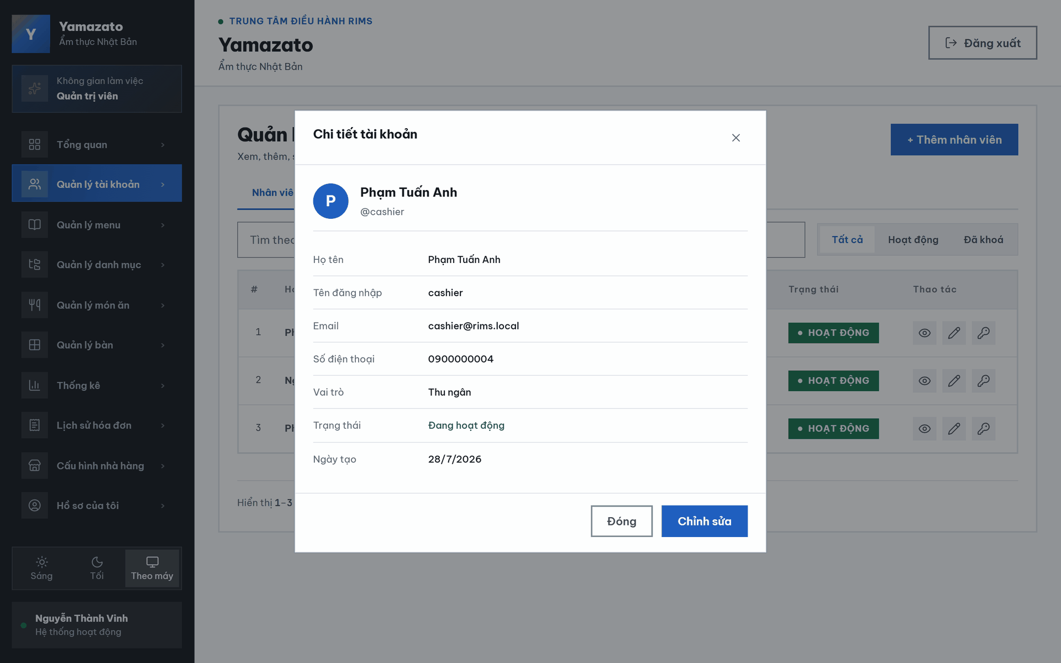
This screen allows the administrator to:
- View Account Information: View detailed account information, including full name, username, email address, phone number, role, account status, account creation date, and loyalty points (for customer accounts).
- Identify Account: View the account avatar, full name, and username for quick identification.
- Navigate: Close the Account Details dialog and return to the Account Management screen.
- Edit Account: Open the Update Account screen to modify the selected account information.

Field Name | Description
× | Closes the account-detail window without making any changes.
Avatar | Displays the first letter of the account holder’s name as a profile avatar.
Phạm Tuấn Anh | Displays the full name of the selected account holder in the profile summary.
@cashier | Displays the username of the selected account in the profile summary.
Họ tên | Displays the account holder’s full name.
Tên đăng nhập | Displays the username used to log in to the system.
Email | Displays the email address associated with the account.
Số điện thoại | Displays the phone number associated with the account.
Vai trò | Displays the role assigned to the account, such as “Thu ngân”.
Trạng thái | Displays the current account status, such as “Đang hoạt động” or “Đã khóa”.
Ngày tạo | Displays the date on which the account was created.
Đóng | Closes the account-detail window and returns the Admin to the account-management screen.
Chỉnh sửa | Opens the account-editing form for the selected account.

2.1.3 Update Account

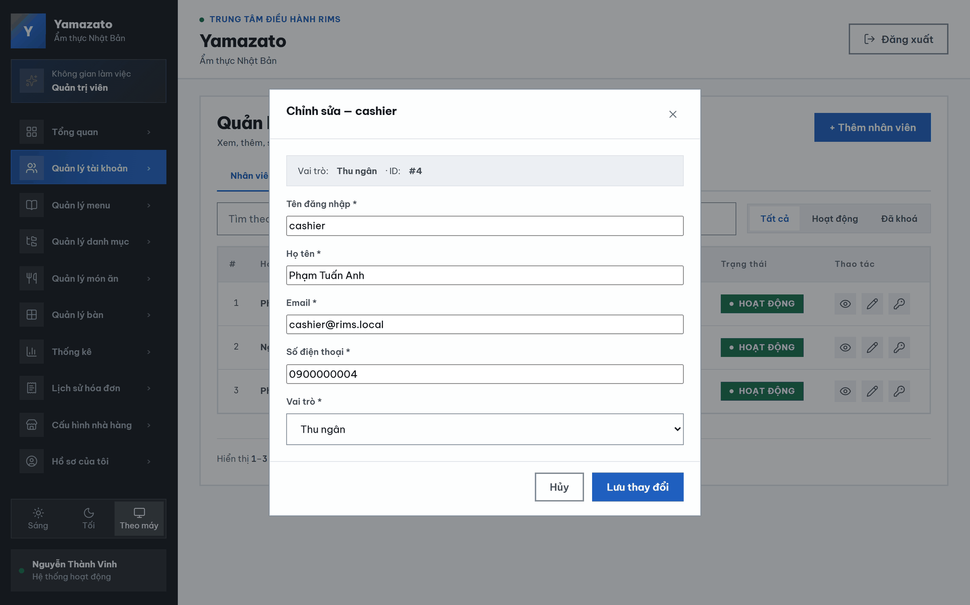
This screen allows the administrator to:
- Edit Account Information: Update the username, full name, email address, and phone number of the selected account.
- View Account Summary: View the account role and account ID in read-only mode.
- Input Validation: Receive validation messages for invalid, duplicate, or missing account information before saving.
- Save Changes: Save the updated account information if all validation rules are satisfied.
- Cancel Update: Cancel the update operation and return to the Account Details or Account Management screen without saving changes.

Field Name | Description
Tên đăng nhập * | Allows the administrator to update the account's Username. The value must satisfy the system validation rules.
Họ tên * | Allows the administrator to update the account owner's Full Name.
Email | Allows the administrator to update the registered Email address.
Số điện thoại * | Allows the administrator to update the registered Phone Number.
Vai trò * | Allows the Admin to select the employee’s assigned role from a drop-down list. This field is required.
Thu ngân | Displays the currently selected employee role in the role drop-down list.
Hủy | Closes the editing form and discards any unsaved changes.
Lưu thay đổi | Validates all entered information. If the validation succeeds, the system updates the account information and displays a success message; otherwise, validation error messages are shown.

2.1.4 Create Account
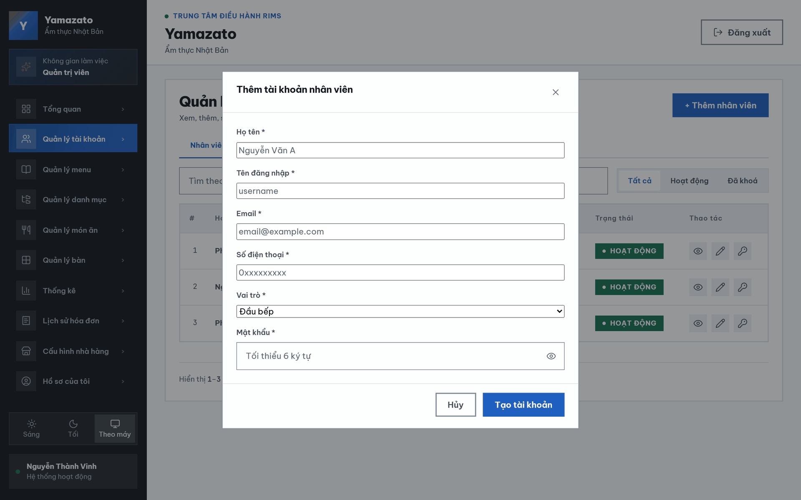

This screen allows the administrator to:
- Enter the employee's Full Name.
- Enter a unique Username.
- Enter a valid Email Address.
- Enter a valid Phone Number.
- Select the employee's Role.
- Enter the employee's initial Password.
- Show or hide the password before submission.
- Submit the information to create a new staff account.
- Cancel the operation or close the dialog without creating an account.

Field Name | Description
Close (X) | Closes the Create Staff Account dialog.
Title | Displays the screen title "Thêm tài khoản nhân viên" (Create Staff Account).
Họ tên * | Allows the administrator to update the account owner's Full Name.
Tên đăng nhập* | Text field for entering a unique username. This field is required.
Email* | Text field for entering the employee's email address. The email must follow a valid format and be unique.
Số điện thoại * | Text field for entering the employee's phone number. The phone number must contain exactly 10 digits and start with 0.
Vai trò * | Drop-down list for selecting the staff role (Chef, Waiter, Cashier). The Administrator role is not available in this list.
Mật khẩu* | Password input field for entering the initial password. Characters are hidden by default.
Hủy | Closes the editing form and discards any unsaved changes.
Tạo tài khoản | Submits the entered information to create a new staff account.

2.2 Manage menu

2.2.1. Menu Overview Screen
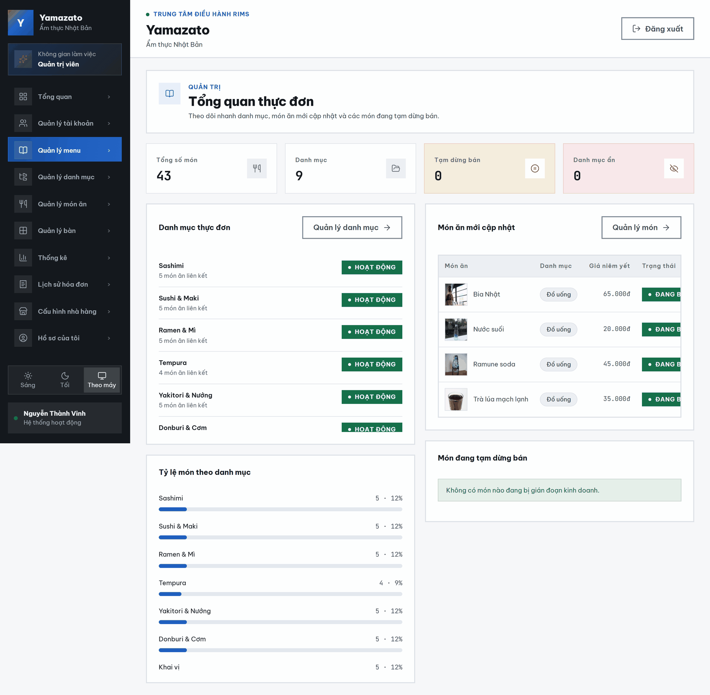

This screen allows the administrator to:
- View the Menu Overview: Monitor the total number of dishes, categories, temporarily unavailable dishes, and hidden categories.
- View Menu Categories: Review the available categories, their linked dish counts, and their current statuses.
- Manage Categories: Click “Quản lý danh mục →” to open the category-management screen.
- View Recently Updated Dishes: Review recently updated dishes, including their categories, listed prices, and current selling statuses.
- Manage Dishes: Click “Quản lý món →” to open the dish-management screen.
- View Dish Distribution: Review the number and percentage of dishes belonging to each category.
- Monitor Temporarily Unavailable Dishes: Check whether any dishes are currently unavailable for sale.
- Review Attention Messages: View system notifications concerning dishes that may interrupt restaurant operations.
- Review Attention Messages: View system notifications concerning dishes that may interrupt restaurant operations.

Field Name | Description
TỔNG SỐ MÓN | Displays the total number of dishes currently recorded in the menu system.
DANH MỤC | Displays the total number of menu categories currently recorded in the system.
TẠM DỪNG BÁN | Displays the number of dishes that are currently temporarily unavailable for sale.
DANH MỤC ẨN | Displays the number of menu categories that are currently hidden from customers.
Danh mục thực đơn | Displays the menu-category list, including each category’s name, linked dish count, and current status.
Quản lý danh mục → | Redirects the Admin to the category-management screen.
10 món ăn liên kết | Displays the number of dishes currently assigned to the corresponding category.
Hoạt động | Indicates that the category is currently active and available for use.
Món ăn mới cập nhật | Displays the list of dishes that were recently added or updated.
Quản lý món | Redirects the Admin to the dish-management screen.
MÓN ĂN | Displays the image and name of each recently updated dish.
DANH MỤC | Displays the category assigned to each dish, such as “Đồ uống”.
GIÁ NIÊM YẾT | Displays the listed selling price of each dish in Vietnamese đồng.
TRẠNG THÁI | Displays the current selling status of each dish.
Đang bán | Indicates that the dish is currently available for customers to order.
Tỷ lệ món theo danh mục | Displays the number and percentage of dishes belonging to each menu category.
10 (8%) | Indicates that the corresponding category contains 10 dishes, representing 8% of the total menu.
Cần chú ý (Món đang tạm dừng bán) | Displays warnings or information about dishes that are currently unavailable for sale.
Tuyệt vời! Hiện tại không có món ăn nào bị gián đoạn kinh doanh. | Confirms that no dishes are currently temporarily unavailable and that menu operations are not being interrupted.

2.2.2 Category Management Screen

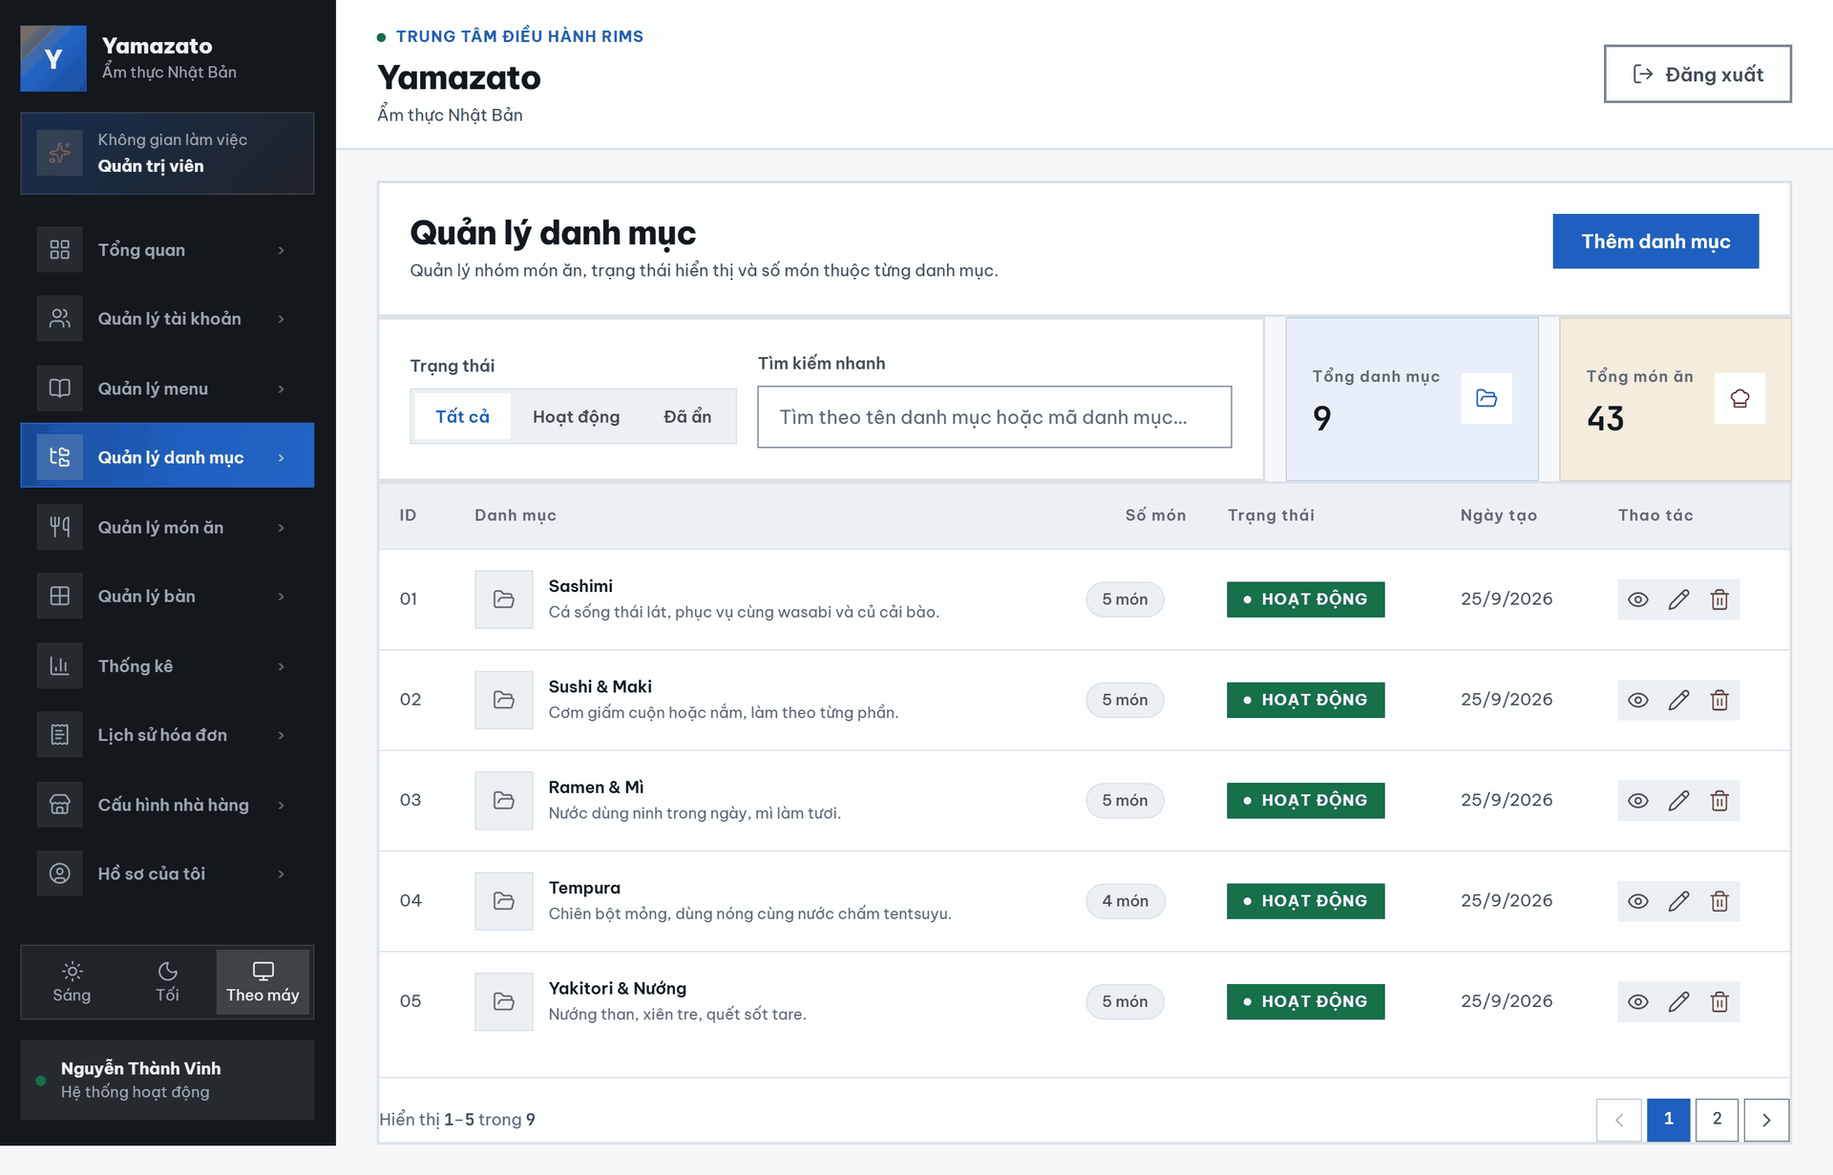

This screen allows the Admin to:
- View Menu Categories: View the ID, category name, description, number of dishes, status, and creation date of each menu category.
- View Category Details: Click the eye icon to view detailed information about the selected category.
- Edit a Category: Click the pencil icon to update the selected category’s information.
- Delete a Category: Click the trash icon to remove the selected category.
- View Category Status: Check whether each category is currently active or inactive.
- Navigate Between Pages: Use the page numbers and navigation buttons to move through the category list.

Field Name | Description
ID | Displays the unique identifier of each menu category, such as 01, 02, or 03.
DANH MỤC & MÔ TẢ | Displays the category icon, category name, and its description.
SỐ MÓN | Displays the number of dishes currently assigned to the category, such as “10 món”.
TRẠNG THÁI | Displays the current operating status of the category.
NGÀY TẠO | Displays the date on which the category was created.
THAO TÁC | Contains the available actions for the selected category.
Ramen & Mì | Displays the name of the menu category.
Nước dùng ninh trong ngày, mì làm tươi | Displays the description of the “Ramen & Mì” category.
10 món | Indicates that 10 dishes are currently assigned to the corresponding category.
Hoạt động | Indicates that the category is currently active and available for use.
Trang 1 / 3 | Displays the current page and the total number of category-list pages.

2.2.3. Category Creation Screen
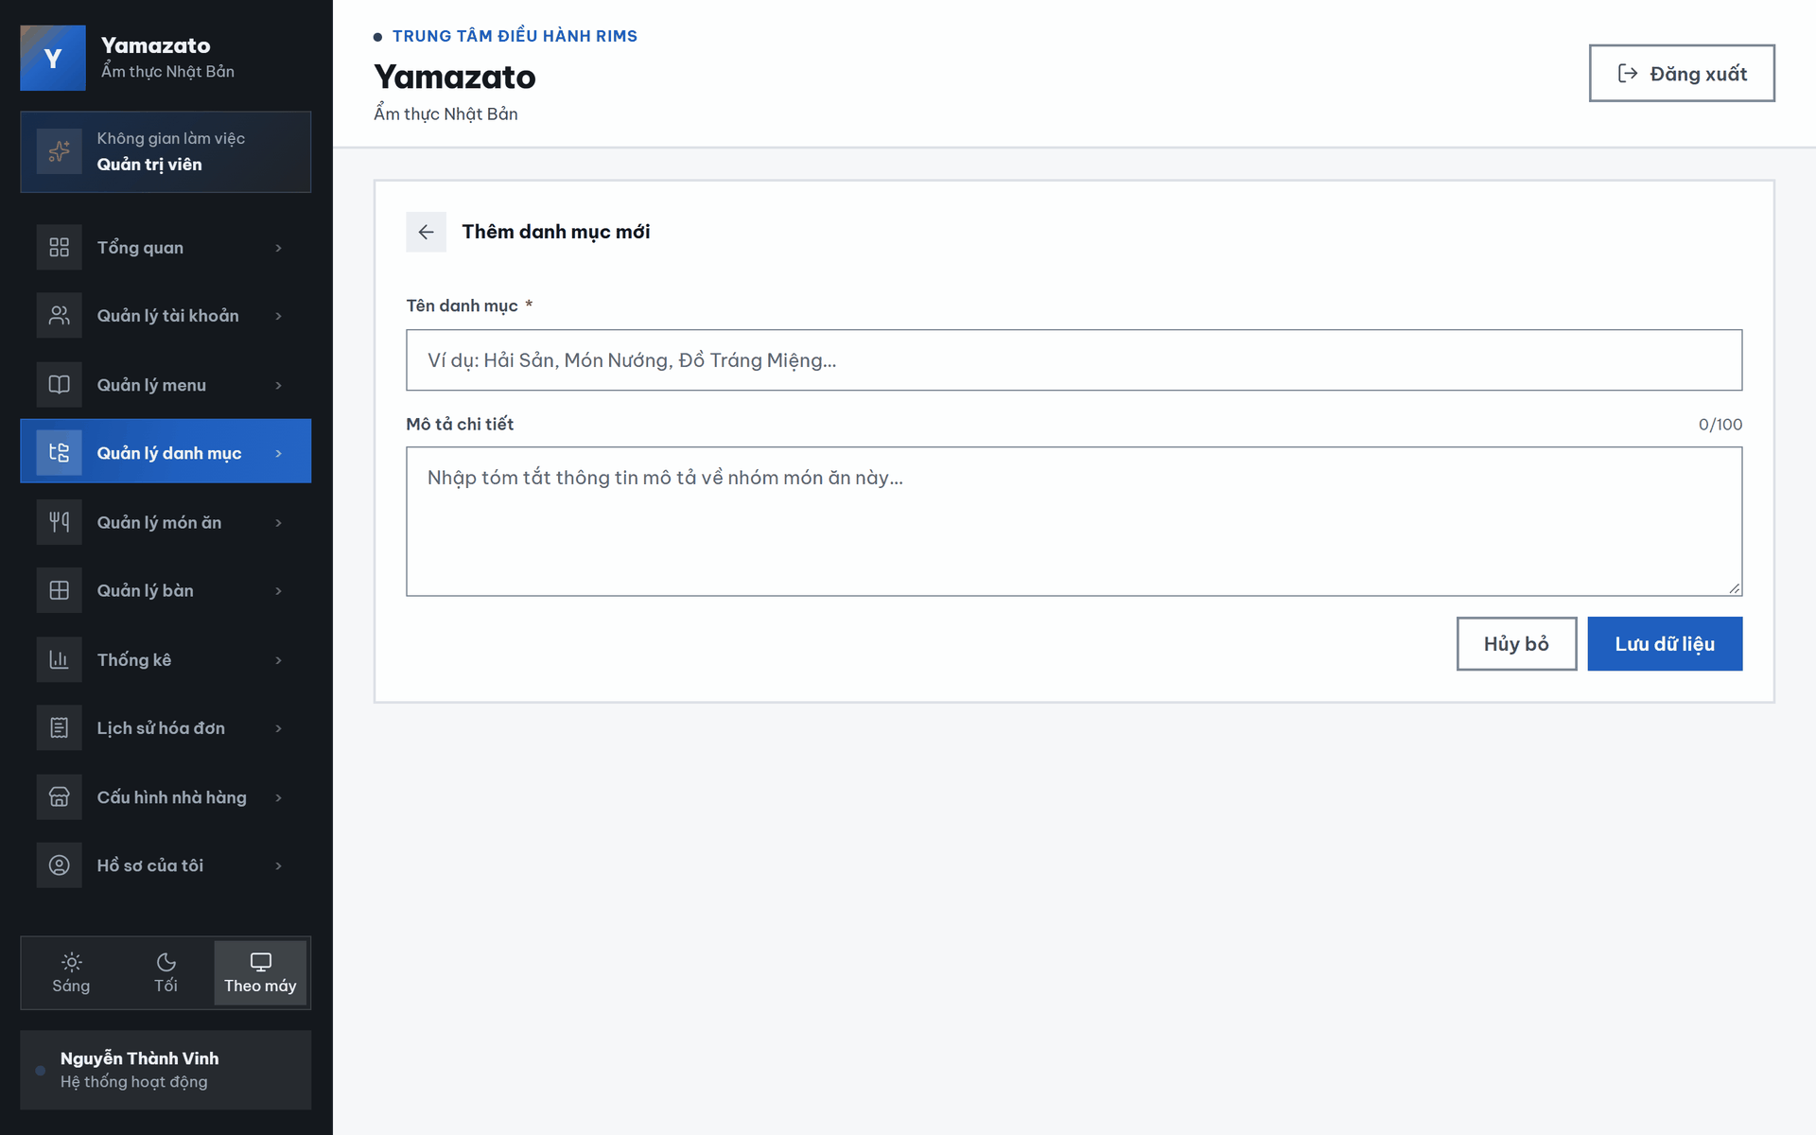

This screen allows the Admin to:
- Return to the Category List: Click the back-arrow button to return to the menu category list.
- Enter a Category Name: Enter the name of the new menu category in the required category-name field.
- Enter a Category Description: Enter a short description explaining the dishes included in the new category.
- Monitor the Description Length: View the current number of characters entered compared with the maximum limit of 100 characters.
- Cancel Category Creation: Click “Hủy bỏ” to discard the entered information and leave the form.
- Save the New Category: Click “Lưu dữ liệu” to validate the entered information and create the new menu category.

Field Name | Description
THÊM DANH MỤC MỚI | Displays the title of the new-category creation screen.
TÊN DANH MỤC * | Allows the Admin to enter the name of the new menu category. The placeholder displays “Ví dụ: Hải Sản, Món Nướng, Đồ Tráng Miệng...”. This field is required.
MÔ TẢ CHI TIẾT | Allows the Admin to enter a short description of the new category. The placeholder displays “Nhập tóm tắt thông tin mô tả về nhóm món ăn này...”.
Hủy bỏ | Cancels the category-creation process and discards any unsaved information.
Lưu dữ liệu | Submits the entered information and creates the new menu category.

2.2.4. Category Details Screen
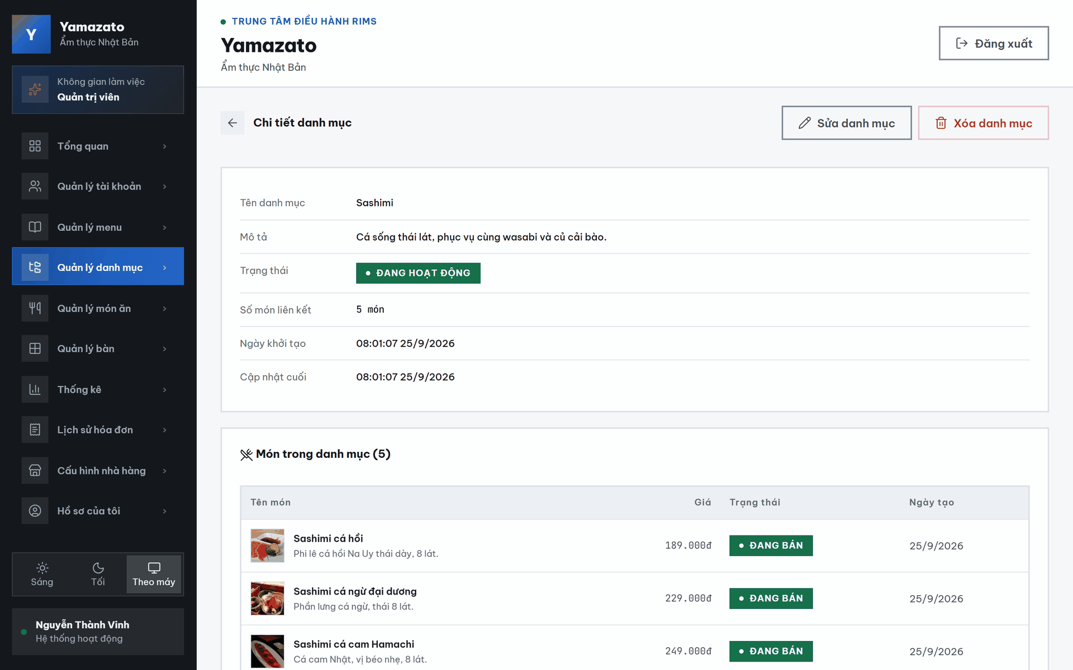

This screen allows the Admin to:
- Return to the Category List: Click the back-arrow button to return to the menu category list.
- View Category Information: View the category name, description, display status, number of linked dishes, creation time, and latest server update time.
- Edit the Category: Click “Sửa danh mục” to open the category-editing screen.
- Delete the Category: Click “Xóa danh mục” to remove the selected category.
- View Linked Dishes: View the dishes currently assigned to the selected category.
- View Dish Information: Review each dish’s name, description, listed price, selling status, and creation date.
- Navigate Between Pages: Use the page numbers and navigation buttons to move through the linked-dish list.

Field Name | Description
← | Returns the Admin to the menu category list.
CHI TIẾT DANH MỤC | Displays the title of the category-detail screen.
Sửa danh mục | Opens the editing screen for the selected category.
Xóa danh mục | Deletes the selected category. The system may require confirmation before completing the deletion.
TÊN DANH MỤC | Displays the name of the selected category, such as “Ramen & Mì”.
MÔ TẢ DANH MỤC | Displays the detailed description of the selected category.
TRẠNG THÁI HIỂN THỊ | Displays whether the category is currently visible and active in the system.
Đang hoạt động | Indicates that the category is currently active and available for use.
SỐ MÓN LIÊN KẾT | Displays the number of dishes currently assigned to the category.
10 món ăn | Indicates that 10 dishes are currently linked to the selected category.
NGÀY KHỞI TẠO | Displays the date and time when the category was created.
CẬP NHẬT CUỐI MÁY CHỦ | Displays the most recent date and time when the category information was updated on the server.
DANH SÁCH MÓN TRONG DANH MỤC (10 món) | Displays the dishes currently assigned to the selected category. The number in parentheses shows the total number of linked dishes.
TÊN MÓN | Displays the image, name, and short description of each linked dish.
GIÁ (VNĐ) | Displays the listed price of each dish in Vietnamese đồng.
TRẠNG THÁI | Displays the current selling status of each dish.
Đang bán | Indicates that the dish is currently available for customers to order.
NGÀY TẠO | Displays the date on which each dish was created.

2.2.5. Category Update Screen
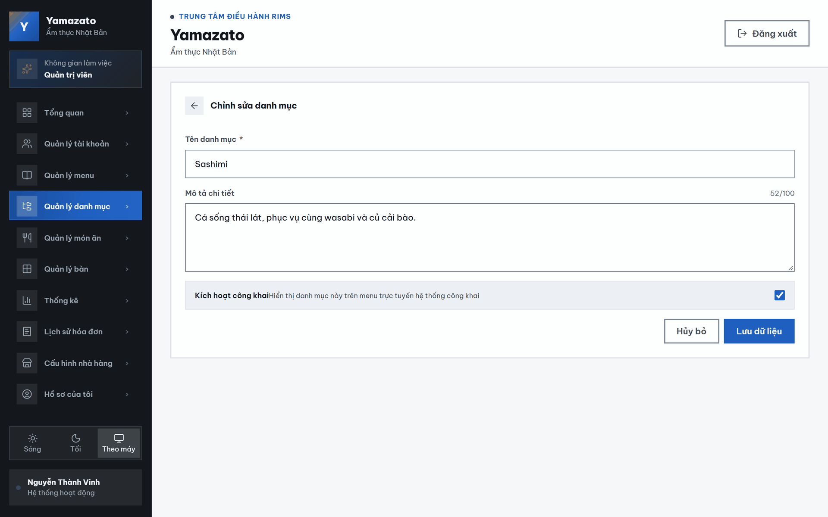

This screen allows the administrator to:
• Existing Data Review: View the current category name, description, and visibility status.
• Category Editing: Modify category information and public visibility.
• Input Validation: Receive validation messages for invalid or duplicated values.
• Change Submission: Save or cancel the category changes.

Field Name | Description
CHỈNH SỬA DANH MỤC | Displays the title of the category-editing screen.
TÊN DANH MỤC * | Allows the Admin to update the category name. The current value displayed is “Ramen & Mì”. This field is required.
MÔ TẢ CHI TIẾT | Allows the Admin to update the category description. The current description is displayed in the text area.
Kích hoạt công khai | Allows the Admin to control whether the category is publicly visible on the online menu.
Hủy bỏ | Cancels the editing process and discards any unsaved changes.
Lưu dữ liệu | Submits the updated information and saves the changes to the selected category.

2.2.6. Dish Management Screen
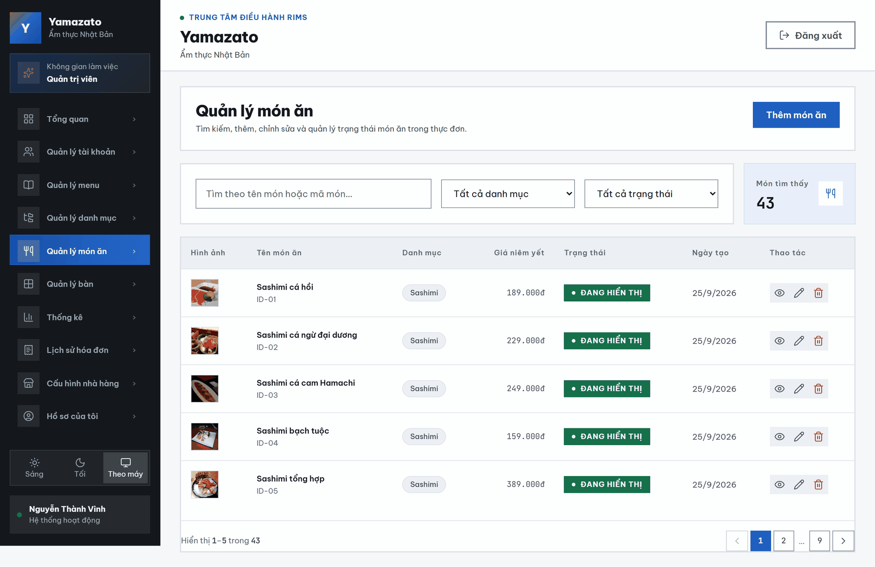

This screen allows the Admin to:
- View the Dish List: View all dishes recorded in the menu system.
- Add a New Dish: Click “+ Thêm Món Ăn” to open the new-dish creation form.
- Search for Dishes: Search for a dish by its name or dish ID.
- Filter by Category: Select a menu category to display only dishes belonging to that category.
- Filter by Status: Select a status to display dishes based on their current visibility.
- View the Number of Results: Check the total number of dishes matching the current search and filter conditions.
- View Dish Information: Review each dish’s image, name, ID, category, listed price, status, and creation date.
- View Dish Details: Click the eye icon to open the selected dish’s detailed information.
- Edit a Dish: Click the pencil icon to update the selected dish’s information.
- Delete a Dish: Click the trash icon to remove the selected dish.
- Navigate Between Pages: Use the page numbers and navigation buttons to move through the dish list.

Field Name | Description
+ Thêm Món Ăn | Opens the form used to create a new dish.
Tìm theo tên món ăn hoặc mã ID... | Allows the Admin to search for dishes by dish name or dish ID.
Tất cả danh mục | Filters the dish list by menu category. The default option displays dishes from all categories.
Tất cả trạng thái | Filters the dish list by visibility status. The default option displays dishes with all statuses.
MÓN TÌM THẤY | Displays the total number of dishes matching the current search and filter conditions.
HÌNH ẢNH | Displays the image associated with each dish.
TÊN MÓN ĂN | Displays the dish name and its dish ID, such as “ID-01”.
DANH MỤC | Displays the menu category assigned to the dish, such as “Ramen & Mì”.
GIÁ NIÊM YẾT | Displays the listed selling price of the dish in Vietnamese đồng, such as 159.000đ.
TRẠNG THÁI | Displays the current visibility status of the dish.
Đang hiển thị | Indicates that the dish is currently visible and available on the menu.
NGÀY TẠO | Displays the date on which the dish was created.
THAO TÁC | Contains the available actions for the selected dish.

2.2.7. Dish Creation Screen
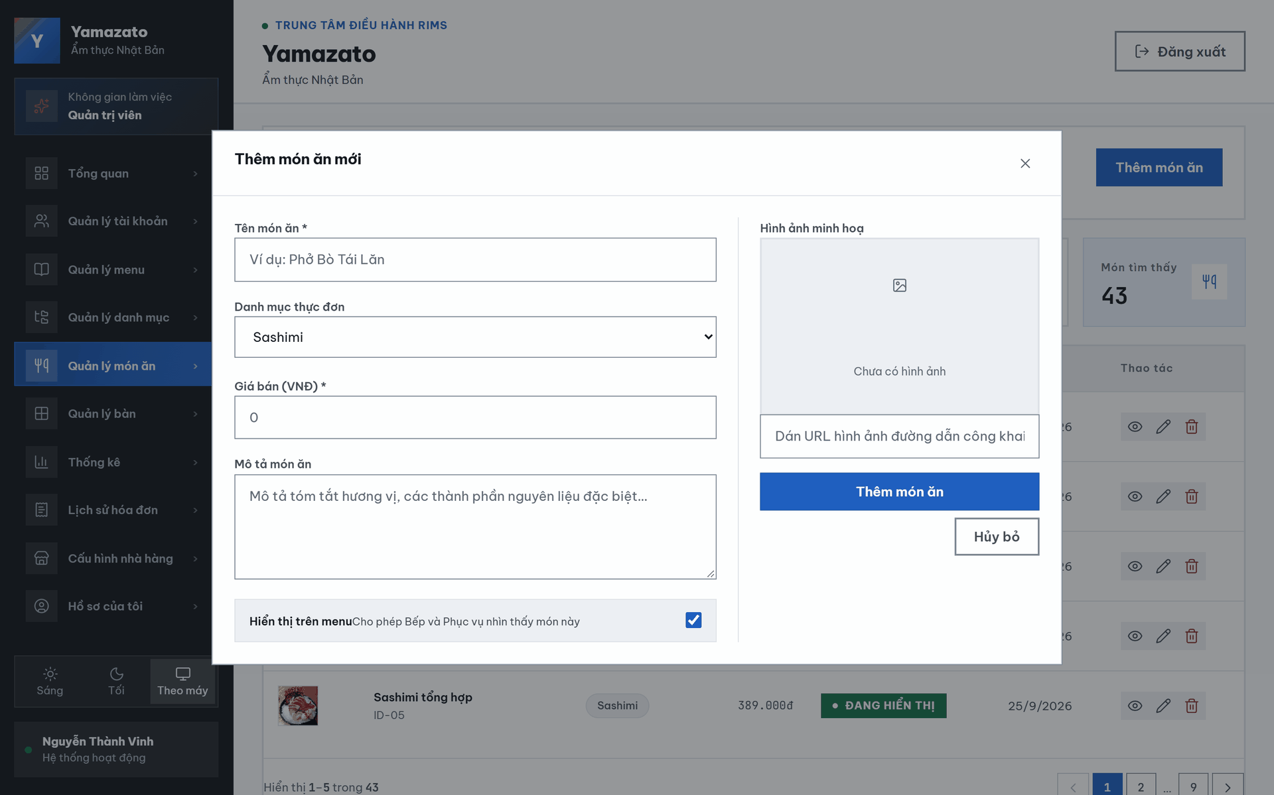

This screen allows the Admin to:
- Return to the Dish List: Click the back-arrow button to return to the dish-management screen.
- Enter a Dish Name: Enter the name of the new dish.
- Select a Menu Category: Assign the new dish to an existing menu category.
- Enter the Selling Price: Specify the dish’s selling price in Vietnamese đồng.
- Enter a Dish Description: Add a short description of the dish, including its flavor, ingredients, or other relevant information.
- Control Menu Visibility: Choose whether the dish is displayed on the restaurant menu for the Chef, Waiter, and customers.
- Add an Illustration Image: Enter an image URL and preview the dish image before saving.
- Create the New Dish: Click “Thêm món ăn” to validate the entered information and add the dish to the menu.
- Cancel Dish Creation: Click “Hủy bỏ” to discard the entered information.

Field Name | Description
← | Returns the Admin to the dish-management screen without creating a new dish.
+ THÊM MÓN ĂN MỚI | Displays the title of the new-dish creation screen.
TÊN MÓN ĂN * | Allows the Admin to enter the name of the new dish. The placeholder displays “Ví dụ: Phở Bò Tái Lăn”. This field is required.
DANH MỤC THỰC ĐƠN | Allows the Admin to select the menu category assigned to the new dish. The currently selected category is “Ramen & Mì”.
GIÁ BÁN (VNĐ) * | Allows the Admin to enter the selling price of the dish in Vietnamese đồng. The default displayed value is 0. This field is required.
MÔ TẢ MÓN ĂN | Allows the Admin to enter a short description of the dish. The placeholder displays “Mô tả tóm tắt hương vị, các thành phần nguyên liệu đặc biệt...”.
Hiển thị trên menu | Controls whether the new dish is visible on the restaurant menu.
Cho phép Bếp và Phục vụ nhìn thấy món này | Explains that enabling menu visibility allows the Chef and Waiter to view the dish.
✓ | Indicates that menu visibility is currently enabled. Clearing the checkbox hides the dish from the menu.
HÌNH ẢNH MINH HỌA | Displays the illustration-image section for the new dish.
Chưa có hình ảnh | Indicates that no valid image has been added or previewed yet.
Dán URL hình ảnh đường dẫn còn | Allows the Admin to enter the URL of the dish image. When a valid URL is provided, the image is displayed in the preview area.
Thêm món ăn | Submits the entered information and creates the new dish.
Hủy bỏ | Cancels the dish-creation process and discards any unsaved information.

2.2.8. Dish Details Screen
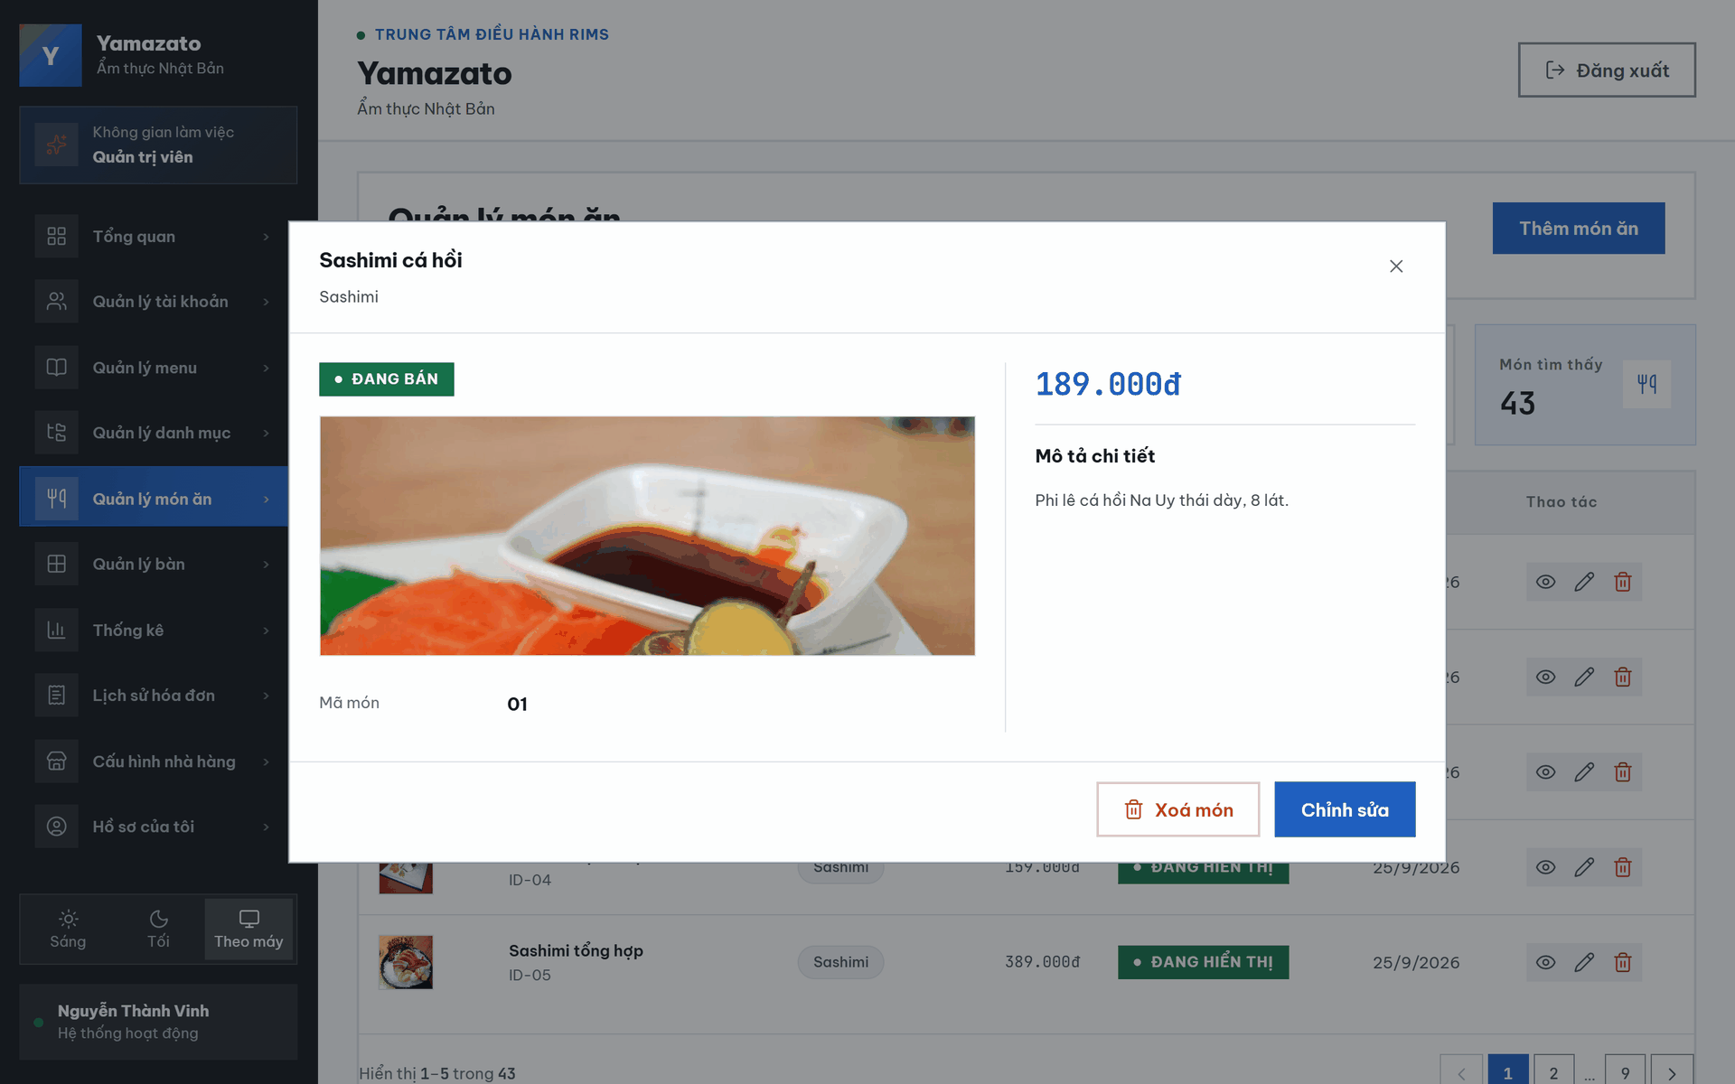

This screen allows the Admin to:
- Return to the Dish List: Click the back-arrow button to return to the dish-management screen.
- View Dish Information: View the selected dish’s image, name, category, selling price, description, visibility status, and dish ID.
- View Dish Visibility: Check whether the dish is currently displayed on the restaurant menu.
- Edit the Dish: Click “Chỉnh sửa” to open the dish-editing screen.
- Delete the Dish: Click “Xóa” to remove the selected dish from the system.

Field Name | Description
← | Returns the Admin to the dish-management screen.
Đang hiển thị | Indicates that the dish is currently visible on the restaurant menu.
RAMEN & MÌ | Displays the menu category assigned to the dish.
Tonkotsu ramen - nước dùng xương heo ninh 12 tiếng | Displays the name of the selected dish.
159.000đ | Displays the dish’s listed selling price in Vietnamese đồng.
Hình ảnh món ăn | Displays the illustration image associated with the selected dish.
MÔ TẢ CHI TIẾT | Displays the detailed description of the dish, including its flavor, ingredients, and serving information.
MÃ ID:01 | Displays the unique identifier assigned to the selected dish.
Chỉnh sửa | Opens the editing screen for updating the selected dish’s information.
Xóa | Deletes the selected dish. The system may require confirmation before completing the deletion.

2.2.9. Dish Update Screen
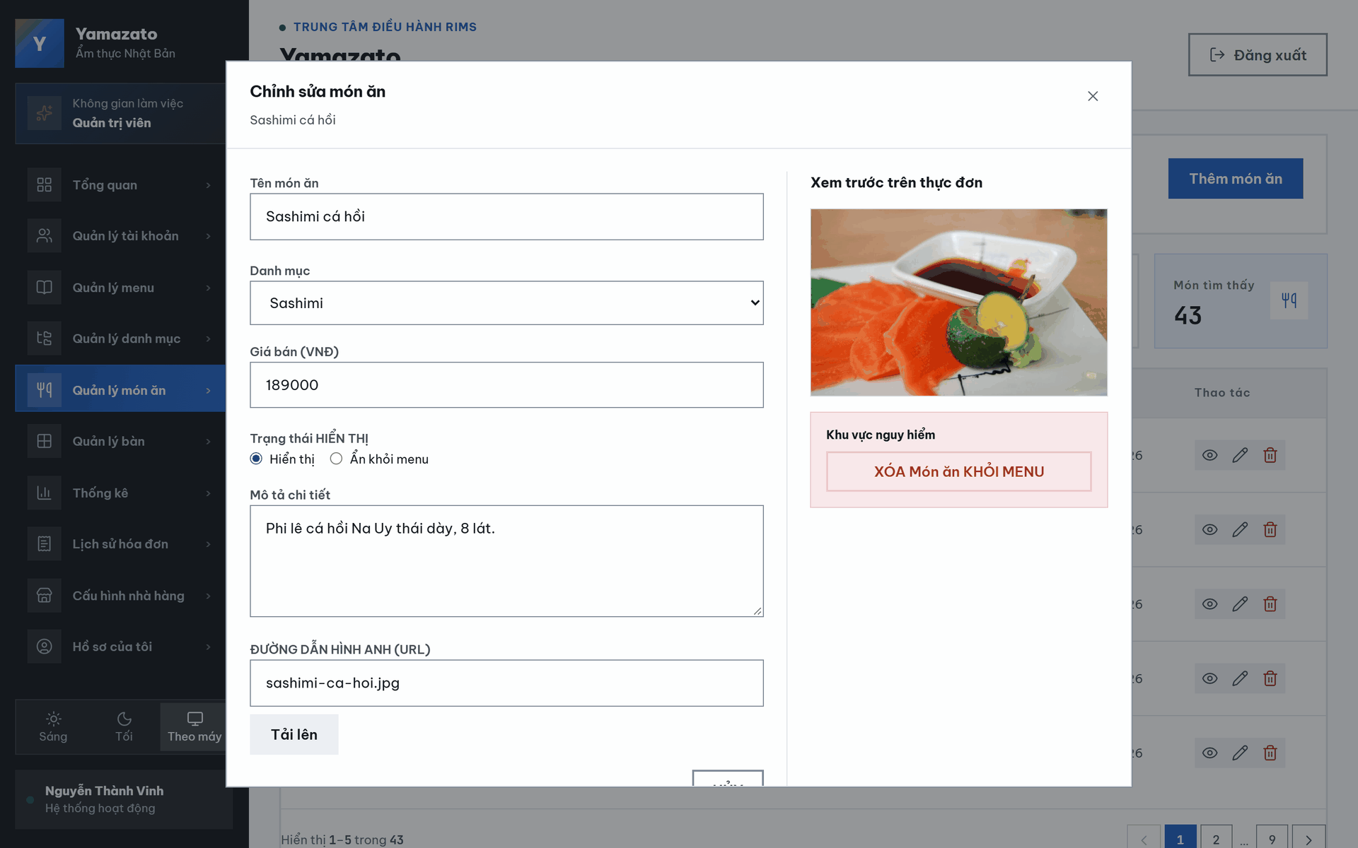

This screen allows the Admin to:
- Return to the Dish Details: Click the back-arrow button to return to the previous dish screen.
- Edit the Dish Name: Update the name of the selected dish.
- Change the Category: Assign the dish to another menu category.
- Update the Selling Price: Change the dish’s selling price in Vietnamese đồng.
- Change the Display Status: Choose whether the dish is visible or hidden from the restaurant menu.
- Edit the Dish Description: Update the detailed description of the dish.
- Update the Dish Image: Enter an image path or URL and upload the new dish image.
- Preview the Dish Image: View how the selected image will appear before saving the changes.
- Cancel Editing: Click “HỦY” to discard unsaved changes.
- Save Changes: Click “CẬP NHẬT” to save the updated dish information.
- Delete the Dish: Click “XÓA MÓN ĂN KHỎI MENU” to remove the dish from the menu.

Field Name | Description
← | Returns the Admin to the previous dish screen without saving the changes.
CHỈNH SỬA MÓN ĂN | Displays the title of the dish-editing screen.
TÊN MÓN ĂN | Allows the Admin to update the dish name. The current dish name is displayed in the input field.
DANH MỤC | Allows the Admin to select the menu category assigned to the dish. The current category displayed is “Ramen & Mì”.
GIÁ BÁN (VNĐ) | Allows the Admin to update the dish’s selling price in Vietnamese đồng.
TRẠNG THÁI HIỂN THỊ | Allows the Admin to control whether the dish is visible on the restaurant menu.
Hiển thị | Makes the dish visible on the menu. The selected radio button indicates that this status is currently active.
Ẩn khỏi menu | Hides the dish from the restaurant menu without deleting its information from the system.
MÔ TẢ CHI TIẾT | Allows the Admin to update the dish description, including its flavor, ingredients, and serving information.
ĐƯỜNG DẪN HÌNH ẢNH (URL) | Allows the Admin to enter the file path or URL of the dish image.
Tải lên | Loads the image entered in the image-path field and displays it in the preview section.
XEM TRƯỚC HIỂN THỊ CHUẨN | Displays a preview of the dish image before the updated information is saved.
HỦY | Cancels the editing process and discards any unsaved changes.
CẬP NHẬT | Submits and saves the updated dish information.
KHU VỰC NGUY HIỂM | Identifies the section containing an irreversible or high-impact dish-management action.
XÓA MÓN ĂN KHỎI MENU | Removes the selected dish from the menu. The system should request confirmation before completing the deletion.

2.3 Statistics

2.3.1 Dashboard Overview Screen
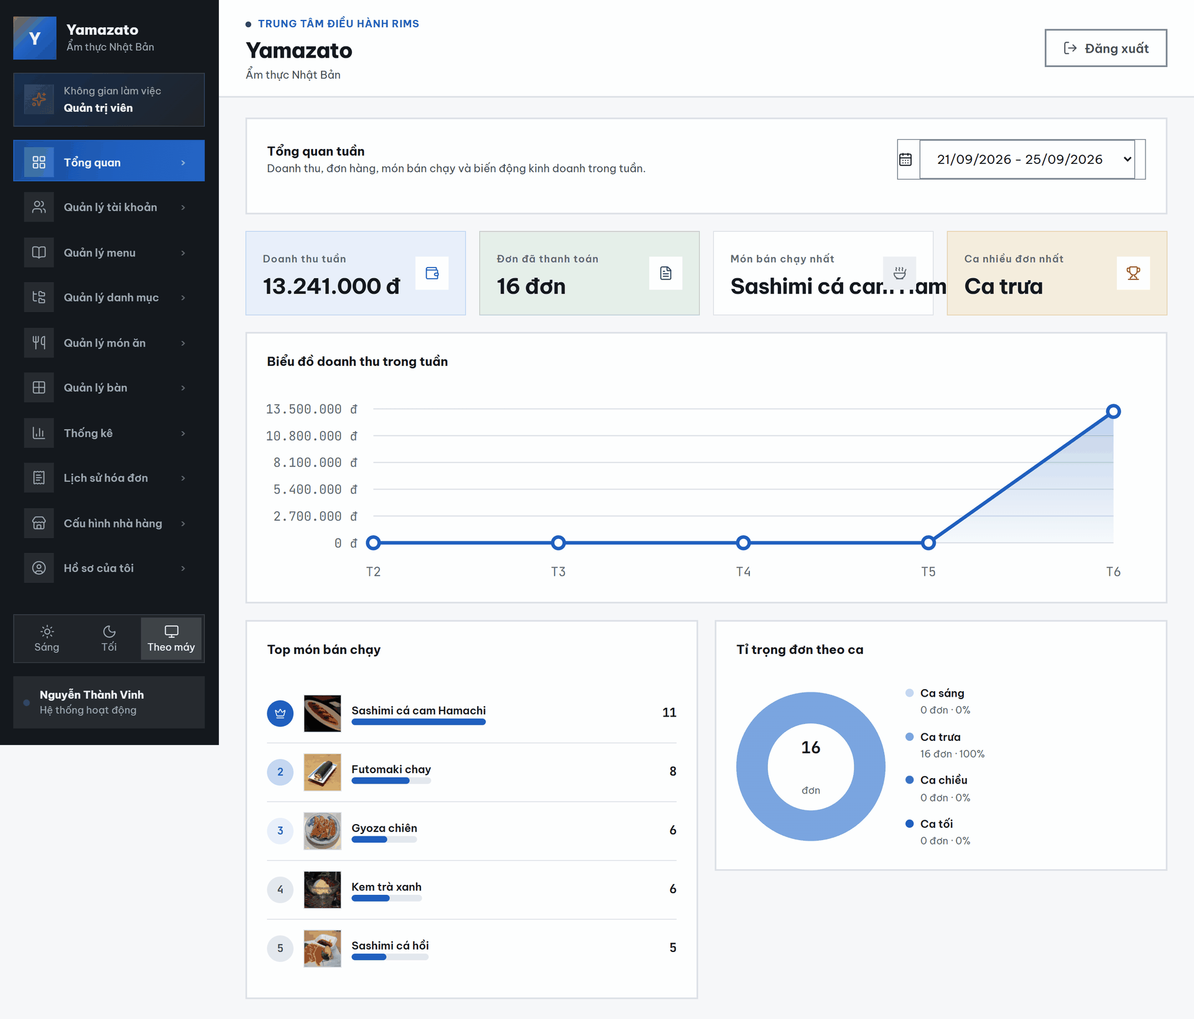
This screen allows the Admin to:
• View the weekly business overview dashboard for the restaurant.
• Select a week to view revenue, paid orders, best-selling dishes, and order-shift statistics within that selected date range.
• View the total restaurant revenue of the selected week, calculated from paid invoices in the selected period.
• View the total number of paid orders in the selected week.
• View the best-selling dish of the selected week, including its name and sold quantity.
• View the order shift with the highest number of paid orders, including the number of orders and its percentage.
• View the daily revenue chart from Monday to Sunday for the selected week.
• View the top 5 best-selling dishes in the selected week, ranked by sold quantity.
• View the percentage of paid orders by shift, including Morning, Noon, Afternoon, and Evening shifts.

Field Description

Field Name | Description
Ô chọn tuần trong năm | Allows the Admin to select a week to view dashboard statistics for that period.
Doanh thu tuần | Displays the total restaurant revenue of the selected week.
Đơn đã thanh toán | Displays the total number of paid orders in the selected week.
Món bán chạy nhất | Displays the dish with the highest sold quantity in the selected week.
Ca nhiều đơn nhất | Displays the shift that has the highest number of paid orders in the selected week.
Biểu đồ doanh thu trong tuần | Displays the restaurant revenue of each day in the selected week.
Top món bán chạy | Displays the 5 best-selling dishes in the selected week.
Tỉ trọng đơn theo ca | Displays the percentage distribution of paid orders by shift in the selected week.

2.3.2 Revenue Report Screen

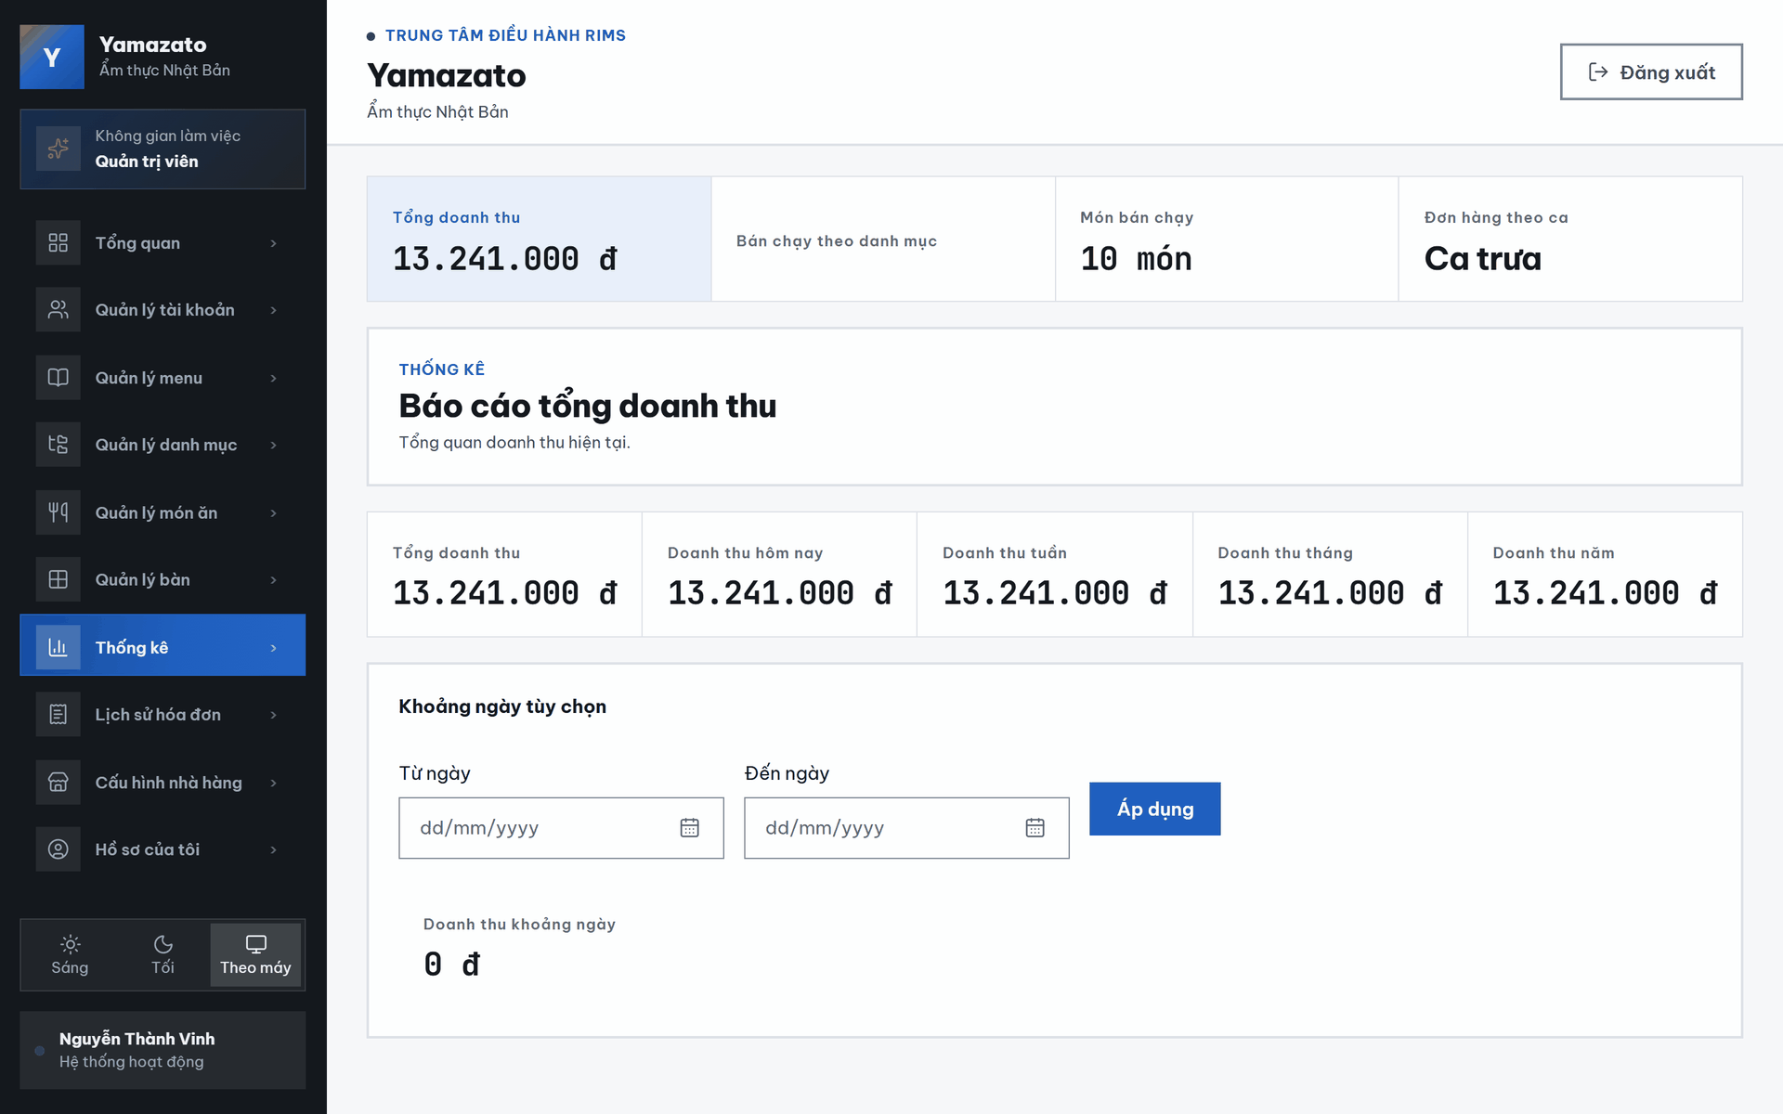
This screen allows the Admin to:
• View the restaurant’s total revenue report.
• View revenue summaries by today, current week, current month, current year, and all time.
• Select a custom date range using the From Date and To Date fields.
• Apply the selected date range to calculate revenue for that period.
• View the total revenue generated within the selected custom date range.

Field Description

Field Name | Description
Tổng doanh thu | Displays the total revenue from all invoices in the system.
Doanh thu hôm nay | Displays the total revenue generated today.
Doanh thu tuần | Displays the total revenue from Monday of the current week to today.
Doanh thu tháng | Displays the total revenue from the first day of the current month to today.
Doanh thu năm | Displays the total revenue from the first day of the current year to today.
Từ ngày | Allows the Admin to select the start date for a custom revenue range.
Đến ngày | Allows the Admin to select the end date for a custom revenue range.
Áp dụng khoảng ngày | Applies the selected date range and loads the revenue for that period.
Doanh thu khoảng ngày | Displays the total revenue within the selected custom date range.

2.3.3 Best-Selling By Category Report Screen

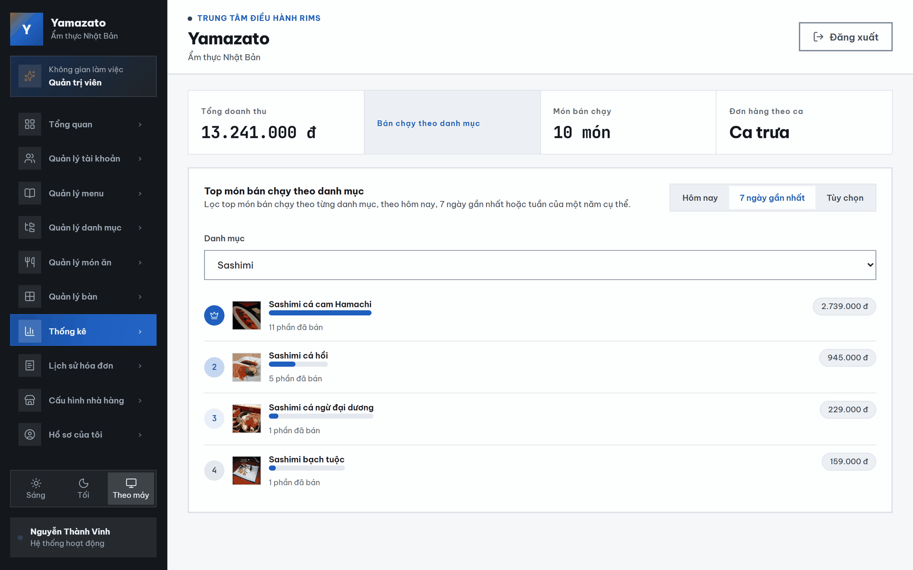

This screen allows the Admin to:
• View best-selling dishes by selected category.
• Filter best-selling dishes by time range: Today, Last 7 Days, or Custom.
• Select a dish category to view the best-selling dishes within that category.
• View ranked dishes based on sold quantity in the selected time range.
• View each dish’s image, name, sold quantity, and sales performance bar.
Field Description

Field Name | Description
Danh mục | Allows the Admin to select a dish category for filtering best-selling dishes
Hôm nay | Filters best-selling dishes for today.
7 ngày gần nhất | Filters best-selling dishes for the last 7 days.
Tùy chọn | Allows the Admin to filter best-selling dishes by a custom time range.
Rank | Displays the ranking position of each best-selling dish.
Dish image | Displays the image of the best-selling dish.
Dish name | Displays the name of the best-selling dish.
Progress bar | Shows the sold quantity of the dish compared with the highest-selling dish in the list.
Quantity | Displays the total sold quantity of the dish.

2.3.4 Top 10 Best-Selling Dish Report Screen
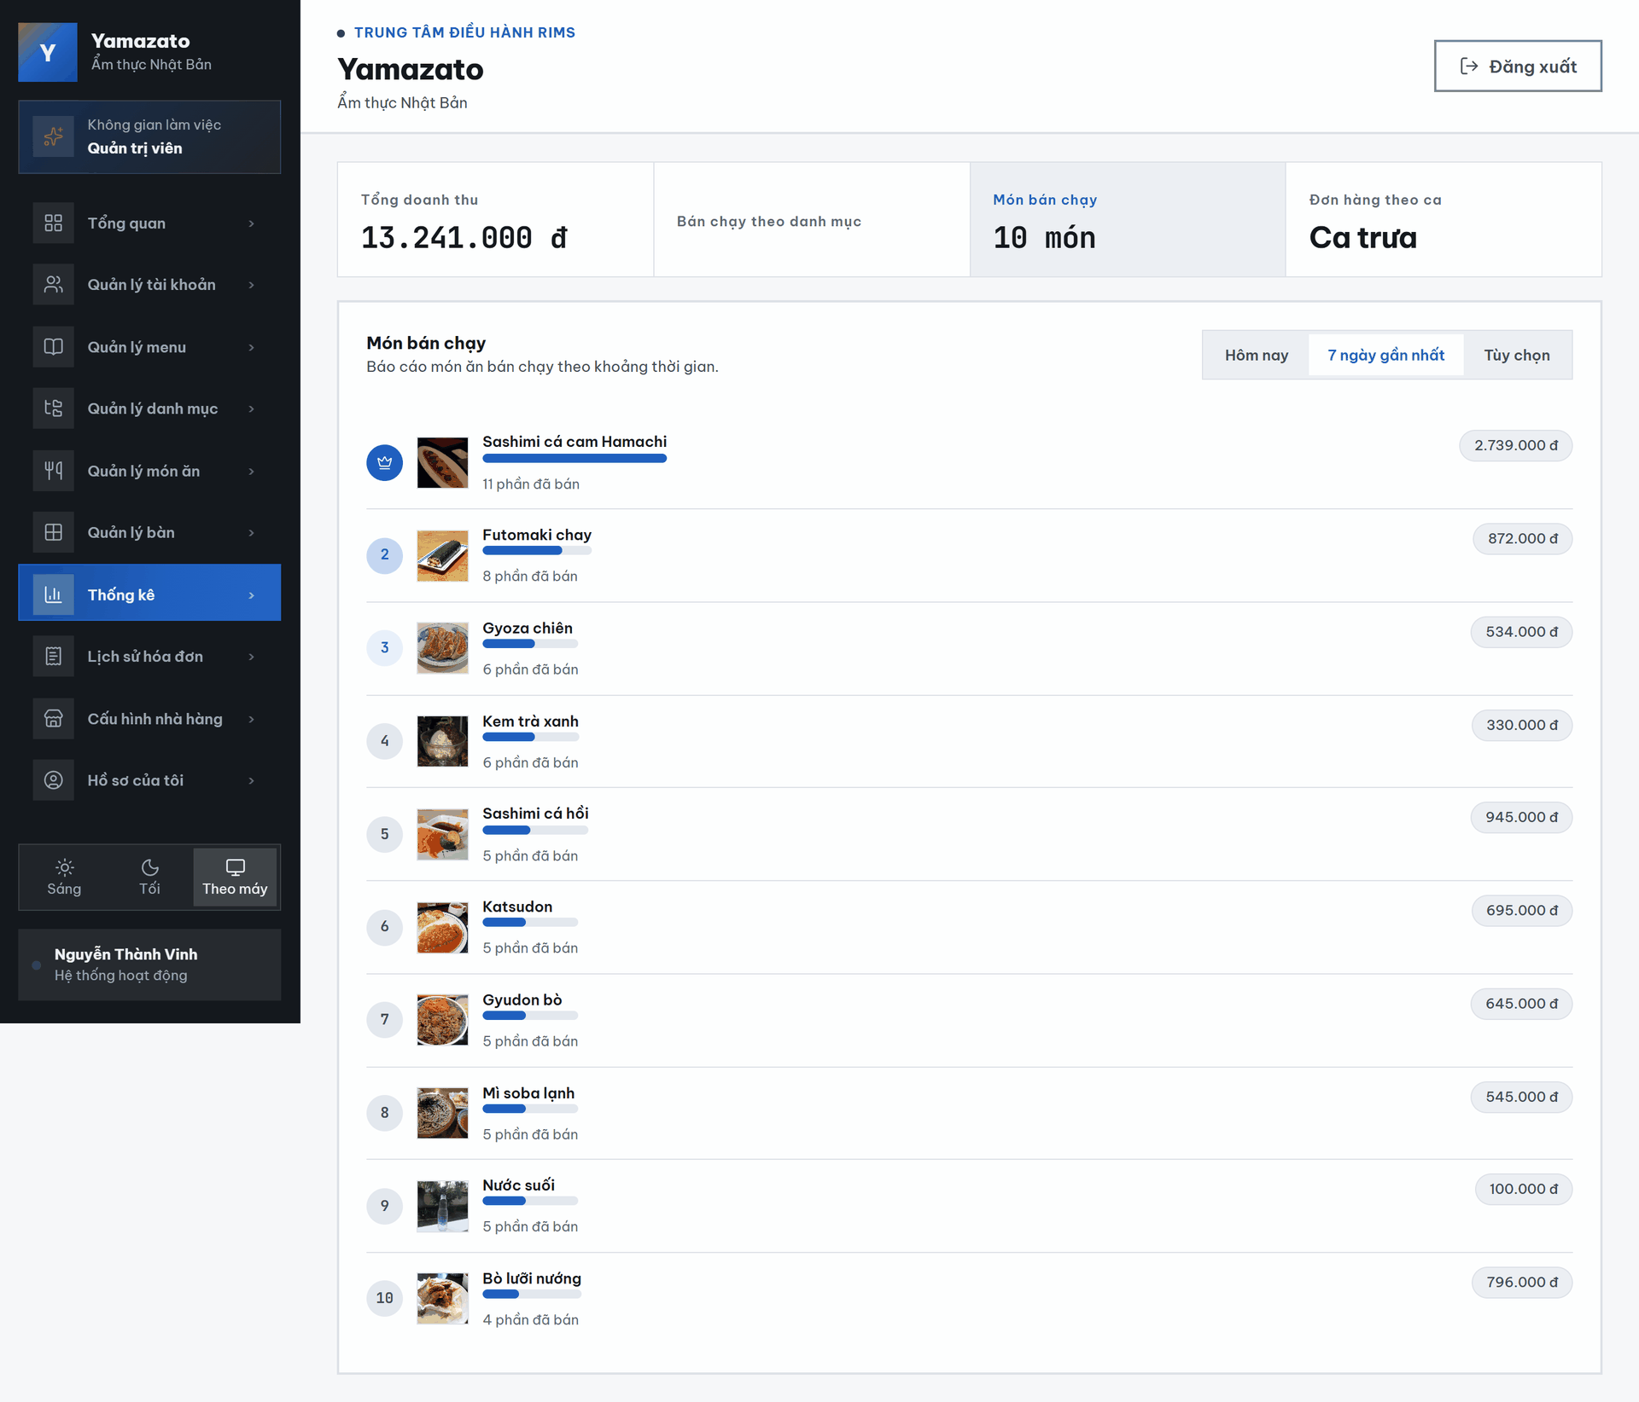

This screen allows the Admin to:
• View the best-selling dishes in the restaurant.
• Filter best-selling dishes by time range: Today, Last 7 Days, or Custom.
• View the top 10 best-selling dishes based on sold quantity.
• Compare dishes by sold quantity using the horizontal display bars.
• View each dish’s rank, image, name, and total sold quantity

Field Description
Field Name | Description
Hôm nay | Filters best-selling dishes for today.
7 ngày gần nhất | Filters best-selling dishes for the last 7 days.
Tùy chọn | Allows the Admin to filter best-selling dishes by a custom time range.
Rank | Displays the ranking position of each best-selling dish.
Dish image | Displays the image of the best-selling dish.
Dish name | Displays the name of the best-selling dish.
Progress bar | Shows how much each dish sold compared with the best-selling dish in the list.
Quantity | Displays the total sold quantity of each dish.

2.3.5 Order Statistics By Shift Screen
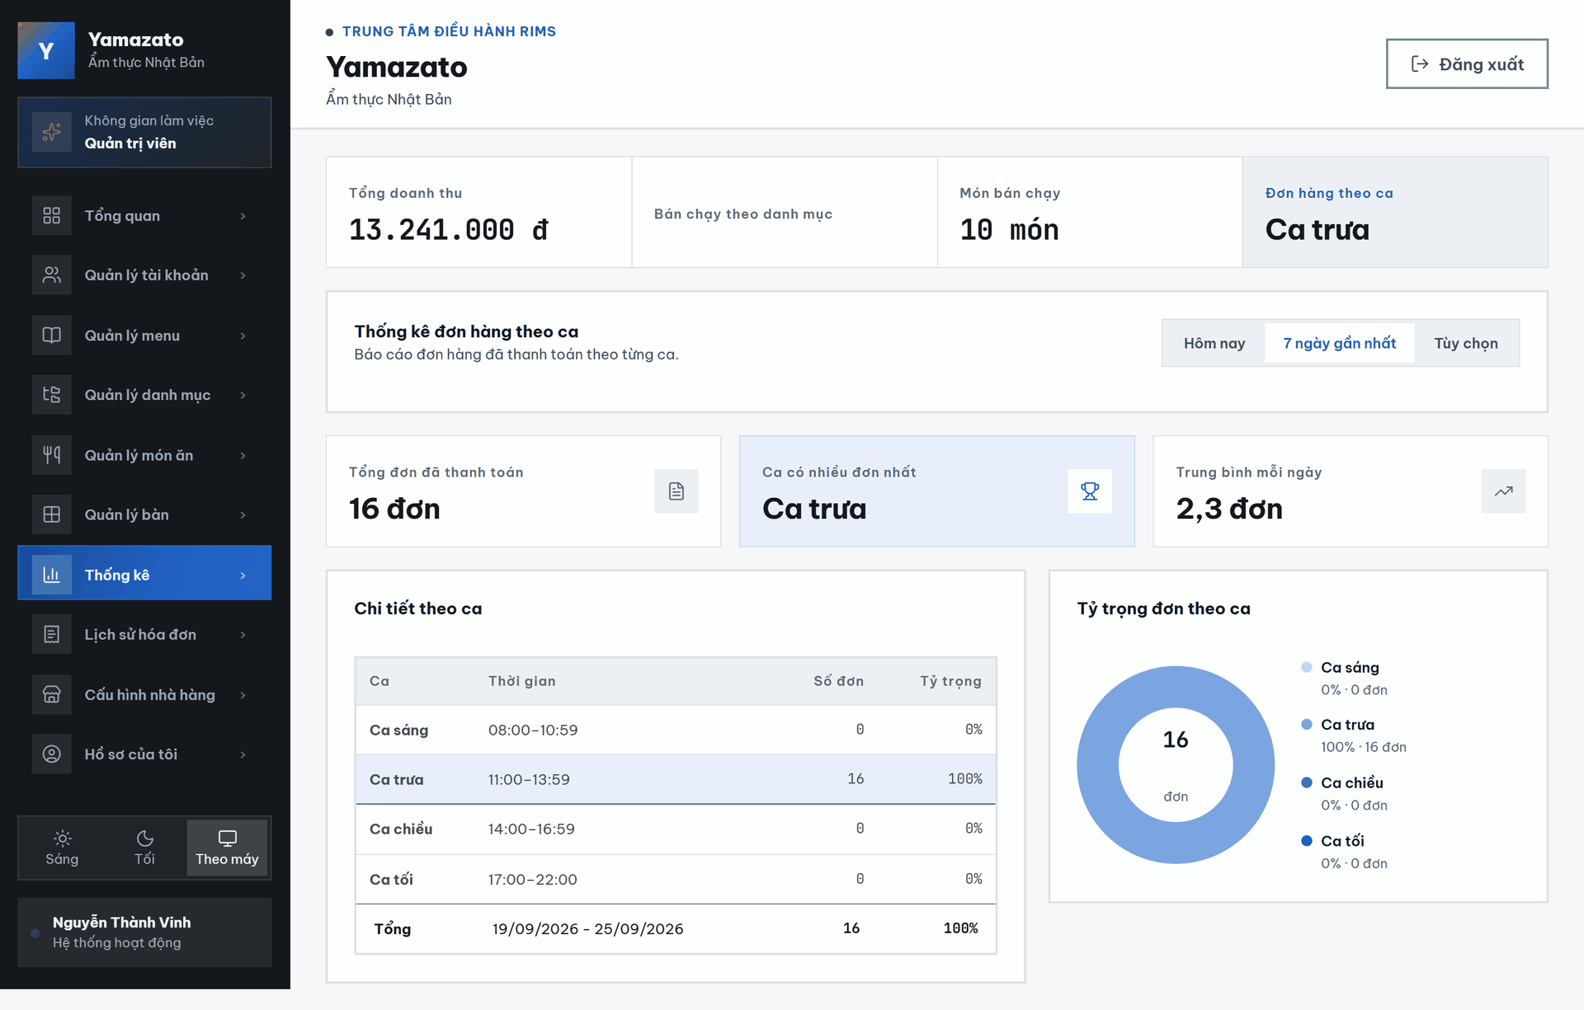

This screen allows the Admin to:
• View paid order statistics by restaurant shift.
• Filter order-shift statistics by time range: Today, Last 7 Days, or Custom.
• View the total number of paid orders in the selected period.
• View the shift with the highest number of paid orders.
• View the average number of paid orders per day.
• View detailed order count and percentage for each shift.
• Compare order distribution across shifts using the donut chart.

Field Description
Field Name | Description
Hôm nay | Filters order-shift statistics for today
7 ngày gần nhất | Filters order-shift statistics for the last 7 days.
Tùy chọn | Allows the Admin to filter order-shift statistics by a custom time range.
Tổng đơn đã thanh toán | Displays the total number of paid orders in the selected period.
Ca có nhiều đơn nhất | Displays the shift with the highest number of paid orders.
Trung bình mỗi ngày | Displays the average number of paid orders per day in the selected period.
Chi tiết theo ca | Displays order statistics for each shift.
Ca | Displays the shift name, including morning, noon, afternoon, and evening
Thời gian | Displays the time range of each shift.
Số đơn đã thanh toán | Displays the number of paid orders in each shift.
Tỷ trọng | Displays the percentage of paid orders in each shift compared with the total paid orders.
Tổng | Displays the selected date range, total paid orders, and total percentage.
Tỷ trọng đơn theo ca | Displays the percentage distribution of paid orders across shifts using a donut chart.

2.4 Invoice History

2.4.1 Invoice History Screen
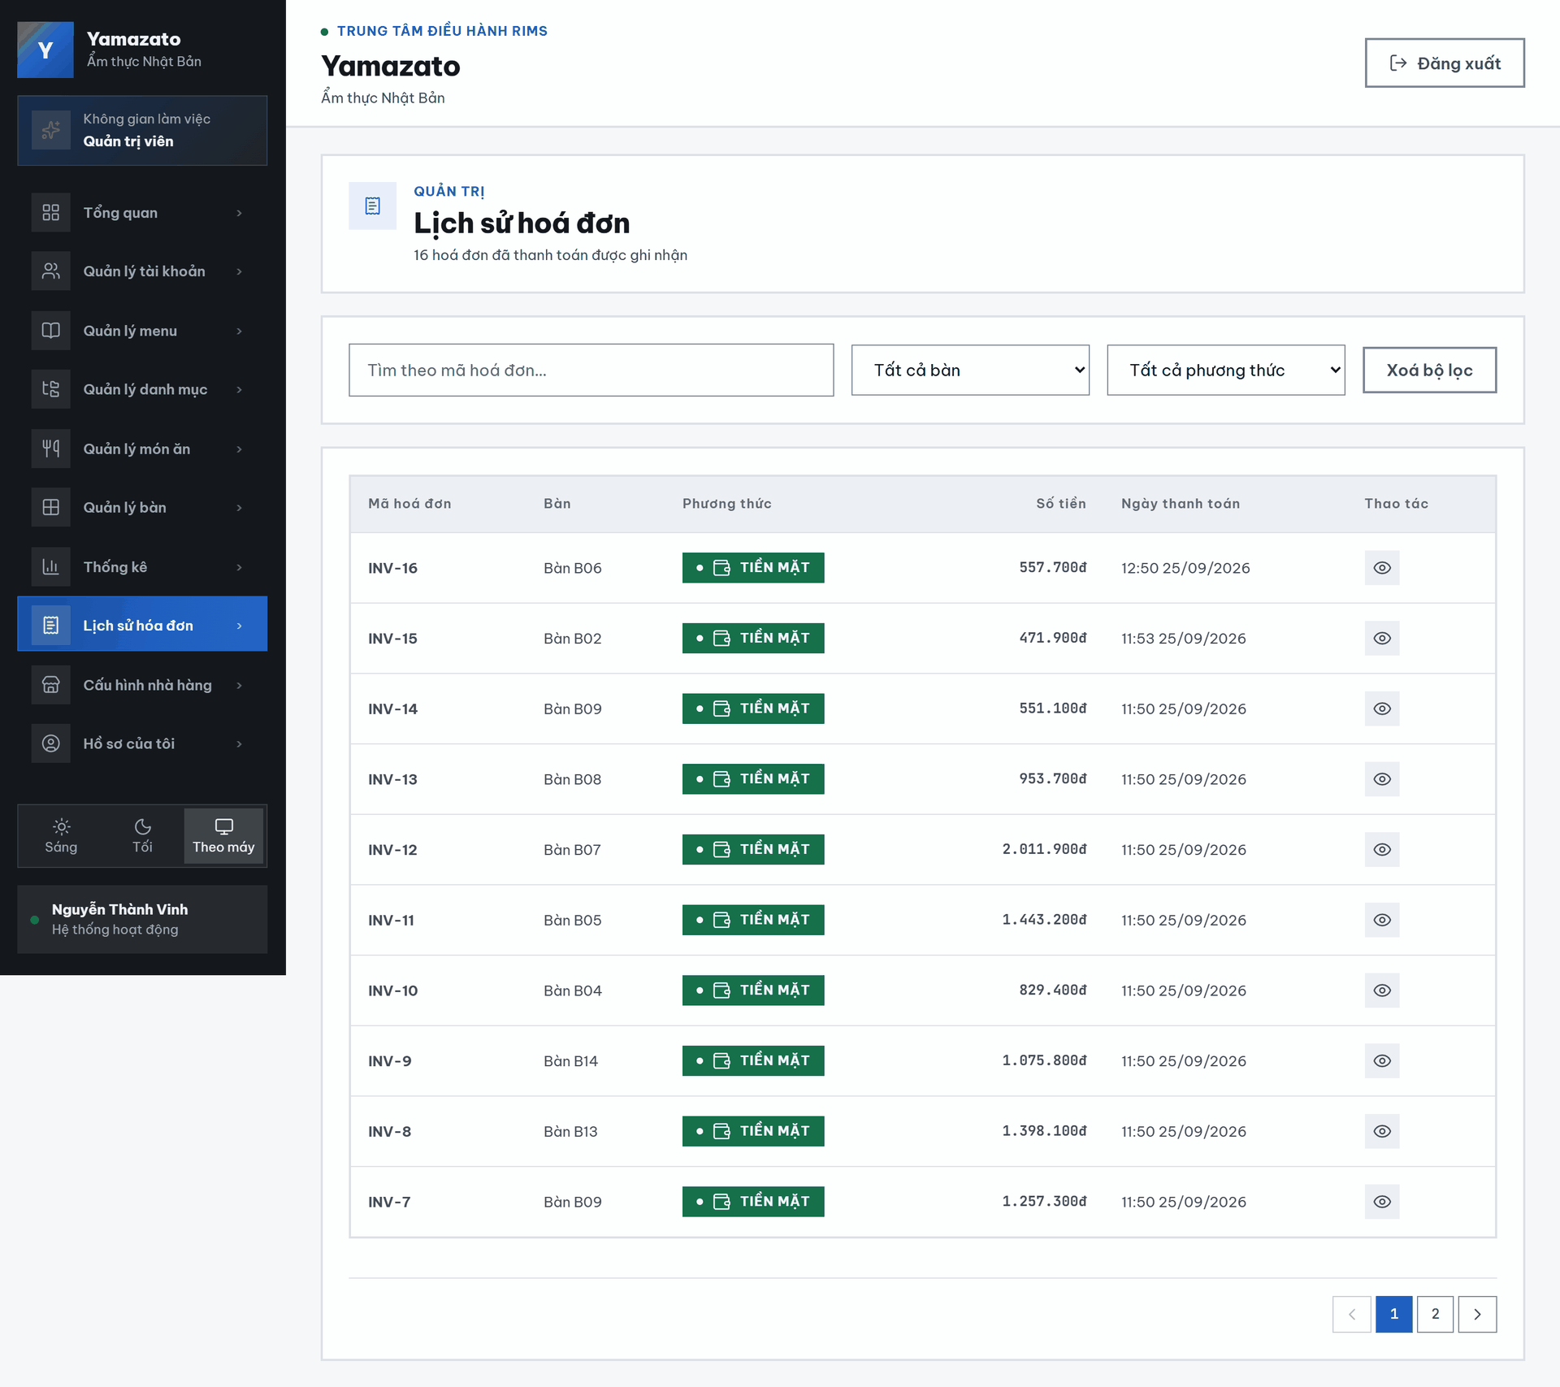

This screen allows the Admin to:
- View Invoice History: View all paid invoices recorded in the restaurant management system.
- Filter by Table: Select a table to display only invoices associated with that table.
- Filter by Payment Method: Select a payment method to display invoices paid by cash or QR code.
- Search by Invoice ID: Enter an invoice ID to find a specific invoice.
- Clear All Filters: Click “Xóa bộ lọc” to reset the table, payment-method, and invoice-ID filters.
- View Invoice Information: Review each invoice’s invoice ID,table, payment method, amount, and payment date.
- View Invoice Details: Click the arrow at invoice row to open its detailed information.

Field Description
Field Name | Description
Lịch sử hóa đơn | Displays the invoice history screen for paid invoices.
Tất cả bàn | Allows the Administrator to filter invoice history by tableNumber. If no table is selected, invoices from all tables are shown.
Tất cả phương thức | Allows the Administrator to filter invoices by payment method. The backend supports CASH and QRCODE.
Xóa bộ lọc | Clears the selected filters and reloads the invoice history list.
Mã hóa đơn(bộ lọc) | Filter invoice by invoiceId
Mã hóa đơn | Display invoiceId paid.
Bàn | Displays the table number linked to the invoice, returned from tableNumber.
Phương thức | Displays the payment method of the invoice, returned from paymentMethod.
Số tiền | Displays the final invoice amount, returned from amount.
Ngày thanh toán | Displays the invoice payment date and time, returned from paymentDate.
Xem chi tiết | Allows the Administrator to open the detail by click each row of invoice history.
Hiển thị 1-10 trong tổng 3000 hóa đơn | Displays the range of invoices currently shown on the page and the total number of invoices.
Trước | Moves to the previous page of invoice history.
Trang 1 / 300 | Displays the current page number and the total number of pages.
Sau | Moves to the next page of invoice history.

2.4.2 Invoice Detail Screen
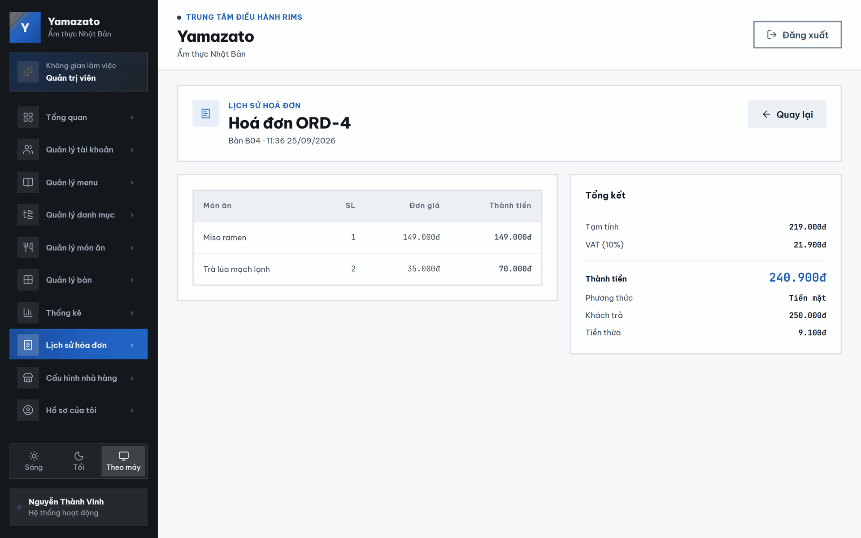
This screen allows the Admin to:
- Return to the Invoice History: Click the back-arrow button to return to the invoice-history screen.
- View Invoice Information: Review the invoice number, table number, and payment date and time.
- View Ordered Dishes: Review the dishes included in the invoice.
- View Quantity and Price: Check the quantity, unit price, and line total of each dish.
- View Payment Calculation: Review the subtotal, VAT amount, and final invoice total.
- View Payment Information: Check the payment method, amount received from the customer, and change returned.

Field Name | Description
Hóa đơn ORD-mã đơn | Displays the invoice detail title. The backend returns orderId, which can be shown by the frontend as ORD-{orderId}.
Bàn | Displays the table number linked to the invoice, returned from tableNumber.
Giờ | Displays the invoice payment date and time, returned from invoiceDate.
Món ăn | Displays the dish name from each invoice item, returned from dishName.
Sl | Displays the quantity of each dish, returned from quantity.
Đơn giá | Displays the unit price of each dish, returned from unitPrice.
Thành tiền món ăn | Displays the line amount for each dish, returned from amount.
Tạm tính | Displays the total amount before VAT. The backend calculates it by summing all item subtotals.
VAT (10%) | Displays the VAT amount. In backend logic, this value is calculated as finalAmount - totalBeforeVat.
Thành tiền hóa đơn | Displays the final invoice amount, returned from finalAmount.
Phương thức | Displays the payment method. The backend uses the first payment method if available, otherwise returns “Không xác định”.
Khách trả | Displays the amount paid by the customer. The backend uses the first payment amount if available, otherwise uses finalAmount.
Tiền thừa | Displays the change amount. The backend calculates it as amountPaid - finalAmount; if the result is negative, it returns 0.
< | Allows the Administrator to return to the previous invoice history screen.

3. Cashier

3.1 Table Map

3.1.1 Table List Screen
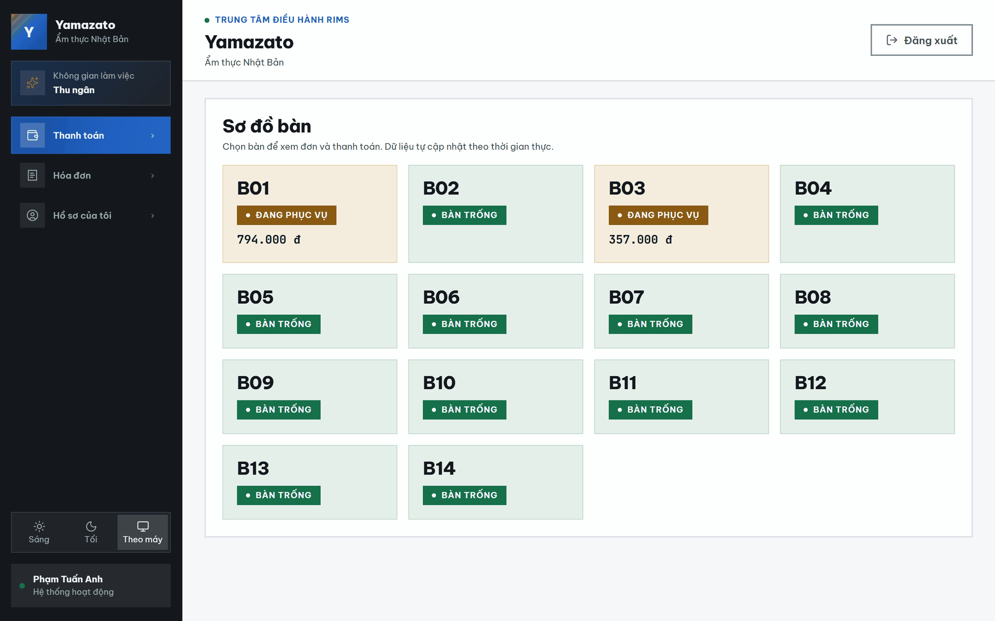

This screen allows the Cashier to:
- View Table List: View the list of all restaurant tables with their current status (Đang Phục Vụ / Bàn Trống) and the associated order, updated in real time.
- Select a Table: Click on a table to open its order details and proceed with checkout.
Field Description
Field Name | Description
Table Card | A clickable card displaying the table number (e.g., T01), used to open the order details for that table.
ID Đơn | Displays the ID of the order currently linked to the table, or "null" if the table has no active order.
Status Label | Shows "● Đang Phục Vụ" (orange) if the table has an active order in Serving/Locked status, or "○ Bàn Trống" (green) if the table is available.

3.2 Order & Checkout

3.2.1 Order Details Panel
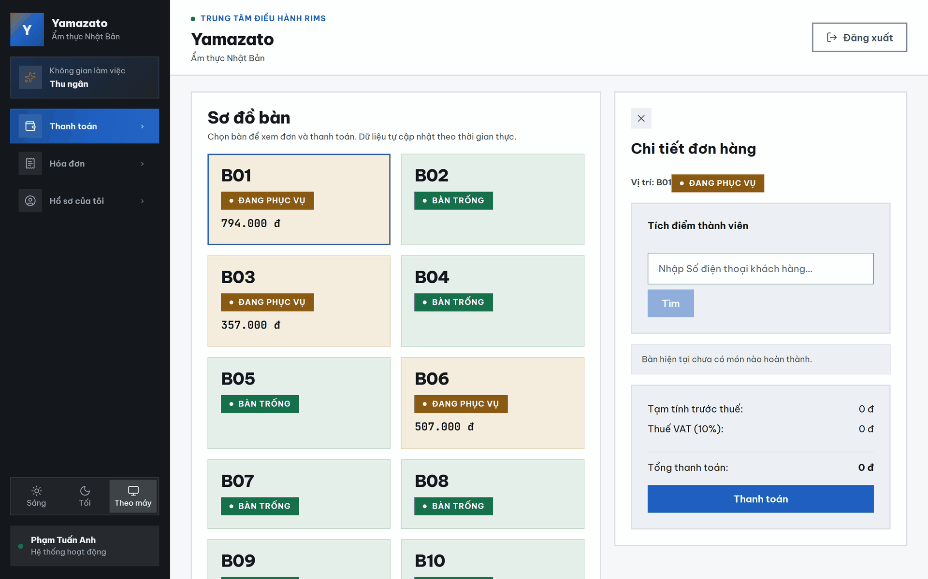
This screen allows the Cashier to:
- View Order Details: View the list of completed dishes for the selected table, including dish name, quantity, and subtotal.
- View Payment Summary: View the pre-tax total, VAT amount, and final amount to be collected.
- Search Customer: Enter a customer's phone number to look up their loyalty account before checkout.
- Start Checkout: Lock the order and proceed to select a payment method.
- Close Panel: Close the order details panel.
Field Description
Field Name | Description
Đóng (✕) | A button that closes the order details panel and deselects the table.
Nhập SĐT khách hàng | A text input for entering the customer's phone number to search for their loyalty account.
Tìm | A button that searches for a member customer by the entered phone number.
Danh sách món ăn (MÓN ĂN / SL / THÀNH ...) | A read-only table listing each completed dish, its quantity, and its subtotal amount.
Tạm tính trước thuế | Displays the total amount of all completed dishes before VAT.
Thuế VAT (10%) | Displays the VAT amount, calculated as 10% of the pre-tax total.
Tổng thanh toán | Displays the final total amount the customer must pay.
CheckOut | A button that locks the order and opens the payment method selection popup.

3.2.2 Customer Loyalty Panel (Customer Found)
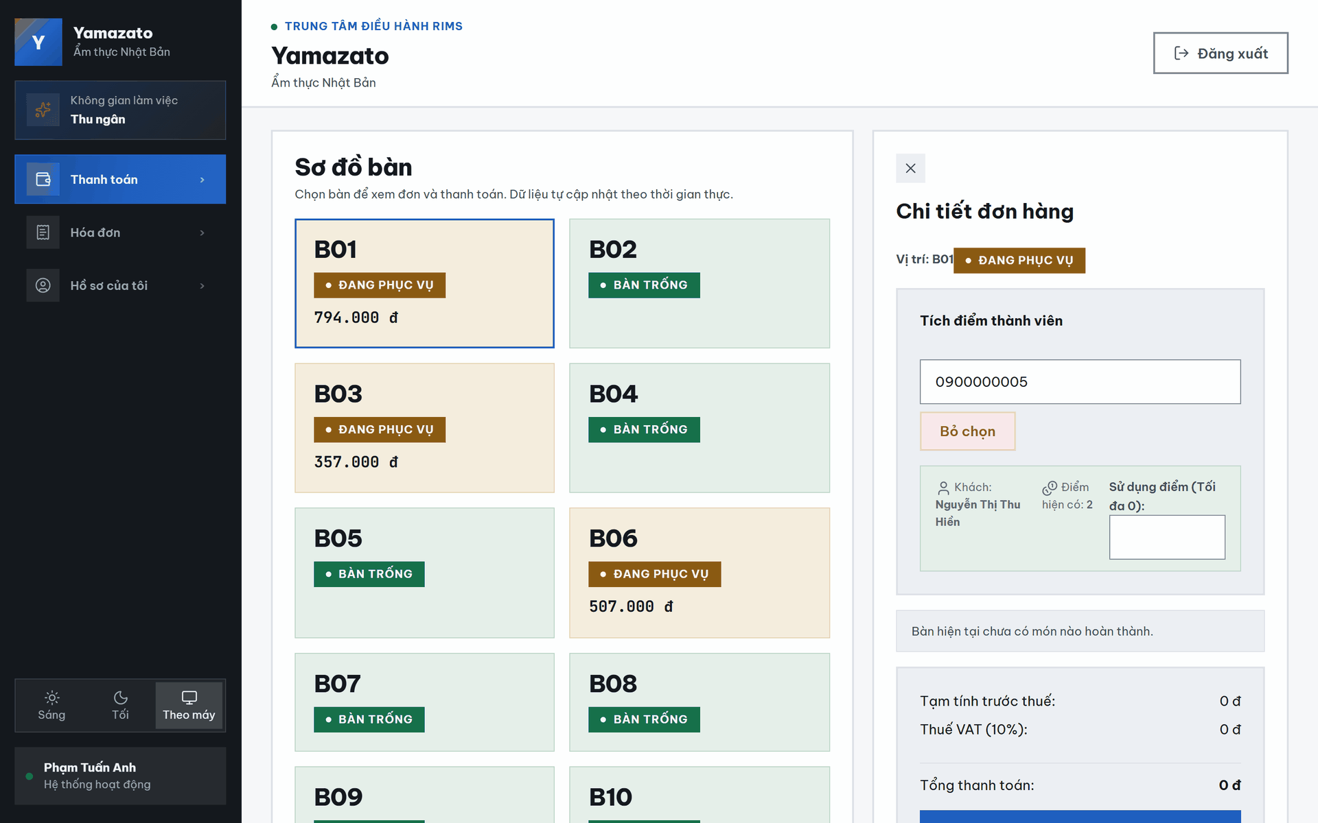
This screen allows the Cashier to:
- View Customer Info: View the found customer's full name and current reward point balance.
- Apply Loyalty Discount: Enter the number of points to redeem for a discount on the current order.
- Unlink Customer: Remove the linked customer from the current order.
Field Description
Field Name | Description
Khách | Displays the full name of the customer found by phone number search.
Điểm hiện có | Displays the customer's current reward point balance.
Sử dụng điểm (Tối đa ...) | A numeric input for the number of points to redeem as a discount (1 point = 1,000 VND); automatically capped at the customer's balance or 50% of the invoice amount, whichever is lower.
Bỏ chọn | A button that unlinks the customer from the order and resets the points-used field to 0.

3.2.3 New Customer Registration Panel
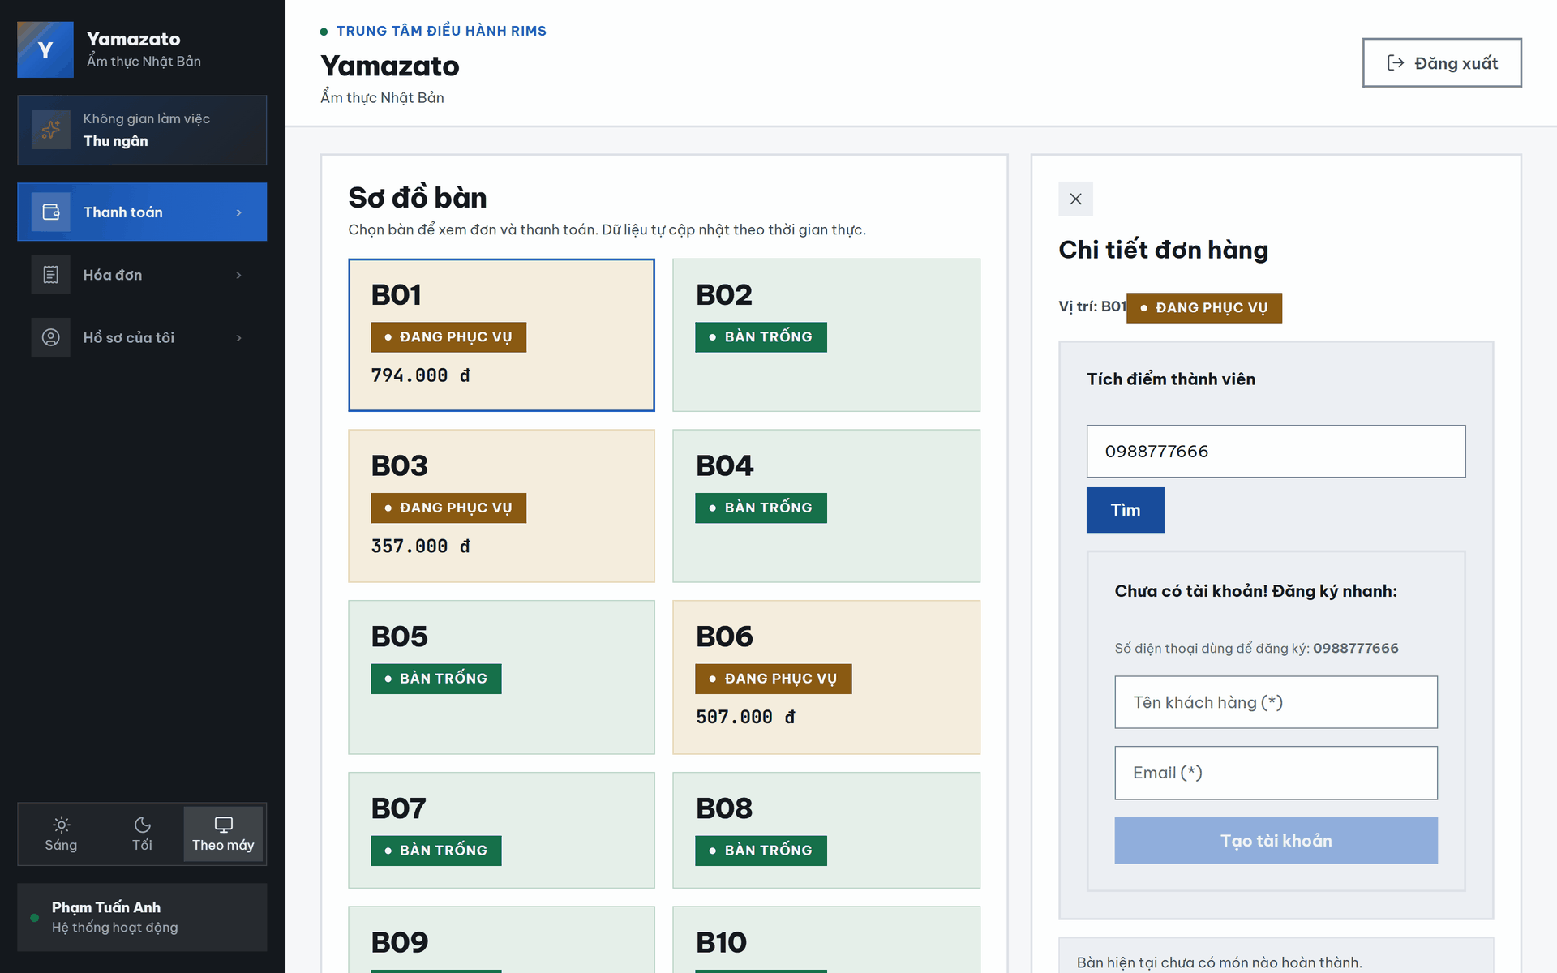
This screen allows the Cashier to:
- Register New Customer: Quickly create a new member account using the searched phone number, so the customer can start earning/using loyalty points on the current order.
Field Description
Field Name | Description
SĐT dùng để đăng ký | Displays the phone number that was searched (read-only), used as the new account's registered phone number.
Tên khách hàng (*) | A required text input for the new customer's full name.
Email (*) | A required text input for the new customer's email address; must be a valid email format.
Tạo Tài Khoản | A button that submits the form, creates the new customer account, and automatically links it to the current order.

3.2.4 Payment Method Selection Pop-up
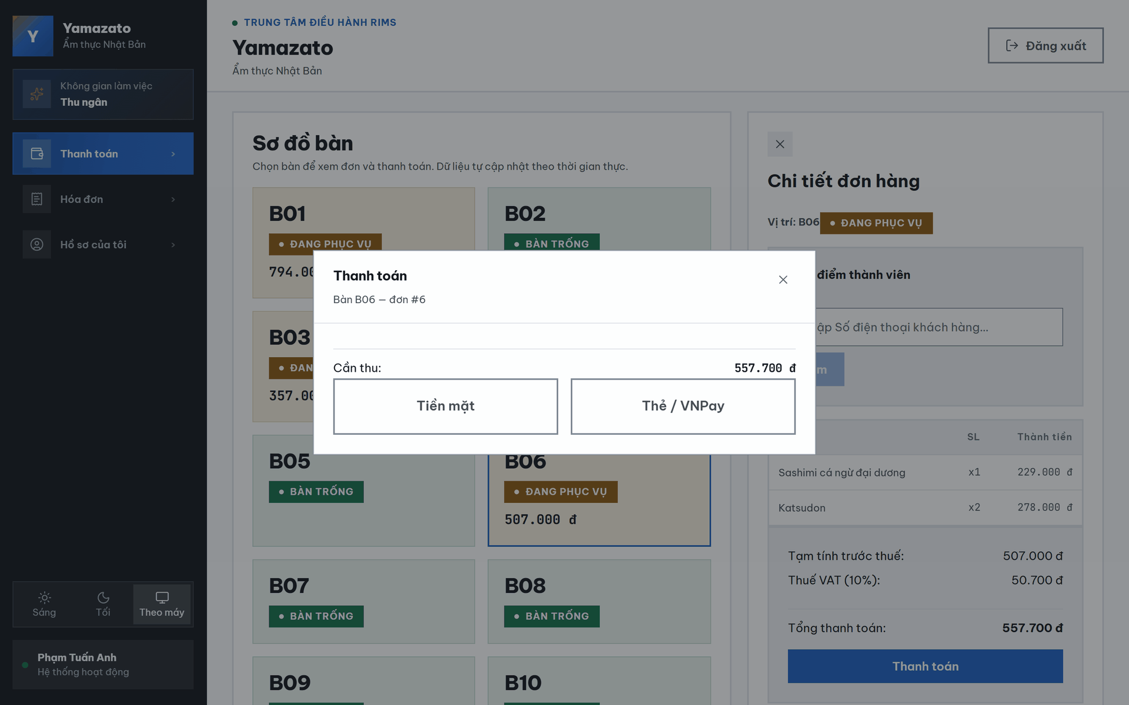

This screen allows the Cashier to:
- View Amount Due: View the final amount to be collected, after any loyalty point discount has been applied.
- View Linked Customer: View the name of the customer linked to this order, if any.
- Select Payment Method: Choose between Cash or VNPay to proceed with the payment.
- Cancel Checkout: Close the popup, which cancels the checkout and unlocks the order.
Field Description
Field Name | Description
Đóng (×) | A button that cancels the checkout, unlocks the order, and closes the popup.
Khách | (Only shown if a customer is linked) displays the name of the linked customer.
Cần thu | Displays the final amount to be collected, after subtracting any loyalty point discount.
Tiền mặt | A button that switches the popup to the Cash Payment form.
Thẻ / VNPay | A button that switches the popup to the VNPay confirmation screen.

3.2.5 Cash Payment Pop-up
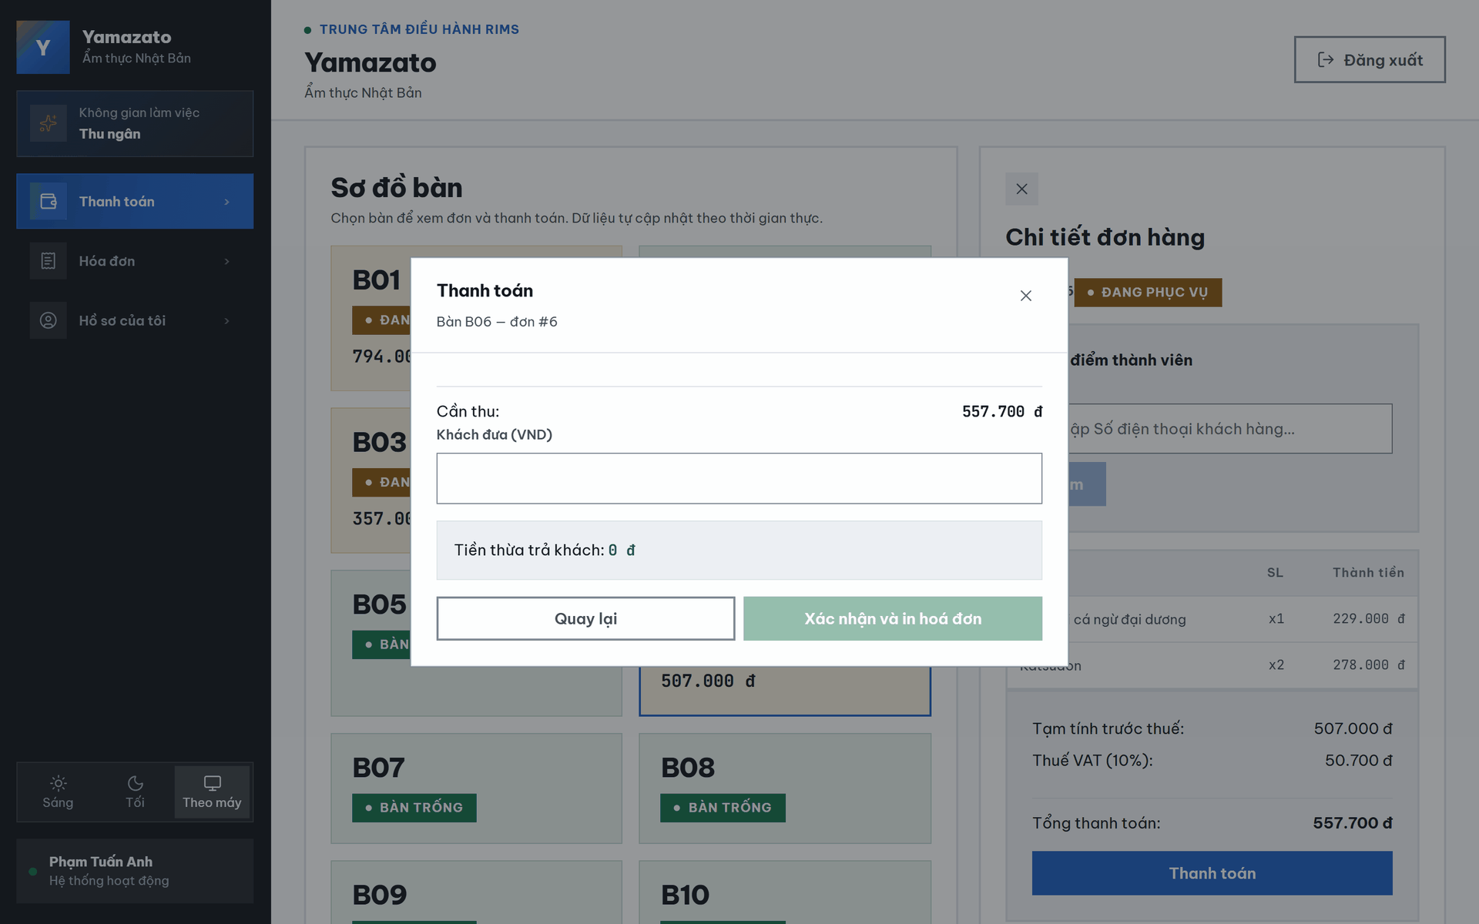

This screen allows the Cashier to:
- View Linked Customer & Discount: View the linked customer's name and the discount applied from redeemed loyalty points, if any.
- Enter Amount Received: Enter the amount of cash handed over by the customer.
- View Change Due: View the change to be returned to the customer, calculated automatically.
- Confirm Payment: Submit the cash payment and generate the invoice.
- Go Back: Return to the Payment Method Selection screen.
Field Description
Field Name | Description
Khách...Đã dùng ... điểm giảm giá | (Only shown if a customer is linked) displays the linked customer's name and the number of loyalty points redeemed for a discount.
Cần thu | Displays the final amount to be collected, after any loyalty point discount.
Khách đưa(VND) | A numeric input for the amount of cash received from the customer.
Tiền thừa trả khách | Read-only text showing the change to return, automatically calculated as Khách đưa − Cần thu.
Quay lại | A button that returns to the Payment Method Selection screen.
Xác nhận & In Hóa Đơn | A primary button that confirms the cash payment and generates the invoice; disabled if the amount received is less than the amount due.

3.2.6 VNPay Confirmation Pop-up
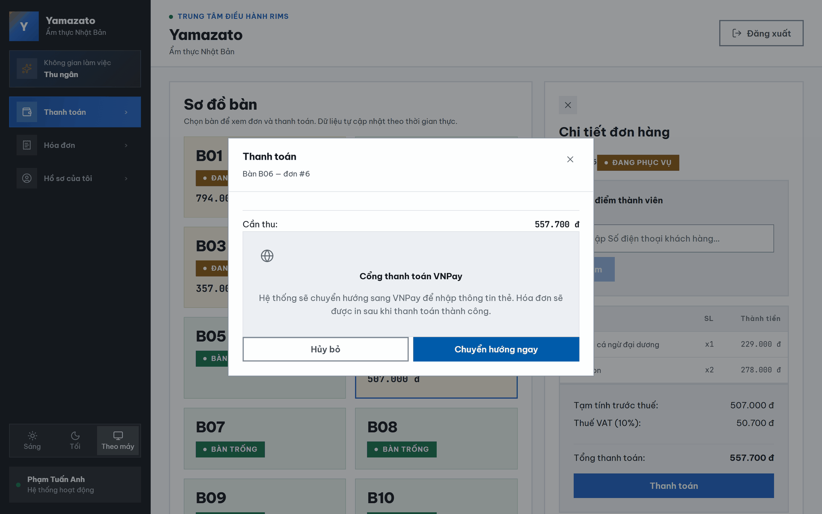

This screen allows the Cashier to:
- View Linked Customer & Discount: View the linked customer's name and the discount applied from redeemed loyalty points, if any.
- View Amount Due: View the final amount to be collected via VNPay.
- Confirm VNPay Redirect: Confirm redirecting to the VNPay payment gateway to complete the transaction.
- Go Back: Cancel and return to the Payment Method Selection screen.
Field Description
Field Name | Description
Khách...Đã dùng ... điểm giảm giá | (Only shown if a customer is linked) displays the linked customer's name and the number of loyalty points redeemed for a discount.
Cần thu | Displays the final amount to be collected via VNPay.
Hủy bỏ | A button that returns to the Payment Method Selection screen.
Chuyển hướng ngay | A button that redirects the browser to the VNPay payment gateway to complete the transaction.

3.2.7 Payment Cash Success Screen
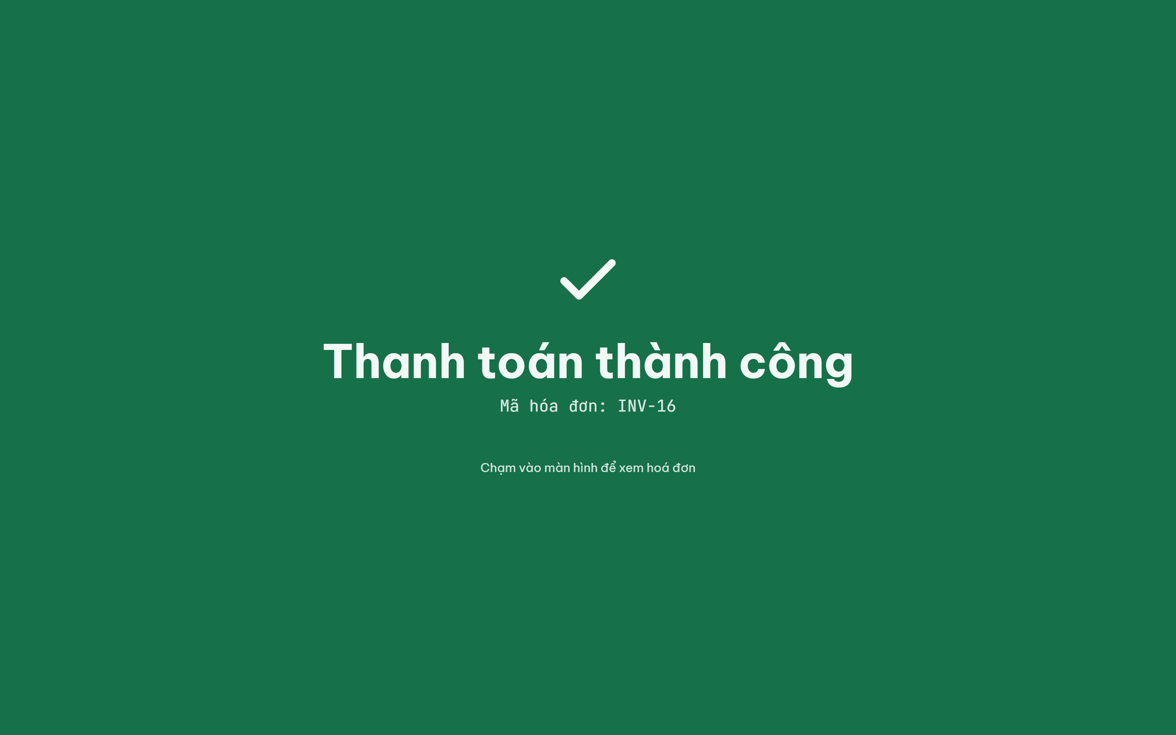
This screen allows the Cashier to:
- View Payment Confirmation: View a full-screen confirmation immediately after a payment is completed successfully.
- View Loyalty Summary: View the linked customer's name and the loyalty points earned from this invoice, if any.
- Proceed to Bill: Tap anywhere on the screen to reveal the full itemized invoice.
Field Description
Field Name | Description
Mã hóa đơn | Displays the code of the generated invoice.
Khách hàng | (Only shown if a customer is linked) displays the name of the customer linked to this invoice.
Tích lũy thêm | (Only shown if a customer is linked) displays the number of loyalty points earned from this invoice.
Chạm vào màn hình để xem hóa đơn | A hint text indicating the whole screen is clickable to proceed to the itemized bill (3.2.8).

3.2.8 Payment Detail and Export PDF Invoice Screen
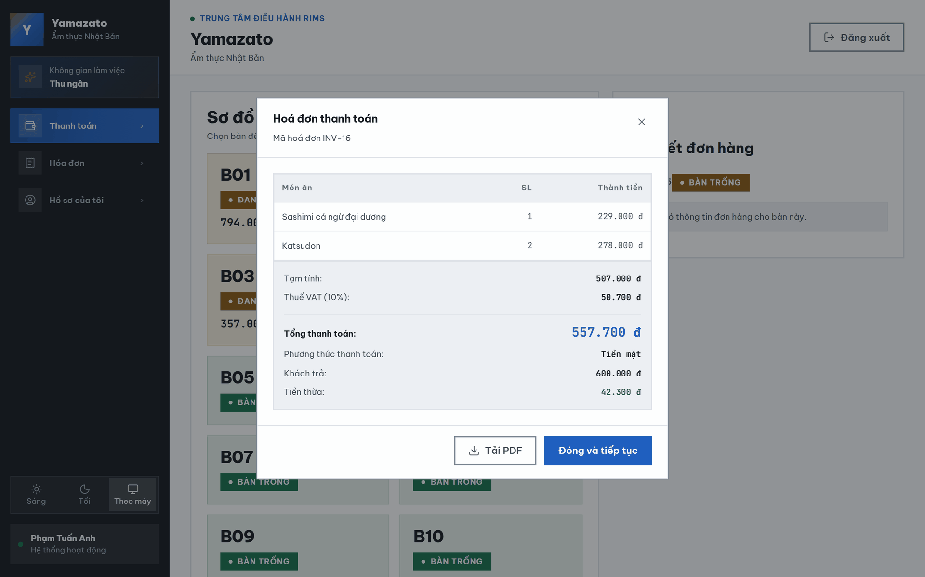

This screen allows the Cashier to:
- View Itemized Bill: View the full invoice, including the dish list, VAT, loyalty details, and final amount paid.
- Download Invoice PDF: Download a PDF copy of the invoice.
- Return to Table Map: Close the bill and return to the Table Map, releasing the table.
Field Description
Field Name | Description
Mã | Displays the code of the generated invoice.
Danh sách món ăn (MÓN ĂN / SL / THÀNH TIỀN) | A read-only table listing each dish, quantity, and subtotal on the final invoice.
Tạm tính | Displays the pre-tax subtotal of the invoice.
Thuế VAT (10%) | Displays the VAT amount, calculated as 10% of the pre-tax subtotal.
Khách hàng | (Only shown if a customer is linked) displays the linked customer's name.
Điểm đã dùng | (Only shown if a customer is linked and points were redeemed) displays the discount amount from redeemed loyalty points.
Điểm tích lũy thêm | (Only shown if a customer is linked) displays the loyalty points earned from this invoice.
TỔNG THANH TOÁN | Displays the final amount paid.
Phương thức thanh toán | Displays the payment method used ("Tiền mặt").
Khách trả | (Cash payment only) displays the amount of cash received from the customer.
Tiền thừa | (Cash payment only) displays the change returned to the customer.
Tải PDF | A button that downloads a PDF copy of the invoice.
Đóng & Tiếp tục | A button that closes the bill and returns to the Table Map.

3.2.9 VNPay Successed Payment Screen
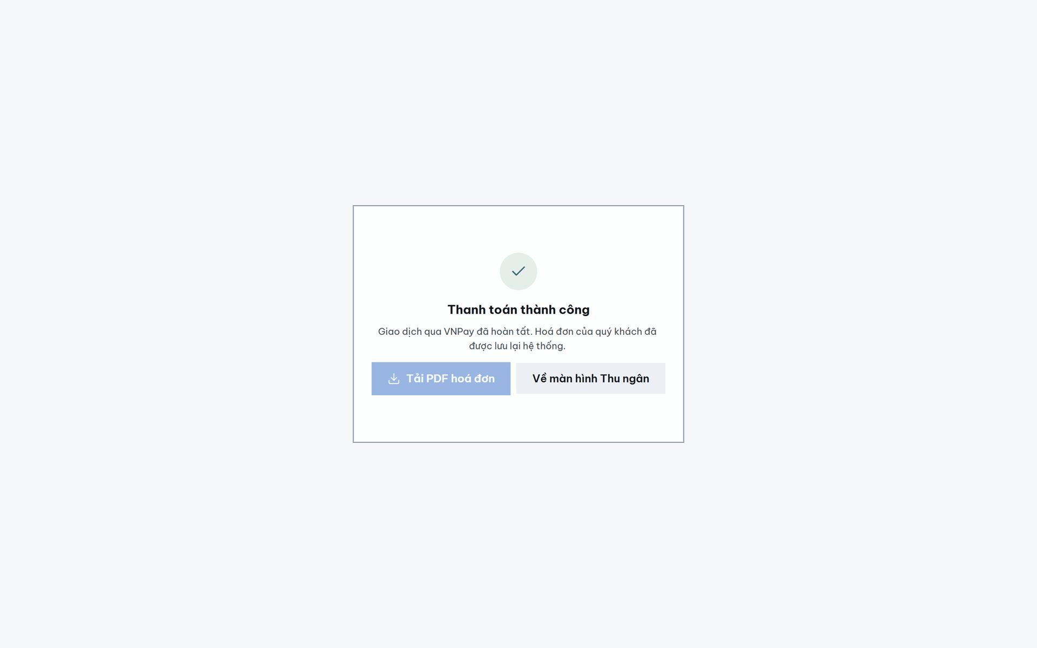

This screen allows the Cashier to:
- View Payment Confirmation: View a confirmation after being redirected back from a successful VNPay transaction.
- Download Invoice PDF: Download a PDF copy of the invoice.
- Return to Table Map: Navigate back to the Table Map screen.
Field Description
Field Name | Description
Mã hóa đơn | Displays the code of the generated invoice.
Tải PDF Hóa Đơn | A button that downloads a PDF copy of the invoice.
Về màn hình Thu Ngân | A button that navigates back to the Table Map screen.

3.2.10 VNPay Failed Payment Screen
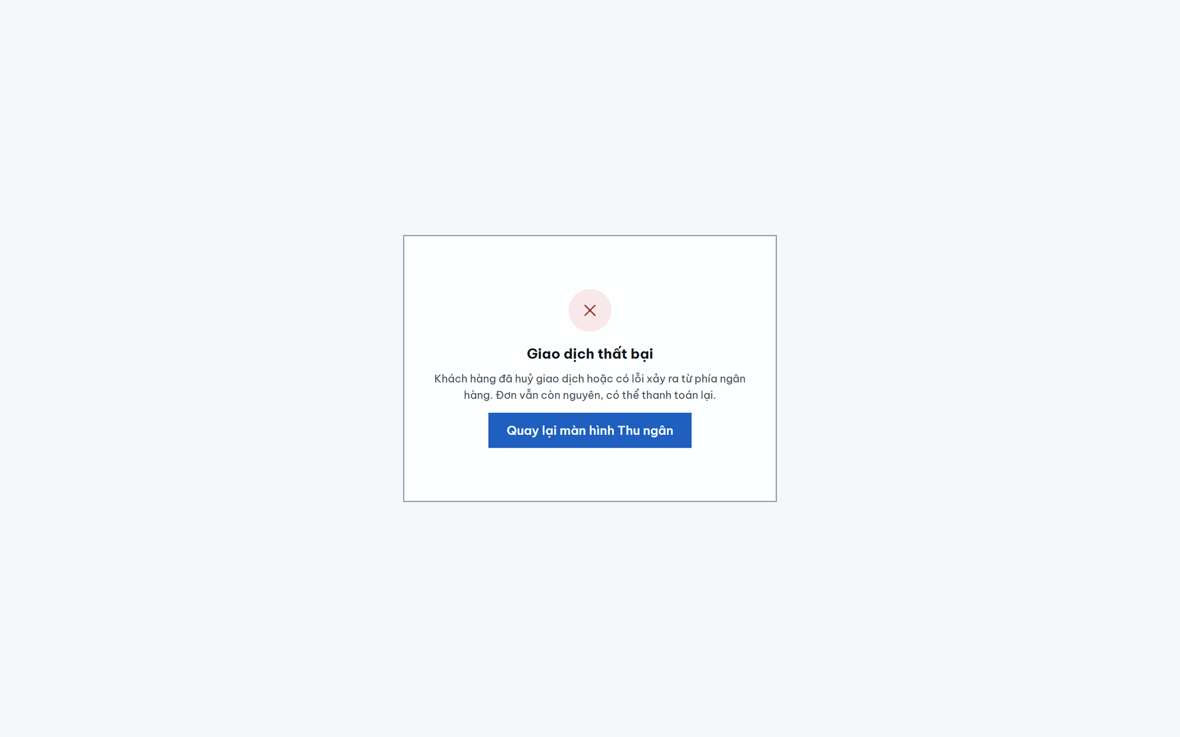
This screen allows the Cashier to:
- View Failure Notice: View a notice after being redirected back from a failed or cancelled VNPay transaction.
- Return to Table Map: Navigate back to the Table Map screen; the order is automatically unlocked and remains open for a retry.
Field Description
Field Name | Description
Quay lại màn hình Thu Ngân | A button that navigates back to the Table Map screen.

3.3 Invoice Management

3.3.1 Invoice List

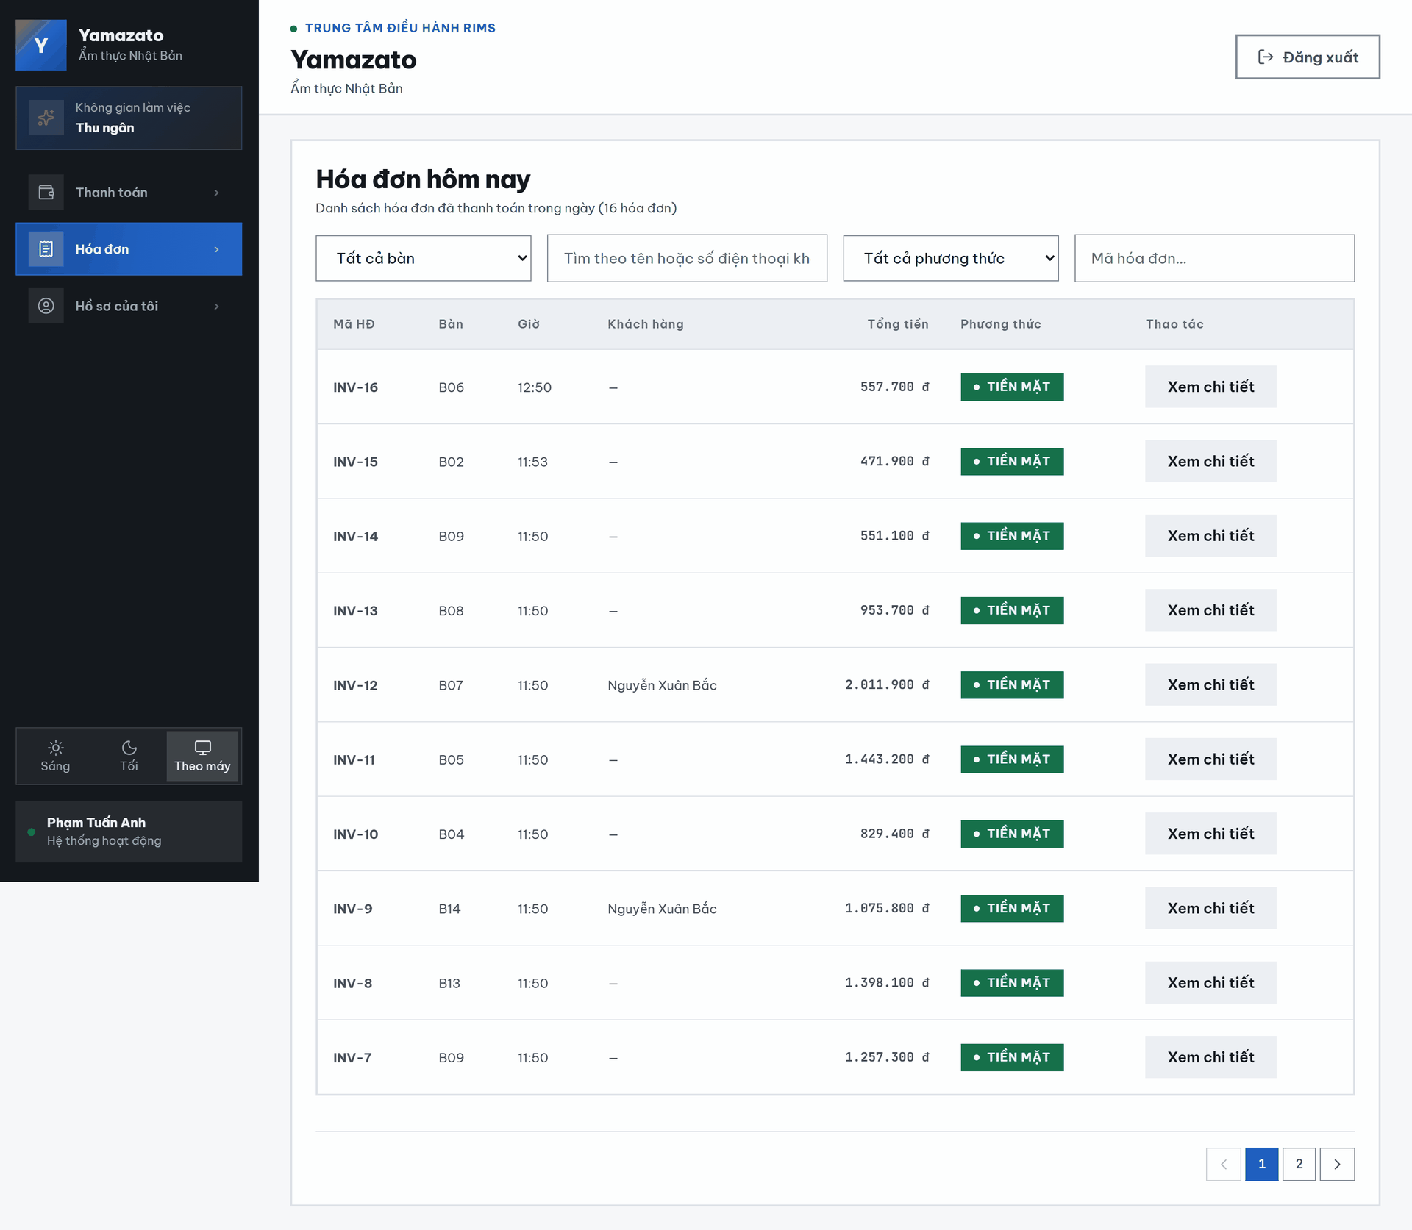
This screen allows the Cashier to:
- View Today's Invoices: View the list of every invoice paid today, sorted by time (newest first).
- Filter Invoices: Narrow the list by table, customer name/phone keyword, payment method, or invoice code.
- Paginate: Browse the list across multiple pages.
- Open Invoice Detail: Open the full detail of a specific invoice.
Field Description
Field Name | Description
Tất cả bàn | A dropdown to filter invoices by table number.
Tìm theo tên/SĐT khách hàng | A text input to filter invoices by customer name or phone keyword.
Tất cả phương thức | A dropdown to filter invoices by payment method (Tiền mặt / VNPay/QR).
Mã hóa đơn | A text input to filter invoices by invoice code.
MÃ HĐ | Displays the invoice code.
BÀN | Displays the table number the invoice belongs to.
GIỜ | Displays the time the invoice was created.
KHÁCH HÀNG | Displays the linked customer's name, or "—" if no customer is linked.
TỔNG TIỀN | Displays the final amount of the invoice.
PHƯƠNG THỨC | Displays the payment method used ("Tiền mặt" or "VNPay/QR").
Xem chi tiết | A button that opens the full detail view of the corresponding invoice.
← Trước / Sau → | Buttons to navigate between pages of the invoice list.

3.3.2 Invoice Detail

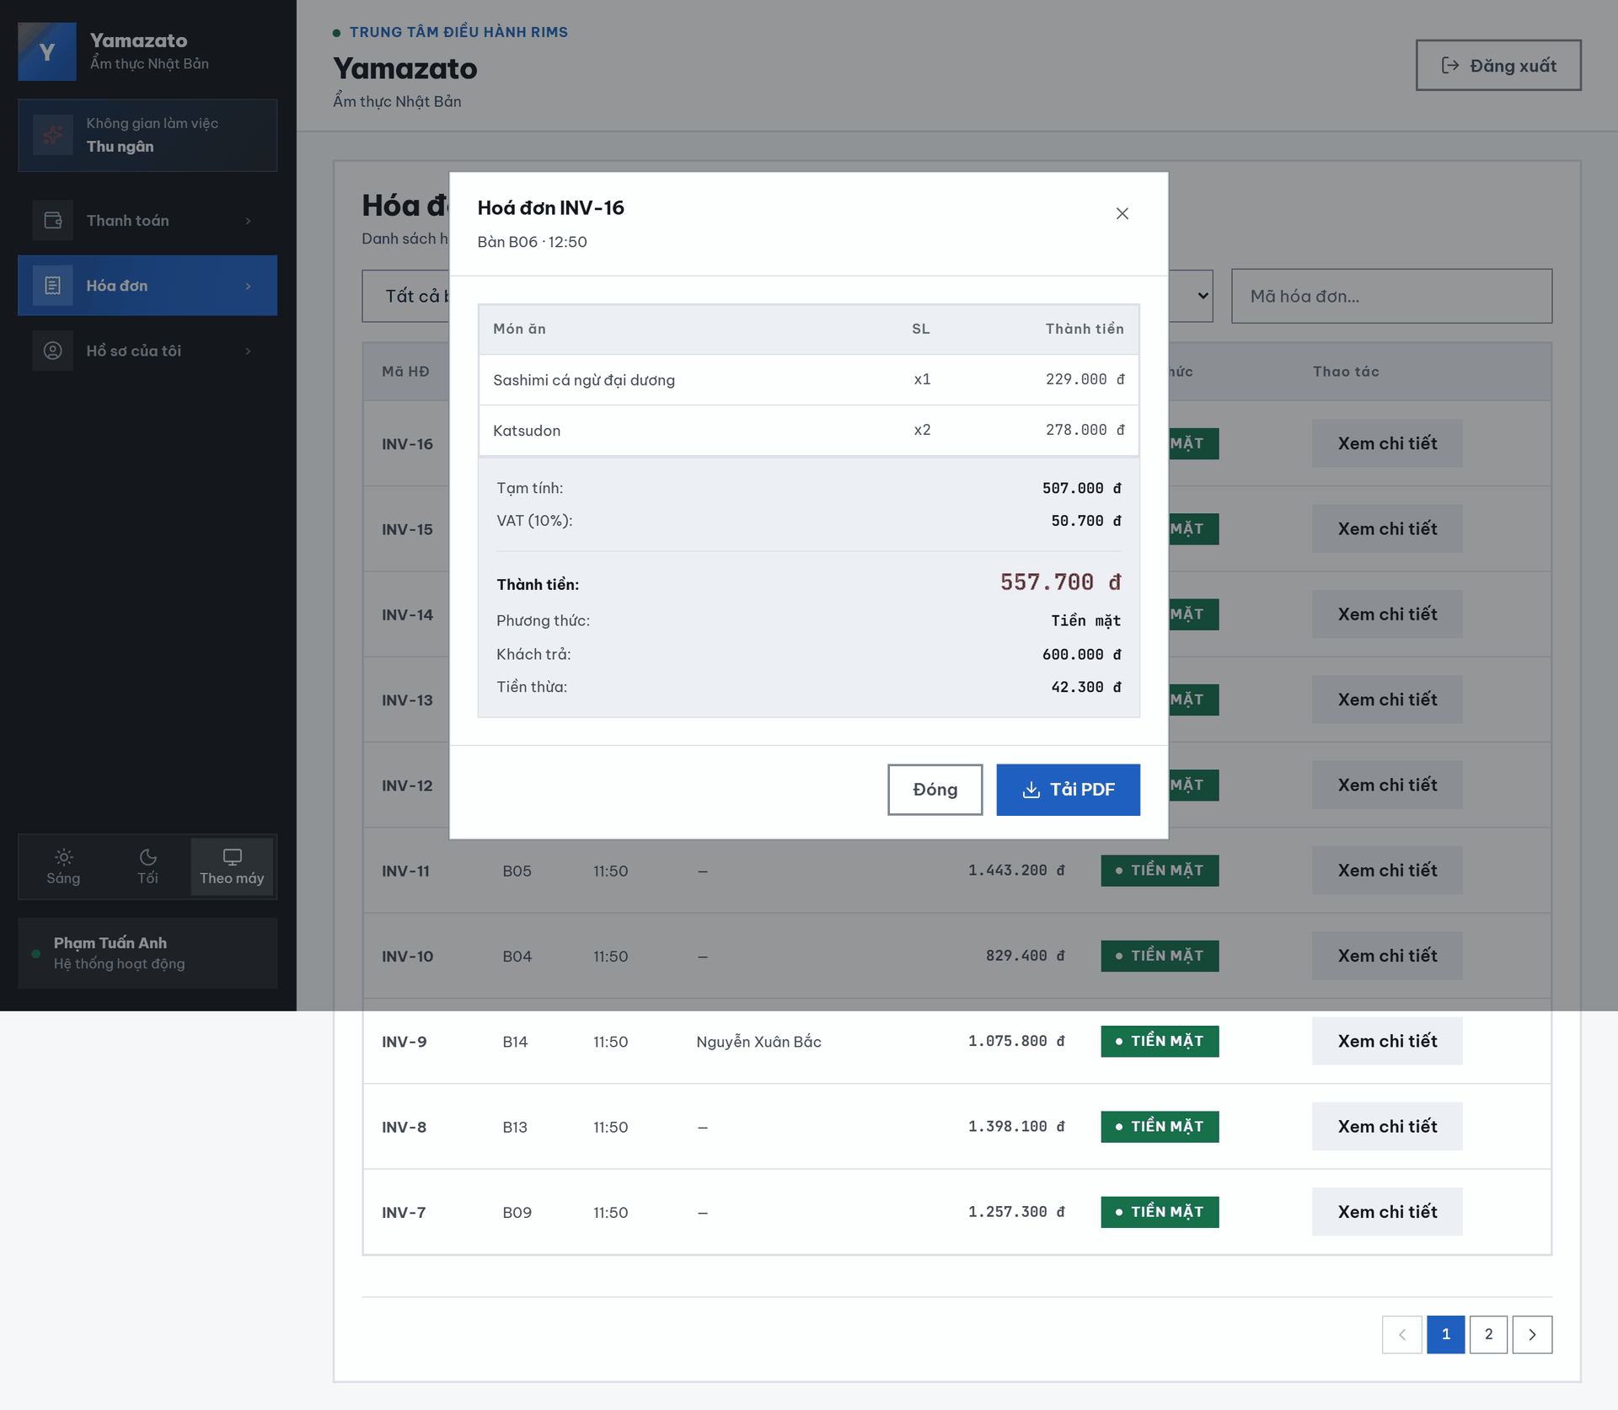

This screen allows the Cashier to:
- View Full Invoice Detail: View the itemized dish list, tax breakdown, loyalty details, and payment information for a specific invoice.
- Download Invoice PDF: Download a PDF copy of the invoice.
- Close: Close the detail view and return to the invoice list.
Field Description
Field Name | Description
Đóng (×) | A button that closes the detail view and returns to the invoice list.
Bàn / Giờ | Displays the table number and the time the invoice was created.
Danh sách món ăn (MÓN ĂN / SL / THÀNH TIỀN) | A read-only table listing each dish, quantity, and subtotal on the invoice.
Tạm tính | Displays the pre-tax subtotal of the invoice.
VAT (10%) | Displays the VAT amount, calculated as 10% of the pre-tax subtotal.
Khách hàng | (Only shown if a customer is linked) displays the linked customer's name.
Điểm đã dùng | (Only shown if points were redeemed) displays the discount amount from redeemed loyalty points.
Điểm tích thêm | (Only shown if a customer is linked) displays the loyalty points earned from this invoice.
THÀNH TIỀN | Displays the final amount of the invoice.
Phương thức | Displays the payment method used ("Tiền mặt" or "VNPay/QR").
Khách trả | (Only shown for Cash invoices) displays the amount of cash received from the customer.
Tiền thừa | (Only shown for Cash invoices) displays the change returned to the customer.
Tải PDF | A button that downloads a PDF copy of the invoice.
Đóng | A button that closes the detail view.

4. Chef

4.1 Chef Dashboard Screen

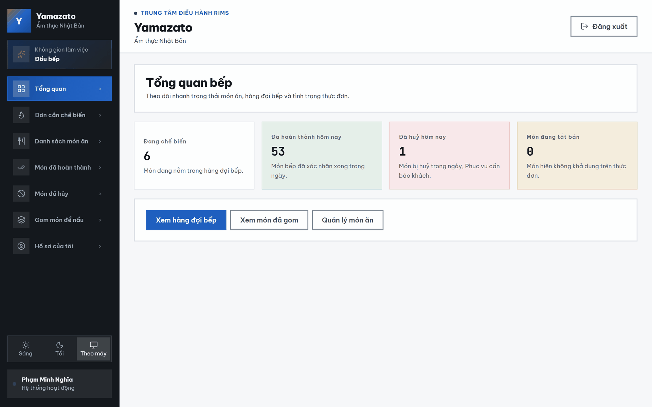

This screen allows the Chef to:

- View Kitchen Overview: Monitor the number of dishes currently being prepared, completed today, cancelled today, and unavailable on the menu.
- View Kitchen Queue: Click the Preparing card or the View Kitchen Queue button to open the list of dishes currently waiting to be prepared.
- View Completed Dishes: Click the Completed Today card to open the list of dishes completed during the current day.
- View Cancelled Dishes: Click the Cancelled Today card to open the list of dishes cancelled during the current day.
- View Unavailable Dishes: Click the Unavailable Dishes card to open the dish list and review dishes that are currently unavailable.
- View Grouped Dishes: Click the View Grouped Dishes button to open the list of dishes grouped together for preparation.
- Manage Dishes: Click the Manage Dishes button to open the dish list and update each dish’s availability status.

Field Description
Field Name | Description
Đang chế biến | A summary card displaying the total number of dishes currently in the PREPARING status and waiting in the kitchen queue. Click the card to open the Kitchen Queue screen.
Số lượng đang chế biến | Displays the total number of dishes currently waiting for or undergoing preparation.
Đã hoàn thành hôm nay | A summary card displaying the total number of dishes with the COMPLETED status recorded during the current day. Click the card to open the Completed Dishes screen.
Số lượng đã hoàn thành | Displays the total number of dishes confirmed as completed by the kitchen during the current day.
Đã hủy hôm nay | A summary card displaying the total number of dishes with the CANCELLED status recorded during the current day. Click the card to open the Cancelled Dishes screen.
Số lượng đã hủy | Displays the total number of dishes cancelled during the current day and requiring the Waiter to communicate with the customer.
Món đang tắt bán | A summary card displaying the total number of dishes currently unavailable on the menu. Click the card to open the Dish List screen.
Số lượng món đang tắt bán | Displays the total number of dishes where available = false.
Xem hàng đợi bếp | A navigation button that opens the Kitchen Queue screen, which displays dishes currently in the PREPARING status.
Xem món đã gom | A navigation button that opens the Grouped Kitchen Orders screen, where similar dishes are grouped to support efficient preparation.
Quản lí món ăn | A navigation button that opens the Dish List screen, allowing the Chef to change a dish’s status between available and unavailable.

4.2 Kitchen Queue Screen

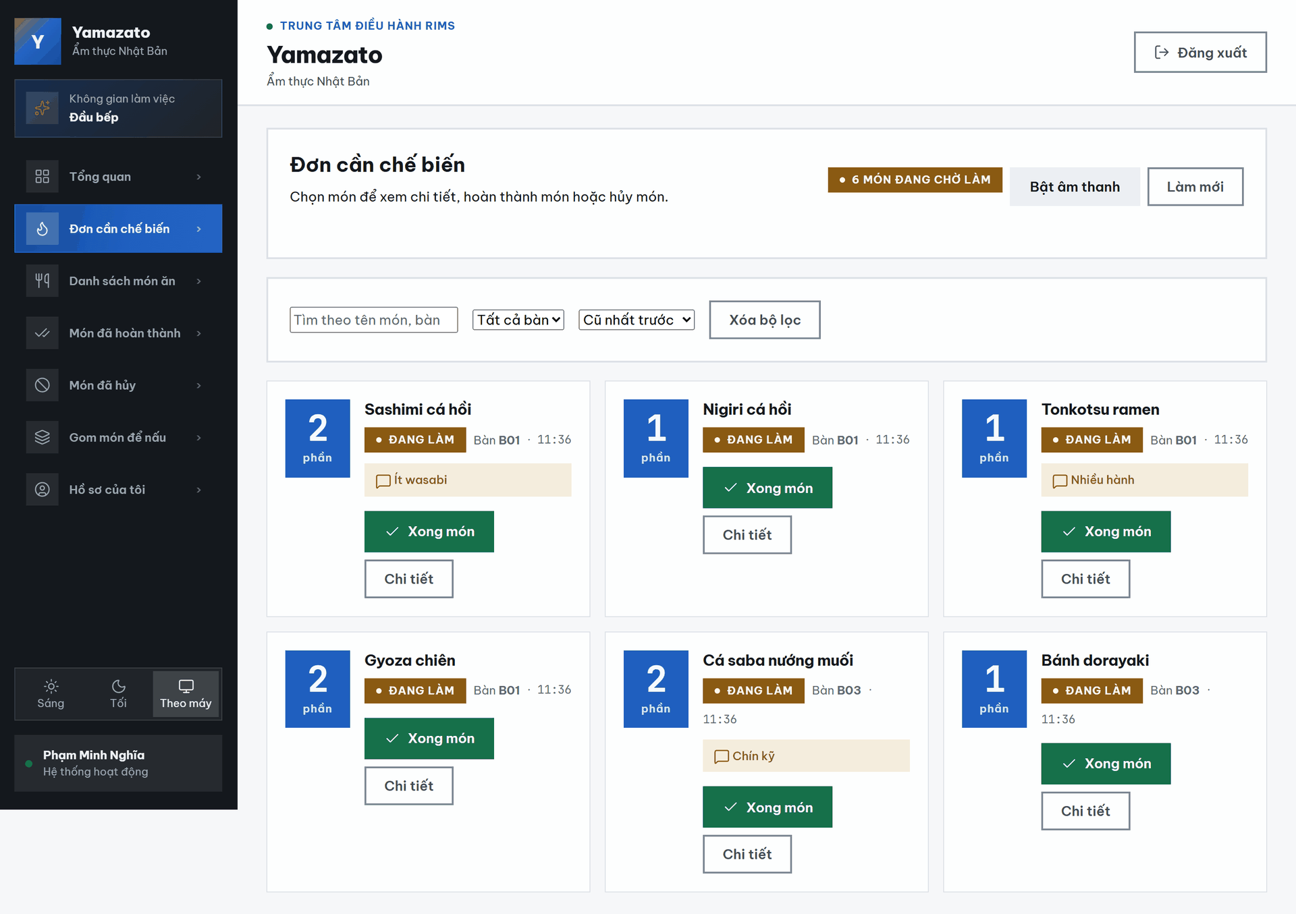
This screen allows the Chef to:
- View Preparing Orders: View all dishes currently in the PREPARING status, including the table number, order ID, order item ID, dish name, quantity, and creation time.
- View Pending Dish Count: View the total number of dishes currently waiting to be prepared.
- Search Orders: Search for a dish by dish name, table number, order ID, or order item ID.
- Filter by Table: Select a specific table to display only the dishes ordered by that table.
- Sort Orders: Sort the kitchen queue by the oldest or newest order first.
- Clear Filters: Reset the search keyword, table filter, and sorting option to their default values.
- View Dish Details: Click a dish card to open its detailed information, including the dish description, customer note, quantity, preparation status, and internal Chef note.
- Complete a Dish: Click the Complete Dish button to confirm that the selected dish has finished preparation.
- Enable New-Order Sound: Click the Enable Sound button to receive an audio notification when a new dish is added to the kitchen queue.
- Refresh the Queue: Click the Refresh button to manually retrieve the latest preparing orders.
- Receive Real-Time Updates: The kitchen queue is automatically refreshed when the system receives a kitchen update through WebSocket.
- Navigate Between Pages: Use the pagination controls to browse the queue when the number of dishes exceeds the number displayed on one page.

Field Description

Field Name | Description
Số món đang chờ | Displays the total number of dishes currently waiting in the kitchen queue.
Bật âm thanh | Enables audio notifications for newly received dishes. The browser may require the Chef to activate this feature manually before sound can be played.
Làm mới | Manually reloads the latest preparing-order data from the system.
Thanh tìm kiếm | Allows the Chef to search by dish name, table number, order ID, or order item ID.
Bộ lọc bàn | A drop-down list used to display dishes belonging to a selected table. The default option displays dishes from all tables.
Thứ tự sắp xếp | A drop-down list used to arrange dishes by creation time. Available options include Oldest First and Newest First.
Xóa bộ lọc | Clears the current search keyword and resets the table and sorting filters to their default values.
Số bàn | Displays the restaurant table associated with the order, such as T08 or T03.
Mã đơn hàng | Displays the identifier of the order containing the dish, such as Order #3001.
Mã món trong đơn | Displays the unique identifier of the individual dish in the order, such as Item #8914.
Thời gian tạo | Displays the time when the dish was added to the order and sent to the kitchen queue.
Nhãn trạng thái | Displays the dish’s current kitchen status. A dish shown on this screen has the PREPARING status.
Tên món | Displays the snapshot name of the dish at the time the order was created.
Số lượng | Displays the number of portions requested for the dish, such as x1 or x2.
Thẻ món | A selectable card containing the dish’s kitchen information. Clicking the card opens the Dish Details window.
Xong món | Confirms that the dish has finished preparation and changes its status from PREPARING to COMPLETED.
Chuyển trang | Allow the Chef to move between pages when more dishes exist than can be displayed on one page.

4.3 Preparing Dish Details Pop-up
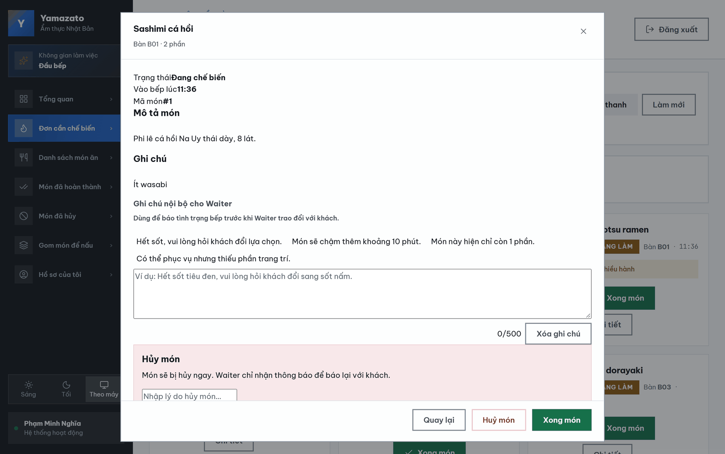
This screen allows the Chef to:
- View Dish Information: View the table number, order item ID, dish name, quantity, current status, and the time when the dish was sent to the kitchen.
- View Dish Description: View the description of the dish stored in the menu.
- View Customer Notes: View special requests or notes submitted with the dish. If no note is available, the system displays No notes.
- Add an Internal Note for the Waiter: Enter information about the dish or kitchen situation so that the Waiter can communicate with the customer.
- Use Quick Notes: Select one of the predefined messages to quickly fill in the internal note field.
- Update an Internal Note: Edit and resend the current internal note to the Waiter.
- Delete an Internal Note: Remove the saved internal note when it is no longer required.
- Track Note Status: Check whether the Waiter has viewed the internal note or whether it is still waiting to be acknowledged.
- Cancel the Dish: Enter a cancellation reason and click Cancel Dish to cancel the selected dish. The dish is cancelled immediately, and the Waiter receives a notification to communicate with the customer.
- Complete the Dish: Click Complete Dish to confirm that preparation is finished and move the dish to the completed-dish list.
- Close the Window: Click Back, the × icon, or the area outside the modal window to close the dish details screen.
Field Description

Field Name | Description
Bàn | Displays the restaurant table associated with the order containing the dish, such as T08.
Mã item | Displays the unique identifier of the dish within the order, such as #8914.
Tên món | Displays the snapshot name of the dish saved when the order was created.
Số lượng | Displays the number of portions ordered by the customer, such as x1 or x2.
Trạng thái | Displays the dish’s current status. The dish can be processed on this screen only when its status is PREPARING.
Thời gian | Displays the time when the dish was created and sent to the kitchen queue.
Mô tả món | Displays the dish description stored in the menu. If no description is available, the system displays No description.
Ghi chú | Displays special instructions or notes submitted by the customer. If no note is available, the system displays No notes.
Trạng thái ghi chú nội bộ | Displays Waiting for Waiter if the note has not been acknowledged or Viewed by Waiter if the Waiter has viewed it.
Ghi chú nhanh | Predefined message buttons that allow the Chef to quickly select commonly used updates about the dish or kitchen situation.
Ô ghi chú nội bộ | Allows the Chef to enter or edit an internal note for the Waiter. The maximum length is 500 characters.
Bộ đếm ký tự ghi chú | Displays the number of entered characters out of the 500-character limit, such as 0/500.
Gửi cho Waiter | Saves the internal note and sends an update notification to the Waiter interface.
Xóa ghi chú | Removes the current internal note and clears its creation and acknowledgement information.
Lý do hủy món | A required text field used to explain why the selected dish is being cancelled. The maximum length is 500 characters.
Bộ đếm lý do hủy | Displays the number of characters entered in the cancellation reason field out of the 500-character limit.
Quay lại | Closes the details window and returns to the Kitchen Queue without changing the dish status.
Hủy món | Changes the selected dish’s status from PREPARING to CANCELLED, saves the cancellation reason, and notifies the Waiter.
Xong món | Confirms that the dish has been prepared and changes its status from PREPARING to COMPLETED.
Nút đóng (×) | Closes the Preparing Dish Details window.

4.4 Dish List Screen

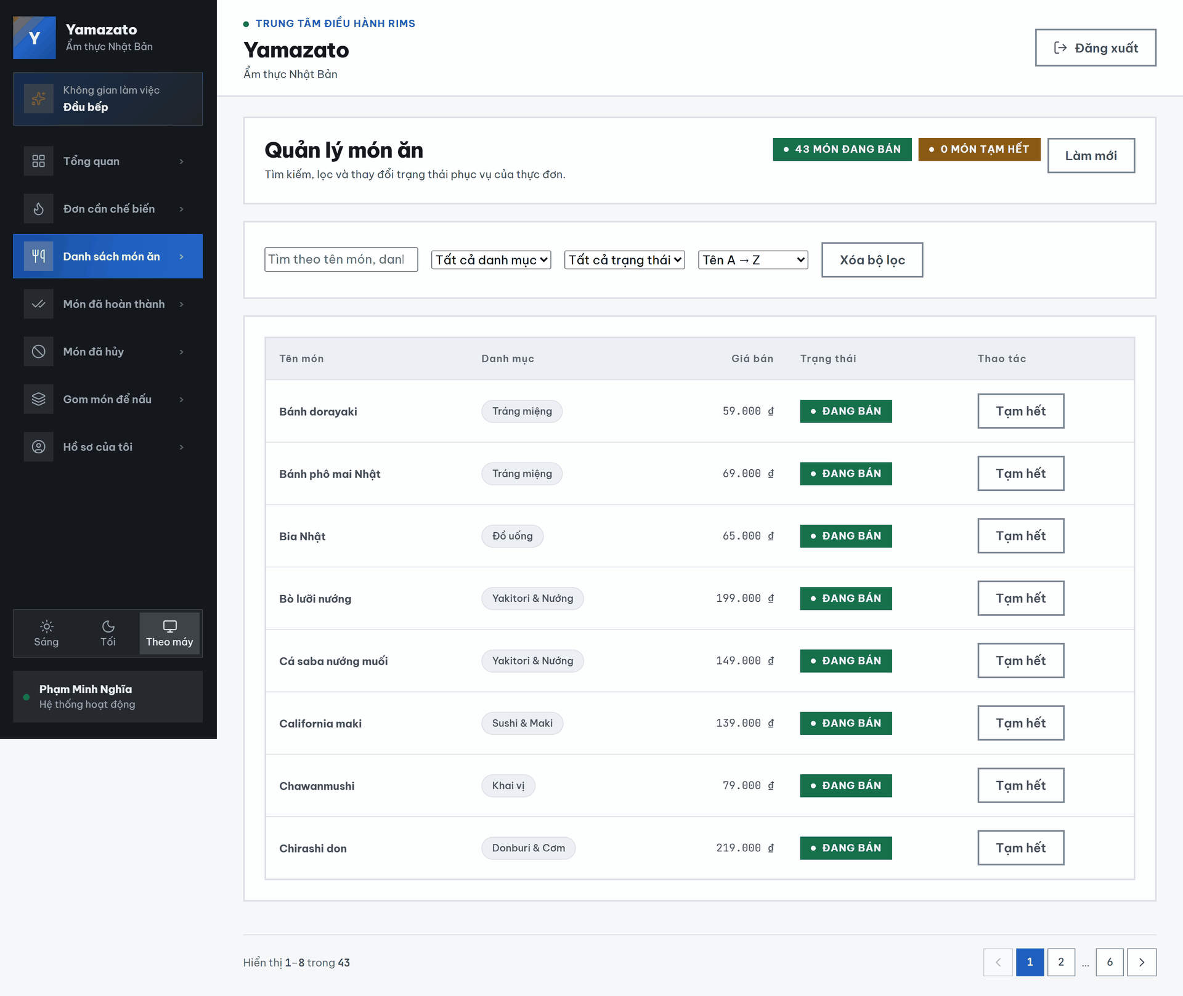

This screen allows the Chef to:
- View Dish List: View all visible dishes in the menu, including the dish name, category, selling price, availability status, and available action.
- View Availability Summary: View the total number of dishes currently available and temporarily unavailable.
- Search for Dishes: Search by dish name, category, or dish ID.
- Filter by Category: Select a category to display only dishes belonging to that category.
- Filter by Status: Display all dishes, available dishes, or temporarily unavailable dishes.
- Sort the Dish List: Sort dishes by name from A to Z, name from Z to A, price from low to high, or price from high to low.
- Clear Filters: Reset the search keyword, category filter, status filter, and sorting option to their default values.
- Mark a Dish as Unavailable: Click Mark Unavailable to stop the selected dish from being sold.
- Reopen a Dish for Sale: Click Open for Sale to make a temporarily unavailable dish available again.
- Refresh the Dish List: Click Refresh to retrieve the latest menu data from the system.
- Receive Real-Time Updates: The dish list is automatically refreshed when the system receives a kitchen update through WebSocket.
- Navigate Between Pages: Use the pagination controls to browse the dish list when the number of dishes exceeds eight items per page.
Field Description

Field Name | Description
Số món đang bán | Displays the total number of dishes currently available for sale.
Số món tạm hết | Displays the total number of dishes currently marked as temporarily unavailable.
Làm mới | Reloads the latest dish and availability information from the system.
Thanh tìm kiếm | Allows the Chef to search by dish name, category, or dish ID.
Bộ lọc danh mục | A drop-down list used to display dishes belonging to a selected category. The default option displays dishes from all categories.
Bộ lọc trạng thái | A drop-down list used to display all dishes, available dishes, or temporarily unavailable dishes.
Thứ tự sắp xếp | A drop-down list used to sort dishes by name or selling price. The available options are Name A–Z, Name Z–A, Price Low to High, and Price High to Low.
Xóa bộ lọc | Clears the search keyword and resets all filters and sorting options to their default values.
Tên món | Displays the name of the dish in the menu.
Danh mục | Displays the menu category to which the dish belongs, such as Khai vị or Tráng miệng.
Giá bán | Displays the dish’s current selling price in Vietnamese đồng, such as 59,000 ₫.
Trạng thái | Displays whether the dish is currently Available or Temporarily Unavailable.
Tạm hết | Changes an available dish to temporarily unavailable. The system requests confirmation before performing this action.
Mở bán | Changes a temporarily unavailable dish back to available for ordering.
Đang cập nhật | Temporarily replaces the action button text while the system is processing an availability update.
Thông tin kết quả | Displays the currently visible dish range and the total number of dishes matching the selected filters.
Trang trước | Moves to the previous page of the filtered dish list. It is disabled on the first page.
Số trang | Opens the selected page of the dish list. The active page is visually highlighted.
Trang sau | Moves to the next page of the filtered dish list. It is disabled on the final page.

4.5 Today Completed Dishes Screen

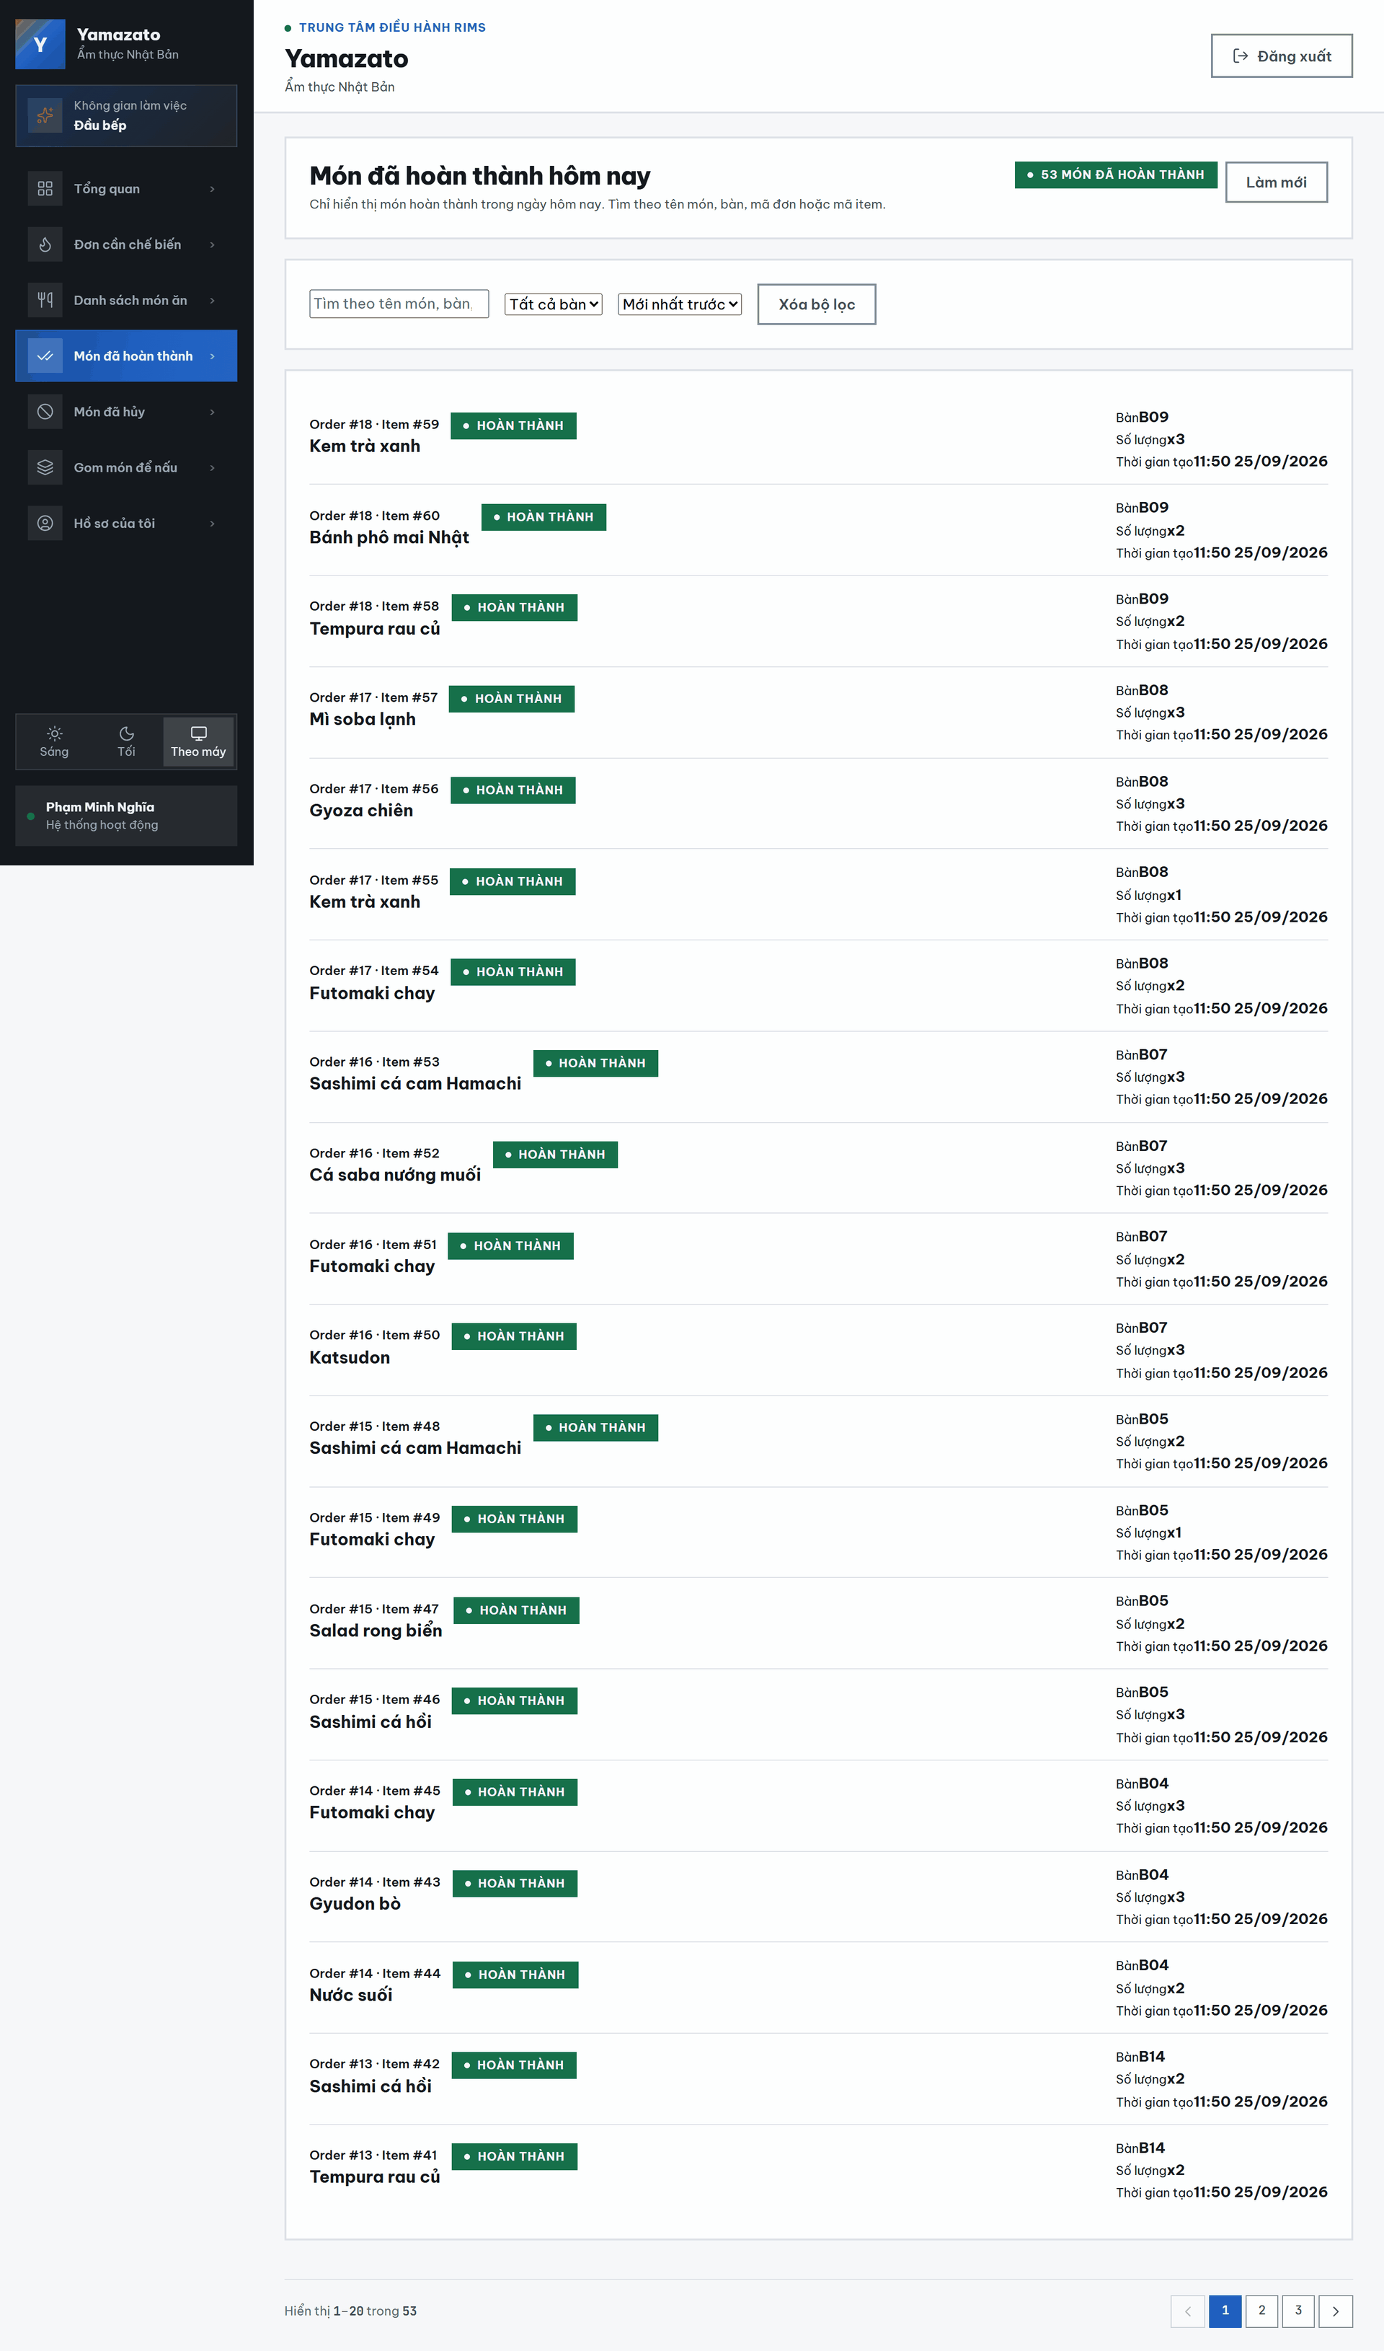

This screen allows the Chef to:
- View Completed Dishes: View dishes with the COMPLETED status recorded by the system during the current day.
- View the Completed Dish Count: Monitor the total number of dishes completed today.
- Search for Dishes: Search by dish name, table number, order ID, or order item ID.
- Filter by Table: Select a specific table to display only completed dishes belonging to that table.
- Sort the List: Sort completed dishes by newest first or oldest first.
- Clear Filters: Clear the search keyword and reset the table filter and sorting option to their default values.
- Refresh the List: Click Refresh to retrieve the latest completed-dish data.
- Receive Real-Time Updates: The list is automatically updated when the system receives a kitchen update through WebSocket.
- Navigate Between Pages: Use the pagination controls when the number of completed dishes exceeds 20 items per page.

Field Name | Description
Số món đã hoàn thành hôm nay | Displays the total number of completed dishes returned by the system for the current day.
Làm mới | Reloads the latest completed-dish list and returns the user to the first page.
Thanh tìm kiếm | Allows the Chef to search by dish name, table number, order ID, or order item ID.
Bộ lọc bàn | A drop-down list used to display completed dishes from a specific table. The default option displays dishes from all tables.
Thứ tự sắp xếp | Allows the Chef to sort the list by Newest First or Oldest First, based on the dish creation time.
Xóa bộ lọc | Clears the search keyword and resets the table filter and sort order to their default values.
Mã đơn hàng | Displays the identifier of the order containing the dish, such as Order #3007.
Mã item | Displays the unique identifier of the dish within the order, such as Item #8930.
Tên món | Displays the snapshot name of the dish saved when the order was created.
Nhãn trạng thái | Displays Completed, corresponding to the COMPLETED status.
Bàn | Displays the table number associated with the order, such as T02 or T07.
Số lượng | Displays the number of completed portions, such as x2.
Thời gian tạo | Displays the date and time when the dish was created and sent to the system.
Thẻ món đã hoàn thành | Displays the order ID, item ID, dish name, table number, quantity, creation time, and completion status of each dish.
Thông tin kết quả | Displays the currently visible item range and the total number of dishes matching the current search and filter conditions.
Trang trước | Moves to the previous page of the list. The button is disabled on the first page.
Số trang | Opens a specific page directly. The current page is visually highlighted.
Trang sau | Moves to the next page of the list. The button is disabled on the final page.

4.6 Today Cancelled Dishes Screen

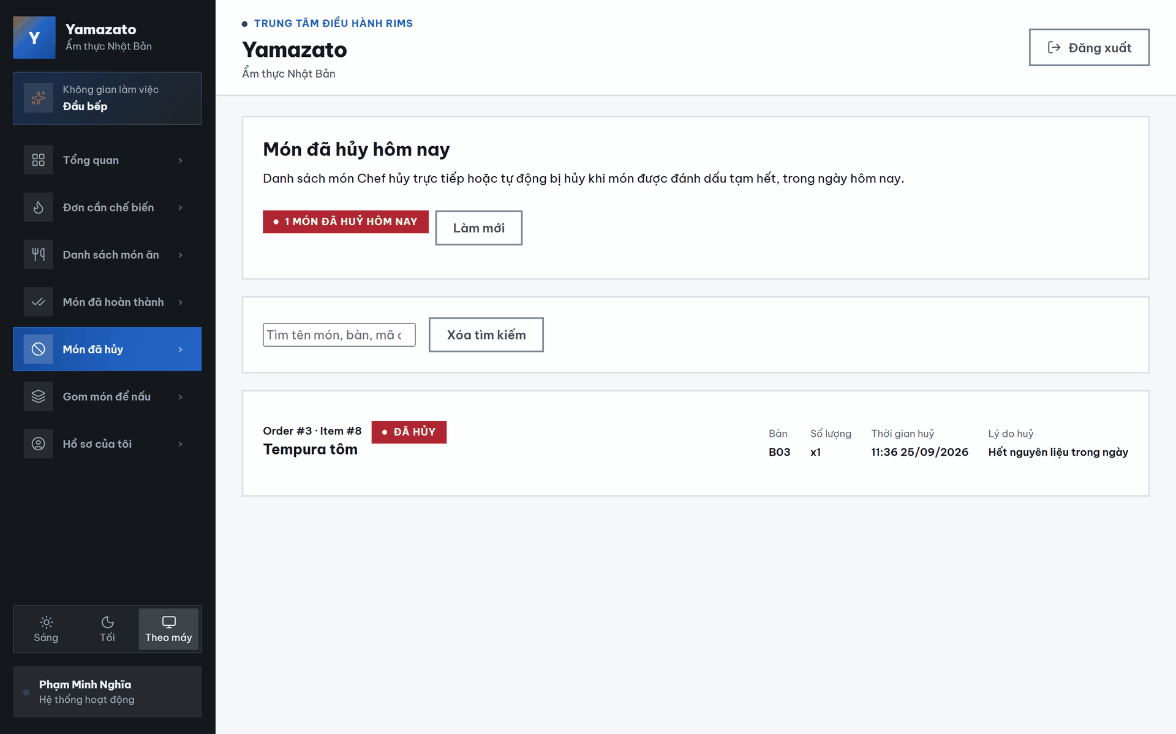

This screen allows the Chef to:
- View Cancelled Dishes: View dishes cancelled directly by the Chef or automatically cancelled when the corresponding menu item was marked as temporarily unavailable.
- View the Cancelled Dish Count: View the total number of cancelled dishes returned for the current day.
- Search Cancelled Dishes: Search by dish name, table number, order ID, order item ID, or cancellation reason.
- Clear Search: Remove the current search keyword and display the complete cancelled-dish list again.
- View Cancellation Information: View the order ID, item ID, dish name, table number, quantity, cancellation time, and cancellation reason.
- Refresh the List: Click Refresh to retrieve the latest cancelled-dish data from the system.
- View the Latest Cancellations First: The system sorts dishes by cancellation time, with the most recently cancelled dishes displayed first.
- Navigate Between Pages: Use the pagination controls when the number of cancelled dishes exceeds 20 items per page.

Field Name | Description
Tổng số món đã hủy hôm nay | Displays the total number of cancelled dishes returned by the system for the current day.
Refresh | Reloads the latest cancelled-dish list from the system.
Thanh tìm kiếm | Allows the Chef to search by dish name, table number, order ID, order item ID, or cancellation reason.
Xóa tìm kiếm | Clears the current search keyword and returns the list to the first page.
Mã đơn hàng | Displays the identifier of the order containing the cancelled dish, such as Order #2992.
Mã item | Displays the unique identifier of the cancelled dish within the order, such as Item #8889.
Tên món | Displays the snapshot name of the dish saved when the order was created.
Nhãn trạng thái | Displays Cancelled, corresponding to the CANCELLED status.
Bàn | Displays the table number associated with the order, such as T12.
Số lượng | Displays the number of cancelled portions, such as x3.
Thời gian hủy | Displays the date and time when the dish was cancelled. If no cancellation time is available, the system displays a dash (—).
Lý do hủy | Displays the reason entered by the Chef or generated automatically by the system. If no reason is available, the system displays No reason provided.
Thẻ món đã hủy | Displays the order ID, item ID, dish name, table number, quantity, cancellation time, cancellation reason, and status of each cancelled dish.
Thông tin kết quả | Displays the currently visible item range and the total number of dishes matching the search keyword.
Trang trước | Moves to the previous page of the list. The button is disabled on the first page.
Số trang | Opens a specific page directly. The current page is visually highlighted.
Trang sau | Moves to the next page of the list. The button is disabled on the final page.

4.7 Grouped Dishes Screen
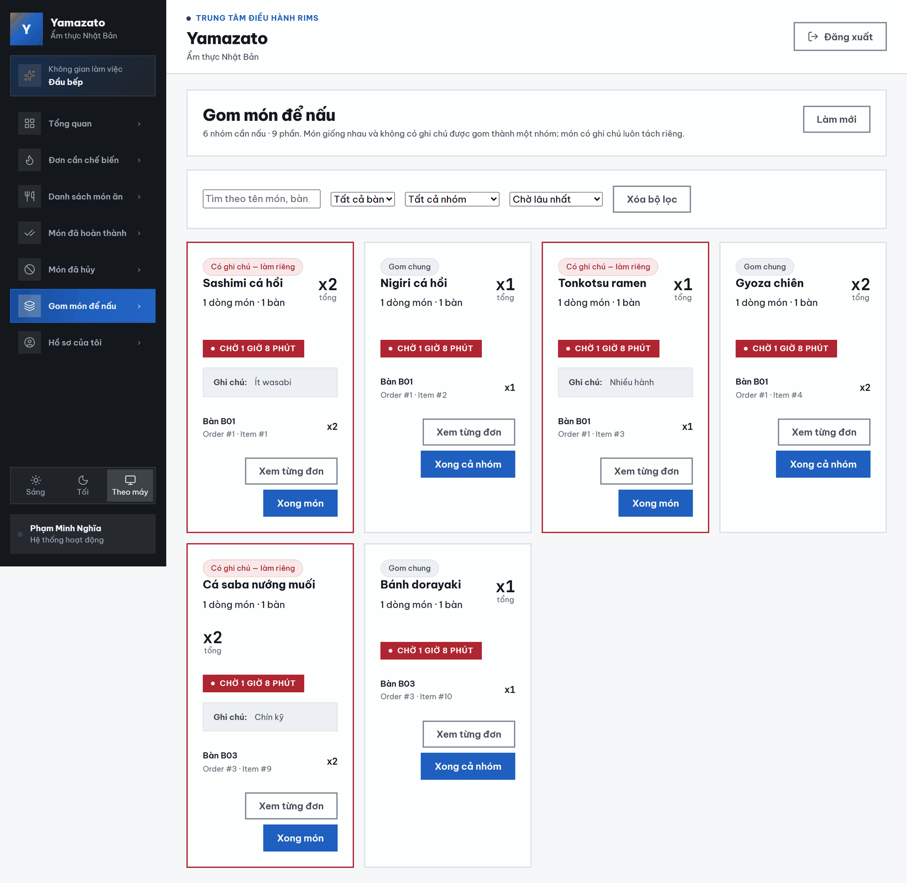

This screen allows the Chef to:
- View Grouped Dishes: View dishes grouped together to support more efficient kitchen preparation.
- View Group Summary: View the total number of groups that need to be prepared and the total number of portions across all groups.
- Search for Groups: Search by dish name, table number, order ID, order item ID, or customer note.
- Filter by Table: Select a table to display groups containing dishes ordered by that table.
- Filter by Group Type: Display all groups, dishes that can be cooked together, or dishes containing special notes.
- Sort Groups: Sort groups by longest waiting time, newest first, or highest total quantity.
- Clear Filters: Reset the search keyword, table filter, group-type filter, and sorting option to their default values.
- View Group Information: View the dish name, number of order items, number of tables, total quantity, waiting time, and the individual orders included in each group.
- View Customer Notes: View the note attached to a dish that must be prepared separately.
- View Individual Orders: Click View Individual Orders to open the Kitchen Queue and review each order item separately.
- Complete an Entire Group: Click Complete Whole Group to confirm that all dishes in a group without notes have been prepared.
- Complete a Separate Dish: Click Complete Dish to complete a dish that has a special note and must be prepared separately.
- Refresh the List: Click Refresh to retrieve the latest grouped-dish data.
- Receive Real-Time Updates: The grouped-dish list is automatically refreshed when the system receives a kitchen update through WebSocket.
- Navigate Between Pages: Use the pagination controls when the number of groups exceeds six groups per page.

Field Name | Description
Số nhóm cần nấu | Displays the total number of dish groups currently waiting to be prepared.
Tổng số phần | Displays the combined quantity of all portions in the grouped-dish list.
Làm mới | Reloads the latest grouped-dish data and returns the Chef to the first page.
Thanh tìm kiếm | Allows the Chef to search by dish name, table number, order ID, order item ID, or customer note.
Bộ lọc bàn | A drop-down list used to display groups containing dishes from a selected table. The default option displays groups from all tables.
Bộ lọc loại nhóm | A drop-down list used to display all groups, groups that can be cooked together, or dishes containing notes.
Thứ tự sắp xếp | A drop-down list used to sort groups by Longest Waiting, Newest, or Highest Quantity.
Xóa bộ lọc | Clears the current search keyword and resets all filters and sorting options to their default values.
Nhãn Gom chung | Indicates that the displayed order items have the same dish and no customer note, allowing them to be cooked together.
Nhãn Có ghi chú – Làm riêng | Indicates that the dish contains a customer note and must be prepared as a separate group.
Tên món | Displays the name of the dish represented by the group.
Số món trong đơn | Displays the number of individual order items included in the group.
Số bàn | Displays the number of different restaurant tables represented in the group.
Tổng số lượng | Displays the combined number of portions included in the group, such as x2.
Thời gian chờ | Displays the number of minutes since the earliest order item in the group was created.
Ghi chú của khách | Displays the customer’s special request when the dish has been separated because of a note.
Số bàn của từng món | Displays the table associated with an individual order item, such as T08.
Mã đơn hàng | Displays the identifier of the order containing the dish, such as Order #3001.
Mã item | Displays the unique identifier of the dish within the order, such as Item #8914.
Số lượng từng món | Displays the quantity contributed by an individual order item to the group.
Xem từng đơn | Opens the Kitchen Queue screen so the Chef can review each order item separately.
Xong cả nhóm | Changes every order item in a grouped batch from PREPARING to COMPLETED.
Xong món | Completes a separate group containing a single dish with a customer note.
Đang cập nhật | Temporarily replaces the completion button text while the system is processing the request.
Thông tin kết quả | Displays the currently visible group range and the total number of groups matching the selected filters.
Trang trước | Moves to the previous page. The button is disabled on the first page.
Số trang | Opens a selected page directly. The current page is visually highlighted.
Trang sau | Moves to the next page. The button is disabled on the final page.

5. Customer

5.1. Customer Profile Screen
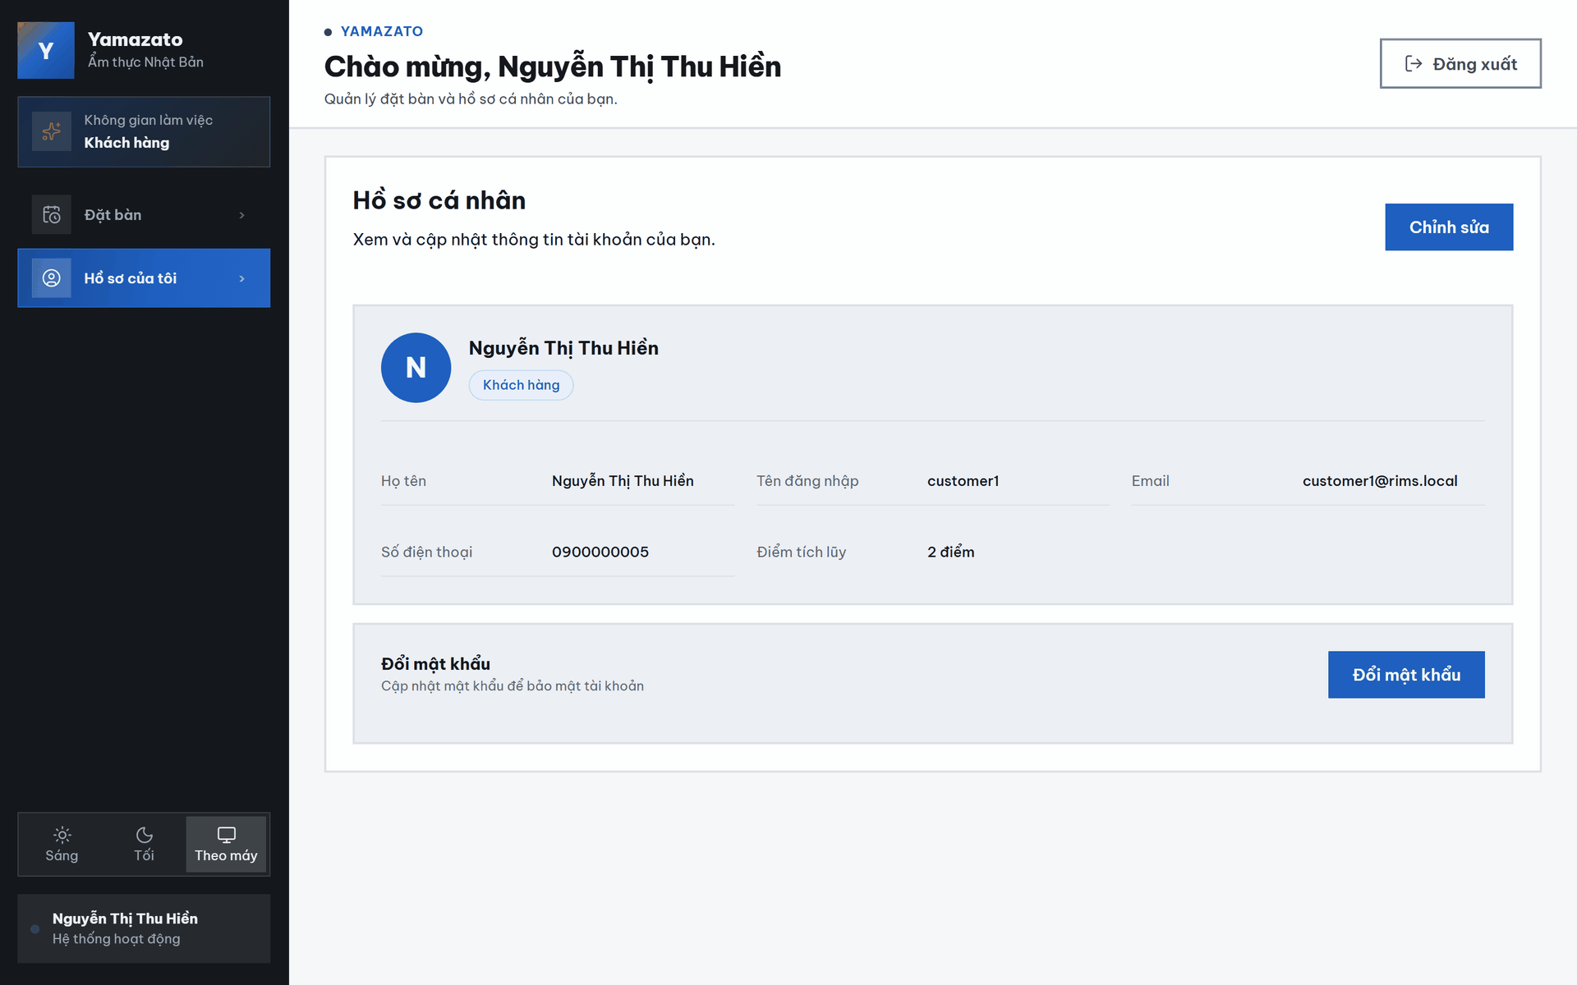
This screen allows the Customer to:
- View Personal Information: Review the full name, username, email address, phone number, account role, and accumulated loyalty points.
- Edit Personal Information: Click “Chỉnh sửa” to update the Customer’s personal information.
- View Loyalty Points: Check the number of points accumulated through restaurant transactions or loyalty activities.
- Change the Account Password: Click “Đổi mật khẩu” to open the password-change form and improve account security.

Field Name | Description
Hồ sơ cá nhân | Displays the title of the Customer’s personal profile screen.
Chỉnh sửa | Opens the profile-editing form so the Customer can update their personal information.
N | Displays the first letter of the Customer’s name as the profile avatar.
Nguyễn Thị Thu Hiền | Displays the Customer’s full name in the profile summary.
Khách hàng | Displays the role assigned to the current account.
Họ tên | Displays the Customer’s full name.
Username | Displays the username used by the Customer to log in to the system.
Email | Displays the email address associated with the Customer account.
Số điện thoại | Displays the phone number associated with the Customer account.
Điểm tích lũy | Displays the Customer’s current loyalty-point balance. The current value shown is 0 điểm.
Đổi mật khẩu | Opens the password-change form so the Customer can update the current account password.

5.2. Password Change Screen
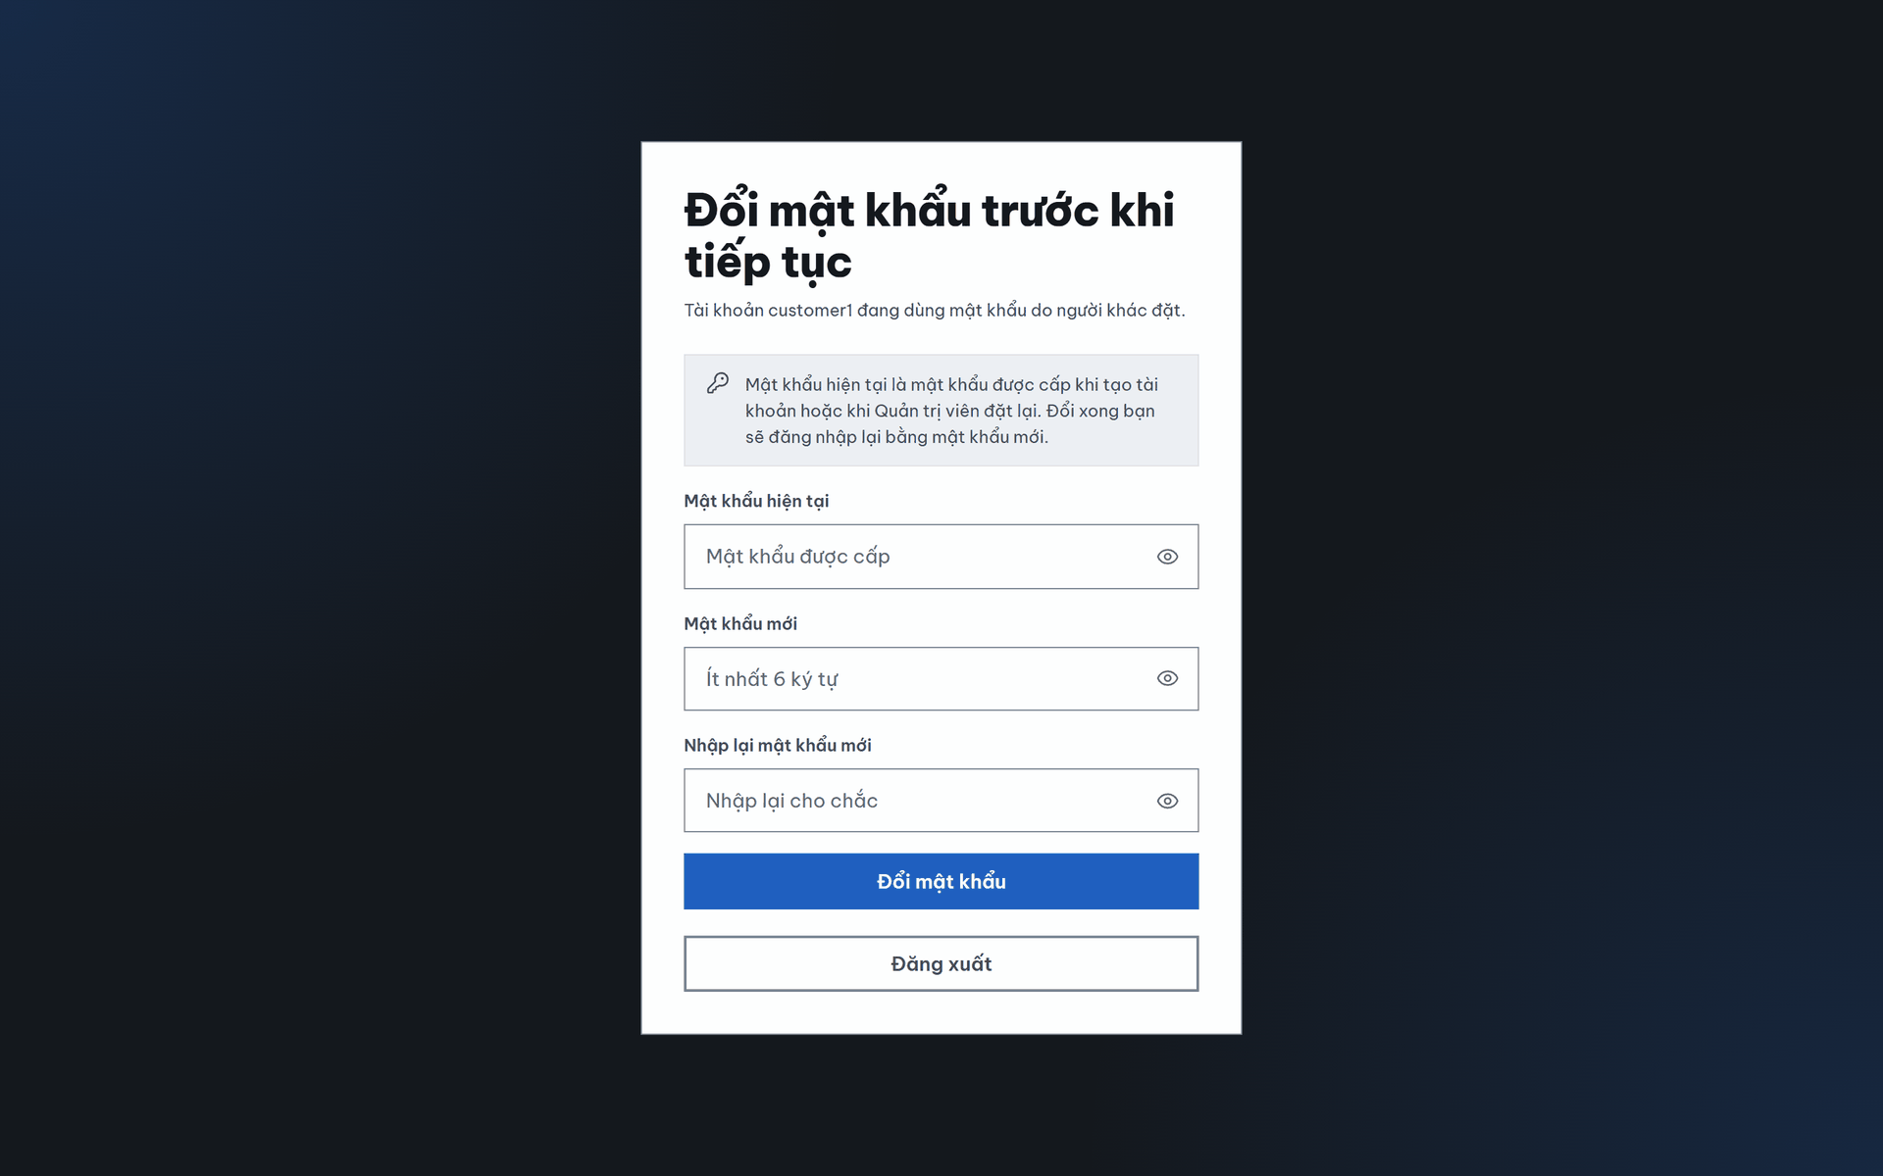

This screen allows the Customer to:
- Enter the Current Password: Provide the account’s existing password for identity verification.
- Enter a New Password: Create a new password containing at least six characters.
- Confirm the New Password: Re-enter the new password to ensure both entries match.
- Show or Hide Passwords: Click the eye icon to display or conceal the characters entered in each password field.
- Cancel the Password Change: Click “Hủy” to close the form without changing the password.
- Confirm the Password Change: Click “Xác nhận đổi mật khẩu” to submit the entered information and update the account password.

Field Name | Description
Mật khẩu hiện tại * | Allows the Customer to enter the password currently used for the account. The entered characters are hidden by default. This field is required.
Mật khẩu mới * | Allows the Customer to enter the new account password. The placeholder displays “Tối thiểu 6 ký tự”, indicating that the password must contain at least six characters. This field is required.
Xác nhận mật khẩu mới * | Allows the Customer to re-enter the new password. The placeholder displays “Nhập lại mật khẩu mới”. The value must match the password entered in “Mật khẩu mới”. This field is required.
Xác nhận đổi mật khẩu | Validates the current password and the two new-password entries, then updates the account password when all information is valid.
Hủy | Cancels the password-change process and closes the form without saving any changes.

5.3. Profile Update Screen
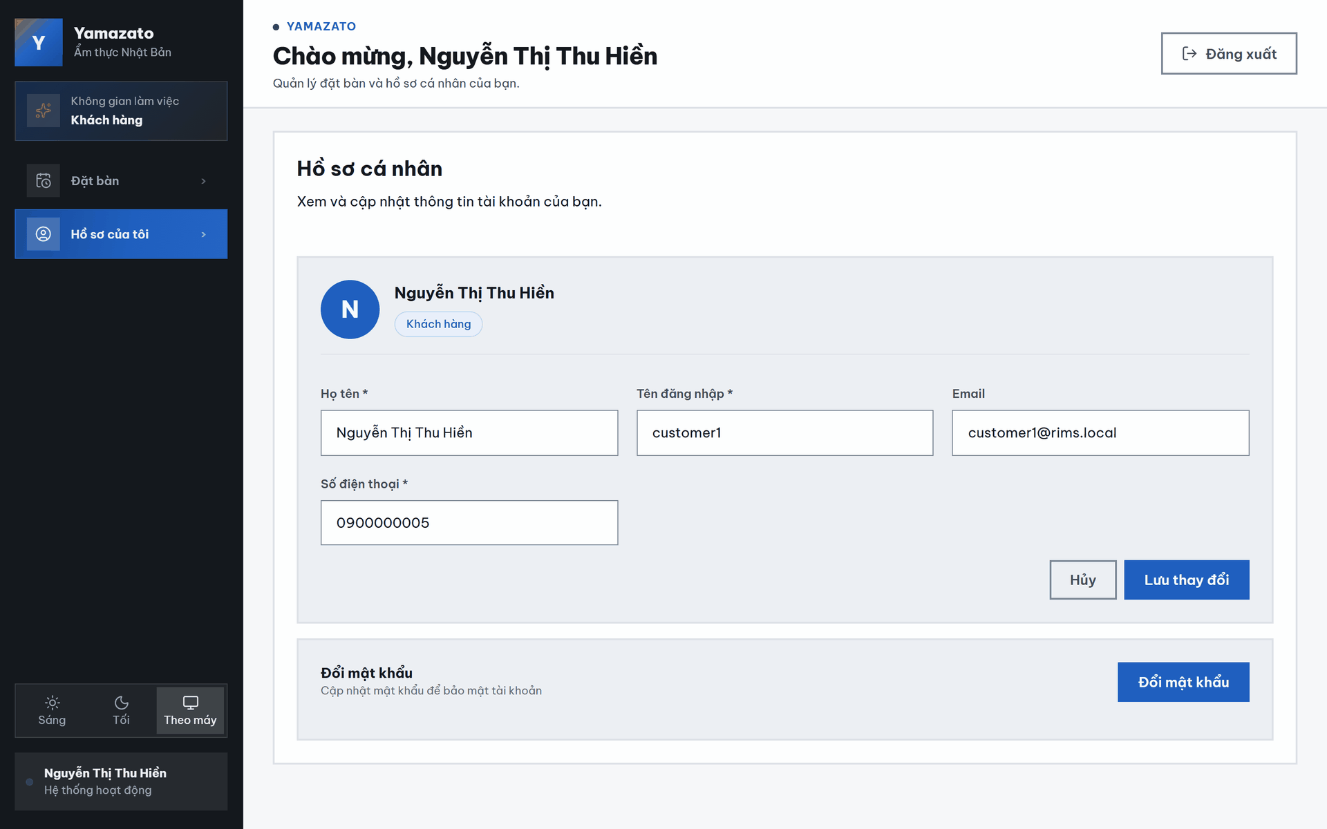
This screen allows the Customer to:
- View the Current Profile: Review the Customer’s name, account role, username, email address, and phone number.
- Edit the Full Name: Update the full name associated with the Customer account.
- Edit the Username: Update the username used to log in to the system.
- Edit the Email Address: Update the email address associated with the account.
- Edit the Phone Number: Update the Customer’s phone number.
- Cancel Editing: Click “Hủy” to discard unsaved changes and return to the profile view.
- Save Changes: Click “Lưu thay đổi” to submit and save the updated profile information.

Field Name | Description
Hồ sơ cá nhân | Displays the title of the Customer profile-editing screen.
N | Displays the first letter of the Customer’s name as the profile avatar.
Nguyễn Thị Thu Hiền | Displays the Customer’s current full name in the profile summary.
Khách hàng | Displays the role assigned to the current account.
Họ tên * | Allows the Customer to update their full name. The current value is displayed in the input field. This field is required.
Username * | Allows the Customer to update the username used to log in to the system. The current value is displayed in the input field. This field is required.
Email | Allows the Customer to update the email address associated with the account.
Số điện thoại * | Allows the Customer to update the phone number associated with the account. The current value is displayed in the input field. This field is required.
Hủy | Cancels the editing process and discards any unsaved changes.
Lưu thay đổi | Submits and saves the updated Customer profile information.

5.4. Reservation Creation Screen
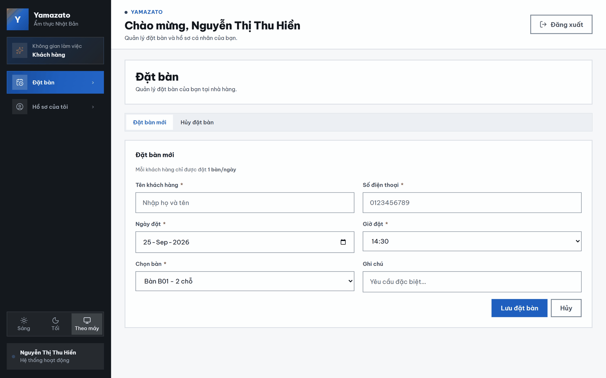
This screen allows the Customer to:
- Create a New Reservation: Enter the required information to reserve a restaurant table.
- Open the Reservation Cancellation Section: Select “Hủy đặt bàn” to access the function for cancelling an existing reservation.
- Enter Customer Information: Provide the Customer’s full name and phone number.
- Select a Reservation Date and Time: Choose the date and available time for the reservation.
- Select a Table: Choose an available table based on its table number and seating capacity.
- Add a Special Request: Enter optional notes or special requirements for the reservation.
- Save the Reservation: Click “Lưu đặt bàn” to submit the entered information and create the reservation.
- Cancel the Form: Click “Hủy” to discard the entered information.

Field Name | Description
Đặt bàn mới | Opens the form used to create a new table reservation.
Hủy đặt bàn | Opens the section used to cancel an existing table reservation.
Mỗi khách hàng chỉ được đặt 1 bàn/ngày | Informs the Customer that only one table reservation can be created per day.
Tên khách hàng * | Allows the Customer to enter their full name. The placeholder displays “Nhập họ và tên”. This field is required.
Số điện thoại * | Allows the Customer to enter a contact phone number. The placeholder displays “0123456789”. This field is required.
Ngày đặt * | Allows the Customer to select the reservation date through the date field or calendar icon. This field is required.
Giờ đặt * | Allows the Customer to select an available reservation time from the drop-down list. This field is required.
Chọn bàn * | Allows the Customer to select an available table. The selected option displays the table number and seating capacity, such as “Bàn T01 - 2 chỗ”. This field is required.
Ghi chú | Allows the Customer to enter optional special requests. The placeholder displays “Yêu cầu đặc biệt”.
Lưu đặt bàn | Validates the entered information and creates the new table reservation.
Hủy | Cancels the reservation-creation process and discards any unsaved information.

5.5. Reservation Cancellation Screen
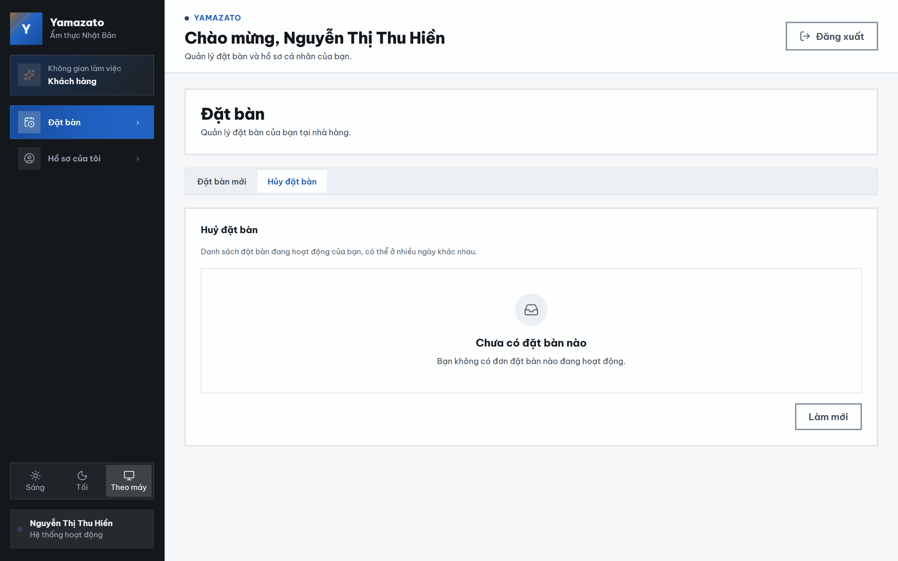

This screen allows the Customer to:
- View Active Reservations: Review the Customer’s current active table reservations.
- Open the New Reservation Form: Select “Đặt bàn mới” to create another table reservation.
- View Reservation Information: Check the reserved table, reservation time, reservation date, and current status.
- Cancel a Reservation: Click “Hủy đặt bàn” on the selected reservation to request its cancellation.
- Refresh the Reservation List: Click “Làm mới” to retrieve the latest reservation information from the system.

Field Name | Description
Đặt bàn mới | Opens the form used to create a new table reservation.
Hủy đặt bàn | Opens the section containing the Customer’s active reservations and cancellation actions.
Đặt bàn: | Identifies the reservation-information section.
Bàn T01 - 09:00 Thứ 3, 28/07/2026 | Displays the reserved table number, reservation time, day of the week, and reservation date.
Đang trong hàng đợi | Displays the current reservation status, indicating that the reservation is waiting to be processed or confirmed.
Hủy đặt bàn | Cancels the selected active reservation. The system may request confirmation before completing the cancellation.
Làm mới | Reloads the active-reservation list and displays the latest reservation status from the system.

6. Waiter

6.1 Table Management Screen
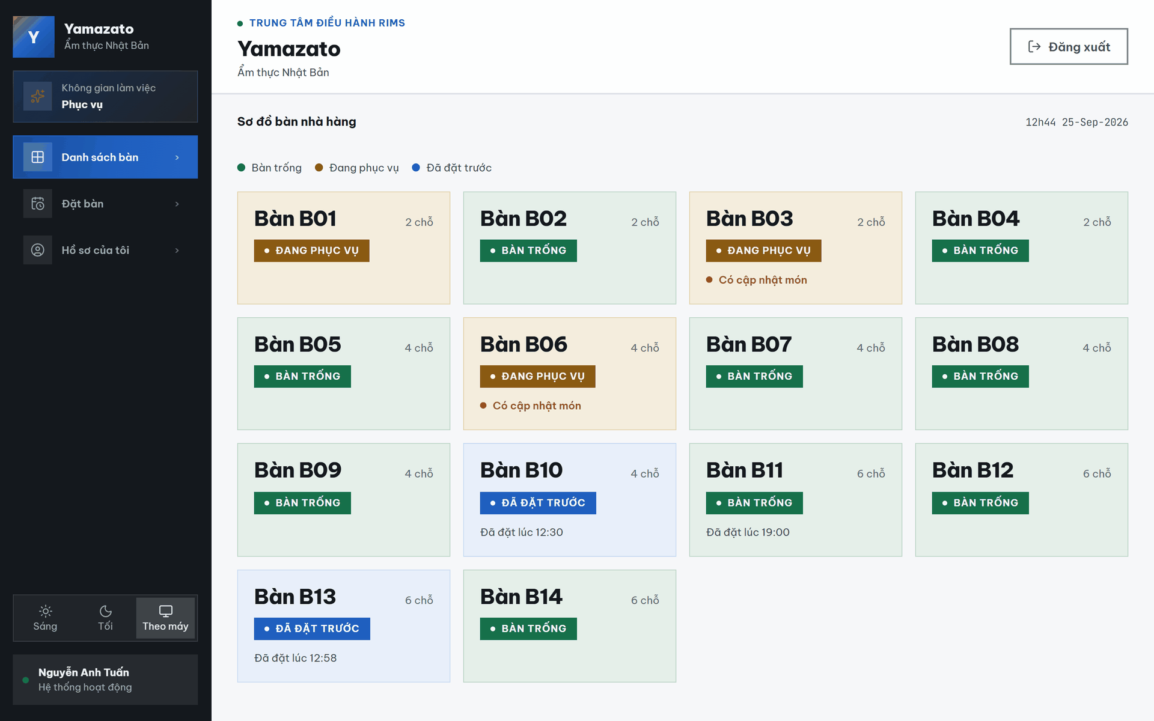
This screen allows the waiter to:
- View all restaurant tables in a grid layout.
- View the table number and seating capacity of each table.
- View the current status of each table (Available, Serving, or Reserved).
- View the legend explaining the meaning of each table status.
- Identify tables that have pending status notifications.
- View the reservation time displayed for reserved tables.
- View an indicator when an available table has an upcoming reservation.
- Select a table to perform the corresponding operation based on its current status.
- Create a new order for an available table.
- Create a reservation for an available table.
- View upcoming reservations before assigning a walk-in customer to an available table.
- Open the active order details of a serving table.
- Open the reservation details of a reserved table.
- Refresh the table status automatically when restaurant data changes.

Field Name | Description
Hệ thống quản lý nhà hàng | Displays the title of the restaurant management system.
Đăng xuất | Signs the Waiter out of the system and returns to the login screen.
Sơ đồ bàn nhà hàng | Displays the restaurant tables in a grid layout together with their capacities and current statuses.
14h36 25-Jul-2026 | Displays the current system time and date.
Bàn trống | Indicates that the table is currently available for customers. This status is represented by green.
Đang phục vụ | Indicates that the table is currently occupied and serving customers. This status is represented by orange.
Đã đặt trước | Indicates that the table has been reserved in advance. This status is represented by blue.
Bàn T01 - 2 chỗ | Displays table number T01 and its seating capacity of 2 customers. The table is currently being served.
Bàn T02 - 2 chỗ | Displays table number T02 and its seating capacity of 2 customers. The table is currently being served.
Bàn T03 - 2 chỗ | Displays table number T03 and its seating capacity of 2 customers. The table is currently being served.
Bàn T04 - 2 chỗ | Displays table number T04 and its seating capacity of 2 customers. The table is reserved for 14:37.
Bàn T05 - 4 chỗ | Displays table number T05 and its seating capacity of 4 customers. The table is currently being served.
Bàn T06 - 4 chỗ | Displays table number T06 and its seating capacity of 4 customers. The table is currently being served.
Bàn T07 - 4 chỗ | Displays table number T07 and its seating capacity of 4 customers. The table is currently being served.
Bàn T08 - 4 chỗ | Displays table number T08 and its seating capacity of 4 customers. The table is currently being served.
Bàn T09 - 4 chỗ | Displays table number T09 and its seating capacity of 4 customers. The table is currently available.
Bàn T10 - 4 chỗ | Displays table number T10 and its seating capacity of 4 customers. The table is reserved for 14:37.
Bàn T11 - 8 chỗ | Displays table number T11 and its seating capacity of 8 customers. The table is currently available.
Bàn T12 - 8 chỗ | Displays table number T12 and its seating capacity of 8 customers. The table is currently available but has an upcoming reservation.
Đã đặt lúc 15:00 | Indicates that the corresponding table has an upcoming reservation scheduled for 15:00.

6.2 Create Order Screen

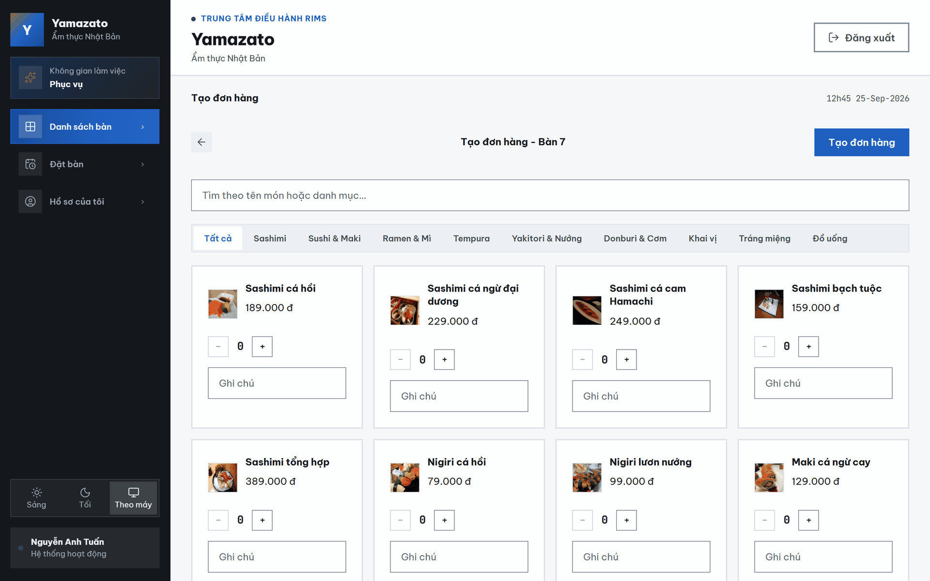
This screen allows the waiter to:
- Create a new order for the selected table.
- View the table number for which the order is being created.
- Return to the Table Management screen.
- Search menu items by name.
- Filter menu items by category.
- Browse all available menu items.
- View each menu item's image, name, and price.
- Add a note for each selected menu item.
- Review the selected items before creating the order.
- View the temporary order summary and estimated total price before confirmation.
- Confirm or cancel order creation.

Field Name | Description
Sơ đồ bàn nhà hàng | Displays the name of the restaurant table-management section.
14h31 25-Jul-2026 | Displays the current system time and date.
← | Returns the Waiter to the restaurant table map without creating the order.
Tạo đơn hàng - Bàn 11 | Displays the title of the order-creation screen and identifies Table 11 as the selected table.
Tạo đơn hàng | Submits the selected dishes, quantities, and notes to create an order for Table 11.
Tìm kiếm món ăn... | Allows the Waiter to search for dishes by name.
Tất cả | Displays dishes from all menu categories. This option is currently selected.
Sashimi | Displays only sashimi — raw fish sliced to order.
Sushi & Maki | Displays only sushi and maki rolls.
Ramen & Mì | Displays only ramen and other noodle dishes.
Tempura | Displays only tempura — lightly battered, deep-fried dishes.
Yakitori & Nướng | Displays only charcoal-grilled and skewered dishes.
Donburi & Cơm | Displays only rice bowls and other rice dishes.
Khai vị | Displays only appetizers.
Tráng miệng | Displays only desserts.
Đồ uống | Displays only drinks and beverages.
Tên món ăn | Displays the name of each dish available for ordering.
Giá món ăn | Displays the selling price of each dish in Vietnamese đồng, such as 159.000 đ.
− | Decreases the selected quantity of the corresponding dish by one. The quantity cannot be reduced below zero.
0 | Displays the current selected quantity of the corresponding dish.
+ | Increases the selected quantity of the corresponding dish by one.
Ghi chú | Allows the Waiter to enter an optional preparation note or customer request for the corresponding dish.
Thẻ món ăn | Displays the dish image, dish name, selling price, quantity controls, and note field for an individual dish.

6.3 Serving Order Detail Screen

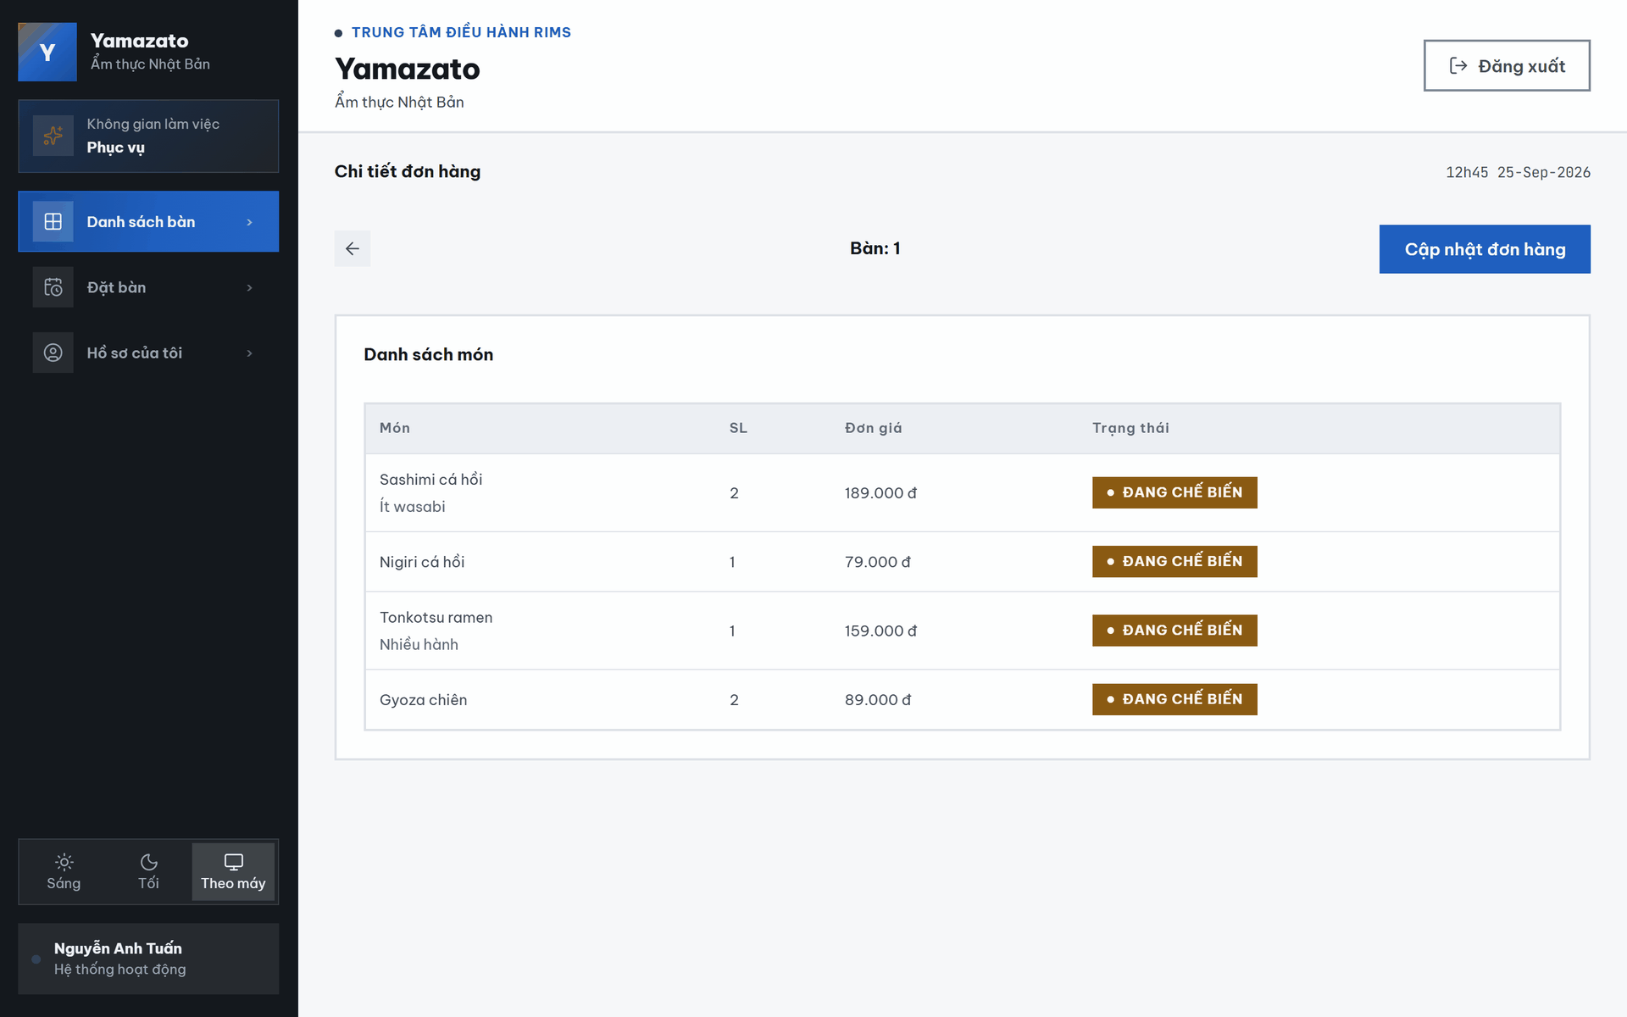

This screen allows the waiter to:
- View the active order for the selected table.
- View all menu items included in the order.
- View the quantity, unit price, and current status of each order item.
- View notes associated with each order item.
- View cancellation reasons for cancelled order items.
- View internal notes provided by the chef.
- Navigate to the Update Order screen.

Field Name | Description
Sơ đồ bàn nhà hàng | Displays the name of the restaurant table-management section.
16h03 25-Jul-2026 | Displays the current system time and date.
← | Returns the Waiter to the restaurant table map.
Bàn: 9 | Identifies Table 9 as the table associated with the displayed order.
Cập nhật đơn hàng | Opens the order-update screen so the Waiter can add dishes or modify the current order.
Danh sách món | Displays all dishes currently included in the order for Table 9.
MÓN | Displays the name of each dish included in the order.
SL | Displays the ordered quantity of each dish.

6.4 Update Order Screen

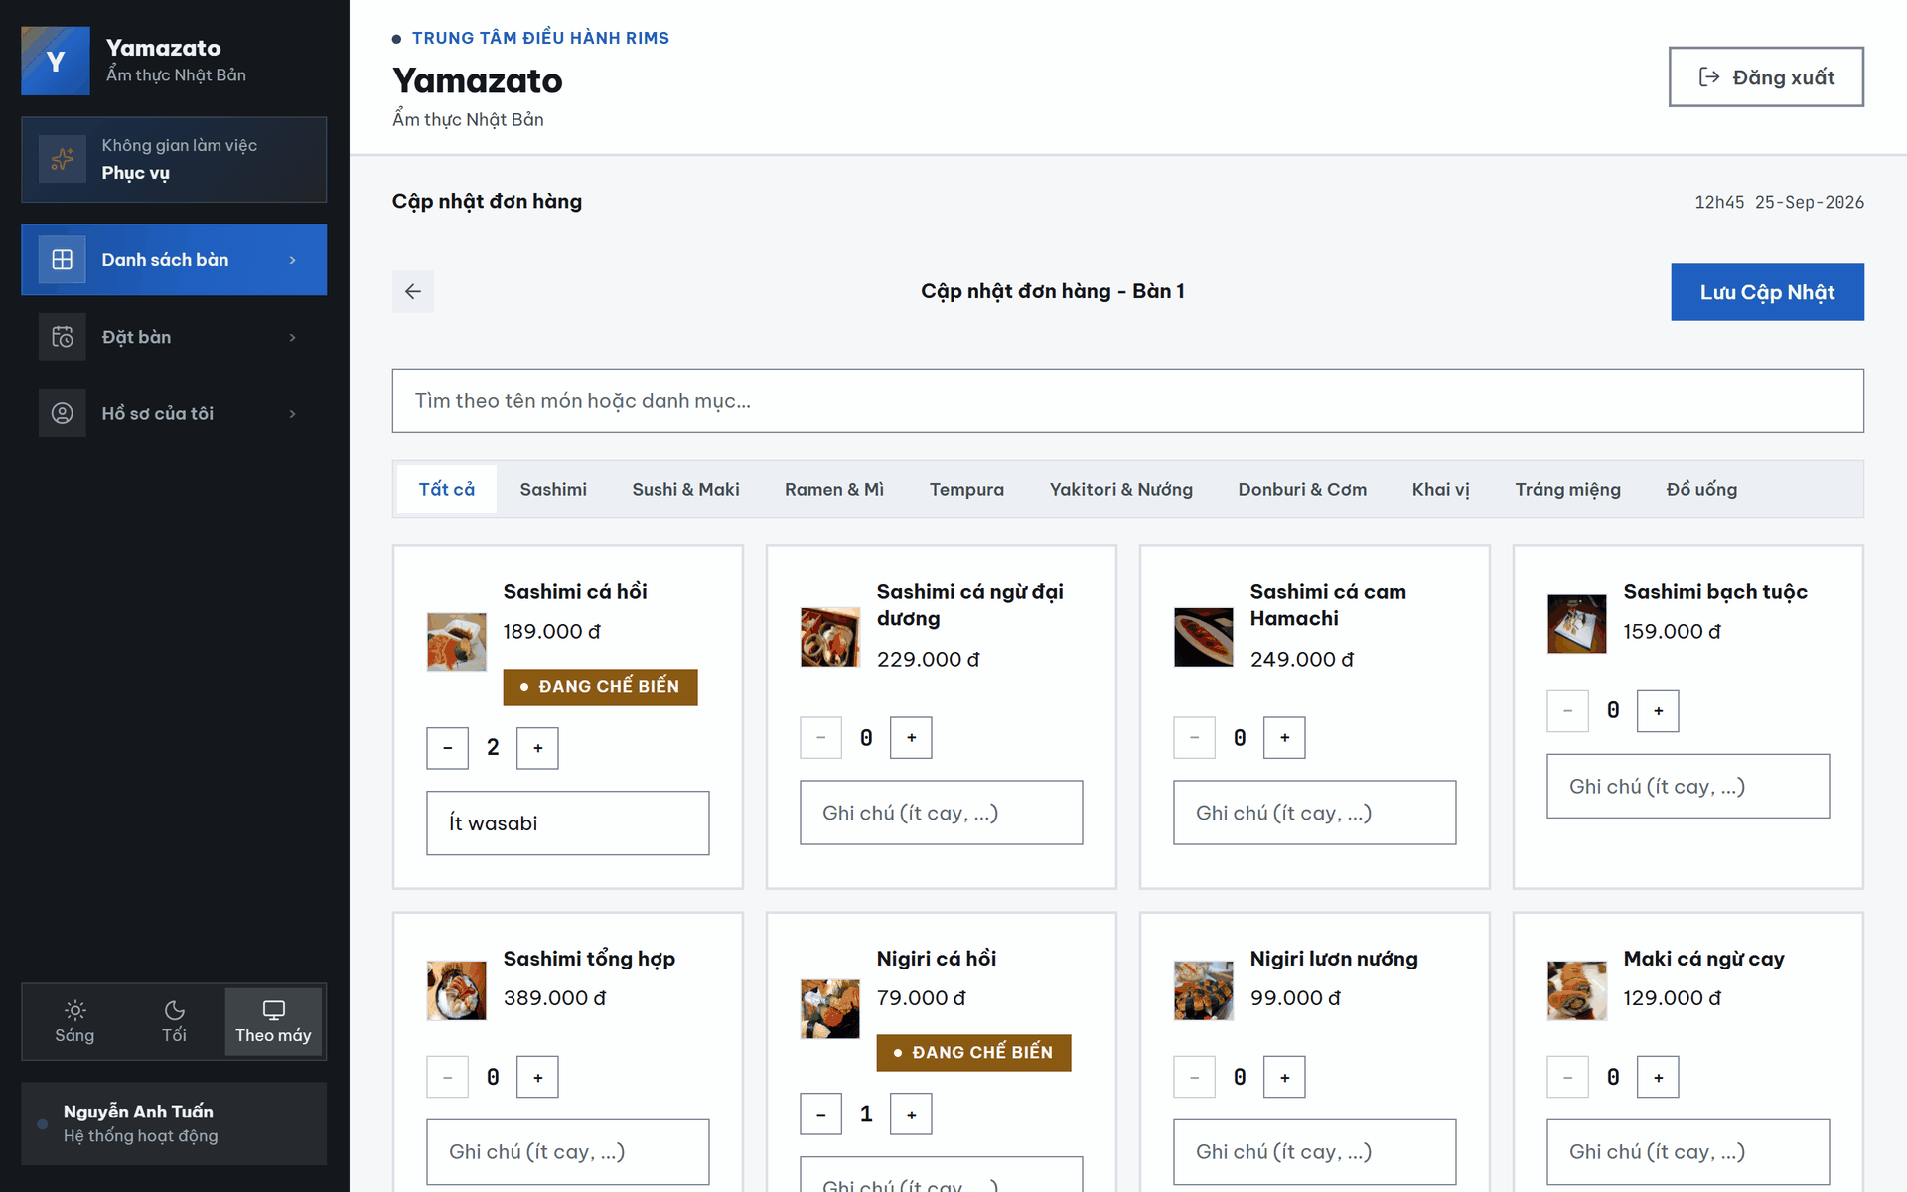

This screen allows the waiter to:
- Update the active order for the selected table.
- Modify the quantity of existing order items.
- Add new menu items to the current order.
- Update notes for existing order items.
- View the current processing status of each order item.
- View chef's internal notes for order items.
- Acknowledge the chef's internal notes.
- View cancellation reasons for cancelled order items.
- View restrictions for completed, cancelled, or unavailable menu items.
- Review all order changes before submitting the update.
- Confirm or cancel the order update.

Field Name | Description
← | Returns the Waiter to the previous order screen without saving the current changes.
Cập nhật đơn hàng - Bàn 9 | Displays the title of the order-update screen and identifies Table 9 as the selected table.
Lưu Cập Nhật | Submits and saves the updated dish quantities, new dishes, and notes for Table 9.
Tìm kiếm món ăn... | Allows the Waiter to search for dishes by name.
Tất cả | Displays dishes from all menu categories. This option is currently selected.
Sashimi | Displays only sashimi — raw fish sliced to order.
Sushi & Maki | Displays only sushi and maki rolls.
Ramen & Mì | Displays only ramen and other noodle dishes.
Tempura | Displays only tempura — lightly battered, deep-fried dishes.
Yakitori & Nướng | Displays only charcoal-grilled and skewered dishes.
Donburi & Cơm | Displays only rice bowls and other rice dishes.
Khai vị | Displays only appetizers.
Tráng miệng | Displays only desserts.
Đồ uống | Displays only drinks and beverages.
PREPARING | Indicates that the corresponding dish has already been submitted and is currently being prepared by the kitchen.
CANCELLED | Indicates that the corresponding dish has been cancelled and will not be prepared.
− | Decreases the selected quantity of the corresponding dish.
0 / 1 | Displays the current selected or ordered quantity of the corresponding dish.
+ | Increases the dish quantity. For a cancelled dish, it adds the dish again as a new order item.
Ghi chú (ít cay, ...) | Allows the Waiter to enter an

6.5 Current Reservation Detail Screen

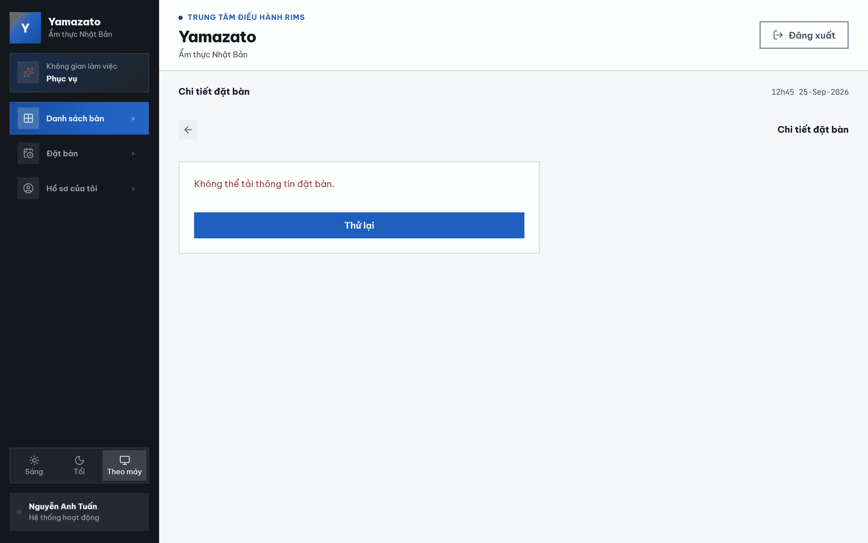

This screen allows the waiter to:
- View the reservation details for the selected table.
- View the reservation ID.
- View the reservation date and time.
- View the customer's name.
- View the customer's phone number.
- View additional reservation notes.
- Start a new order for the reserved customer.

Field Name | Description
Sơ đồ bàn nhà hàng | Displays the name of the restaurant table-management section.
14h30 25-Jul-2026 | Displays the current system time and date.
← | Returns the Waiter to the restaurant table-map screen.
Chi tiết đặt bàn — Bàn 4 | Displays the title of the reservation-detail screen and identifies Table 4 as the selected table.
Bắt đầu Order | Starts the order-creation process for Table 4 using the displayed reservation information.
Thông tin đặt bàn | Displays the detailed information of the selected reservation.
Mã đặt bàn | Displays the unique identifier of the reservation. The current reservation ID is 1.
Thời gian | Displays the scheduled reservation date and time. The current value is 2026-07-25 – 14:37.

6.6 Create Reservation Screen

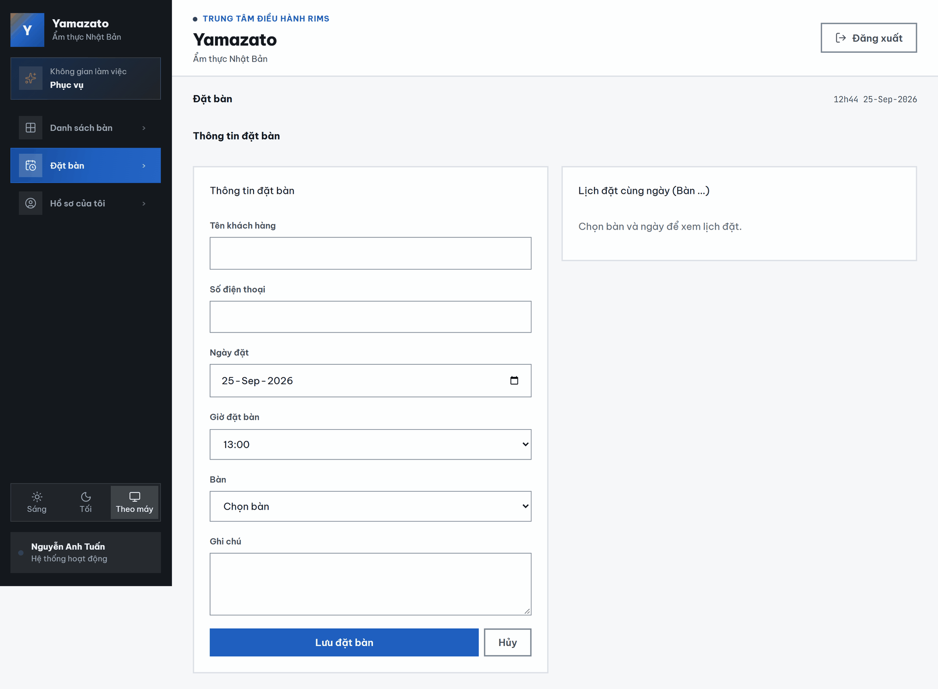

This screen allows the waiter to:
- Create a new table reservation.
- Enter the customer's name and phone number.
- Select the reservation date and time.
- Select a restaurant table for the reservation.
- Enter additional reservation notes.
- View existing reservations for the selected table on the selected date.
- Edit an existing reservation from the reservation schedule.
- Save or cancel the reservation.

Field Name | Description
14h33 25-Jul-2026 | Displays the current system time and date.
Đặt Bàn | Displays the title of the table-reservation creation screen.
Thông tin đặt bàn | Contains the customer and reservation information required to create a new reservation.
Tên khách hàng | Allows the Waiter to enter the name of the customer making the reservation.
Số điện thoại | Allows the Waiter to enter the customer’s contact phone number.
Ngày đặt | Allows the Waiter to select the reservation date. The current value displayed is 25-Jul-2026.

6.7 Edit Reservation Screen

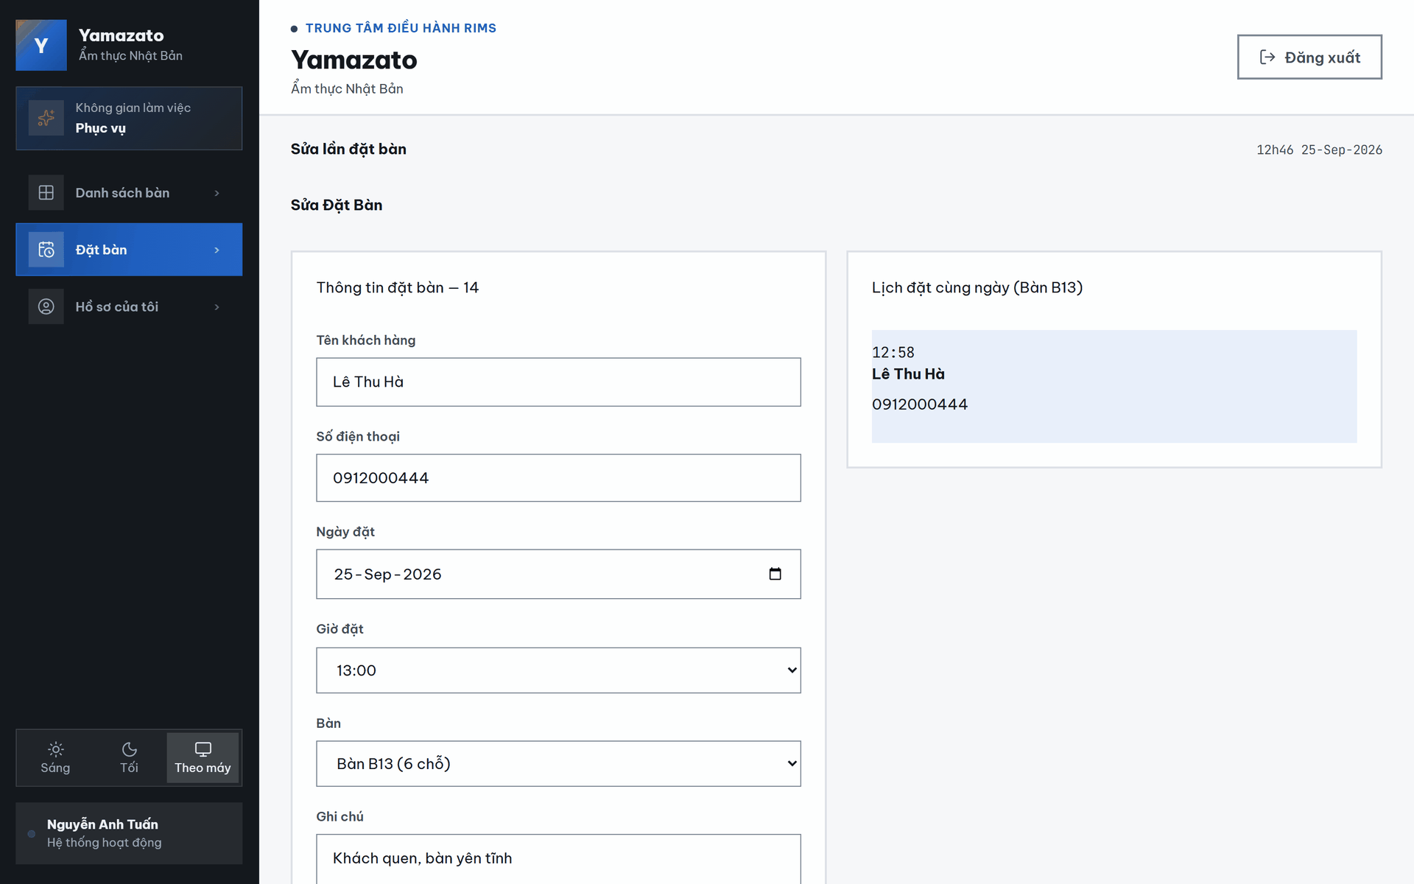
This screen allows the waiter to:
- Modify an existing reservation.
- Update the customer information.
- Update the reservation date, time, assigned table, and reservation note.
- View the current reservation highlighted in the reservation schedule.
- Navigate to another reservation from the reservation schedule.
- Save the updated reservation.
- Cancel the reservation.
- Return to the Table Management screen without saving changes.

Field Name | Description
Sơ đồ bàn nhà hàng | Displays the name of the restaurant table-management section.
14h33 25-Jul-2026 | Displays the current system time and date.
Sửa Đặt Bàn | Displays the title of the reservation-editing screen.
Thông tin đặt bàn — 1 | Displays the reservation-editing form and identifies the selected reservation by ID 1.
Tên khách hàng | Allows the Waiter to update the customer’s name. The current value displayed is “Nguyễn Thị Lan”.
Số điện thoại | Allows the Waiter to update the customer’s contact phone number. The current value displayed is 0912345678.
Ngày đặt | Allows the Waiter to change the reservation date. The current value displayed is 25-Jul-2026.
Giờ đặt | Allows the Waiter to select a different reservation time from the drop-down list. The current value displayed is 15:00.
Bàn | Allows the Waiter to change the table assigned to the reservation.
Bàn T04 (2 chỗ) | Indicates that Table T04, with a seating capacity of 2 customers, is currently assigned to the reservation.
Ghi chú | Allows the Waiter to update the customer’s special request. The current note is “Kỷ niệm ngày cưới, cần bàn yên tĩnh”.
Lịch đặt cùng ngày (Bàn T04) | Displays reservations scheduled for Table T04 on the selected date.
14:37 | Displays the scheduled time of another reservation for the selected table.
Nguyễn Thị Lan | Displays the customer name associated with the same-day reservation.
0912345678 | Displays the contact phone number associated with the same-day reservation.
Lưu thay đổi | Validates and saves the updated reservation information.
Hủy đặt bàn | Cancels the selected reservation. The system may require confirmation before completing the cancellation.
Quay lại | Returns the Waiter to the previous screen without saving unsaved changes.

III. System Design

1. Software Architecture

1.1 Overall Architectural Diagram
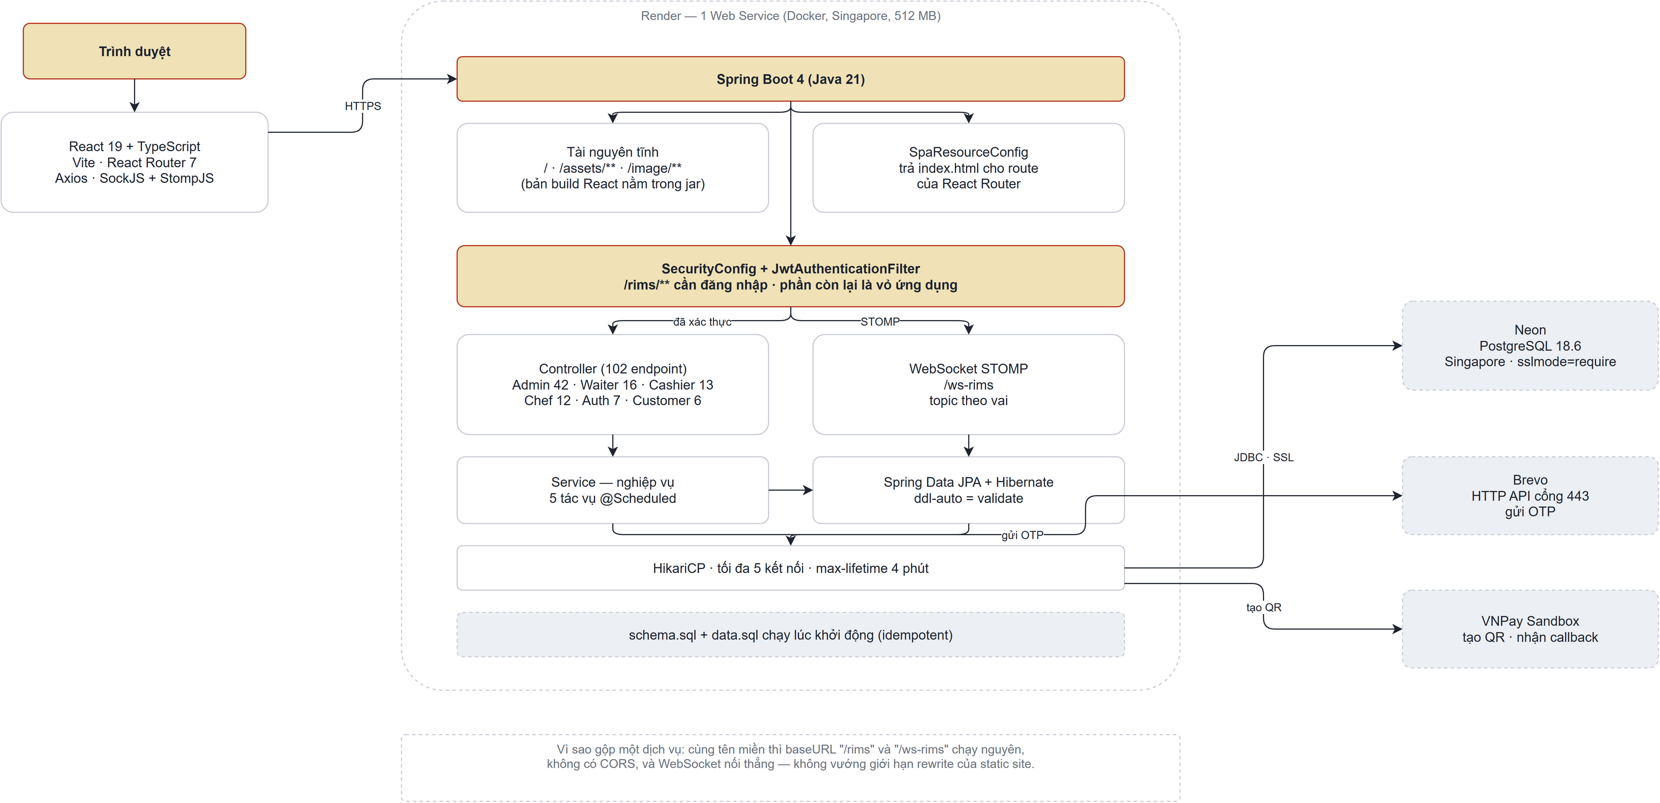

1.2 Component Descriptions

No | Layer/Type | Component | Description
1 | Presentation Layer | UI Components | Provides the graphical user interface, including pages, forms, dialogs, tables, and reusable components that enable users to interact with the system.
2 | Presentation Layer | UI Process Components | Manages client-side application logic, including routing, state management, input validation, and communication with backend REST APIs.
3 | Business Logic Layer | REST Controllers | Exposes RESTful API endpoints, receives HTTP requests, validates input, delegates processing to the service layer, and returns standardized HTTP responses.
4 | Business Logic Layer | Service Layer | Implements business rules and application workflows, coordinates transactions, interacts with repositories, and integrates with external services.
5 | Data Access Layer | Repository Layer | Provides data access operations using Spring Data JPA repositories, handling CRUD operations and custom database queries while abstracting persistence logic.
6 | Data Access Layer | Business Entities | Defines the domain model as JPA entities, representing business objects and their relationships while mapping them to database tables.
7 | External Services | VNPay | Integrates with the VNPay payment gateway to process online payment transactions and verify payment results.
8 | External Services | Brevo Email API | Sends system-generated emails, including account verification and password reset, by calling the Brevo transactional email REST API over HTTPS.
9 | Security Mechanism | JWT Authentication | Authenticates users and authorizes access to protected resources using JSON Web Tokens (JWT), ensuring secure communication between clients and the backend.
10 | Communication Mechanism | HTTP/REST API | Provides the communication protocol between the frontend and backend, enabling request-response interactions through RESTful web services.
11 | Data Source | PostgreSQL | Serves as the relational database management system for storing and managing persistent application data and other business information. Deployed on Neon, a serverless PostgreSQL service.

2. Database Design

2.1 Database Schema
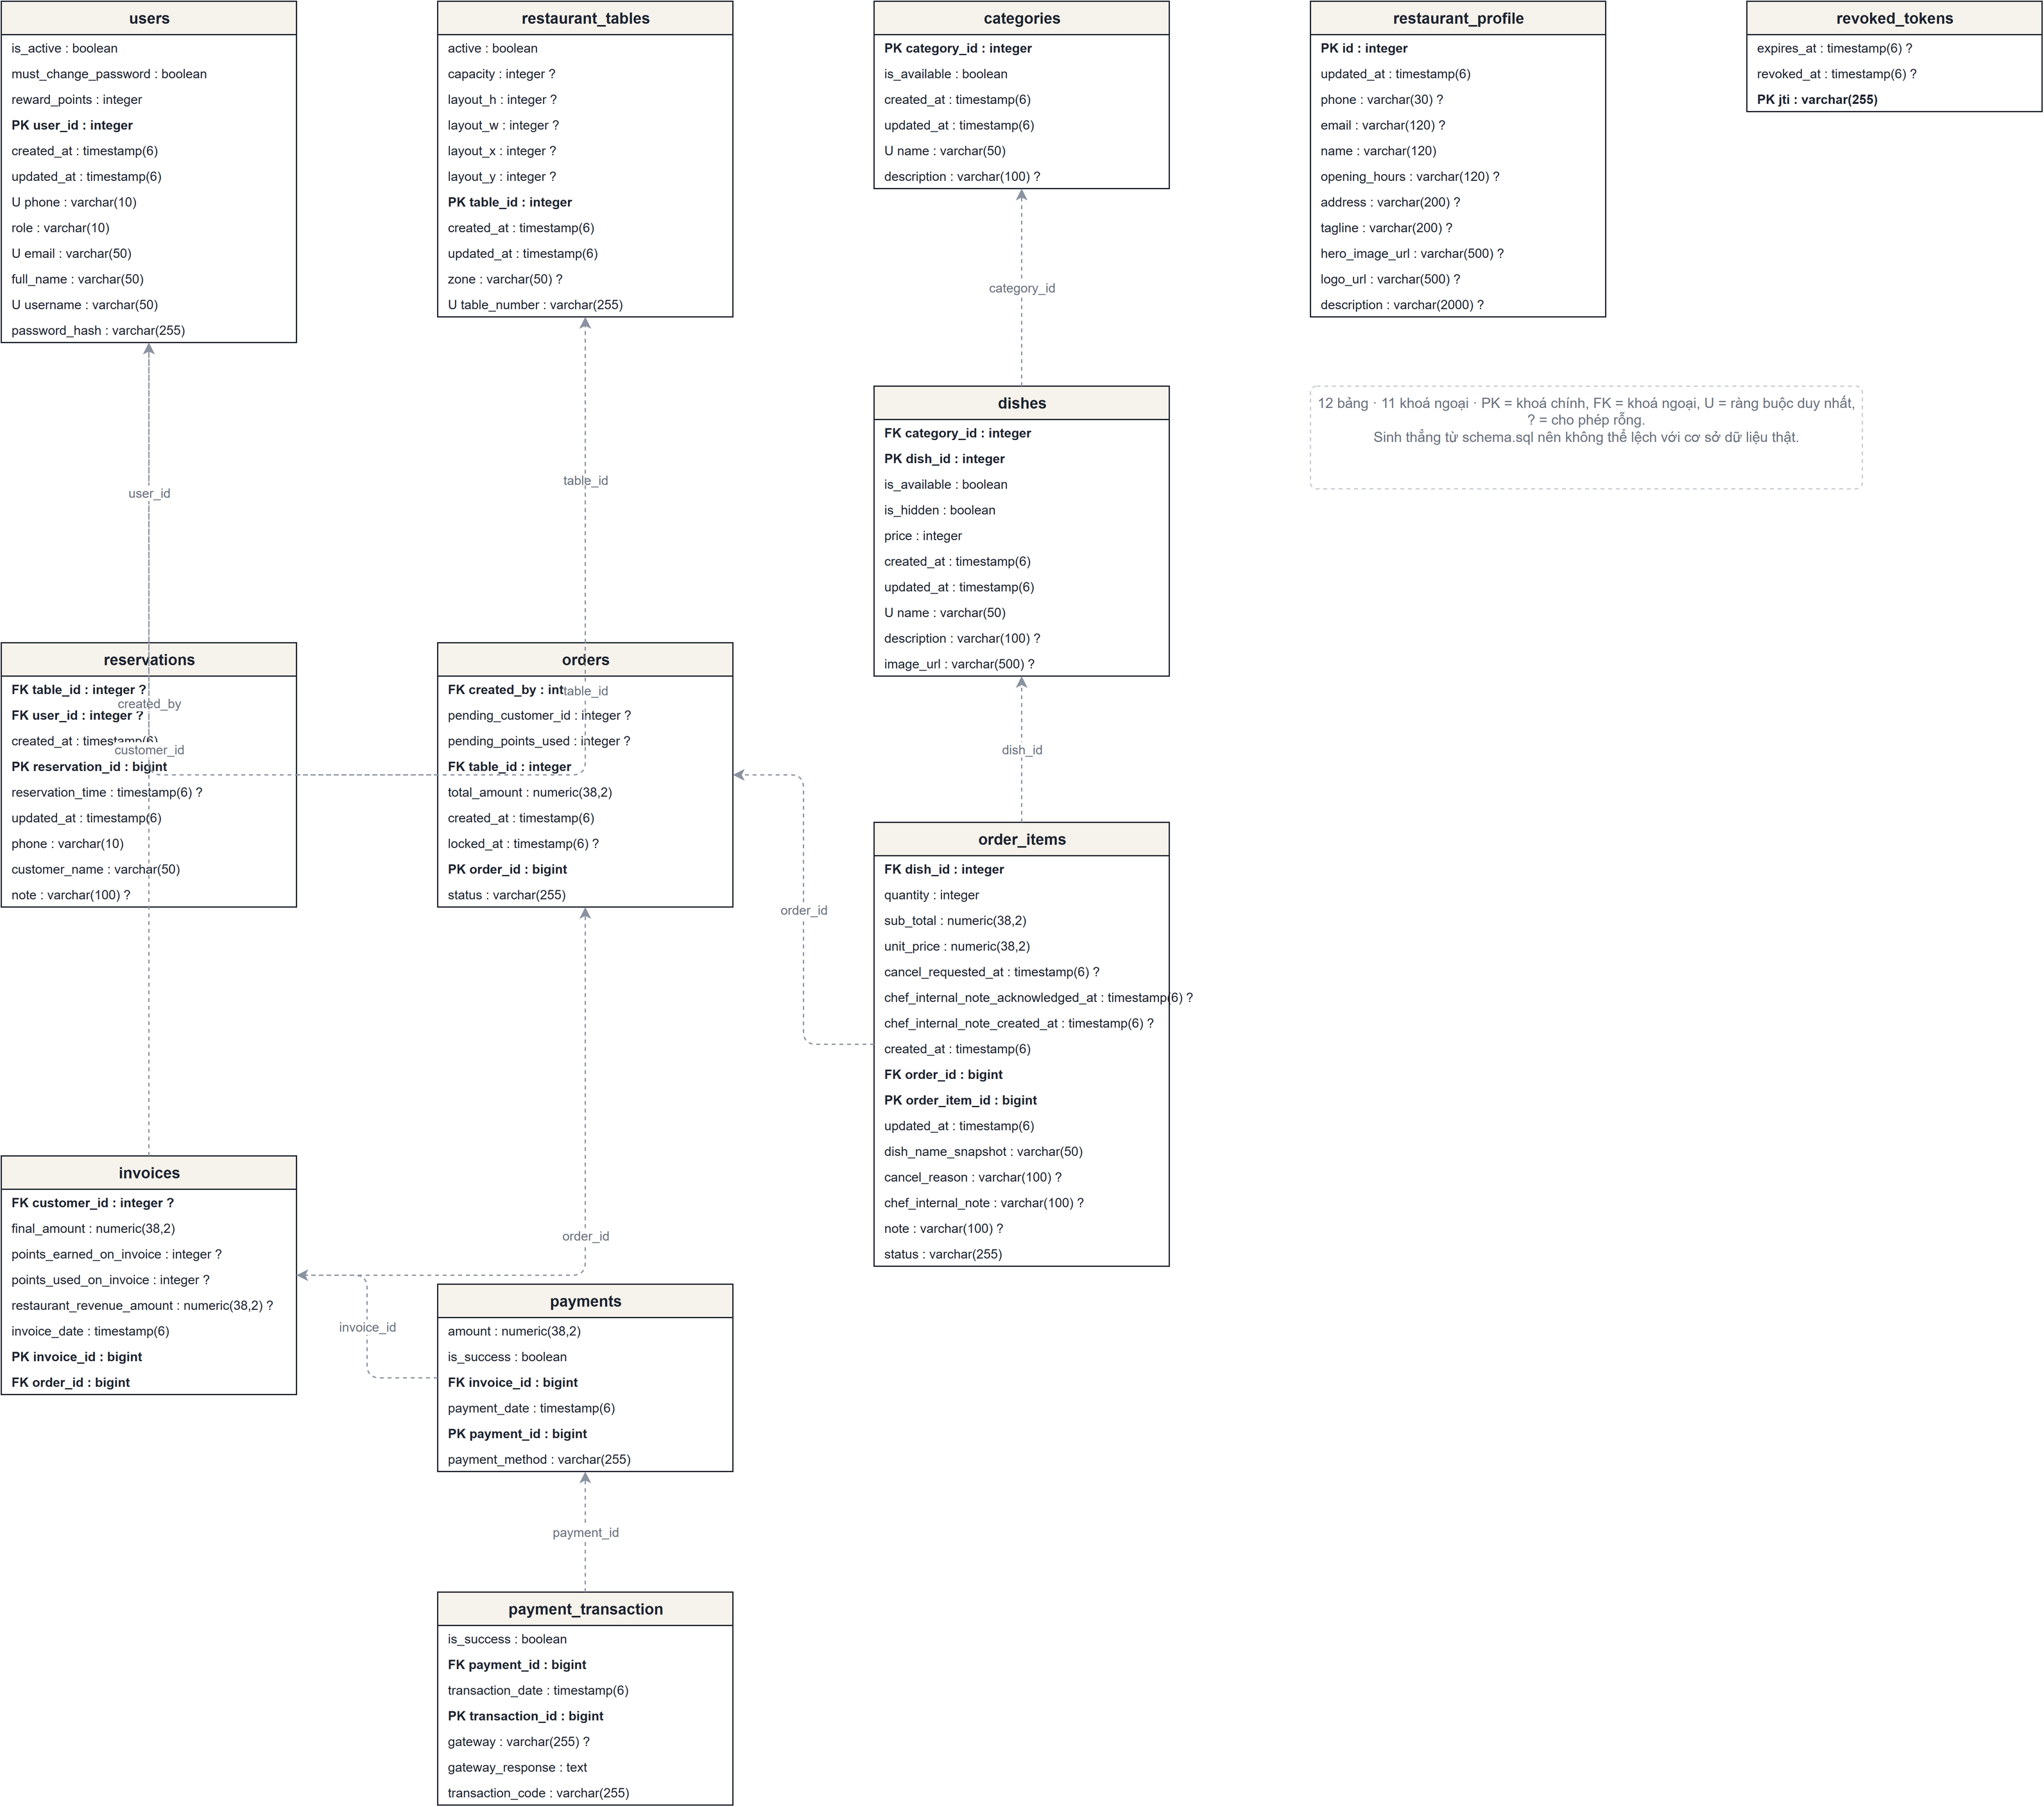

2.2 Table Descriptions

2.2.1 User

No | Field | PK | FK | UN | NN | Description
1 | user_id | ✓ |  |  | ✓ | User identifier, auto-incrementing
2 | role |  |  |  | ✓ | User's role in the system: ADMIN, CHEF, WAITER, CASHIER, CUSTOMER
3 | username |  |  | ✓ | ✓ | Username, maximum 50 characters, unique
4 | full_name |  |  |  | ✓ | Full name of the user, maximum 50 characters
5 | email |  |  | ✓ |  | Email address, maximum 50 characters, unique
6 | phone |  |  | ✓ | ✓ | Phone number, maximum 10 characters, unique
7 | password_hash |  |  |  | ✓ | Hashed password
8 | is_active |  |  |  |  | Account activation status, true or false
9 | reward_points |  |  |  | ✓ | Accumulated reward points of the user, default is 0
10 | created_at |  |  |  | ✓ | Timestamp of record creation
11 | updated_at |  |  |  | ✓ | Timestamp of last record modification
12 | must_change_password |  |  |  | ✓ | Forces the user to set a new password at next login. Set when an Admin creates the account or resets its password.

2.2.2 Restaurant Tables

No | Field | PK | FK | UN | NN | Description
1 | table_id | ✓ |  |  | ✓ | Restaurant table identifier, auto-incrementing
2 | table_number |  |  | ✓ | ✓ | Restaurant table number or table code, unique
3 | capacity |  |  |  | ✓ | Maximum number of guests that the table can serve
4 | status |  |  |  | ✓ | Current table status, such as AVAILABLE, OCCUPIED, RESERVED
5 | created_at |  |  |  | ✓ | Timestamp of record creation
6 | updated_at |  |  |  | ✓ | Timestamp of last record modification
7 | zone |  |  |  |  | Name of the area the table belongs to, maximum 50 characters.
8 | layout_x |  |  |  |  | Horizontal position of the table on the floor plan grid.
9 | layout_y |  |  |  |  | Vertical position of the table on the floor plan grid.
10 | layout_w |  |  |  |  | Width of the table on the floor plan grid.
11 | layout_h |  |  |  |  | Height of the table on the floor plan grid.
12 | active |  |  |  | ✓ | Whether the table is still in use. An inactive table is kept for historical orders but is hidden from the table map.

2.2.3 Categories

No | Field | PK | FK | UN | NN | Description
1 | category_id | ✓ |  |  | ✓ | Dish category identifier, auto-incrementing
2 | name |  |  | ✓ | ✓ | Category name, unique
3 | description |  |  |  |  | Detailed description of the category
4 | is_available |  |  |  | ✓ | Availability status of the category, true or false
5 | created_at |  |  |  | ✓ | Timestamp of record creation
6 | updated_at |  |  |  | ✓ | Timestamp of last record modification

2.2.4 Dishes

No | Field | PK | FK | UN | NN | Description
1 | dish_id | ✓ |  |  | ✓ | Dish identifier, auto-incrementing
2 | category_id |  | ✓ |  | ✓ | Reference to the category that the dish belongs to
3 | name |  |  |  | ✓ | Dish name
4 | description |  |  |  |  | Detailed description of the dish
5 | price |  |  |  | ✓ | Selling price of the dish
6 | image_url |  |  |  |  | Image URL of the dish
7 | is_available |  |  |  | ✓ | Availability status of the dish, true or false
8 | is_hidden |  |  |  | ✓ | Display status of the dish in the menu, true or false
9 | created_at |  |  |  | ✓ | Timestamp of record creation
10 | updated_at |  |  |  | ✓ | Timestamp of last record modification

2.2.5 Orders

No | Field | PK | FK | UN | NN | Description
1 | order_id | ✓ |  |  | ✓ | Order identifier, auto-incrementing
2 | table_id |  | ✓ |  | ✓ | Reference to the restaurant table used for the order
3 | created_by |  | ✓ |  | ✓ | Reference to the staff user who created the order
4 | pending_customer_id |  | ✓ |  |  | Reference to the pending customer account, if any
5 | pending_points_used |  |  |  | ✓ | Reward points temporarily applied to the order before payment
6 | total_amount |  |  |  | ✓ | Total amount of the order
7 | status |  |  |  | ✓ | Current order status, such as OPEN, LOCKED, COMPLETED, CANCELLED
8 | created_at |  |  |  | ✓ | Timestamp when the order was created
9 | locked_at |  |  |  |  | Timestamp when the order was locked before payment

2.2.6 Order Items

No | Field | PK | FK | UN | NN | Description
1 | order_item_id | ✓ |  |  | ✓ | Order item identifier, auto-incrementing
2 | order_id |  | ✓ |  | ✓ | Reference to the order that contains this item
3 | dish_id |  | ✓ |  | ✓ | Reference to the ordered dish
4 | dish_name_snapshot |  |  |  | ✓ | Dish name saved at the time of ordering
5 | quantity |  |  |  | ✓ | Quantity of the dish ordered
6 | unit_price |  |  |  | ✓ | Unit price of the dish at the time of ordering
7 | sub_total |  |  |  | ✓ | Subtotal amount of the order item
8 | status |  |  |  | ✓ | Current order item status, such as PENDING, SERVED, CANCELLED
9 | note |  |  |  |  | Customer note or special instruction for the item
10 | cancel_reason |  |  |  |  | Reason for cancelling the order item
11 | cancel_requested_at |  |  |  |  | Timestamp when cancellation was requested
12 | chef_internal_note |  |  |  |  | Internal note created by the chef
13 | chef_internal_note_created_at |  |  |  |  | Timestamp when the chef internal note was created
14 | chef_internal_note_acknowledged_at |  |  |  |  | Timestamp when the chef internal note was acknowledged
15 | created_at |  |  |  | ✓ | Timestamp when the order item was created
16 | updated_at |  |  |  | ✓ | Timestamp of last order item modification

2.2.7 Invoices

No | Field | PK | FK | UN | NN | Description
1 | invoice_id | ✓ |  |  | ✓ | Invoice identifier, auto-incrementing
2 | order_id |  | ✓ |  | ✓ | Reference to the order from which the invoice is generated
3 | customer_id |  | ✓ |  |  | Reference to the customer receiving the invoice, if any
4 | final_amount |  |  |  | ✓ | Final payable amount after adjustments and points
5 | points_earned_on_invoice |  |  |  | ✓ | Reward points earned from this invoice
6 | points_used_on_invoice |  |  |  | ✓ | Reward points used for this invoice
7 | restaurant_revenue_amount |  |  |  | ✓ | Revenue amount recognized by the restaurant
8 | invoice_date |  |  |  | ✓ | Date and time when the invoice was created

2.2.8 Payments

No | Field | PK | FK | UN | NN | Description
1 | payment_id | ✓ |  |  | ✓ | Payment identifier, auto-incrementing
2 | invoice_id |  | ✓ |  | ✓ | Reference to the invoice paid by this payment
3 | payment_method |  |  |  | ✓ | Payment method, such as CASH or QRCODE
4 | amount |  |  |  | ✓ | Payment amount
5 | is_success |  |  |  | ✓ | Payment success status, true or false
6 | payment_date |  |  |  | ✓ | Date and time when the payment was made

2.2.9 Payment Transaction

No | Field | PK | FK | UN | NN | Description
1 | transaction_id | ✓ |  |  | ✓ | Payment transaction identifier, auto-incrementing
2 | payment_id |  | ✓ |  | ✓ | Reference to the related payment
3 | gateway |  |  |  | ✓ | Payment gateway or external payment provider
4 | transaction_code |  |  | ✓ |  | External transaction code returned by the payment gateway, unique if provided
5 | gateway_response |  |  |  |  | Raw response or message returned by the payment gateway
6 | transaction_date |  |  |  | ✓ | Date and time when the transaction was processed
7 | is_success |  |  |  | ✓ | Transaction success status, true or false

2.2.10 Reservations

No | Field | PK | FK | UN | NN | Description
1 | reservation_id | ✓ |  |  | ✓ | Reservation identifier, auto-incrementing
2 | table_id |  | ✓ |  | ✓ | Reference to the reserved restaurant table
3 | user_id |  | ✓ |  |  | Reference to the user who made the reservation, if registered
4 | reservation_time |  |  |  | ✓ | Date and time of the reservation
5 | customer_name |  |  |  | ✓ | Name of the customer making the reservation
6 | phone |  |  |  | ✓ | Contact phone number of the customer
7 | status |  |  |  | ✓ | Current reservation status, such as PENDING, CONFIRMED, CANCELLED
8 | note |  |  |  |  | Additional note for the reservation
9 | created_at |  |  |  | ✓ | Timestamp of record creation
10 | updated_at |  |  |  | ✓ | Timestamp of last record modification
11 | needs_attention |  |  |  | ✓ | Flags a reservation the staff must handle manually, for example when no suitable table could be assigned automatically.

2.2.11 Revoked Tokens

No | Field | PK | FK | UN | NN | Description
1 | jti | ✓ |  |  | ✓ | Unique JWT token identifier used to identify a revoked token
2 | revoked_at |  |  |  | ✓ | Timestamp when the token was revoked
3 | expires_at |  |  |  | ✓ | Expiration timestamp of the revoked token

2.2.12 Restaurant Profile
No | Field | PK | FK | UN | NN | Description
1 | id | ✓ |  |  | ✓ | Profile identifier. The table holds exactly one row, whose id is 1.
2 | name |  |  |  | ✓ | Restaurant name, maximum 120 characters. Shown on the home page, the login page, e-mail signatures and the printed invoice.
3 | tagline |  |  |  |  | Short line displayed under the name, maximum 200 characters.
4 | description |  |  |  |  | Introduction text for the home page, maximum 2000 characters.
5 | logo_url |  |  |  |  | Link to the logo image, maximum 500 characters. When empty the interface shows the first letter of the name instead.
6 | hero_image_url |  |  |  |  | Link to the large banner image on the home page, maximum 500 characters.
7 | address |  |  |  |  | Restaurant address, maximum 200 characters. Printed on the invoice.
8 | phone |  |  |  |  | Contact phone number, maximum 30 characters. Printed on the invoice.
9 | email |  |  |  |  | Contact e-mail address, maximum 120 characters.
10 | opening_hours |  |  |  |  | Opening hours written for people to read, maximum 120 characters, for example "10:00 - 22:00 daily".
11 | updated_at |  |  |  | ✓ | Timestamp of last record modification.

IV. Non-Functional Requirements

1.1 External Interfaces

1.1.1 User Interfaces
NFR | Description
UI-01 | The system shall display different interfaces based on user roles (Admin, Waiter, Chef, Cashier, and Customer), ensuring users can only access functions permitted to their roles.
UI-02 | The user interface shall maintain a consistent layout, navigation menu, color scheme, and button style across all pages to improve usability.

1.1.2 Software Interfaces
NFR | Description
SW-01 | The system shall use PostgreSQL as the relational database management system for storing restaurant data, including users, orders, reservations, invoices, and loyalty points.
SW-02 | The system shall integrate with VNPay to process online payment transactions and automatically update payment status after successful payment.
SW-03 | The system shall integrate with the Brevo transactional email API over HTTPS to send OTP verification codes and password reset emails.
SW-04 | The backend shall be developed using Spring Boot with Spring Data JPA/Hibernate, while the frontend shall be developed using React and communicate with the backend through RESTful APIs.

1.1.3 Communication Interfaces
NFR | Description
CM-01 | The system shall use standard HTTP methods (GET, POST, PUT, DELETE) and HTTP status codes (200, 201, 400, 401, 403, 404, 500) to exchange data and indicate request results.
CM-02 | The system shall use WebSocket over SockJS with the STOMP protocol to push real-time updates to the table map, the kitchen queue and the statistics dashboard, so that a change made by one user is reflected on other screens without a page reload.

2.2 Quality Attributes

2.2.1 Usability
NFR | Description
US-01 | New users shall be able to complete basic tasks (e.g., login, view profile, create an order, or make a reservation) within 10 minutes of first using the system without formal training.
US-02 | The system shall display validation or error messages within 1 second after invalid input is submitted (e.g., invalid email format, duplicate username, or missing required fields).
US-03 | Users shall be able to access any primary function (e.g., Order Management, Reservation, Profile, Account Management) within 3 mouse clicks from the main navigation menu.

2.2.2 Performance
NFR | Description
PE-01 | The system shall load any standard web page (Dashboard, Menu, Profile, Reservation List, Account List) within 3 seconds under a network speed of at least 20 Mbps.
PE-02 | The system shall process 95% of API requests (Login, View Profile, Create Reservation, Update Account, Create Order) within 2 seconds under normal operating conditions.
PE-03 | The system shall support at least 100 concurrent users while maintaining an average CPU utilization below 70% and average memory usage below 80% on the application server.

